

**Upper Tribunal**

**(Immigration and Asylum Chamber)** Appeal Numbers: IA/02301/2016

IA/02302/2016

**THE IMMIGRATION ACTS**

|  |  |
| --- | --- |
| **Heard at Birmingham** | **Decision & Reasons Promulgated** |
| **On 12 June 2018** | **On 21 June 2018** |
|  |  |

**Before**

**DEPUTY JUDGE OF THE UPPER TRIBUNAL McCARTHY**

**Between**

**NEERJA CLAIRE (1)**

**YOGESHWAR SONDHI (2)**

**(anonymity ORDER NOT MADE)**

Appellant

**and**

**THE SECRETARY OF STATE FOR THE HOME DEPARTMENT**

Respondent

**Representation:**

For the Appellant: Ms K Tobin, instructed by Hiren Patel Solicitors

For the Respondent: Mr D Mills, Senior Home Office Presenting Officer

**DECISION AND REASONS**

1. The appellants challenge with permission the decision and reasons statement of FtT Judge Nixon that was issued on 17 October 2017.
2. The case below involved whether the respondent was entitled to refuse further leave to remain to the first appellant as a tier 4 (general) student migrant when the respondent had failed to comply with published policy regarding the procedure to be followed when a sponsoring licence is revoked. The appellant has consistently argued that the respondent failed to provide a certified copy of her passport when notifying her she had 60 days to find a new sponsor and thereby failed to comply with published policy.
3. The second appellant is the husband of the first appellant and his case is dependent on hers.
4. The appellants challenge Judge Nixon’s decision in relation to two issues. First, the judge applied the wrong legal framework to the appeal because she treated the appeal as if it was subject to the provisions of part V of the Nationality, Immigration and Asylum Act 2002 as amended by s.15 of the Immigration Act 2014 when the various transitional provisions meant this was not such a case and the earlier appeal regime applies.
5. Second, the appellants submit that Judge Nixon erred in not realising that the respondent failed to adhere to the published policy specified in guidance regarding the correct approach to be taken where a sponsorship licence is revoked whilst an application for tier 4 leave was pending. The specific issue was the failure to recognise that the policy required the respondent to supply a copy of the first appellant’s passport so she was able to look for an alternative sponsor.
6. At the start of the hearing, Mr Mills conceded that the respondent had failed to comply with published policy and that was a legal error in this case. He acknowledged that Judge Nixon had also erred by considering the appeal within the wrong legal framework. Of itself, the second error would not have been material, but the first error is material and requires Judge Nixon’s decision to be set aside and remade.
7. With the concession made, Ms Tobin had no further submissions to make.
8. In light of the agreement between the parties, and having carefully examined the decision and reasons statement, the grounds and other documents supplied, I make the following findings and direction.
9. I am satisfied the decision and reason statement of FtT Judge Nixon contains legal error that is material and requires her decision to be set aside.
10. I remake the Tribunal’s decision by allowing it to the limited extent that the decision made by the respondent was not in accordance with the law.
11. I direct the respondent to make a lawful decision, applying s.87(1) of the 2002 Act.
12. In remaking the decision, I am satisfied that the “old” appeal regime applies and that the appeal falls to be decided under that regime because the transitional provisions depend on when the tier 4 application was made and not when the refusal decision was made.

**Notice of Decision**

The linked appeals are allowed.

The decision of FtT Judge Nixon contains legal error and is set aside.

I remake the decision and allow the original appeals to the extent that the decision is not in accordance with the law.

I direct the respondent to make a lawful decision.

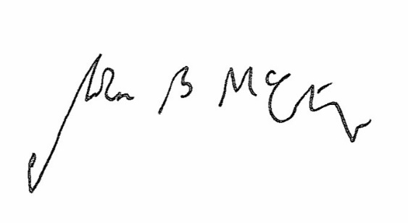

Signed Date 12 June 2018

Judge McCarthy

Deputy Judge of the Upper Tribunal