

**Upper Tribunal**

**(Immigration and Asylum Chamber) Appeal Number: IA/23994/2014**

**IA/23998/2014**

**IA/24002/2014**

**THE IMMIGRATION ACTS**

|  |  |  |
| --- | --- | --- |
| **Decided on the papers** | **Decision and Reasons Promulgated** | |
| **On 16 August 2018** | **On 17 August 2018** |

**Before**

**UPPER TRIBUNAL JUDGE SMITH**

**Between**

**MR ANDRIY DMYTRENKO**

**MRS OLHA DMYTRENKO**

**MISS BOHDANA SHASHOK DMYTRENKO**

(ANONYMITY DIRECTION NOT MADE)

Appellants

**and**

**SECRETARY OF STATE FOR THE HOME DEPARTMENT**

Respondent

**DECISION AND REASONS**

1. These appeals have been remitted to this Tribunal by the Court of Appeal following a consent order sealed on 4 September 2017. The accompanying statement of reasons provides that there can be no challenge to the decision of Deputy Upper Tribunal Judge Doyle promulgated on 6 October 2015 (“the Decision”) insofar as that set aside the decision of First-tier Tribunal Judge Swaniker promulgated on 12 May 2015 which allowed the Appellants’ appeals. This is because of the limited nature of the grant of permission to appeal by the Court of Appeal. It was however agreed that the Decision insofar as it dismissed the Appellants’ appeals contained a material error of law. The effect of the consent order and statement of reasons therefore is that the Appellants continue to appeal against the Respondent's decisions dated 14 May 2014 refusing them leave to remain on human rights grounds. The hearing of the Appellants’ appeals is listed on Wednesday 20 August 2018.
2. By an e-mail dated 15 August 2018, the Respondent has informed the Tribunal as follows:

“The SSHD applies under Rule 17 of the UTPRs to withdraw the case from the UT’s jurisdiction. Having reviewed the case in advance of the hearing on the 22nd August 2018 the SSHD has taken the view that the Appellant and his wife should be granted leave to remain under the family life provisions in Appendix FM (the 10 year route) based upon their relationship to their daughter who was granted British nationality on the 10th May 2018. This decision has been made with reference to the HO policy on the reasonableness of expecting a British Citizen child to leave the UK/EU.

It is understood that colleagues are in the process of obtaining biometric information in order to complete the grant of leave (the underlying decision to refuse having been withdrawn) but in order to avoid wasted time the SSHD has decided to ask consent for withdrawal.”

1. The Respondent has not yet granted leave to remain and the appeal is not therefore treated as abandoned by operation of statute. Whilst the Respondent is right to point out that Rule 17 does permit either party to withdraw its case, the appeals remain those of the Appellants. The Appellants have not yet responded to the Respondent’s e mail indicating a consent to withdrawal of their appeals. Accordingly, I have decided that the better course of action is to set aside the Decision of DUTJ Doyle in which he dismissed the appeals and to re-make the decision, allowing the Appellants’ appeals by consent on the basis that the Respondent’s decision under appeal has been withdrawn.
2. I therefore allow the Appellants’ appeals.

**DECISION**

**I am satisfied that the Decision of DUTJ Doyle contains a material error of law insofar as that dismissed the Appellants’ appeals. That decision is therefore set aside.**

**I re-make the decision. I allow the Appellants’ appeals.**

Signed 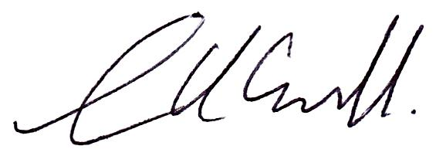 Dated: 16 August 2018

Upper Tribunal Judge Smith