

**Upper Tribunal**

**(Immigration and Asylum Chamber)** Appeal Number: IA/33851/2015

**THE IMMIGRATION ACTS**

|  |  |
| --- | --- |
| **Heard at Field House** | **Decision and Reasons Promulgated** |
| **On 20.08.2018** | **On 30.08.2018** |

**Before**

**UPPER TRIBUNAL JUDGE GRUBB**

**Between**

**PETER OWUSU ANSAH**

**(anonymity direction not made)**

Appellant

**and**

**THE SECRETARY OF STATE FOR THE HOME DEPARTMENT**

Respondent

**Representation:**

For the Appellant:       Mr A Otchie instructed through direct access   

For the Respondent:    Mr C Howells, Senior Home Office Presenting Officer

**NOTICE OF DECISION**

1. Both subparagraphs of rule 40(3) apply to this decision.
2. The decision of the First-tier Tribunal (Judge Powell) sent out on 27 September 2017 is erroneous in law. I set it aside.
3. The appeal is remitted to be determined *de novo* by the First-tier Tribunal other than Judge Powell.
4. The respondent is directed to serve upon the appellant **within 21 days** of this decision being sent (i) the respondent’s bundle; and (ii) any evidence relied upon in relation to the issue of the subsistence of the appellant’s marriage, including any evidence from the appellant’s spouse.

Signed 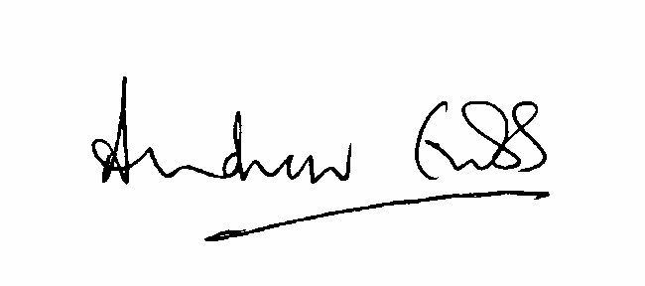

A Grubb

Judge of the Upper Tribunal dated 20 August 2018