

**Upper Tribunal**

**(Immigration and Asylum Chamber)** Appeal Numbers: IA/36307/2014

IA/38031/2014

IA/38049/2014

**THE IMMIGRATION ACTS**

|  |  |
| --- | --- |
| **Heard at Field House, London** | **Decision & Reasons Promulgated** |
| **On 7 September 2018** | **On 17 September 2018** |
|  |  |

**Before**

**DEPUTY JUDGE OF THE UPPER TRIBUNAL McCARTHY**

**Between**

**vikas [p] (1)**

**hinal [p] (2)**

**[y p] (3)**

**(anonymity direction not made)**

Appellants

**and**

**THE SECRETARY OF STATE FOR THE HOME DEPARTMENT**

Respondent

**Representation:**

For the Appellants: Ms A Nizami, Counsel instructed by Singhania & Co Solicitors

For the Respondent: Ms A Fijiwala, Senior Home Office Presenting Officer

**DECISION AND REASONS**

1. The first and second appellants are husband and wife and are the parents of the third appellants. All are citizens of India.
2. The linked appeals have a complex history, most of which is irrelevant to the issues for me to consider. What is relevant is to recognise that the first appellant’s appeal was against the refusal of further leave as a tier 4 (general) student migrant and against a decision to refuse his associated human rights claim, while the appeals against the second and third appellants arise from their applications for further leave as the dependants of a student migrant and from the refusal of their human rights claims.
3. Because these appeals were subject to the previous appeal regime, Ms Fijiwala conceded that First-tier Tribunal Judge Martins erred by not allowing the appeals against the refusal of further leave to remain as a student and dependants of a student migrant on the basis that the decision appealed was not in accordance with the law because relevant policy had not been followed, which raised an issue of unfairness.
4. Furthermore, Ms Nizami and Ms Fijiwala agreed that the other appeals should have been allowed to a similar extent because the refusals of the appellants’ human rights claims were infected with the same error because the respondent had failed to justify the decisions that refused further leave and necessitated the appellants leave the UK.
5. In such circumstances, I agreed that it was appropriate to set aside the decisions in the linked appeals and to substitute a decision that the appeals are allowed to the limited extent that the decisions appealed were not in accordance with the law.
6. I record the following so the likely impact of this decision is clear but I have no jurisdiction to direct the parties act in the ways they describe.
7. The result of my decision is that the original applications remain outstanding before the Secretary of State. The Secretary of State will have to decide what action to take, but it was suggested by both representatives that the proper course would be for the Secretary of State to issue a 60-day letter or a grant leave for a similar period to enable the appellants to secure the evidence and documents they would need to make further applications. The representatives thought any human rights issues should be decided afresh by the respondent subject to the outcome of such further applications because at present there was no public interest in expelling the family group.

**Notice of Decision**

1. The decision and reasons statement of First-tier Tribunal Judge Martins contains legal error and is set aside.
2. 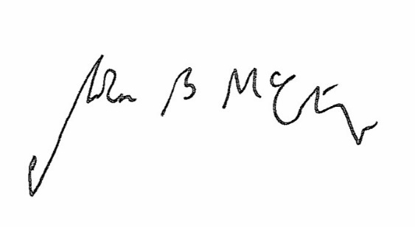I remake the decision allowing the linked appeals to the limited extent that the decisions appealed were not in accordance with the law.

Signed Date 11 September 2018

Judge McCarthy

Deputy Judge of the Upper Tribunal