

**Upper Tribunal**

**(Immigration and Asylum Chamber) Appeal Number: PA/00301/2018**

**THE IMMIGRATION ACTS**

|  |  |
| --- | --- |
| **Heard at Field House** | **Decision and Reason Promulgated** |
| **On 3 July 2018** | **On 12 July 2018** |
|  |  |

**Before**

**DEPUTY UPPER TRIBUNAL JUDGE DOYLE**

**Between**

**R H**

(ANONYMITY DIRECTION MADE)

Appellant

**and**

**SECRETARY OF STATE FOR THE HOME DEPARTMENT**

Respondent

**Representation:**

For the Appellant: Ms R Akthar (counsel) instructed by Edward Alam & Associates

For the Respondent: Mr D Mills, Senior Home Office Presenting Officer

**DECISION AND REASONS**

1. I make an anonymity order under Rule 14 of the Tribunal Procedure (Upper Tribunal) Rules 2008, precluding publication of any information regarding the proceedings which would be likely to lead members of the public to identify the appellant because this is a protection claim.

2. This is an appeal by the Appellant against the decision of First-tier Tribunal Judge Behan promulgated on 16 April 2018, which dismissed the Appellant’s appeal.

Background

3. The Appellant was born on 03 May 1975 and is a national of Bangladesh. On 26/07/2017 the appellant made a protection claim. On 19 December 2017 the Secretary of State refused the Appellant’s application.

The Judge’s Decision

4. The Appellant appealed to the First-tier Tribunal. First-tier Tribunal Judge Behan (“the Judge”) dismissed the appeal against the Respondent’s decision. Grounds of appeal were lodged and on 8 May 2018 Judge Pickup gave permission to appeal stating inter alia

It is arguable that there was procedural unfairness in refusing to adjourn and in continuing with the hearing when the appellant was unfit to give evidence. There was no medical evidence and the appellant’s representative appears to have taken a point of principle and declined to take instructions from his client. The appellant was not called to give evidence and the Judge therefore reduced the credit to be given to his claim to be a BNP activist in Bangladesh. Subsequently, it transpires that the appellant was suffering from gastroenteritis.

The hearing

5. For the respondent Mr Mills told me that the decision contains an error of law. The respondent now correctly concedes that the Judge’s refusal to adjourn the hearing has given rise to procedural unfairness, and the decision can no longer stand. Both Mr Mills and Ms Akthar asked me to set the decision aside and to remit this case to the First-tier Tribunal to be determined of new.

Analysis

6. In Nwaigwe (adjournment: fairness) [2014] UKUT 00418 (IAC) it was held that if a Tribunal refuses to accede to an adjournment request, such decision could, in principle, be erroneous in law in several respects: these include a failure to take into account all material considerations; permitting immaterial considerations to intrude; denying the party concerned a fair hearing; failing to apply the correct test; and acting irrationally. In practice, in most cases the question will be whether the refusal deprived the affected party of his right to a fair hearing. Where an adjournment refusal is challenged on fairness grounds, it is important to recognise that the question for the Upper Tribunal is not whether the First-tier Tribunal acted reasonably. Rather, the test to be applied is that of fairness: was there any deprivation of the affected party’s right to a fair hearing?

7. It is now clear that the appellant was suffering from gastroenteritis on the day of the hearing before the First-tier tribunal. He could not have been expected to participate in the hearing. The combination of the appellant’s illness and the Judge’s refusal to adjourn effectively excluded the appellant from his own appeal hearing.

8. I therefore find that the decision promulgated on 16 April 2018 contains a material error of law, because the proceedings were tainted by unfairness. I set the decision aside.

9. I cannot substitute my own decision because a new fact-finding exercise is necessary.

Remittal to First-Tier Tribunal

10. Under Part 3 paragraph 7.2(b) of the Upper Tribunal Practice Statement of the 25th of September 2012 the case may be remitted to the First-tier Tribunal if the Upper Tribunal is satisfied that:

(a) the effect of the error has been to deprive a party before the First-tier Tribunal of a fair hearing or other opportunity for that party’s case to be put to and considered by the First-tier Tribunal; or

(b) the nature or extent of any judicial fact finding which is necessary in order for the decision in the appeal to be re-made is such that, having regard to the overriding objective in rule 2, it is appropriate to remit the case to the First-tier Tribunal.

11. In this case I have determined that the case should be remitted because a new fact-finding exercise is required. None of the findings of fact are to stand and a complete re hearing is necessary.

12. I remit the matter to the First-tier Tribunal sitting at Hatton Cross to be heard before any First-tier Judge other than Judge Behan.

**Decision**

**18. The decision of the First-tier Tribunal is tainted by material errors of law.**

**19. I set aside the Judge’s decision promulgated on 16 April 2018. The appeal is remitted to the First-tier Tribunal to be determined of new.**

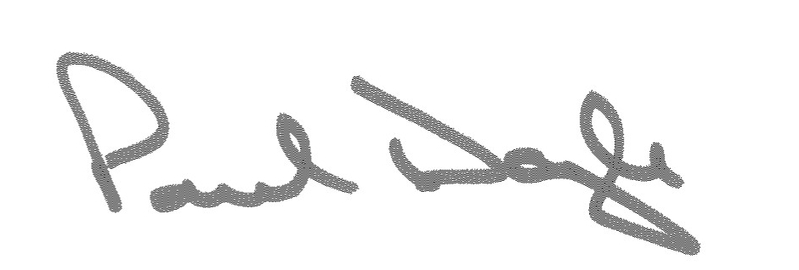Signed Date 9 July 2018

Deputy Upper Tribunal Judge Doyle