

**Upper Tribunal**

**(Immigration and Asylum Chamber)** **Appeal Number: PA/0084/12018**

**THE IMMIGRATION ACTS**

|  |  |  |
| --- | --- | --- |
| **Heard at Field House** | **Decision & Reasons Promulgated** | |
| **On 21May 2018** | **On 08 June 2018** | |
|  | |  |

**Before**

**UPPER TRIBUNAL JUDGE PERKINS**

**Between**

**V S**

(ANONYMITY DIRECTION made)

Appellant

**and**

**SECRETARY OF STATE FOR THE HOME DEPARTMENT**

Respondent

**Representation:**

For the Appellant: The appellant did not appear and was not represented.

For the Respondent: Ms A Everett, Senior Home Office Presenting Officer

**DECISION AND REASONS**

1. This is an appeal by a citizen of the Ukraine against the decision of the First-tier Tribunal dismissing his appeal against the decision of the Secretary of State refusing him asylum or leave to remain on human rights or humanitarian grounds. The appellant did not appear before me. This is slightly surprising given the nature of the case and the money that has already been spent on it, but there was no appearance or explanation for absence by the time it was convenient to deal with this case at about 1.25 p.m. and the papers show that notice of hearing was sent to the appellant and his solicitors by first class post at their respective addresses on 30 April 2010. I am therefore satisfied there was good service in accordance with the Rules and, the being no explanation for absence and it was just to continue.
2. I hope I am not over-summarising the grounds but it seems to me the real point taken here is that it is said that the First-tier Tribunal Judge did not give proper regard to the expert evidence that the documents tending to show that the claimant was in trouble for avoiding the draft in the Ukraine were reliable documents.
3. I think I can put the position simply in these terms. There is clear evidence that prison conditions in the Ukraine are extremely grave and a person facing a custodial sentence in the Ukraine is likely to be facing conditions contrary to the requirements of Article 3 in the European Convention on Human Rights. In short, if there is a real risk of the appellant going to go to prison in the event of return then his appeal ought to have been allowed.
4. The First-tier Tribunal Judge was clearly aware of this. The documents tended to show that the appellant is a person who had been convicted and did risk going to prison. This was explained carefully in an apparently sensible and serious expert report by an expert who had examined the necessary documents, compared them with originals and regarded them as genuine. However, they are not particularly sophisticated documents and not the kind of documents that would require, for example, highly specialised stationery of the kind we might see on a United Kingdom driving licence. The judge recognised the expertise of the witness but did not find the opinion persuasive.
5. I find paragraph 40 of the judge’s decision particularly apt. The judge has looked at the country guidance given in VB and another (draft evaders and prison conditions) Ukraine v SSHD [2017] UKUT 79. He then recognised that the view of the Tribunal, after looking at the matter with the particular care appropriate for a country guidance case, was that the arrangements for the draft in Ukraine are disorganised and even chaotic, that many people ignore the draft with impunity, or those that are punished do not face particularly severe sanctions. It would be unusual in the extreme to be sent to prison for avoiding the draft.
6. In this case the judge, having expressed his reasons for being unpersuaded by the documents, said:

“It follows that if the documents in this appeal are reliable ones, this Appellant is on the very cusp of a new wave of convictions and sentences, unknown to the country experts at the end of 2016, when the hearings in **VB** took place. However, the purported Court judgment from the Buchach District Court is dated 25 November 2014. All the call up papers were dated in 2014, so the alleged court process occurred with remarkable speed, particularly when considering the material contents of **VB**.”

1. In my judgment the judge has recognised that the evidence shows the documents are reliable in that they are in the correct form and show the things that they ought to show, but they would be reliable only if the process of bringing somebody who avoids the draft to the point of conviction had proceeded at a rate quite out of the experience of the Tribunal and quite out of keeping with what happens in the Ukraine.
2. The judge was not persuaded by the documents and if the documents are not reliable the case falls away.
3. I am wholly unpersuaded that the First-tier Tribunal Judge did anything other than look carefully, conscientiously and lawfully at the documents in front of him and reached a rational decision open to him on the evidence and I dismiss the appeal against this decision.

**Notice of Decision**

The appeal is dismissed.

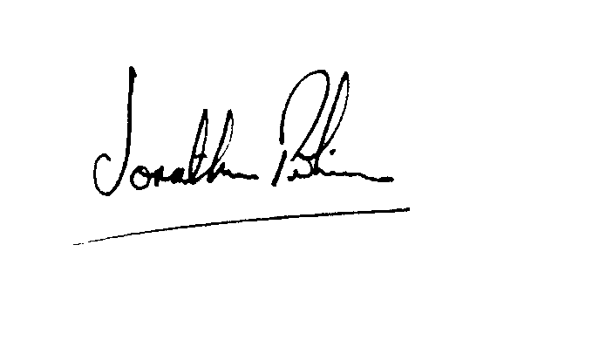

|  |  |
| --- | --- |
| Signed |  |
| Jonathan Perkins, Upper Tribunal Judge | Dated: 25 April 2018 |