

**Upper Tribunal**

**(Immigration and Asylum Chamber)** Appeal no: **PA/01091/2016**

**THE IMMIGRATION ACTS**

|  |  |
| --- | --- |
| At **Royal Courts of Justice, Belfast** | Decision signed: **24.07.2018** |
| on **24.07.2018** | sent out: **02.08.2018** |

Before:

Upper Tribunal Judge

**John FREEMAN**

Between:

**[F H]**

appellant

**and**

respondent

Representation:

For the appellant: *Stuart McTaggart* (counsel instructed by Andrew Russell & Co)

For the respondent: Mr A McVeety

**DETERMINATION AND REASONS**

This is an appeal, by the , against the decision of the First-tier Tribunal (Judge Francis Farrelly), sitting at Belfast on 21 July 2017, to  an asylum appeal by a Ndebele citizen of Zimbabwe, born 1956.

1. The appellant said she had been seriously assaulted in September 2003, together with her son, who had died of his injuries. The perpetrators had been a group of police and others who had wanted to know the whereabouts of her brother, a former policeman and an opponent of the regime as a ZAPU member. In his account of the respondent’s case at paragraph 6, the judge noted that the appellant had also said in her asylum interview, though not at her screening interview, that she had been “… arrested a lot during the 2013 elections and questioned about her brother’s whereabouts”.
2. If the appellant’s claim of present risk on return to Zimbabwe were to have any chance of succeeding at all, then clearly she needed to establish her credibility on the 2013 incidents, though in the light of political changes since, that would only be the first step. The judge, at 23, accepted the 2003 events; but he made no direct credibility finding on those of 2013, though at 20 he referred in general terms to “… inconsistencies in her account as set out by the respondent”. He needed to reach his own view on that, and explain why, before going on to say “The appellant has been able to live in her home area ever since [2003]”.
3. This was why Mr McVeety realistically conceded that this appeal must be allowed and a fresh hearing directed.

**Appeal** **: first-tier decision set aside**

**Fresh hearing in First-Tier Tribunal at Belfast, not before Judge Farrelly**

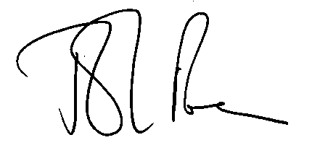 (a judge of the Upper Tribunal)

**Date: 24 July 2018**