

**Upper Tribunal**

**(Immigration and Asylum Chamber) Appeal Number: PA/01147/2018**

**THE IMMIGRATION ACTS**

|  |  |  |
| --- | --- | --- |
| **Heard at Field House** | **Decision & Reasons Promulgated** | |
| **On 13 June 2018** | **On 05 July 2018** | |
|  | |  |

**Before**

**UPPER TRIBUNAL JUDGE PERKINS**

**Between**

**Mr R O B**

(ANONYMITY DIRECTION made)

Appellant

**and**

**SECRETARY OF STATE FOR THE HOME DEPARTMENT**

Respondent

**Representation:**

For the Appellant: Mr A Khan, Counsel, instructed by Barnes Harrild & Dyer Solicitors

For the Respondent: Ms A Everett, Senior Home Office Presenting Officer

**DECISION AND REASONS**

1. This is the substantially unmodified transcript of my extempore judgement given at the end of the hearing on 13 June 2018.
2. Pursuant to rule 14 of the Tribunal Procedure (Upper Tribunal) Rules 2008 I make an order prohibiting the disclosure or publication of any matter likely to lead members of the public to identify the Appellant. Breach of this order can be punished as a contempt of court. I make this order because this is a protection case and there is invariably a risk in cases of this kind that publicity will itself create a risk.
3. The appellant is a citizen of Iraq and appeals against the decision of the First-tier Tribunal dismissing his appeal against the decision of the Secretary of State refusing him asylum or humanitarian protection.
4. The First-tier Tribunal has made substantial findings that are very much to the appellant’s advantage. There was no Rule 24 notice before me to suggest that those findings are wrong or not open to the judge and it is those findings that frame the decision.
5. Mr Khan has taken considerable care to produce (appropriately) lengthy grounds of appeal comprising mainly of extracts from the operative part of the country guidance decision **AA (Article 15(c)) Iraq CG [2015] UKUT 00544 (IAC)**, which identifies the category of people who are most likely to be at risk in the event of return. It is also right to say that the appellant appears on the judge’s findings to be in the category of people who are most at risk. Mr Khan put it particularly helpfully at paragraph 6 of his skeleton argument, where he says:

“It follows that for a person, from a minority group, who can’t speak Arabic, has no CSID and who does not have any family support in Baghdad, would be the group of people least able to provide for himself (para 202) and it would be unreasonable and unduly harsh to relocate to Baghdad (para 203).”

1. This is a fair summary of the judge’s findings and it might have been thought the judge was setting up to allow the appeal.
2. However, the judge dismissed the appeal. The judge said at paragraph 66, having referred to the case of **AA**, that:

“There is some evidence that returned failed asylum seekers are provided with the support generally available to IDPs. I have been provided with no evidence that the appellant could not access such support. The burden is on him to show he could not access such support. He has not done so. I therefore find he could access such support. As such he would not be destitute.”

1. This is a slightly troubling paragraph for a variety of reasons. I do not think it follows at all from the fact that he had not shown that he could not access support that it was open to the judge to find that he could access support. At best it would be a finding that he may be able to access such support. It is a finding which is based largely on speculation, supported by what Mr Khan says, I think probably about correctly, is a misreading of the decision in **AA**. I think the point that the Tribunal was trying to make in **AA** was that there is some evidence that a failed asylum seeker will get the support available to an internally displaced person and that is something the judge must bear in mind when the decisions are being made.
2. I do not understand how an appellant can realistically be expected to prove that he would not get such support. Rather, I see it as a marker for those who monitor these things to be aware of the shifts in evidence. It may be that on some future occasion it will be clearer what the position is but I see it no more as a note of caution and the judge has converted it, I find wrongly, into a strict requirement and something that has to be proved, and I find that is going too far.
3. What this appellant has clearly done to the satisfaction of the judge is show that he is in the category of people who are most likely to be at risk and the fact that there is some evidence that he might get help from IDPs is not, I find, a proper reason to dismiss the appeal, and it is really was the only reason given to dismiss the appeal.
4. I find that Mr Khan’s arguments in his grounds of appeal, with respect, are entirely cogent. The judge’s findings only properly support one decision, and it is a decision to allow the appeal, and I set aside the judge’s decision and I shall replace the decision allowing the appeal of the appellant against the decision of the Secretary of State.

**Notice of Decision**

I set aside the decision of the First-tier Tribunal and I substitute a decision allowing the appellant’s appeal.

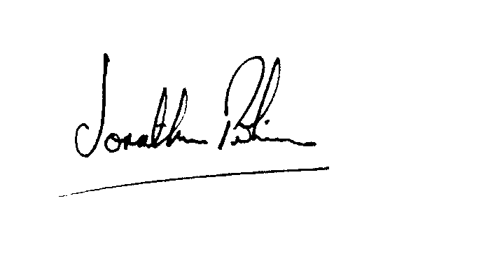

|  |  |
| --- | --- |
| Signed |  |
| Jonathan Perkins, Upper Tribunal Judge | Dated: 4 July 2018 |