

**Upper Tribunal**

**(Immigration and Asylum Chamber)** Appeal Number: PA/02697/2017

**THE IMMIGRATION ACTS**

|  |  |
| --- | --- |
| **Heard at Newport (Columbus House)** | **Decision and Reasons Promulgated** |
| **On 18 September 2018** | **On 20 September 2018** |

**Before**

**UPPER TRIBUNAL JUDGE GRUBB**

**Between**

**STEPHEN [J]**

**(anonymity direction not made)**

Appellant

**and**

**THE SECRETARY OF STATE FOR THE HOME DEPARTMENT**

Respondent

**Representation:**

For the Appellant:       Mr G Hodgetts, instructed by Duncan Lewis Solicitors

For the Respondent:    Mr C Howells, Senior Home Office Presenting Officer

**NOTICE OF DECISION**

1. Both subparagraphs of rule 40(3) of the Tribunal Procedure (Upper Tribunal) Rules 2008 (SI 2008/2698 as amended) apply to this decision.
2. The decision of the First-tier Tribunal (Judge I D Boyes) sent out on 7 July 2018 is erroneous in law. I set it aside.
3. The appeal is remitted to be determined by the First-tier Tribunal *de novo* at an oral hearing by a judge other than Judge I D Boyes.

Signed

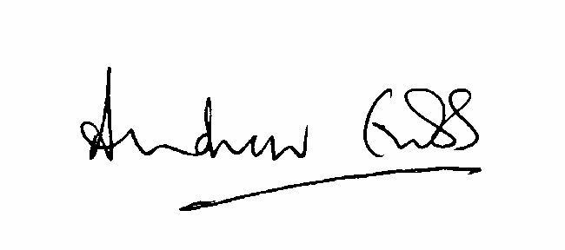

A Grubb

Judge of the Upper Tribunal

Date 18, September 2018