

**Upper Tribunal**

**(Immigration and Asylum Chamber)** Appeal Number: PA/03283/2017

PA/05040/2017

**THE IMMIGRATION ACTS**

|  |  |
| --- | --- |
| **Done at Field House** | **Determination Promulgated** |
| **On 24 July 2018** | **On 31 July 2018** |
|  |  |

**Before**

**UPPER TRIBUNAL JUDGE PERKINS**

**Between**

**A--- K---**

**S--- K---**

**(anonymity order in force)**

Appellant

**and**

**SECRETARY OF STATE FOR THE HOME DEPARTMENT**

Respondent

**DETERMINATION AND REASONS**

1. Pursuant to rule 14 of the Tribunal Procedure (Upper Tribunal) Rules 2008 I make an order prohibiting the disclosure or publication of any matter likely to lead members of the public to identify the Appellants. Breach of this order can be punished as a contempt of court. I make this order because this is a protection case and there is invariably a risk in cases of this kind that publicity will itself create a risk.
2. This is an appeal against a decision of the First-tier Tribunal dismissing the Appellants’ appeals against a decision of the Respondent to refuse their claims for international protection and/or leave to remain on human rights grounds.
3. The parties agree that the First-tier Tribunal erred in law by failing to consider properly (or at all) an expert report and by unlawfully making an adverse credibility finding without considering the evidence in the round.
4. They further agree that these failings should be remedied by setting aside the decision of the First-tier Tribunal and remitting the appeal to the First-tier Tribunal to be heard again.
5. They are right to agree that the First-tier Tribunal materially erred in law. I set aside its decision.
6. Further, as the agreed errors go to the core of the adverse credibility finding the Appellant might have a justified sense of grievance if I did not remit the appeal so that his further appeal rights were not prejudiced.
7. I can see no need to keep the appeal in the Upper Tribunal.
8. 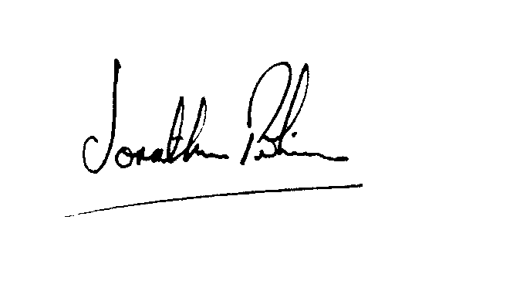It follows that, with the consent of the parties, I set aside the decision of the First-tier Tribunal and I direct that the appeal be heard again on the First-tier Tribunal by a judge other than the one whose decision I have set aside.

|  |  |
| --- | --- |
| Signed |  |
| Jonathan Perkins  Judge of the Upper Tribunal | Dated 24 July 2018 |