

**Upper Tribunal**

**(Immigration and Asylum Chamber)** Appeal Number: PA/03426/2017

**THE IMMIGRATION ACTS**

|  |  |
| --- | --- |
| **Heard at Field House** | **Decision & Reasons Promulgated** |
| **On 26 April 2018** | **On 15 May 2018** |
|  |  |

**Before**

**UPPER TRIBUNAL JUDGE PERKINS**

**Between**

**THE Secretary of State FOR THE Home Department**

Appellant

**and**

**S K P**

**(ANONYMITY DIRECTION made)**

Respondent

**Representation:**

For the Appellant: Mr I Jarvis, Home Office Presenting Officer

For the Respondent: The Respondent appeared in person

**DECISION AND REASONS**

1. Pursuant to rule 14 of the Tribunal Procedure (Upper Tribunal) Rules 2008 I make an order prohibiting the disclosure or publication of any matter likely to lead members of the public to identify the Respondent. Breach of this order can be punished as a contempt of court. I make this order because, although not apparent from this Decision, this is a protection case and there is invariably a risk in cases of this kind that publicity will itself create a risk.
2. This is an appeal by the Secretary of State against a decision of the First-tier Tribunal allowing on human rights grounds the appeal of the Respondent, hereinafter “the Claimant”, against the decision of the Secretary of State refusing him leave to remain on asylum and human rights grounds.
3. I do not think it is necessary to go into the details of the decision. The problem is that the decision to allow the appeal under Article 2 and Article 3 of the European Convention on Human Rights seems to be wholly anachronistic and contrary to the clear indication given by the judge when he dismissed the appeal on asylum grounds. I can see no possible basis whatsoever on which the judge could have intended the allow the appeal with reference to Article 2 and Article 3.
4. The Claimant has conducted himself throughout these proceedings with considerable thought and dignity and he made no effort to persuade me that the judge meant to allow the appeal even though that is what the judge said. It follows therefore that this is an unsatisfactory decision.
5. I have to consider if the proper thing to do would be to follow the judge’s findings and dismiss the appeal on human rights grounds. However, Mr Phiri, who represented himself in the First-tier Tribunal, has produced a detailed statement and has explained what happened in the First-tier Tribunal. He says in short, and I am paraphrasing things a little, so I hope I will be excused any inaccuracies, that he expected to be represented before the First-tier Tribunal, that he was let down at the last minute and asked for an adjournment but the Judge insisted the case went ahead.
6. The Judge did not record in the decision that he had been asked to adjourn the appeal but the papers were sent back to the Judge to comment in the light of the Claimant’s suggestion and there was no reply. I have no evidence to go behind the Claimant’s contention that he asked for an adjournment and the fact that that application was not recorded was at best unfortunate. The Claimant says that he was not expecting to have to present his appeal and he did not present his appeal as well as he should have done because he was rather unsettled by discovering at short notice he had to present his appeal. Such arguments are not necessarily particularly persuasive but I am satisfied that that is what happened here.
7. There is another element of this case that I find disturbing. In paragraph 2 of the Decision and Reason the Judge refers to the Claimant in the female gender. I do not think this is anything other than the thoughtless use of a standard paragraph but it is very undesirable to make a mistake like that, particularly given the core nature of the Claimant’s case. I apologise to the Claimant for that mistake being made, I do not think it arises from anything other than carelessness but I really wish it had not happened.
8. 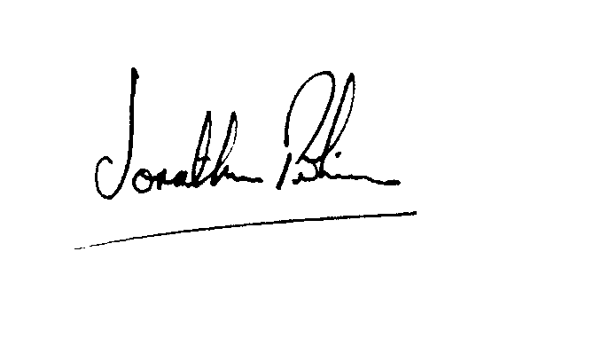In the circumstances I set aside the decision in its entirety and I direct the case be heard again in the First-tier Tribunal. There is no way this can be salvaged. There has been no proper hearing and the appeal needs to be reheard before a different judge.

|  |  |
| --- | --- |
| Signed |  |
| Jonathan Perkins, Upper Tribunal Judge | Dated: 11 May 2018 |