

**Upper Tribunal**

**(Immigration and Asylum Chamber)** Appeal Number: PA/03552/2018

**THE IMMIGRATION ACTS**

|  |  |
| --- | --- |
| **Heard at Field House, London** | **Decision & Reasons Promulgated** |
| **On 7 September 2018** | **On 18 September 2018** |
|  |  |

**Before**

**DEPUTY JUDGE OF THE UPPER TRIBUNAL McCARTHY**

**Between**

**THE SECRETARY OF STATE FOR THE HOME DEPARTMENT**

Appellant

**and**

**jamal [M]**

**(anonymity direction not made)**

Respondent

**Representation:**

For the Appellant: Ms A Fijiwala, Home Office Presenting Officer

For the Respondent: Mr K Gayle, Counsel instructed by Elder Rahimi Solicitors

**DECISION AND REASONS**

1. The respondent was born on 8 May 1999 and is a Iranian national of Kurdish ethnicity.
2. On 5 July 2018, First-tier Tribunal Judge E B Grant granted the Secretary of State permission to appeal against the decision and reasons statement of First-tier Tribunal Judge Heatherington that was issued on 14 June 2018. Judge Heatherington found the respondent to be credible on the core issues of his protection claim, namely that he had a low-level involvement in the KDPI and concluded the respondent had a well-founded fear of persecution in Iran because of his political opinions. The Secretary of State argued Judge Heatherington’s findings were inadequate owing to a lack of reasoning.
3. After hearing from Ms Fijiwala and Mr Gayle, I announced my decision.
4. Of course, there is nothing in any argument that a decision contains an error of law merely because it is brief. I mention this because the grant of permission alludes to the decision and reasons statement being short.
5. I am satisfied Judge Heatherington adequately considered and determined the issues held against the appellant’s credibility in paragraphs 27, 28, 29, 30, 31 and 32 of the reasons for refusal letter dated 1 March 2018. Judge Heatherington deals with the issues arising in paragraph 27 and 28 in paragraph 8.6(a) of his decision, with the issues arising in paragraphs 30 and 31 in paragraph 8.6(c) of his decision and the issues arising in paragraph 32 in his paragraph 8.6(b). In each case, Judge Heatherington has provided sufficient indication that he was aware of the Secretary of State’s allegations and why those allegations did not stand. I find the Secretary of State’s allegations that Judge Heatherington did otherwise is mere disagreement with the findings made.
6. In reaching this decision I have remembered that reasons do not have to be lengthy. I have also accepted Mr Gayle’s submission that the arguments presented by the respondent in the reasons for refusal letter were weakened by the fact they misrepresented the respondent’s evidence when interviewed. For example, in answer to question 50 in the asylum interview, the respondent said he did not know if the Iranian authorities recognised him when ambushed. It did not follow, as alleged in the reasons for refusal letter, that the Iranian authorities had no interest in him. But these points merely add weight to what is obvious, that Judge Heatherington dealt sufficiently with the core issues in the appeal.
7. I have also considered whether Judge Heatherington dealt appropriately with the allegations that were made about whether the respondent left Iran illegally. Although Judge Heatherington makes no direct reference to paragraphs 35 and 36 of the reasons for refusal letter he did not have to address them since the allegation the appellant had not left illegally was predicated on the respondent not being credible on his core account. I find there is no legal error on this point.
8. I am not satisfied, however, that Judge Heatherington made findings in relation to the section 8 issues raised in paragraph 37 of the reasons for refusal letter. There is no explicit mention of those issues in his decision and reasons statement. It is trite law that the judge was required to take into consideration the failure of the respondent to claim asylum in France. Not only was that a requirement under section 8 but it is also part and parcel of the proper approach to paragraph 339L of the immigration rules, with reference to paragraph 339N.
9. I find this failure amounts to legal error in the decision.
10. However, I do not find this error is sufficient to set aside the decision. At paragraph 36 of the reasons for refusal letter, the Secretary of State records the respondent explained he had not claimed asylum in France because he did not know where he was and he followed the agent’s (the person directing his journey) advice. This is a reasonable explanation given what is known about refugee migration routes and the actions of such agents, particularly bearing in mind the respondent’s limited educational attainment and the fact he was just 18 when he left Iran. Given that the core of the respondent’s account was found for good reasons to be sound, weight can be given to this explanation and that is sufficient to rebut the section 8 allegation.
11. Therefore, despite there being legal error, I uphold the decision of Judge Heatherington that the appellant is a refugee.

**Notice of Decision**

There is legal error in the decision and reasons statement of First-tier Tribunal Judge Heatherington but it is not sufficient to set aside his decision because it is not material.

The Secretary of State’s appeal to the Upper Tribunal is dismissed.

I uphold the decision and reasons statement of First-tier Tribunal Judge Heatherington.

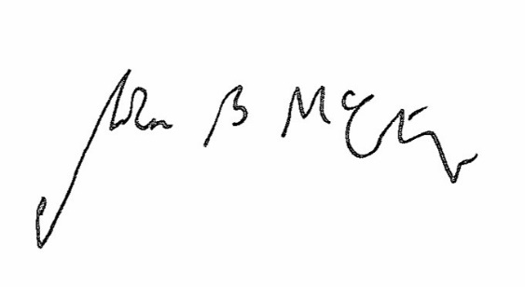

Signed Date 13 September 2018

Judge McCarthy

Deputy Judge of the Upper Tribunal