

**Upper Tribunal**

**(Immigration and Asylum Chamber)** Appeal Number: PA/04868/2017

**THE IMMIGRATION ACTS**

|  |  |
| --- | --- |
| **Heard at Birmingham** | **Decision & Reasons Promulgated** |
| **On 10 July 2018** | **On 10 August 2018** |
|  |  |

B**efore**

**DEPUTY UPPER TRIBUNAL JUDGE McCARTHY**

**Between**

**THE SECRETARY OF STATE FOR THE HOME DEPARTMENT**

Appellant

**and**

**TFA**

**(anonymity direction MADE)**

Respondent

**Representation:**

For the Appellant: Mr D Mills, Senior Home Office Presenting Officer

For the Respondent: Ms M Chaggar, instructed by Frence & Co, Nottingham

**DECISION AND REASONS**

1. The anonymity direction made by the First-tier Tribunal is continued, albeit that it is now made under Rule 14(1) of the 2008 Upper Tribunal Procedure Rules.
2. The appellant was born on 27 May 1986 and is a citizen of Nigeria. Her appeal against the refusal of a protection claim was allowed by First-tier Tribunal Judge Birk on 20 July 2017.
3. Permission to appeal to the Upper Tribunal was granted by UT Judge Eshun on 6 November 2017. This key issue in this appeal was whether Judge Birk was entitled to make her own findings as to whether the appellant had been trafficked given that there was a negative conclusive grounds decision by the competent authority, a different part of the Home Office than that deciding immigration and protection matters.
4. This appeal is brought by the Secretary of State. Since the appeal was determined, the position as to how conclusive grounds decisions should be viewed by the First-tier Tribunal has been clarified by the Court of Appeal by its judgment, *SSHD v MS (Pakistan)* [2018] EWCA Civ 594. Mr Mills relied on this judgment to support his case.
5. Ms Chaggar relied on the rule 24 response prepared by Mr S Vokes, which the Tribunal received on 8 December 2017. He focused on the apparent different standards of proof used by the competent authority when assessing the trafficking issue and the Tribunal when assessing whether there is a real likelihood of persecution or other serious harm.
6. At the hearing I discussed with Mr Mills and Ms Chaggar the concern regarding the standard of proof. The preamble to the competent authority’s decision was expressed in terms of applying a balance of probabilities. That suggested a higher standard of proof than the Tribunal could apply.
7. Although not raised by either party, I recalled that the Supreme Court had confirmed that all evidence in a protection claim appeal was to be assessed at the lower standard of proof (see [16] and [17] of *MA (Somalia) v SSHD* [2010] UKSC 49). The Supreme Court endorsed the principles in *Karanakaran v SSHD* [2000] EWCA Civ 11, which confirm that the lower standard of proof applies to all the evidence to be assessed in a protection claim. These points appeared to add weight to Mr Vokes’s argument because it was unclear how a decision made using a higher standard of proof could bind the Tribunal when determining an appeal against the refusal of a protection claim.
8. *MS (Pakistan)* is silent on this issue. Although discussed at length, the point was not answered by either representative. My own view, having listened to their arguments, is that the decision of the competent authority is not a judicial decision and it is unclear if the decision maker understands the different standards of proof that apply. When I examine the conclusive grounds decision, I find it reflects very well the approach taken in letters detailing why a protection claim has been refused. I am of the opinion that irrespective of the description given by the competent authority, the standard of proof that has in fact been applied is comparable to that used in a decision refusing a protection claim. There is, therefore, in reality no difference in the standard of proof.
9. As a result, after the discussion, I indicated that the decision of Judge Birk contains legal error because she had no proper basis to go behind the decision of the competent authority. There was no evidence to suggest that decision was legally perverse. As a result, the assessment of the appellant’s case and the risk on return are fundamentally flawed and the decision must be set aside.
10. Given the fact the case will have to begin again, the parties agreed that the appeal should be remitted de novo to the First-tier Tribunal. I agree.

**Notice of Decision**

The decision of FtT Judge Birk contains an error of law and is set aside.

The appeal is remitted to the First-tier Tribunal for a fresh decision made by a judge other than Judge Birk.

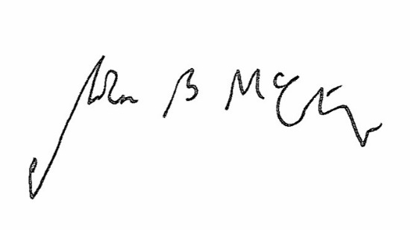

Signed Date 6 August 2018

Judge McCarthy

A Deputy Judge of the Upper Tribunal