

**Upper Tribunal**

**(Immigration and Asylum Chamber)** Appeal Number: PA/05695/2017

**THE IMMIGRATION ACTS**

|  |  |
| --- | --- |
| **Heard at Birmingham** | **Decision & Reasons Promulgated** |
| **On 12 June 2018** | **On 21 June 2018** |
|  |  |

**Before**

**DEPUTY JUDGE OF THE UPPER TRIBUNAL McCARTHY**

**Between**

**SHADYA [H]**

**(anonymity ORDER NOT MADE)**

Appellant

**and**

**THE SECRETARY OF STATE FOR THE HOME DEPARTMENT**

Respondent

**Representation:**

For the Appellant: Ms H Masih, instructed by Braitch RB Solicitors

For the Respondent: Mr D Mills, Senior Home Office Presenting Officer

**DECISION AND REASONS**

1. The appellant appeals with permission granted by UT Judge Rintoul against the decision and reasons statement of FtT Judge Chapman that was issued on 18 July 2017.
2. The grounds settled by Ms Masih are detailed and substantive. The following is a summary, which I hope does them justice. The appellant’s principle complaint is that when assessing her credibility, Judge Chapman’s repeatedly uses the phrase, “she does not satisfactorily explain …”. The repetitive use of this phrase indicates, according to Ms Masih, that Judge Chapman has failed to give adequate reasons for finding the appellant to lack credibility. The other five grounds stem from this principle complaint. The lack of adequate reasoning suggests the judge failed to consider material evidence (and in so doing at one point he made an error of fact) as well as failing to make findings on key issues.
3. Ms Masih amplified her grounds during the hearing. She pointed to a number of juncture in the decision and reasons statement where it was unclear if Judge Chapman had properly considered the evidence. For example, at [50(4)], Judge Chapman suggests the appellant’s account was not credible because of the risks she apparently took, yet he failed to appreciate the appellant’s evidence about how she acted carefully to minimise risks of being seen. Ms Masih raised similar concerns over other parts of the appellant’s evidence, which appears to have been overlooked by Judge Chapman. I do not need to record them all here; they are numerous and similar in content to the example I have recorded.
4. Mr Mills submitted that although the decision and reasons statement appeared at a superficial level to be a good statement, he understood Ms Masih’s concerns. It is unclear how Judge Chapman’s conclusions of credibility at [51] and [52] are drawn from the evidence, when the judge does not explain how he has considered the evidence. Mr Mills said he was not able to concede the error of law issue but recognised this is a case where it would have been useful if Judge Chapman had given more detail.
5. I have given careful thought to the submissions and after examining the decision and reasons statement thoroughly am satisfied it contains the errors of law identified by Ms Masih. Given the number of and nature of the errors, the only possible outcome is that the decision is set aside and I remit the appeal for a fresh hearing in the First-tier Tribunal by a judge other than Judge Chapman.
6. I share Mr Mills’s misgivings over what might on the face of it appear to be a satisfactory decision and reasons statement. But misgivings are not evidence of an error of law. I turn to consider the principle complaint made by the appellant, about the phrase oft repeated by Judge Chapman, “[The appellant] does not satisfactorily explain …”. On its own, it suggests to me that the judge was applying some test. I also immediately notice that Judge Chapman does not explain why the explanation offered – and explanations were offered by the appellant – were not satisfactory. He merely states they are unsatisfactory.
7. In several cases, the lack of a satisfactory explanation is in fact a gap in the evidential matrix. For example, at [50(1)], Judge Chapman says the appellant did not satisfactorily explain how she was working on the family farm and then went to the local park. It is unclear from the decision and reasons statement as to whether Judge Chapman sought to explore these gaps in the evidential matrix and this undermines the phrase, “[The appellant] does not satisfactorily explain …”. The appellant indicated events in her account and was not asked to explain the issues held against her. The Tribunal has regularly said that where a judge believes there is a gap in the evidential matrix, then it should be put to the appellant (see *AM (fair hearing) Sudan* [2015] UKUT 656 for a recent case on this point). Because I have no evidence this was done, I conclude the findings made throughout [50] are unsound.
8. It follows that the credibility findings made by Judge Chapman cannot stand and must be set aside. In cases where the credibility assessment must be carried out afresh, the proper course is to remit the appeal to the First-tier Tribunal to be heard by a judge other Judge Chapman. In light of the above, it goes without saying that none of his findings are preserved.

**Notice of Decision**

The appeal to the Upper Tribunal is allowed.

The decision of FtT Judge Chapman contains legal error and is set aside.

The appeal is remitted to the First-tier Tribunal for a fresh hearing before a different judge. Nothing is preserved.

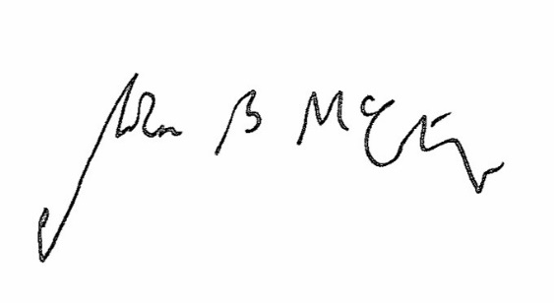Signed Date 18 June 2018

Judge McCarthy

Deputy Judge of the Upper Tribunal