

**Upper Tribunal**

**(Immigration and Asylum Chamber) Appeal Number: PA/06032/2017**

**THE IMMIGRATION ACTS**

|  |  |
| --- | --- |
| **Heard at Newport** | **Decision & Reasons Promulgated** |
| **On 3 May 2018** | **On 17 May 2018** |
|  |  |

**Before**

**UPPER TRIBUNAL JUDGE GRUBB**

**Between**

**d h**

(ANONYMITY DIRECTION made)

Appellant

**and**

**THE SECRETARY OF STATE FOR THE HOME DEPARTMENT**

Respondent

**Representation:**

For the Appellant: Ms S Alban of Fountain Solicitors

For the Respondent: Mr P Duffy, Senior Home Office Presenting Officer

**DECISION AND REASONS**

1. Pursuant to rule 14 of the Tribunal Procedure (Upper Tribunal) Rules 2008 (SI 2008/2698) I make an anonymity order prohibiting the disclosure or publication of any matter likely to lead to members of the public identifying the appellant. A failure to comply with this direction could lead to Contempt of Court proceedings.
2. The appellant is a citizen of Iraq who was born on 1 January 1996. She arrived in the United Kingdom illegally on 15 December 2016 and claimed asylum the next day.
3. On 9 June 2017, the Secretary of State rejected the appellant’s claim for asylum, humanitarian protection and under Art 8 of the ECHR.
4. The appellant appealed to the First-tier Tribunal. Judge Suffield-Thompson dismissed the appellant’s appeal on all grounds.
5. The appellant sought permission to appeal challenging the judge’s decision in respect of her asylum claim, her claim to humanitarian protection under Art 15(c) of the Qualification Directive and Art 8 of the ECHR.
6. On 25 October 2017, the First-tier Tribunal (Judge Bird) granted the appellant permission to appeal.
7. On 10 November 2017, the Secretary of State filed a rule 24 response seeking to uphold the judge’s decision.
8. At the hearing, Mr Duffy, who represented the Secretary of State conceded that the judge’s adverse decision in respect of Art 8 could not stand. He conceded that the judge’s finding in para 92 that it would not be unreasonable to expect the appellant and her son (and her partner) to leave the UK was contrary to the respondent’s own guidance. He acknowledged that the appellant’s partner was a British citizen and so was his child. In those circumstances, Mr Duffy accepted that the Secretary of State’s position was that only if there was criminality or a very poor immigration history would it be reasonable to expect the child and the appellant’s partner (the child’s father) to leave the UK.
9. In those circumstances, he invited me to set aside the judge’s decision in respect of Art 8 and to re-make the decision allowing the appeal under Art 8 of the ECHR.
10. Ms Alban, who represented the appellant, in the light of Mr Duffy’s position indicated that the appellant no longer challenged the adverse decision in respect of her international protection claim. She was content that the appeal should be allowed under Art 8.

**Decision**

1. In the light of the respondent’s concession, which was entirely properly made, I am satisfied that the judge materially erred in-law in dismissing the appellant’s appeal under Art 8.
2. That decision is set aside.
3. I remake the decision allowing the appeal under Art 8.
4. The judge’s decisions to dismiss the appeal on asylum and humanitarian protection grounds stand.

Signed

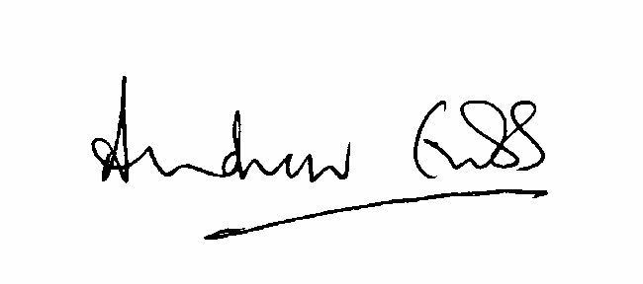

A Grubb

Judge of the Upper Tribunal

14 May 2018