

**Upper Tribunal**

**(Immigration and Asylum Chamber)** **Appeal Number: PA/07002/2017**

**THE IMMIGRATION ACTS**

|  |  |  |
| --- | --- | --- |
| **Heard at Field House** | **Decision and Reasons Promulgated** | |
| **On 2 July 2018** | **On 24 July 2018** | |
|  | |  |

**Before**

**DEPUTY UPPER TRIBUNAL JUDGE DOYLE**

**Between**

**C C**

**(ANONYMITY DIRECTION MADE)**

Appellant

**and**

**SECRETARY OF STATE FOR THE HOME DEPARTMENT**

Respondent

**Representation:**

For the Appellant: absent

For the Respondent: Ms Willocks-Briscoe, Senior Home Office Presenting Officer

**DECISION AND REASONS**

1. I make an anonymity order under Rule 14 of the Tribunal Procedure (Upper Tribunal) Rules 2008, precluding publication of any information regarding the proceedings which would be likely to lead members of the public to identify the appellant because this is a protection claim.

2. This is an appeal by the Appellant against the decision of First-tier Tribunal Judge Caswell promulgated on 13 September 2017, which dismissed the Appellant’s appeal against the respondent’s decision to refuse her protection claim.

Background

3. The Appellant was born on 12 December 1993 and is a national of Zimbabwe. On 15 June 2017 the respondent refused the appellant’s protection claim.

The Judge’s Decision

4. The Appellant appealed to the First-tier Tribunal. First-tier Tribunal Judge Caswell (“the Judge”) dismissed the appeal against the Respondent’s decision. Grounds of appeal were lodged and on 15 May 2018 Upper Tribunal Judge Plimmer gave permission to appeal stating

It is arguable that given the particular circumstances, which included the appellant indicating the day before her asylum appeal that she wanted it to proceed on the papers but the SSHD’s representative objecting to this on the morning of the hearing and as such the appeal proceeded as an oral hearing in her absence, fairness demanded that the oral hearing be adjourned to ensure the attendance of both parties.

The Hearing

5. The Appellant did not attend the appeal nor was she represented at the appeal. I am satisfied that due notice of the appeal was served upon the Appellant at the address that was given. I am therefore satisfied that, as the appellant has been served notice of the hearing, it is in the interests of justice to proceed with the hearing in the Appellant’s absence relying on paragraph 38 of The Tribunal Procedure (Upper Tribunal) Rules 2008.

6. Ms Willocks-Briscoe told me that the decision does not contain an error of law. She told me that I would have to ask myself whether or not the Judge applied rule 25 of The Tribunal Procedure (First-tier Tribunal) (Immigration and Asylum Chamber) Rules 2014 correctly, and whether or not the appellant has been treated fairly.

7. In her letter of appeal, the appellant reiterates because she is gay and that she faces abuse potential death if returned to Zimbabwe. The appellant complains that internal relocation is impossible because it is unduly harsh. The appellant says that she did not want an oral hearing and specifically asked for her case to be determined on the papers only.

Analysis

8. The appellant’s notice of appeal to the First-tier Tribunal was received on 26 July 2017. In August 2017 the appellant was sent notice of a pre hearing review to take place on 23 August 2017, and asked to complete a reply notice. The appellant completed the reply notice and returned it on 18 August 2017. In that reply notice the appellant said

I do not want an oral hearing.

9. Directions were sent to the appellant on 24 August 2017 advising the appellant that a substantive hearing had been fixed to take place at 6 September 2017. On 5 September 20 17 the appellant emailed the Fist-tier Tribunal saying

….. I do not wish to have an oral hearing. I wish my appeal to be heard through written documents. I have no desire for an oral hearing to be conducted. So if you would kindly revert my hearing to a written hearing.

10. The case called for hearing before the Judge on 6 September 2017. Only the Home Office presenting officer was present and only he made submissions. The record of proceedings records that the hearing lasted 10 minutes. The Home Office presenting officer’s submissions are recorded as being a submission that the respondent believes there is no risk to the appellant on return and reliance is placed on country guidance caselaw.

11. Permission to appeal was granted on the basis that there may have been procedural unfairness. Rule 25 of The Tribunal Procedure (First-tier Tribunal) (Immigration and Asylum Chamber) Rules 2014 says

**25.**—(1) The Tribunal must hold a hearing before making a decision which disposes of proceedings except where—

(a) each party has consented to, or has not objected to, the matter being decided without a hearing;

(b) the appellant has not consented to the appeal being determined without a hearing but the Lord Chancellor has refused to issue a certificate of fee satisfaction for the fee payable for a hearing;

(c) the appellant is outside the United Kingdom and does not have a representative who has an address for service in the United Kingdom;

(d) it is impracticable to give the appellant notice of the hearing;

(e) a party has failed to comply with a provision of these Rules, a practice direction or a direction and the Tribunal is satisfied that in all the circumstances, including the extent of the failure and any reasons for it, it is appropriate to determine the appeal without a hearing;

(f) the appeal is one to which rule 16(2) or 18(2) applies; or

(g) subject to paragraph (2), the Tribunal considers that it can justly determine the matter without a hearing.

(2) Where paragraph (1)(g) applies, the Tribunal must not make the decision without a hearing without first giving the parties notice of its intention to do so, and an opportunity to make written representations as to whether there should be a hearing.

(3) This rule does not apply to decisions under Part 4 or Part 5.

12. At [1] of the decision the Judge clearly considers rule 25 of the 2014 procedure rules. The case file demonstrates that both parties to this appeal were advised of the time, date and place of the hearing. The submissions that the Judge recorded are brief. The Judge writes a full decision and clearly considers the documentary evidence (which is what the appellant wants) at [14] of the decision. At [17] and [18] the Judge analyses the evidence before reaching a conclusion which is well within the range of reasonable conclusions available to the Judge.

13. There is nothing wrong with the Judge’s fact-finding exercise. The Judge considered rule 25 of the 2014 Procedure Rules. The Judge did not have the consent of both parties and so could not consider the appeal without a hearing. Written notice of the hearing had been given to the appellant (more than once). The Judge then concluded that she could justly consider this appeal in the appellant’s absence. The Procedure Rules have been correctly applied.

14. I consider whether listening to a submission which lasted less than 10 minutes is likely to put the appellant at a disadvantage. The record of proceedings indicates that the submission was predictable and did not depart from the respondent’s position in the reasons for refusal letter. The appellant has had fair notice of what was to be said against her, and has had the opportunity to come to hear the submissions and respond to them, but decided not to. The appellant has always requested a “paper hearing”, but was clearly told that this case would be dealt with at a substantive hearing. Even when the appellant emailed the First-tier Tribunal, less than 24 hours before the substantive hearing (complaining that the case should be listed for paper hearing only) the appellant had no reason to believe that the hearing set for 6 September 2017 would not go ahead, or that the respondent would not be represented at it.

15. In reality, the appellant’s appeal amounts to little more than a disagreement with the way the Judge has applied the facts as she found them to be. The appellant might not like the conclusion that the Judge has come to, but that conclusion is the result of the correctly applied legal equation. The correct test in law has been applied. The decision does not contain a material error of law.

16. The Judge correctly applied rule 25 of the 2014 procedure rules. The Judge took correct guidance in law. There has been no procedural unfairness. The appellant has not suffered prejudice because brief, but predictable submissions, were made by the Home Office presenting officer. The Judge clearly considers all of the documentary evidence (which is what the appellant has always wanted the Judge to do)

17. The Judge’s decision, when read as a whole, sets out findings that are sustainable and sufficiently detailed.

**18. No errors of law have been established. The Judge’s decision stands.**

**DECISION**

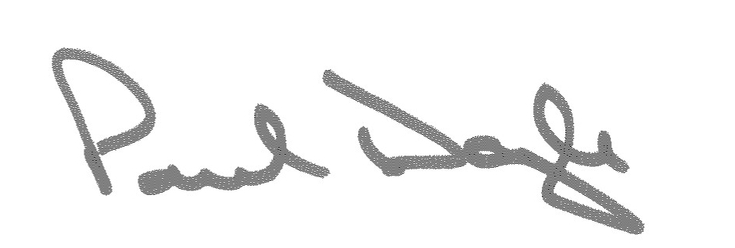**The appeal is dismissed. The decision of the First-tier Tribunal, promulgated on 13 September 2017, stands.**

Signed Date 7 July 2018

Deputy Upper Tribunal Judge Doyle