

**Upper Tribunal**

**(Immigration and Asylum Chamber)** Appeal Number: PA/07889/2017

**THE IMMIGRATION ACTS**

|  |  |  |
| --- | --- | --- |
| **Heard at Field House London** | **Decision & Reasons Promulgated** | |
| **On 15 May 2018** | **On 23 May 2018** | |
|  | |  |

**Before**

**DEPUTY JUDGE OF THE UPPER TRIBUNAL McCARTHY**

**Between**

**HS**

**(anonymity direction continued)**

Appellant

**and**

**THE SECRETARY OF STATE FOR THE HOME DEPARTMENT**

Respondent

**Representation:**

For the Appellant: Ms S Akinbolu, instructed by Lawrence & Co Solicitors

For the Respondent: Mr L Tarlow, Senior Home Office Presenting Officer

**DECISION AND REASONS**

1. Given the nature of the appellant’s appeal, which involves issues of international protection and a question about whether he is a minor, it is appropriate to continue the anonymity direction made by the First-tier Tribunal. The full terms of my order are set out at the end of this decision and reasons statement.
2. The appellant appeals to the Upper Tribunal with permission against the decision and reasons statement of First-tier Tribunal Judge Andrew that was issued on 27 September 2017. Permission to appeal was granted by Upper Tribunal Judge Plimmer on 12 February 2018 because it was arguable there had been a procedural error.
3. The appellant alleged he had not been given an opportunity to find a replacement representative, his previous legal representatives having ceased to act for him the day before the First-tier Tribunal hearing because of a lack of legal aid. Ms Akinbolu mentioned that it was odd for a solicitor to act in this way because a merits assessment should not be carried out at the last minute. It was bad practice for a legal representative to have behaved in this way. I reminded myself this was not a case where the appellant was paying for his legal representation. He was relying on legal aid, as confirmed in the letter from Legal Justice Solicitors, which is mentioned by Judge Andrew.
4. The appellant also alleged that he had not been given sufficient assistance at the hearing to present his case in the absence of a legal representative. He said he had been nervous and isolated, particularly facing a presenting officer and having no one to assist him. The appellant complained that he was unable because of his lack of knowledge about the Tribunal procedures to request time to obtain a new representative or to produce documentary evidence of his identity and age that he had received shortly before the hearing.
5. The respondent initially opposed the appeal, as stated in the rule 24 response dated 19 March 2018, but at the start of the hearing, Mr Tarlow informed me this was no longer the case. I discussed the situation with Mr Tarlow and Ms Akinbolu to check this was the correct course to take, given that the appellant’s account in his statement which accompanied the application for permission to appeal was somewhat at odds with the events recorded by Judge Andrew. Mr Tarlow maintained his position based on the fact Judge Andrew had not recorded that she gave the appellant an opportunity to obtain alternative representation but instead assumed he would not be able to secure such representation. That was clearly not the case since Lawrence & Co had accepted instructions.
6. Ms Akinbolu reminded me that the appellant had obtained documentary evidence about his age, which the judge had not examined fully because the documentary evidence had not been properly considered. Mr Tarlow agreed that the documentary evidence required further examination. He requested the original was provided (which it was). I infer from his comments that he would have expected the presenting officer in the First-tier Tribunal to have sought an adjournment to have the document examined because of the importance it might have to the age assessment question.
7. I have no criticism for the way Judge Andrew proceeded. Most First-tier Tribunal judges would have done likewise because it is often found that a person who has been refused legal aid by one provider cannot secure representation elsewhere. However, in this case, because of the issues regarding the late documentation and the importance that might have in assessing the appellant’s age, I understand why Mr Tarlow no longer opposed the appeal.
8. I find there is legal error in the approach taken by Judge Andrew. Although it was inadvertent, it falls in the category of procedural unfairness, and her decision must be set aside. Given the issues to be reconsidered, the parties requested the appeal be remitted to the First-tier Tribunal for a fresh hearing before a different judge. I agree.

**Notice of Decision**

The appeal is allowed.

The decision of FtT Judge Andrew is set aside.

The appeal is remitted to the First-tier Tribunal for a fresh decision before a different judge.

**Anonymity**

I make the following order. I prohibit the parties or any other person from disclosing or publishing any matter likely to lead members of the public to identify the appellant. The respondent can be referred to as “HS”.

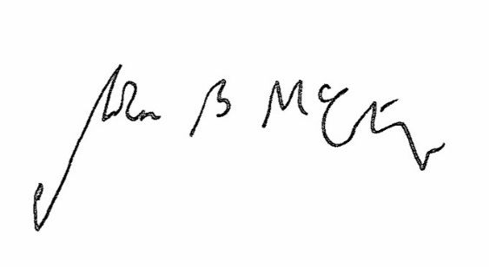

Signed Date 16 May 2018

Judge McCarthy

Deputy Judge of the Upper Tribunal