

**Upper Tribunal**

**(Immigration and Asylum Chamber) Appeal Number: PA/08356/2017**

**THE IMMIGRATION ACTS**

|  |  |
| --- | --- |
| **Heard at Glasgow** | **Decision & Reasons Promulgated** |
| **On 30 August 2018** | **On 10 September 2018** |

**Before**

**DEPUTY UPPER TRIBUNAL JUDGE DOYLE**

**Between**

**SHABANA [K]**

**(ANONYMITY DIRECTION NOT MADE)**

Appellant

**and**

**The SECRETARY OF STATE FOR THE HOME DEPARTMENT**

Respondent

**Representation:**

For the Appellant: Mr S Martin, of Neil & Ruddy, solicitors

For the Respondent: Mr A Govan, Senior Home Office Presenting Officer

**DECISION AND REASONS**

1. I have considered whether any parties require the protection of an anonymity direction. No anonymity direction was made previously in respect of this Appellant. Having considered all the circumstances and evidence I do not consider it necessary to make an anonymity direction.

2. This is an appeal by the Appellant against the decision of First-tier Tribunal Judge D H Clapham promulgated on 17 January 2018, which dismissed the Appellant’s appeal on all grounds.

Background

3. The Appellant was born on 01/01/1980 and is a national of Pakistan. On 17 August 2017 the Respondent refused the Appellant’s protection claim.

The Judge’s Decision

4. The Appellant appealed to the First-tier Tribunal. First-tier Tribunal Judge D H Clapham (“the Judge”) dismissed the appeal against the Respondent’s decision. Grounds of appeal were lodged and on 13 February 2018 Judge Hodgkinson gave permission to appeal stating

“1. Permission is sought to appeal, in time, the decision of First-tier Tribunal Judge DH Clapham, dated 17 January 2018, dismissing the appellant’s appeal against the respondent’s decision to refuse her protection and human rights claims.

2. The grounds, which are prolix, argue that the Judge erred as follows: first, at [95] –[96] of her decision, in her consideration of the letter from the Ahmadiyya Muslim Association UK (“AMA UK”) and its import; second, at [86] – [97], in her reasoning in arriving at certain adverse credibility conclusions.

3. It is arguable that the Judge has misinterpreted the import of the letter from AMA UK and/or has not adequately considered its import in the context of relevant country guidance (MN and others (Ahmadis – country conditions – risk) Pakistan CG [2012] UKUT 00389(IAC)). Additionally, a number of the Judge’s adverse credibility findings are arguably unsustainable. Permission is granted on the grounds as pleaded.”

The Hearing

5. (a) For the appellant, Mr Martin moved the grounds of appeal. He told me that the Judge erred in her assessment of the letter of support from the Ahmadiyya Muslim Association, produced in the first inventory of productions for the appellant. He told me that the Judge had failed to take full account of the guidance given in MJ & ZM (Ahmadis -Risk) Pakistan CG [2008] UKAIT 00033 and did not give sufficient weight to the contents of that letter.

(b) Mr Martin told me that between [86] and [97] the Judge’s credibility assessment is flawed. He told me that the Judge relies on her own view of plausibility and does not explain her reasons, so that there is an inadequacy reasoning. He told me that the Judge repeatedly relies on expressions of disbelief rather than explaining why some evidence is rejected. He told me that overall the decision contains an inadequate analysis of the evidence, and insufficient reasoning.

(c) Mr Martin asked me to find that the decision is tainted by material errors of law and to set the decision aside. He told me that an updated, more detailed, letter from the Ahmadiyya Muslim Association is now available. He told me that further fact-finding is necessary and asked me to remit this case to the First-tier Tribunal to be determined of new.

6. For the respondent, Mr Govan told me that the decision does not contain errors of law, material or otherwise. He took me to [95] and [96] of the decision and told me that those paragraphs must be read together with [86] and [87] of the decision. He told me that the Judge gave clear reasons for finding that the appellant was neither a credible nor a reliable witness. He referred me to a letter from Ahmadiyya Muslim Association UK, and told me that the Judge was perfectly entitled to find that letter does not say that the appellant proselytises. He took me through the Judge’s credibility findings and told me that they are adequately reasoned. He asked me to dismiss the appeal and allow the Judge’s decision to stand.

Analysis

7. In [MN and others (Ahmadis – country conditions – risk) Pakistan CG [2012] UKUT 00389(IAC)](http://www.ait.gov.uk/Public/Upload/j2531/00389_ukut_iac_2012_mn_ors_pakistan_cg.doc) **the Tribunal held that e**vidence likely to be relevant includes confirmation from the UK Ahmadi headquarters regarding the activities relied on in Pakistan and confirmation from the local community in the UK where the claimant is worshipping. InAB (Ahmadiyya Association UK: letters) Pakistan [2013] UKUT 00511 (IAC)it was held that in deciding a claim to international protection based on a person’s Ahmadi faith where credibility was in issue, the more that a letter from the Ahmadiyya Association UK contained specific information as to the claimant’s activities in the United Kingdom, the more likely the letter was to be given weight.

8. The Judge’s findings of fact begin at [84] of the decision. The Judge finds that the appellant is a member of the Ahmadi faith and that she was secretary of the local Jamat. Between [87] and [94] the Judge makes a number of adverse credibility findings. In the last sentence of [90] the Judge appears to search for corroboration. In the last sentence of [91] the Judge says

“I simply do not believe her.”

9. At [95] the Judge turns her attention to the letter from the Ahmadi Muslim Association. At [97] the Judge reaches the conclusion that the appellant does not have any religious profile outside her own community and the appellant has lied about converting two women.

10. The letter from the Ahmadiyya Muslim Association UK says that the appellant is a Musi, whose duties include teaching the Quran and treating the propagation of her faith as a fundamental duty. The updated letter from Ahmadiyya Muslim Association (which was not before the Judge) provides much more detailed information about the appellant’s activities.

11. The Judge’s credibility findings between [86] and [92] are not adequately reasoned. It is open to the Judge to find that the appellant is not telling the truth, to find that the appellant gives an inconsistent account, to find that the appellant’s account is vague, but the Judge must say why. There is a conflict between the Ahmadi Muslim Associations record of the appellants fundamental religious duty and the Judge’s findings. That conflict is not reconciled in the Judge’s decision.

12. In MK (duty to give reasons) Pakistan [2013] UKUT 00641 (IAC), it was held that (i) It was axiomatic that a determination disclosed clearly the reasons for a tribunal’s decision. (ii) If a tribunal found oral evidence to be implausible, incredible or unreliable or a document to be worth no weight whatsoever, it was necessary to say so in the determination and for such findings to be supported by reasons. A bare statement that a witness was not believed or that a document was afforded no weight was unlikely to satisfy the requirement to give reasons.

13. The Judge does not set out sufficient reasoning in her credibility assessment between [86] and [97]. That is a material error of law. I set the decision aside.

14. I consider whether I can substitute my own decision but find that I cannot because further fact-finding is necessary.

Remittal to First-Tier Tribunal

15. Under Part 3 paragraph 7.2(b) of the Upper Tribunal Practice Statement of the 25th of September 2012 the case may be remitted to the First-tier Tribunal if the Upper Tribunal is satisfied that:

(a) the effect of the error has been to deprive a party before the First-tier Tribunal of a fair hearing or other opportunity for that party’s case to be put to and considered by the First-tier Tribunal; or

(b) the nature or extent of any judicial fact finding which is necessary in order for the decision in the appeal to be re-made is such that, having regard to the overriding objective in rule 2, it is appropriate to remit the case to the First-tier Tribunal.

16. In this case I have determined that the case should be remitted because a new fact-finding exercise is required. None of the findings of fact are to stand and a complete re hearing is necessary.

17. I remit the matter to the First-tier Tribunal sitting at Glasgow to be heard before any First-tier Judge other than Judge D H Clapham.

**Decision**

**The decision of the First-tier Tribunal is tainted by material errors of law.**

**I set aside the Judge’s decision promulgated on 17 January 2018. The appeal is remitted to the First-tier Tribunal to be determined of new.**

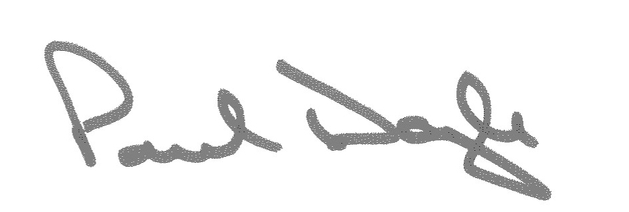

Signed Date 5 September 2018

Deputy Upper Tribunal Judge Doyle