

Upper-Tier Tribunal

(Immigration and Asylum Chamber) Appeal Numbers: PA/09556/2017

THE IMMIGRATION ACTS

Heard at Manchester Civil Justice Centre Decision & Reasons Promulgated

On the 31st May 2018 On the 4th July 2018

Before:

DEPUTY UPPER TRIBUNAL JUDGE MCGINTY

Between:

MR K.O.

(Anonymity direction made)

Appellant

and

SECRETARY OF STATE FOR THE HOME DEPARTMENT

Respondent

Representation:

For the Appellant: Mr Brown (Counsel)

For the Respondent: Mrs Aboni (Senior Home Office Presenting Officer)

DECISION AND REASONS

1. This is the Appellant's appeal against the decision of First-tier Tribunal Judge Williams promulgated on the 28th November 2017, in which he dismissed the Appellant's asylum appeal.
2. The Appellant is a citizen of Iran who was born on the 1st January 1991. It is the Appellant's case that his sister introduced him to the PJAK and that he assisted the PJAK by accepting deliveries of political material, medicine and weapons. He says that on the 18th April 2017 he learned that Salim, one of the PJAK members who had been delivering items to him had been arrested and that he then went into hiding on the 21st April 2017. He says at that Ettela’at raided his home and workplace and that he then fled Iran. He claimed asylum on the basis of his actual or imputed political opinion.
3. Judge Williams dismissed the Appellant's asylum claim, finding that the Appellant's answers in interview regarding his knowledge of the PJAK were vague and that he could not reply satisfactorily to most of the questions in interview regarding PJAK. He further found that the Appellant’s answers in interview regarding his sister's involvement with the PJAK were inadequate, in that he was then unable to describe when she had become a member, her motives for doing or what she did and this, Judge Williams found, did not sit with him being persuaded by his sister to assist the PJAK, when he had not even clarified his own sister's role or motives. Thirdly, Judge Williams found that the Appellant had been inconsistent in relation to the number of times that he had stored weapons/materials, and found that at one point in interview, he said that he had stored them once or twice whereas elsewhere in interview he said that he had stored them 15 or 16 times. Judge Williams further found that the Appellant was vague regarding circumstances surrounding the discovery that Salim had been arrested, and further found that is was not reasonably likely that Ettela’at would have waited three days before raiding the Appellant's home taking into account the resolve that Ettela’at have in suppressing the PJAK and that if they had waited that amount of time it was reasonably likely the Appellant would have used that opportunity to hide and dispose of incriminating evidence at his family chicken farm or got others to do so on his behalf.
4. Judge Williams further found that the Appellant’s sur place activities in the UK would not be likely to bring him to the adverse attention of the Iranian authorities upon return, such that the Appellant would not be at a real risk upon return.
5. The Appellant has now sought to appeal against that decision for the reasons set out within the Grounds of Appeal. This is a matter of record and is therefore not repeated in its entirety here, but in summary, it is argued that in some of the Judge’s findings were based on misunderstandings of the Appellant's evidence in his asylum interview or otherwise misconceived. It is argued that whereas Judge Williams found that there was inconsistency regarding the number of times that weapons and materials had been stored, at question 94 of the asylum interview the Appellant had been referring to having only stored weapons once or twice, as opposed to more innocuous material such as CDs and leaflets, which he had stored maybe 15 or 16 times, such there was no discrepancy in his answer in that regard.
6. Secondly, it is argued that Judge Williams erred in finding that it was not credible that the Appellant did not know the date when Salim had been arrested, in circumstances where the Appellant was not told the date by Rabin, and the fact that Salim had been arrested and that the Appellant giving a date for the arrest itself would be no more than a guess and speculation. It is argued that in fact it was Judge Williams who had speculated and second-guessed in stating that it was not reasonably likely that Ettela’at would have waited three days before raiding the Appellant’s residence at the chicken farm and that one cannot know why it would be the Iranian authorities had waited such time before raiding the farm and it could be that it had taken three days of torture before Salim gave the Appellant's address.
7. It is further argued within the Grounds of Appeal that the Judge had not adequately explained or justified what the Appellant ought to have known more about, in respect of his sister's involvement with PJAK or her motivations beyond what was said within his appeal statement, to which it is argued the Judge had made little or no reference and it is argued that the Judge’s criticisms of the Appellant's level of knowledge of PJAK were misconceived in the context of the Appellant's involvement as a mere conduit of materials and no more.
8. Permission to appeal has been granted by First-tier Tribunal Judge Pullig on the 21st December 2017, who found that all of the grounds of appeal were arguable.
9. In his oral submissions to the Upper Tribunal, Mr Brown argued that at paragraph 7 of the Appellant's witness statement, the Appellant had given further details of the date when the Appellant sister joined PJAK, in 2009, the fact that she had runway from home and left the village when she did so and at a time when she was just 21 years old. He argued that the Appellant within his asylum interview had been able to answer questions regarding PJAK's aims and policies and had not been vague in his answers and had given details as to the leadership of PJAK and argued that Judge's conclusion that the answers were vague was not justified. He further argued there was no inconsistency in the number of times the Appellant had stored materials and argued that the Appellant had been specifically talking about having stored weapons on 1 or 2 occasions, as opposed to other materials such as books, leaflets and CDs bought from city. Mr Brown argued that Judge Williams had not properly taken account of the evidence given by the Appellant in his witness statement and argued that there was little point in the Appellant producing a witness statement, if the Judge was not going to take account of the same. He further argued that the Judge’s finding that it was unlikely that Ettela’at would have waited three days before raiding the chicken farm was speculative.
10. In her submissions on behalf of the Secretary of State, Mrs Aboni argued that the First-tier Tribunal Judge had directed himself appropriately and made findings that were open to him, with adequate reasons, based on the evidence before him. She argued that the Judge had rejected the Appellant’s asylum claim for a number of reasons and the Judge had explained why it was that he had taken more account on what was said by the Appellant in interview rather than in his statement, as the answers given in interview would have been those which were fresher in his mind and without time to research answers having already been asked such questions in interview and that when subsequently asked questions he would know what to expect. She argued that the Judge had given adequate reasons for placing little weight on the statement and that the Judge had adequately explained why he did not accept the Appellant would have become involved, given his lack of knowledge of his sister's involvement with PJAK. She conceded that the Judge had made an error in respect of the number of times that weapons and materials had been stored, in finding that there was an inconsistency in the answers given, in that when talking about having stored items once or twice, the Appellant was clearly talking about weapons, as opposed to other materials, but she argued that cumulatively the credibility findings were sound and the Judge would have reached to the same conclusion in any event.

My Findings on Error of Law and Materiality

1. As stated above, it is conceded by Mrs Aboni on behalf of the Secretary of State that First-tier Tribunal Judge Williams did err at [26] of the judgement in finding that the Appellant was inconsistent in relation to the number of times that the Appellant had stored weapons/materials, as to whether it was once or twice or 15 to 16 times. The Appellant had explained within his interview that he was referring to having stored weapons only once or twice, as opposed to other materials. Indeed, at question [56], the Appellant had been asked what materials were brought to him by the PJAK and he stated that the PJAK supplied books, leaflets and CDs and then when asked at the next question "anything else?" he replied that the items they had brought from the city include money and weapons, provisions of clothes and shoes and medicines and tablets. When asked how many times they had brought those materials to the farm at [81] he said 15 or 16 times. At question 94 the Appellant had been asked why if he did not believe in violence he agreed to store weapons such as AK-47s and pistols to which he replied "I stored them once or twice, I had no option but to do it".
2. As properly conceded by Mrs Aboni, there was no inconsistency in that regard and the Judge did err in finding there was an inconsistency in his evidence on that issue. Further, although Judge Williams found that the Appellant's evidence regarding PJAK was vague and could not reply to most of the questions in interview regarding PJAK (as say of way of an example question 85 and 86 at [24]), in fact, when one reads the interview, at question 49 the Appellant had talked about the aims, objectives and policies of PJAK in order to liberate Kurdistan, to obtain equality between males and females and to establish a Kurdish independent government. He also at question 85 and 86 stated that Haji Ahmed had founded PJAK in 1383 (2004 or 2005) and he had been able to name leaders and hierarchy of PJAK at question 100. At question 94 he was asked to provide more details of PJAK rather than just simply its general aims, but was unable to provide any further information. Judge Williams further found that the Appellant’s description of the PJAK flag was erroneous and he confused the location of the PJAK base and when asked to just discuss PJAK he stated "sorry I have no further information" at question 84.
3. In such circumstances, where the Appellant had not been able to provide further details regarding PJAK's aims other than there broad aims he initially outlined, in circumstances where he claimed to be a member of PJAK for 5 years on his arrival to the UK, I do find that it was open to Judge Williams to find that his answers were somewhat vague in answering questions asked regarding PJAK in interview.
4. Further, it was open to Judge Williams on the evidence before him to find that in interview the Appellant had been unable to describe when his sister became a member of PJAK and her motives for doing so, or what she did. The Appellant specifically stated "I don’t know anything" at question 117 in interview and when asked again whether or not he could add anything more than that she was a Peshmerga, he stated "I know nothing else" at question 118. The Judge's findings that it was not reasonably likely the Appellant would agreed to assist the party when he was not aware of his own sister's role or motive, was therefore open to the Judge on the evidence before him.
5. Although it is argued by Mr Brown that the Judge did not then take account of the Appellant's evidence and his witness statement at paragraph 7 regarding his sister having joined PJAK when she was 21 years old in 1388 (2009), the Appellant had not been able to provide such details in his asylum interview and said at that time that he did not know. In such circumstances, it was open to the Judge find that he could place little weight on the evidence given by the Appellant in his witness statement to the extent that they were inconsistent with the answers given in his interview, at which stage he said that he did not know anything else about his sisters role as a Peshmerga or when she became one at question 117, and the Appellant had time to "beef up his claim" before his asylum interview. That was a finding opened to the Judge on the evidence before him, given those inconsistencies.
6. Further, I find it was open to Judge Williams to make finding that it was not reasonably likely that the Appellant would have known the specific details that Salim had been arrested whilst in possession of materials that he had collected, in circumstances where the other information provided to the Appellant regarding Salim’s purported arrest having been so vague in terms of not having any idea of the date or any other details in terms of the location of the arrest. Further, the point being made by Judge Williams was that it was not reasonably likely that Ettela’at would have waited three days before raiding the Appellant’s home taking into account the resolve they have in suppressing the PJAK, but that had they waited that length of time it was reasonably likely that the Appellant would have used that opportunity to dispose or hide any incriminating evidence at the chicken farm, or got others such as Rabin with whom he was in contact to do so for him at [27] and that again was a finding open to the Judge on the evidence before him.
7. In such circumstances, although Judge Williams did err in respect of the finding that the Appellant had been inconsistent regarding the number of times that materials had been stored as opposed to simply weapons, in light of the other specific findings made by Judge Williams, which were open to him regarding the Appellant’s lack of detailed knowledge of PJAK’s aims despite his purported membership of that party for at least 5 years; his error regarding the description of the PJAK flag and location of the PJAK base; the Appellant's lack of detailed knowledge regarding his sister’s involvement with PJAK despite the fact that she was the one who is said to have led the Appellant to join PJAK; further the Judge's findings regarding Salim’s arrest and the Judge's findings regarding the time taken for Ettela’at to raid the chicken farm which would have given time for any incriminating materials to be removed, in my judgement's means that Judge Williams would have reached the same conclusion, even if the error regarding the number of times in which weapons were stored as opposed to other materials had not been made. In circumstances where the Judge's overall conclusion that the Appellant’s account was not credible, I find would have been the same in any event, given the findings which were made which were open to him on the evidence, I find that the error is not material, and that the decision of Judge Williams in such circumstances is maintained.

Notice of Decision

The decision of First-tier Tribunal Judge Williams does not contain any material errors of law and is maintained.

Given this claim includes an asylum claim, I do make an anonymity direction. The Appellant is granted anonymity and no record or transcript of these proceedings shall identify the Appellant or any member of his family either directly or indirectly. This direction applies both to the Appellant and to the Respondent. Failure to comply with this direction can lead to contempt of court proceedings.

Signed

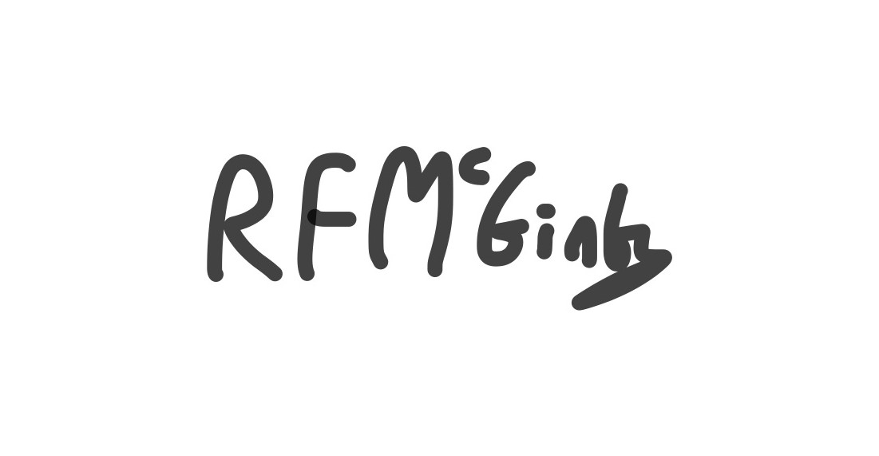

Deputy Upper Tribunal Judge McGinty Dated 7th June 2018