

**Upper Tribunal**

**(Immigration and Asylum Chamber) Appeal Number: PA/10502/2017**

**THE IMMIGRATION ACTS**

|  |  |
| --- | --- |
| **Heard at Field House** | **Decision & Reasons Promulgated** |
| **On 6 June 2018** | **On 11 June 2018** |
|  |  |

**Before**

**UPPER TRIBUNAL JUDGE ALLEN**

**Between**

**i M J**

(anonymity direction made)

Appellant

**and**

**THE SECRETARY OF STATE FOR THEHOME DEPARTMENT**

Respondent

**Representation:**

For the Appellant: Ms P Yong instructed by Wimbledon Solicitors (Merton Road)

For the Respondent: Ms Z Ahmad, Home Office Presenting Officer

**DECISION AND REASONS**

1. This is the appeal of Ms I M J against the Secretary of State’s decision of 4 October 2017 refusing asylum. She appealed that decision to the First-tier Tribunal and the matter was heard in March of this year and the appeal was dismissed.

2. The appellant has appealed on various grounds and it is common ground between the representatives before me today, Ms Yong for the appellant and Ms Ahmad for the Secretary of State, that without going into great detail the grounds are essentially made out. There are, in particular, challenges to the judge’s decision in taking on the role of an expert, including issues of medical evidence, challenges to the credibility findings without a proper consideration of the psychiatrist’s evidence, failure to make a finding whether the appellant was a vulnerable adult and therefore a failure to comply with the Presidential Guidelines in that regard. I think those are the main matters.

**Notice of Decision**

3. I do not think that I need to go into the other points that are raised because there is sufficient there to make it clear on the one hand that the decision is materially flawed as a matter of law, and also that the nature of the flawed findings by the judge is such that it can really only be properly dealt with by being remitted back to the First-tier Tribunal for a full hearing at Taylor House, so that is what will be done in this case.

**Direction Regarding Anonymity – Rule 14 of the Tribunal Procedure (Upper Tribunal) Rules 2008**

Unless and until a Tribunal or court directs otherwise, the appellant is granted anonymity. No report of these proceedings shall directly or indirectly identify her or any member of her family. This direction applies both to the appellant and to the respondent. Failure to comply with this direction could lead to contempt of court proceedings.

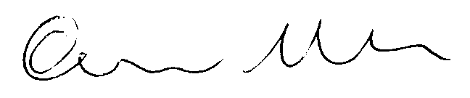

Signed Date 7 June 2018

Upper Tribunal Judge Allen