

**Upper Tribunal**

**(Immigration and Asylum Chamber)** Appeal Number: PA/12570/2017

**THE IMMIGRATION ACTS**

|  |  |
| --- | --- |
| **Heard at Field House** | **Decision & Reasons Promulgated** |
| **On 11 May 2018** | **On 21 May 2018** |
|  |  |

**Before**

**UPPER TRIBUNAL JUDGE PERKINS**

**Between**

**the Secretary of State for the Home Department**

Appellant

**and**

**N E**

**(ANONYMITY DIRECTION made)**

Respondent

**Representation:**

For the Appellant: Mr S Walker, Home Office Presenting Officer

For the Respondent: Ms S Panagiotopoulou, Counsel instructed by Sentinel Solicitors

**DECISION AND REASONS**

1. Pursuant to rule 14 of the Tribunal Procedure (Upper Tribunal) Rules 2008 I make an order prohibiting the disclosure or publication of any matter likely to lead members of the public to identify the Respondent. Breach of this order can be punished as a contempt of court. I make this order because this is a protection case and there is invariably a risk in cases of this kind that publicity will itself create a risk.
2. This is an appeal by the Secretary of State against a decision of the First-tier Tribunal allowing the appeal of the respondent (hereinafter “the claimant”) against a decision of the Secretary of State refusing him asylum. I dismiss the Secretary of State’s appeal. My reasons are set out below.
3. The Secretary of State’s first ground complains that the First-tier Tribunal did not have a sufficient, or lawful regard, to the claimant’s delay presenting his claim for asylum. This is not a good point at all. It is quite right that there was a substantial delay. The claimant admitted being in the United Kingdom since September 2005. He had had previous dealings with the authorities and did not claim asylum until March 2017. There is a well known statutory recognition that delay damages credibility. However, it does not destroy it. The weight to be given to the delay is a matter for the judge and the judge was plainly aware of the delay because it is something on which he comments on more than one occasion in the Decision.
4. Further, I do not see this is a case that is particularly dependent on credibility. The reasons for allowing the appeal in the first place, to which I will come in a moment, depend largely on matters of agreed fact or background evidence. In addition, I do not understand why it should be thought by the Secretary of State that the fact that during the long intervening period certain members of the claimant’s family had been recognised as refugees and become British citizens somehow undermines the credibility of the claim. If it is relevant at all, and that is not necessarily the case that is, it seems to me that it improves it rather than diminishes the credibility of parts of the claim.
5. The claimant gave a reason for delay. He attributed it to conflicting advice from family members. That is probably not an *entirely* satisfactory reason, but the judge gave it weight and I see absolutely no merit in ground 1. The decision is not wrong because of judge’s consideration of the delay in making the claim.
6. The reasons for allowing the appeal are probably summarised in paragraph 34 and particularised rather better in the paragraphs from around 36 to 38. The clear point is that the claimant is a Kurd, that he is from the south east, he is somebody who has not done military service and he is somebody who has previously come to the attention of the authorities for pro-PKK activity.
7. He has not committed any criminal offences, but I find it is entirely open to the judge to conclude that his past would be known if the authorities bothered to look, and they would be bothered to look in the event of his being returned now when his travel documents would suggest strongly that his departure from Turkey was not entirely regular. There is nothing wrong in the finding that there is a real risk of his being investigated and identified as a person described. It does not follow necessarily from that that he would be ill-treated, but asylum claims rarely depend on clear proof. Rather they depend on a low standard and reasonable deductions. The First-tier Tribunal Judge clearly had in mind recent background material postdating well-known political changes in Turkey and set out before him, not only in the form of evidence but summarised in the skeleton argument. With the benefit of hindsight, I put it no more than that, it would have been more helpful if the judge had said a little bit more about the background material but the background material is all identified. It was clearly before the judge and, despite Mr Walker’s best efforts, I am entirely satisfied that the conclusion that this man is in a category of people who would be at risk on return was at the very least open to the judge and I find no material error of law there.
8. The third ground, if that is what it is, is puzzling. I do not agree that the judge has made his decision because other members of the family are in the United Kingdom and have refugee status, but it is certainly open to the judge to assume that if people have refugee status in the United Kingdom it is because they risk ill-treatment in their country of nationality. In a country such as Turkey where there is very considerable intelligence that cross-refers to close members of the family, the idea that it would be known to the authorities in Turkey that a returning resident is related to people who were, in the mind of the Turkish state, at least questionable and that this link would add to risk facing the claimant, is something that was at the very least open to the judge.
9. This is not a decision that says that all people of that profile from Turkey are at risk now. It is a decision that says this judge has given sufficient reasons in deciding that this appeal is one that ought to be allowed and I dismiss the Secretary of State’s appeal against that decision.

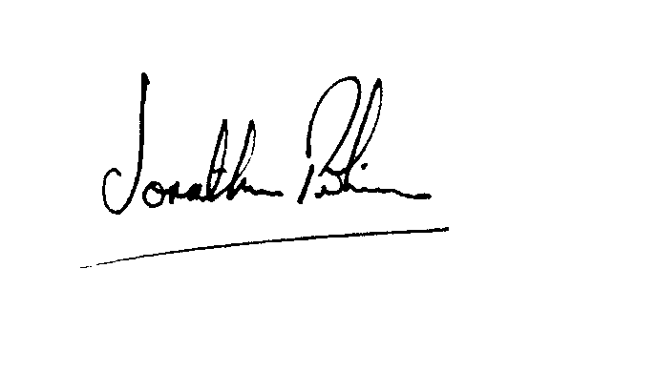

|  |  |
| --- | --- |
| Signed |  |
| Jonathan Perkins, Upper Tribunal Judge | Dated: 17 May 2018 |