

**Upper Tribunal**

**(Immigration and Asylum Chamber)** Appeal Number: pa/12658/2017

**THE IMMIGRATION ACTS**

|  |  |
| --- | --- |
| **Heard at Newport** | **Decision & Reasons Promulgated** |
| **On 18 September 2018** | **On 24 September 2018** |
|  |  |

**Before**

**UPPER TRIBUNAL JUDGE GRUBB**

**Between**

**ORH**

**(ANONYMITY DIRECTION made)**

Appellant

**and**

**THE SECRETARY OF STATE FOR THE HOME DEPARTMENT**

Respondent

**Representation:**

For the Appellant: In person

For the Respondent: Mr C Howells, Senior Home Office Presenting Officer

**DECISION AND REASONS**

1. Pursuant to Rule 14 of the Tribunal Procedure (Upper Tribunal) Rules 2008 (SI2008/2698) I make an anonymity order prohibiting the disclosure or publication of any matter likely to lead to members of the public identifying the appellant. A failure to comply with this direction could lead to Contempt of Court proceedings.
2. The appellant is a citizen of Nigeria who was born on 27 April 1980.
3. The appellant entered the United Kingdom on 15 February 2013 on a six months’ visit visa; she overstayed. On 19 February 2015, the appellant sought leave to remain on the basis of her private and family life in the UK. That application was refused on 25 June 2015 with a right of appeal. The appellant exercised that right of appeal but, on 21 December 2015, the First-tier Tribunal dismissed her appeal. Her subsequent applications for permission to appeal were refused first, by the First-tier Tribunal on 11 August 2016 and secondly, by the Upper Tribunal on 1 November 2016.
4. On 22 December 2016, the appellant claimed asylum. In a decision dated 17 November 2017, the Secretary of State refused the appellant’s claims for asylum, humanitarian protection and on human rights grounds under Art 8 of the ECHR.
5. The appellant again appealed to the First-tier Tribunal. In a determination sent on 8 February 2018, Judge O’Brien dismissed the appellant’s appeal on all grounds. He rejected the appellant’s international protection claims and also under Art 8.
6. The appellant appealed to the Upper Tribunal. She did not seek to challenge the judge’s dismissal of her asylum and humanitarian protection claims but, in relation to his dismissal of her claim under Art 8, she contended that the judge had made a mistake by failing to appreciate that her 5 year old daughter, who was born in the United Kingdom, is a British citizen. Attached to her application for permission was a photocopy of her daughter’s British passport issued on 8 October 2013.
7. On 6 March 2018, the First-tier Tribunal (Judge Birrell) granted the appellant permission to appeal.
8. On 23 March 2018, the Secretary of State filed a rule 24 notice seeking to uphold the judge’s decision on the basis that any mistake as to her daughter’s citizenship was not material.
9. Thus, the appeal came before me.
10. Mr Howells, who represented the Secretary of State, acknowledged that the Secretary of State had referred to the appellant’s daughter as being a British citizen in para 12 of the decision letter. However, he acknowledged that the judge had failed to take into account that the appellant’s daughter was, in fact, a British citizen at para 44 of his determination. Mr Howells indicated that a copy of the appellant’s child’s passport was in the Home Office file. Mr Howells accepted that the judge had materially erred in law in assessing the appellant’s Art 8 claim due to his mistake as to her daughter’s citizenship. He conceded that the judge’s decision should be set aside and that the appeal should be remitted to the First-tier Tribunal for a *de novo* rehearing in respect of Art 8.

**Decision**

1. On the basis of Mr Howells’ concession, which in my judgment was properly made, I am satisfied that the judge materially erred in law in assessing the appellant’s Art 8 claim by failing to take into account that the appellant’s daughter is a British citizen.
2. His decision in respect of Art 8 cannot stand and is set aside.
3. The judge’s decision to dismiss the appeal on asylum and humanitarian protection grounds stand.
4. The appeal is remitted to the First-tier Tribunal for a *de novo* rehearing in respect of the appellant’s Art 8 claim only to be heard by a judge other than Judge O’Brien.

Signed

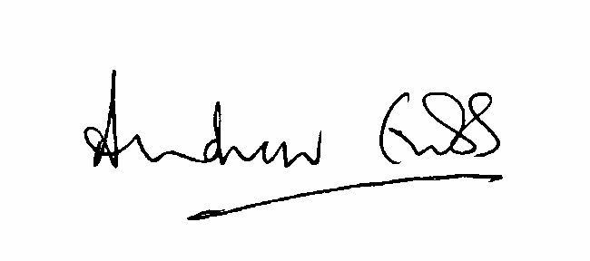

A Grubb

Judge of the Upper Tribunal

24 September 2018