

**Upper Tribunal**

**(Immigration and Asylum Chamber) Appeal Number: PA/13218/2017**

**THE IMMIGRATION ACTS**

|  |  |
| --- | --- |
| **Heard at Field House** | **Decision & Reasons Promulgated** |
| **On 24 May 2018** | **On 6 June 2018** |
|  |  |

**Before**

**Upper Tribunal Judge John FREEMAN**

**Between**

**B A M**

appellant

**and**

**THE SECRETARY OF STATE FOR THE HOME DEPARTMENT**

respondent

**Representation:**

For the appellant: *Zoe McCallum*, counsel instructed by Sutovic & Hartigan

For the respondent: Mr Steven Kotas

**DECISION AND REASONS**

1. This is an appeal against a decision in an asylum case given by Judge Claire O’Garro at Hatton Cross on 22 January this year, by someone born in Iran, of Kurdish descent, on 12 February 2001. He arrived by lorry in 2017 and claimed asylum. He was refused soon after, but given leave to remain until he reached the age of 17½ on 12th August this year.

2. The judge gave various reasons for disbelieving his account. She did mention the country expert report, but dismissed it on the basis that it was predicated on the appellant’s credibility.

3. However, as Mr Kotas has recognized in conceding that there must be a re-hearing, the country expert report did contain some material relevant to credibility (set out at paragraph 12 of the grounds of appeal), which the judge needed to assess before reaching the conclusion she did.

4. It follows that there will have to be a fresh hearing, which can take place at Hatton Cross, but not before Judge O’Garro.

**Appeal** **: decision set aside**

**Fresh hearing as directed**

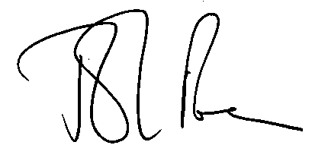 (a judge of the Upper Tribunal)