

**Upper Tribunal**

**(Immigration and Asylum Chamber) Appeal Number: PA/13784/2017**

**THE IMMIGRATION ACTS**

|  |  |
| --- | --- |
| **Heard at Field House** | **Decision & Reasons Promulgated** |
| **On 21 May 2018** | **On 8 June 2018** |
|  |  |

**Before**

**UPPER TRIBUNAL JUDGE PERKINS**

**Between**

**M—A—A--**

(ANONYMITY DIRECTION made)

Appellant

**and**

**SECRETARY OF STATE FOR THE HOME DEPARTMENT**

Respondent

**Representation:**

For the Appellant: Mr W M Rees, Counsel instructed by Connaughts

For the Respondent: Ms A Everett, Home Office Presenting Officer

**DECISION AND REASONS**

1. Pursuant to rule 14 of the Tribunal Procedure (Upper Tribunal) Rules 2008 I make an order prohibiting the disclosure or publication of any matter likely to lead members of the public to identify the appellant. Breach of this order can be punished as a contempt of court. I make this order because this is a protection case and publicity could harm the Appellant.
2. This is an appeal by a citizen of Pakistan against a finding of the First-tier Tribunal dismissing his appeal against a decision of the Secretary of State refusing his claim for asylum. The core issue is whether the appellant is at risk because he is gay. The First-tier Tribunal did not believe the appellant. I am persuaded, having heard the submissions from both parties that the judge’s reasons are not safe.
3. I was faced today with an application to amend the grounds. The applicant asked to add a ground alleging procedural impropriety and I refused that application. The short point is that the contention made in the proposed amended grounds, although interesting in its own terms, was made astonishingly late and too late, I found, to be given any weight. The complaint was that the judge had wrongly prevented the appellant relying on an interpreter. There are references in the judge’s decision and in the notes to the appellant not having any problem in managing the English language. It may be that the appellant’s nose was slightly put out of joint by not having an interpreter, but if there was any proper basis for thinking he was not able to give his evidence clearly because he was not sufficiently competent in the use of the English language it would have been made before today. The appellant has been represented at all times and the grounds of appeal have been settled by experienced Counsel. I rule against that point, although making it clear Mr Rees was absolutely right to raise it because it was made to him and he has only been recently instructed.
4. I permitted the appellant to rely on ground 1 of the grounds which had not been permitted by the First-tier Tribunal Judge. Ms Everett accepted that she was in a position to deal with it, although she did not concede the application I found it was right to allow the application to rely on all the grounds. I did not think they were sufficiently different to be regarded as wholly distinct points and most importantly it did not disadvantage the Secretary of State unfairly if I allowed the appellant to rely on all of his grounds.
5. It is said that the judge did not consider the evidence properly. The criticism is made out two ways. First, there is a letter in the bundle from a former partner. It is at page 82 of the bundle. It purports to be from Mr S F. It is in manuscript form. It says that he is a former partner, that they were in an open relationship and his letter was accompanied by a note from the Home Office written across his residence permit in which he identified himself so that his claimed identity could be checked. This may or may not be a particularly helpful document, but it is an important document because if it is right it adds a great deal of weight to the appellant’s case and it is not clear to me that the judge has actually considered it at all. Perhaps he did, but it is not explained and it needs to be explained. This is a significant fault.
6. I am also concerned that the judge has not necessarily given proper consideration to photographs that were included in the bundle. It may be that the judge’s point was that they are all too recent to be of any value, although the fact the photographs are recent does not necessarily mean they are not of value, but they are more amenable to the criticism that they had been posed for the benefit of a claim rather than reflecting a true relationship between the parties, but there are photographs in the bundle which show affectionate conduct between men and go some way to suggesting that the appellant is indeed gay as he claims.
7. I find that the photographs are potentially of such importance that the Decision and Reasons should have shown that the judge had considered them and either explained precisely why he regarded them as being of no value or gave them weight in his assessment. Neither of those things were done and they should have been done. It may be that this is just because of the way the decision was written, but I think it is common ground that if the appellant is gay and from Pakistan he may be somebody who needs protection and it is very important to make a good decision and that has not happened here.
8. I am less impressed with the criticism that the decision was not made in the round. All judges have to start somewhere and I am not persuaded that the criticism that he did not make an overall assessment is made out.
9. In some ways he did but in the two areas identified he did not show specific consideration and evaluation of evidence which is potentially important.
10. I therefore set aside the decision for error of law. I have to decide what to do next and in my judgment this is a case that needs to go back to the First-tier Tribunal. It can only be decided again by a complete new credibility finding and that is generally best done in the First-tier.
11. Certainly there is no reason to think it would be done any better here or any quicker. For those reasons I remit it to Taylor House to be decided again.
12. It should be decided by a different judge and an interpreter should be available.

Notice of Decision

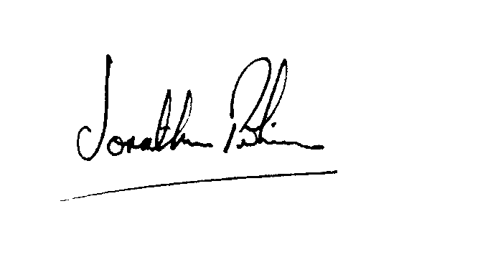The appeal is allowed to the extent that the decision of the First-tier Tribunal is set aside and I direct that the case be heard again in the First-tier Tribunal.

|  |  |
| --- | --- |
| Signed |  |
| Jonathan Perkins, Upper Tribunal Judge | Dated: 7 June 2018 |