

**Upper Tribunal**

**(Immigration and Asylum Chamber) Appeal Number: pa/14077/2016**

**THE IMMIGRATION ACTS**

|  |  |
| --- | --- |
| **Heard at Newport** | **Decision & Reasons Promulgated** |
| **On 3 May 2018** | **On 17 May 2018** |
|  |  |

**Before**

**UPPER TRIBUNAL JUDGE GRUBB**

**Between**

**EF**

(ANONYMITY DIRECTION MADE)

Appellant

**and**

**THE SECRETARY OF STATE FOR THE HOME DEPARTMENT**

Respondent

**Representation:**

For the Appellant: In person

For the Respondent: Mr P Duffy, Senior Home Office Presenting Officer

**DECISION AND REASONS**

1. Pursuant to rule 14 of the Tribunal Procedure (Upper Tribunal) Rules 2008 (SI2008/2698) I make an anonymity order prohibiting the disclosure or publication of any matter likely to lead to members of the public identifying the appellant. A failure to comply with this direction could lead to Contempt of Court proceedings.
2. The appellant is a citizen of Libya who was born on 1 March 1992. He entered the UK illegally, at an uncertain time, before he was encountered and arrested on suspicion of illegal entry on 14 November 2014.
3. On 11 June 2016, the appellant claimed asylum.
4. On 9 December 2016, the Secretary of State refused the appellant’s claims for asylum, humanitarian protection and on human rights grounds.
5. The appellant appealed to the First-tier Tribunal. In a determination promulgated on 18 May 2017, Judge Walker dismissed the appellant’s appeal on all grounds.
6. The appellant sought permission to appeal to the Upper Tribunal challenging the decision in respect of humanitarian protection. Permission was initially refused by the First-tier Tribunal on 7 September 2017. However, on 30 October 2017, the Upper Tribunal (UTJ Jordan) granted the appellant permission to appeal.
7. On 17 November 2017, the Secretary of State filed a rule 24 response seeking to uphold the First-tier Tribunal’s decision.
8. Before me, Mr Duffy, who represented the Secretary of State conceded that the judge had erred in law in her consideration of the background evidence relating to the Art 15(c) risk in Libya which, shortly after her decision, had led to the country guidance decision in ZMM (Article 15(c)) Libya CG [2017] UKUT 263 (IAC). Mr Duffy accepted that the appellant’s return to Libya would breach Art 15(c) and he invited me to set aside the First-tier Tribunal’s decision and to allow the appeal under Art 15(c).

**Decision**

1. In the light of that concession, I am satisfied that the decision of the First-tier Tribunal to dismiss the appellant’s appeal on humanitarian protection grounds involved the making of an error of law. That decision is set aside.
2. I remake the decision allowing the appellant’s appeal on humanitarian protection grounds, namely Art 15(c) of the Qualification Directive.
3. The judge’s decision to dismiss the appellant’s appeal on asylum and human rights grounds, which has not been challenged, stands.

Signed

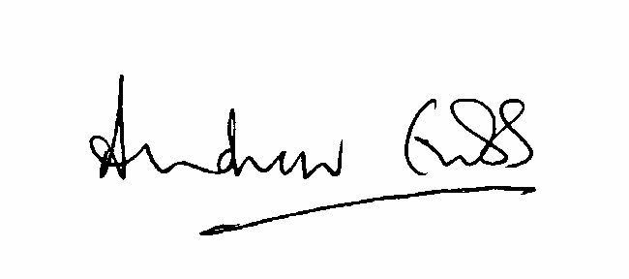

A Grubb

Judge of the Upper Tribunal

14 May 2018