DSS Prototype Analysis

Alvin Murphy

## DSS Prototype Overview

### Installation as a Docker Container

https://github.com/jupyter/docker-stacks  
https://hub.docker.com/r/jupyter/r-notebook/tags/

*(optional) docker pull jupyter/r-notebook:latest*

We want the Jupyter container to mount the DDS Prototype ~/analysis/ directory to provide access to scripts and data. Use the following to mount the analysis directory (i.e. current working directory) as a volume in the Juypter container. Note that the directory needed to be added as a valid mount point via the Docker Desktop Dashboard on Mac.

*docker run -it –rm -d -p 10000:8888 -v ${PWD}:/home/jovyan/work –name notebook jupyter/r-notebook:latest*

To find the token from the container:  
*docker exec -it notebook jupyter server list*  
or  
*docker logs notebook*

Navigate to the container UI and enter the token: http://localhost:10000

### System Context

Figure 1 depicts the context for the DSS. The DSS operator interacts with the DSS Prototype for decision assitance. The DSS relies on a aircraft database to gather real-time flight data to review in decision support algorithms.

|  |
| --- |
| DSS Context Diagram |

### Container Architecture

Nine containers are instantiated as part of the DSS architecuture (see Figure 2). Six provide the DSS implementation while the additional 3 support collection and calculation of metrics. Each application container was designed around the 12-Factor Application “Single Responsibility Principle”; e.g. each app has one purpose to enable rapid insertion of new capabilities with low cohesion to other functionality. At this time, all responses are canned without underlying calculations to focus on meeting the 500 ms hypothesis pryor to burdening the application with calculation latency.

|  |
| --- |
| DSS Deployment Diagram |

#### Applications

* opensky-int: Provides the OpenSky API for flight data. The app provides data about aircraft within 60 NM of Richmond (RIC) or Dulles (IAD) airports.
* tm-server: Provides sensor track data (e.g. OpenSky) and system tracks to support DSS services. System tracks represent the system-wide common understanding of track object states used for decision support.
* wa-app: The Weapon Assessment Application determines which weapons are capable to successfully engage a target. The wa-app uses the tm-server api to get track data.
* te-app: The Trail Engage Application predicts the success probability of an engagement with a specific weapon target pairing. The predicted track kinematic data at engagement time is provided; therefore, the current track kinematics from the tm-server are not queried prior to providing a response.
* test-app: Provides an ability to initiate automated tests. the test-app uses the dss-ui to call dss-ui endpoint to replicate operator interactions with the DSS Prototype.
* dss-ui: Provides a simple graphical interface to launch DSS services.

#### Tools

* telem-jaeger: The open source Jaeger containter collects “span” data from the DSS applications. Spans collect duration data for service calls amongst containers; e.g. latency. This the fundamental data that is being analysed here.
* grafana: The open source Grafana container connects to the telem-jaeger container to create visualization dashboards. Also, Grafana faciliates the export of data as a .csv file for analysis.
* notebook: The Jupyter Notebook container supports analysis of the data recorded by Jaeger and exported by Grafana. An embedded R software library is used for analysis.

### Hypothesis

Hypotheses are “innocent until proven guilty.” We’ll assume that SpaceX and others have proven that DevSecOps tech can meet hard-real-time requirements but nothing available in the body of knowledge documents this.

**Hypothesis:** Modern DevSecOps architectures can be designed to meet hard-real-time latency () requirements using modern computing environments and computing infrastructure.

with jitter within latency bounds  
 with jitter exceeding latency bounds

*Murphy, Alvin C. and Moreland Jr, James D. ‘Integrating AI Microservices into Hard-Real-Time SoS to Ensure Trustworthiness of Digital Enterprise Using Mission Engineering’. 1 Jan. 2021 : 38 – 54.*

Scrucca L., Fop M., Murphy T. B. and Raftery A. E. (2016) mclust 5: clustering, classification and density estimation using Gaussian finite mixture models The R Journal 8/1, pp. 289-317

## Load Data Files

### Load MacBook Air (2017) Data

Trace.ID Trace.name Start.time Duration   
 Length:100 Length:100 Length:100 Length:100   
 Class :character Class :character Class :character Class :character   
 Mode :character Mode :character Mode :character Mode :character

A data.frame: 6 × 2

|  | Trace.ID <chr> | Trace.name <chr> |
| --- | --- | --- |
| 1 | 9ee3577fb1b427bc4fc17fecc5154d7d | dss-prototype: /TE |
| 2 | f05ddc4dc13aff5c3098011b2a402401 | dss-prototype: /tracks |
| 3 | 2bd901fbbfc9ee8dfa7c9629d93a1567 | dss-prototype: /IAD |
| 4 | 69a48381a14e79da08aaa2353f7db4b2 | dss-prototype: /RIC |
| 5 | e83037dcb9438c04dc12fba373b5502f | dss-prototype: /WA |
| 6 | 7e381cd880adb670bb9627ca47020938 | dss-prototype: /TE |

A data.frame: 6 × 2

|  | Start.time <chr> | Duration <chr> |
| --- | --- | --- |
| 1 | 2022-05-02 10:25:01.366 | 36.0 ms |
| 2 | 2022-05-02 10:25:00.309 | 43.3 ms |
| 3 | 2022-05-02 10:24:58.818 | 464 ms |
| 4 | 2022-05-02 10:24:57.307 | 494 ms |
| 5 | 2022-05-02 10:24:56.128 | 139 ms |
| 6 | 2022-05-02 10:24:55.081 | 30.3 ms |

#### Add Source Indicator to MacBook Data

### Load Linux PC (2012) Data

### Load Raspberry Pi 4 (2020) Data

### Load AWS EC2 t2.micro Data

### Load ODU CCI Data

### Merge Data Files

Trace.ID Trace.name Start.time Duration   
 Length:400 Length:400 Length:400 Length:400   
 Class :character Class :character Class :character Class :character   
 Mode :character Mode :character Mode :character Mode :character   
 platform   
 Length:400   
 Class :character   
 Mode :character

A data.frame: 6 × 2

|  | Trace.ID <chr> | Trace.name <chr> |
| --- | --- | --- |
| 1 | 9ee3577fb1b427bc4fc17fecc5154d7d | dss-prototype: /TE |
| 2 | f05ddc4dc13aff5c3098011b2a402401 | dss-prototype: /tracks |
| 3 | 2bd901fbbfc9ee8dfa7c9629d93a1567 | dss-prototype: /IAD |
| 4 | 69a48381a14e79da08aaa2353f7db4b2 | dss-prototype: /RIC |
| 5 | e83037dcb9438c04dc12fba373b5502f | dss-prototype: /WA |
| 6 | 7e381cd880adb670bb9627ca47020938 | dss-prototype: /TE |

A data.frame: 6 × 3

|  | Start.time <chr> | Duration <chr> | platform <chr> |
| --- | --- | --- | --- |
| 1 | 2022-05-02 10:25:01.366 | 36.0 ms | 2017-macbook |
| 2 | 2022-05-02 10:25:00.309 | 43.3 ms | 2017-macbook |
| 3 | 2022-05-02 10:24:58.818 | 464 ms | 2017-macbook |
| 4 | 2022-05-02 10:24:57.307 | 494 ms | 2017-macbook |
| 5 | 2022-05-02 10:24:56.128 | 139 ms | 2017-macbook |
| 6 | 2022-05-02 10:24:55.081 | 30.3 ms | 2017-macbook |

## Convert Data into Useable Metrics

To make the data more usable and easier to understand we apply conversions from text to numeric and add additional columns with supporting information. A **useCase** column is added to identify specific DSS request use cases; e.g. Get Dulles Airport Data. The data also indicates whether the request is managed internally or a connection to an external service is required to provided a response (i.e., https://opensky-network.org). A **numContainers** column is added to indicate the number of containers involved in providing a use case response (e.g. independent variable). An **extNetworkHops** column is added to include network hops for external requests as an additional independent variable.

### Add Additional Column Descriptors

Trace.ID Trace.name Start.time Duration   
 Length:400 Length:400 Min. :1.651e+09 Min. :0.004290   
 Class :character Class :character 1st Qu.:1.654e+09 1st Qu.:0.009577   
 Mode :character Mode :character Median :1.655e+09 Median :0.036450   
 Mean :1.654e+09 Mean :0.226089   
 3rd Qu.:1.655e+09 3rd Qu.:0.433250   
 Max. :1.655e+09 Max. :2.000000   
 platform useCase numContainers extNetworkHops  
 Length:400 Length:400 Min. :2.0 Min. : 0.0   
 Class :character Class :character 1st Qu.:2.0 1st Qu.: 0.0   
 Mode :character Mode :character Median :3.0 Median : 0.0   
 Mean :2.6 Mean : 5.6   
 3rd Qu.:3.0 3rd Qu.:14.0   
 Max. :3.0 Max. :14.0

A data.frame: 6 × 5

|  | Trace.ID <chr> | Trace.name <chr> | Start.time <dbl> | Duration <dbl> | platform <chr> |
| --- | --- | --- | --- | --- | --- |
| 1 | 9ee3 | /TE | 1651487101 | 0.0360 | 2017-macbook |
| 2 | f05d | /tracks | 1651487100 | 0.0433 | 2017-macbook |
| 3 | 2bd9 | /IAD | 1651487098 | 0.4640 | 2017-macbook |
| 4 | 69a4 | /RIC | 1651487097 | 0.4940 | 2017-macbook |
| 5 | e830 | /WA | 1651487096 | 0.1390 | 2017-macbook |
| 6 | 7e38 | /TE | 1651487095 | 0.0303 | 2017-macbook |

A data.frame: 6 × 3

|  | useCase <chr> | numContainers <dbl> | extNetworkHops <dbl> |
| --- | --- | --- | --- |
| 1 | Trial Engage (Internal) | 2 | 0 |
| 2 | Get Stored Local DSS Tracks (Internal) | 2 | 0 |
| 3 | Get Dulles Airport Data (External) | 3 | 14 |
| 4 | Get Richmond Airport Data (External) | 3 | 14 |
| 5 | Assess Weapons (Internal) | 3 | 0 |
| 6 | Trial Engage (Internal) | 2 | 0 |

### Exploratory Analysis Plots

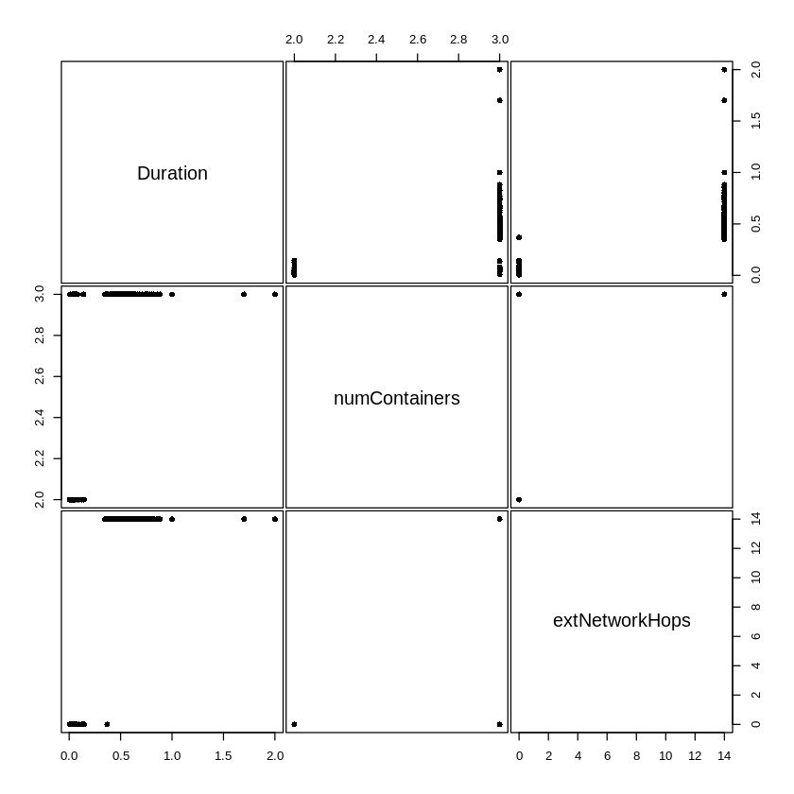

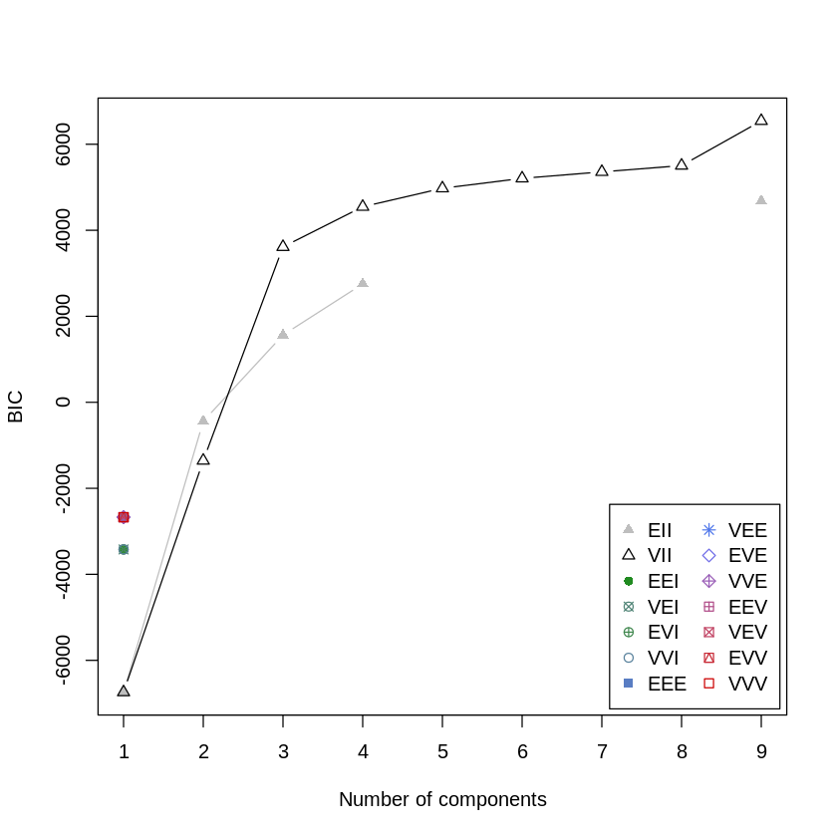

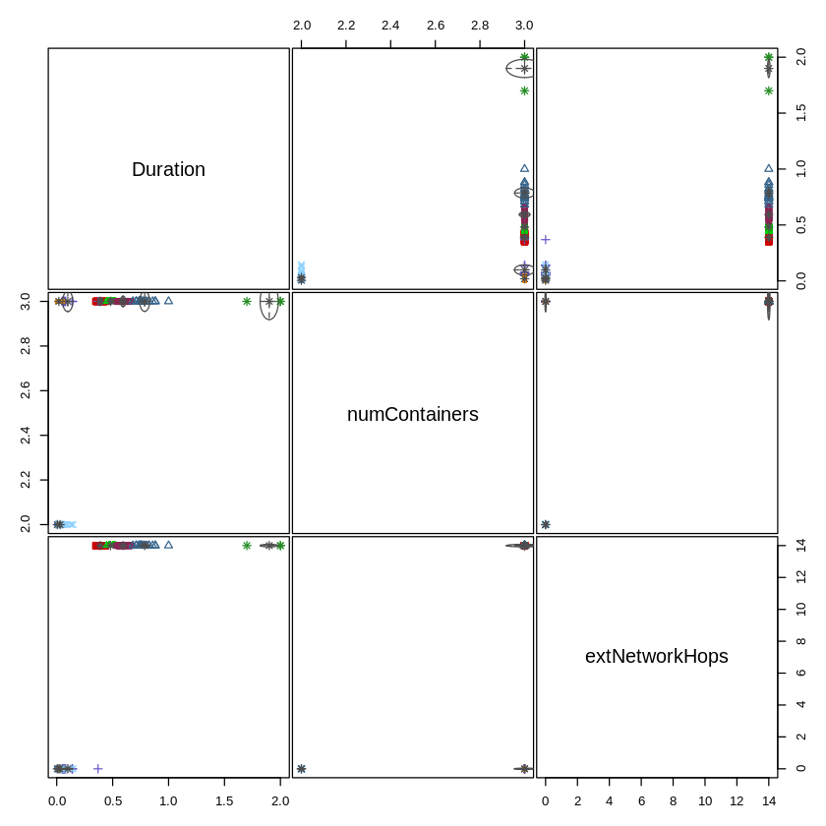

'Mclust' model object: (VII,9)   
  
Available components:   
 [1] "call" "data" "modelName" "n"   
 [5] "d" "G" "BIC" "loglik"   
 [9] "df" "bic" "icl" "hypvol"   
[13] "parameters" "z" "classification" "uncertainty"

Best BIC values:  
 VII,9 VII,8 VII,7  
BIC 6543.025 5503.962 5357.604  
BIC diff 0.000 -1039.063 -1185.420

----------------------------------------------------   
Gaussian finite mixture model fitted by EM algorithm   
----------------------------------------------------   
  
Mclust VII (spherical, varying volume) model with 9 components:   
  
 log-likelihood n df BIC ICL  
 3403.325 400 44 6543.025 6532.676  
  
Clustering table:  
 1 2 3 4 5 6 7 8 9   
80 64 40 15 65 80 35 3 18   
  
Mixing probabilities:  
 1 2 3 4 5 6 7   
0.19998789 0.16003456 0.09874244 0.03732462 0.16267538 0.20001211 0.08773675   
 8 9   
0.00750000 0.04598624   
  
Means:  
 [,1] [,2] [,3] [,4] [,5]  
Duration 0.005314462 0.3894187 0.4815126 0.09855145 0.01903641  
numContainers 2.000000000 3.0000000 3.0000000 3.00000000 3.00000000  
extNetworkHops 0.000000000 14.0000000 14.0000000 0.00000000 0.00000000  
 [,6] [,7] [,8] [,9]  
Duration 0.02960357 0.5933374 1.9 0.786242  
numContainers 2.00000000 3.0000000 3.0 3.000000  
extNetworkHops 0.00000000 14.0000000 14.0 14.000000  
  
Variances:  
[,,1]  
 Duration numContainers extNetworkHops  
Duration 1.865673e-07 0.000000e+00 0.000000e+00  
numContainers 0.000000e+00 1.865673e-07 0.000000e+00  
extNetworkHops 0.000000e+00 0.000000e+00 1.865673e-07  
[,,2]  
 Duration numContainers extNetworkHops  
Duration 0.0003107502 0.0000000000 0.0000000000  
numContainers 0.0000000000 0.0003107502 0.0000000000  
extNetworkHops 0.0000000000 0.0000000000 0.0003107502  
[,,3]  
 Duration numContainers extNetworkHops  
Duration 0.0001882382 0.0000000000 0.0000000000  
numContainers 0.0000000000 0.0001882382 0.0000000000  
extNetworkHops 0.0000000000 0.0000000000 0.0001882382  
[,,4]  
 Duration numContainers extNetworkHops  
Duration 0.002082958 0.000000000 0.000000000  
numContainers 0.000000000 0.002082958 0.000000000  
extNetworkHops 0.000000000 0.000000000 0.002082958  
[,,5]  
 Duration numContainers extNetworkHops  
Duration 4.843538e-05 0.000000e+00 0.000000e+00  
numContainers 0.000000e+00 4.843538e-05 0.000000e+00  
extNetworkHops 0.000000e+00 0.000000e+00 4.843538e-05  
[,,6]  
 Duration numContainers extNetworkHops  
Duration 0.0001635017 0.0000000000 0.0000000000  
numContainers 0.0000000000 0.0001635017 0.0000000000  
extNetworkHops 0.0000000000 0.0000000000 0.0001635017  
[,,7]  
 Duration numContainers extNetworkHops  
Duration 0.0005640015 0.0000000000 0.0000000000  
numContainers 0.0000000000 0.0005640015 0.0000000000  
extNetworkHops 0.0000000000 0.0000000000 0.0005640015  
[,,8]  
 Duration numContainers extNetworkHops  
Duration 0.006666667 0.000000000 0.000000000  
numContainers 0.000000000 0.006666667 0.000000000  
extNetworkHops 0.000000000 0.000000000 0.006666667  
[,,9]  
 Duration numContainers extNetworkHops  
Duration 0.002007611 0.000000000 0.000000000  
numContainers 0.000000000 0.002007611 0.000000000  
extNetworkHops 0.000000000 0.000000000 0.002007611

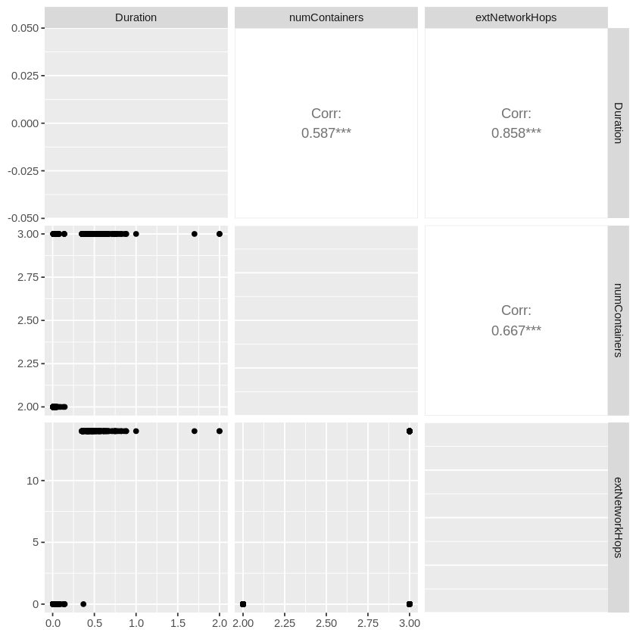

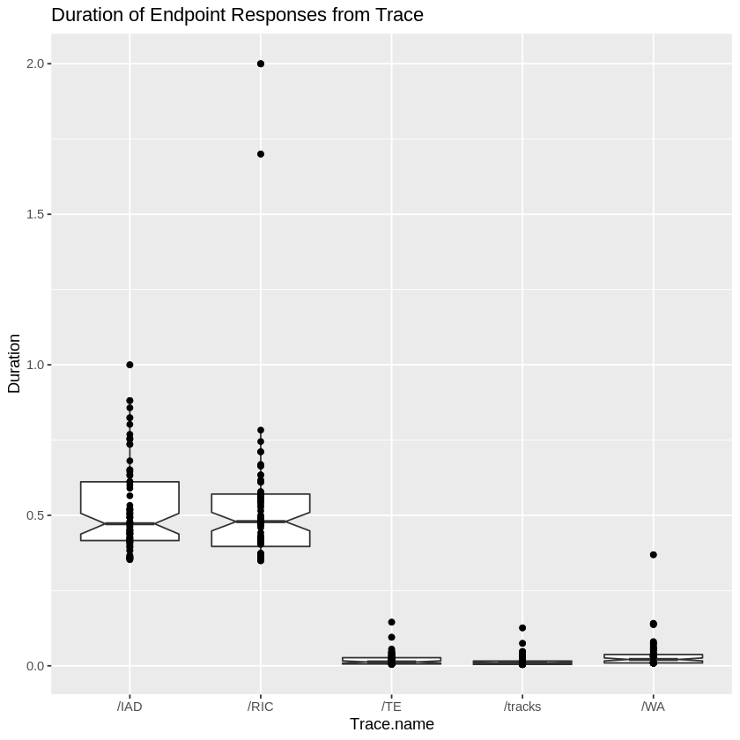

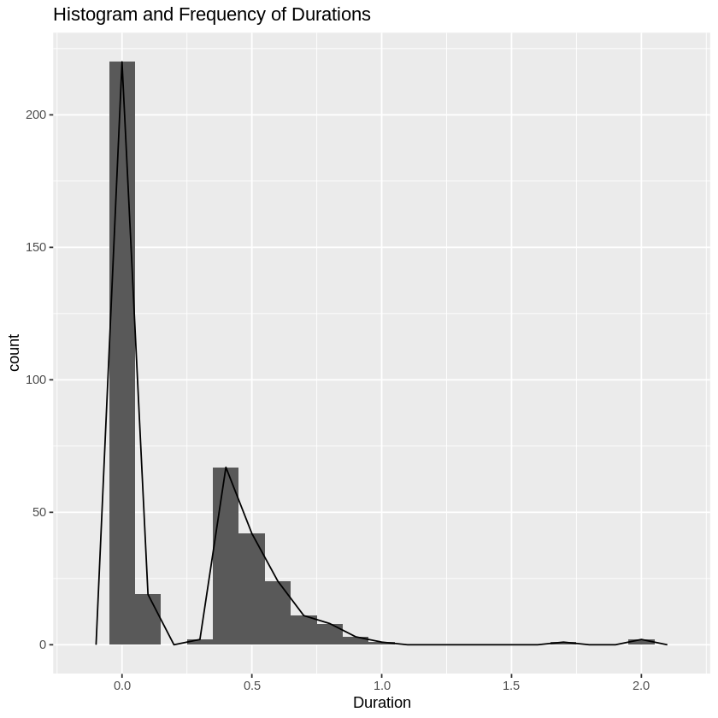

### Q-Q Normality Test

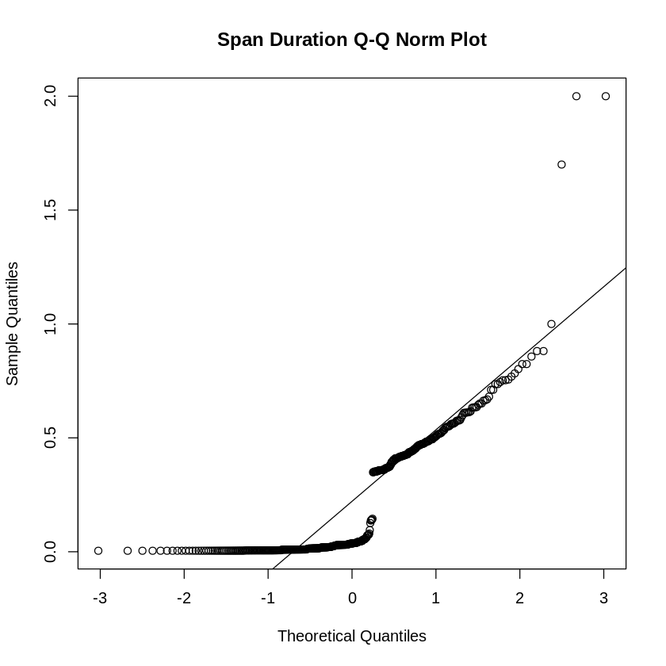

A transformation is needed to apply statistical analysis.

## Clean the Data

### Search for Outliers

1. 2
2. 2
3. 1.7

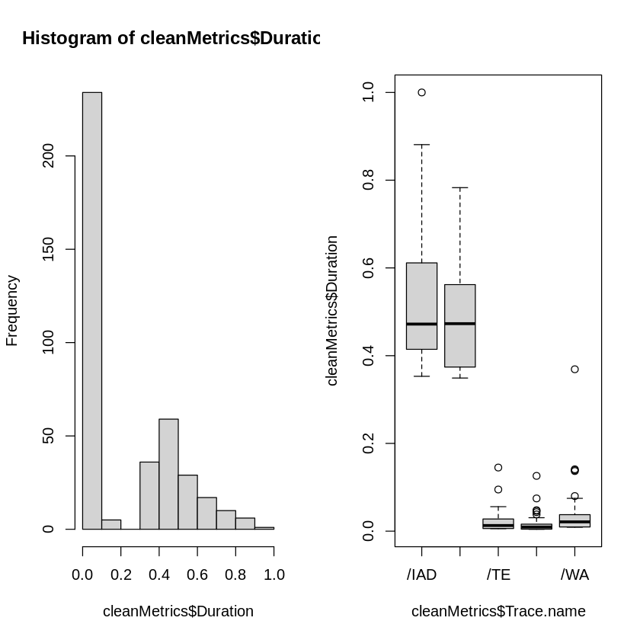

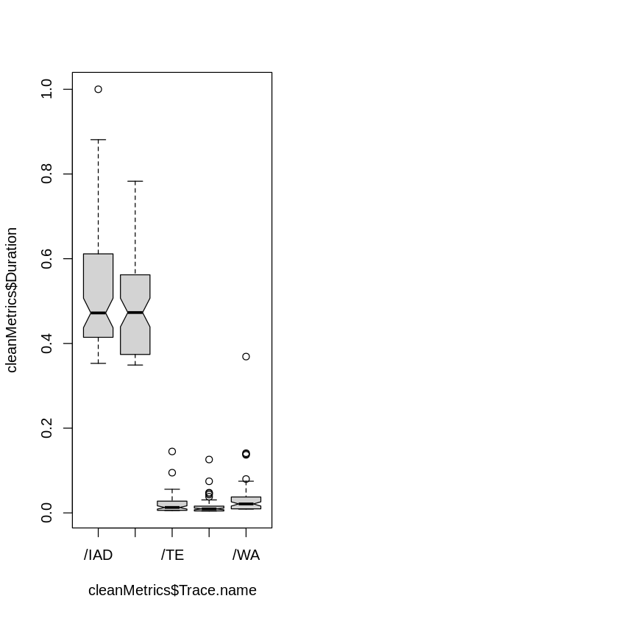

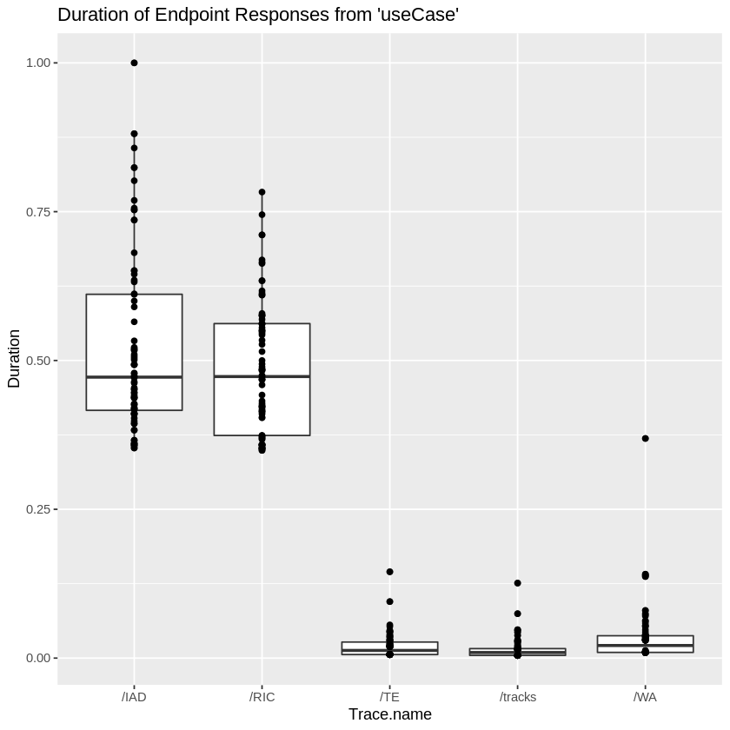

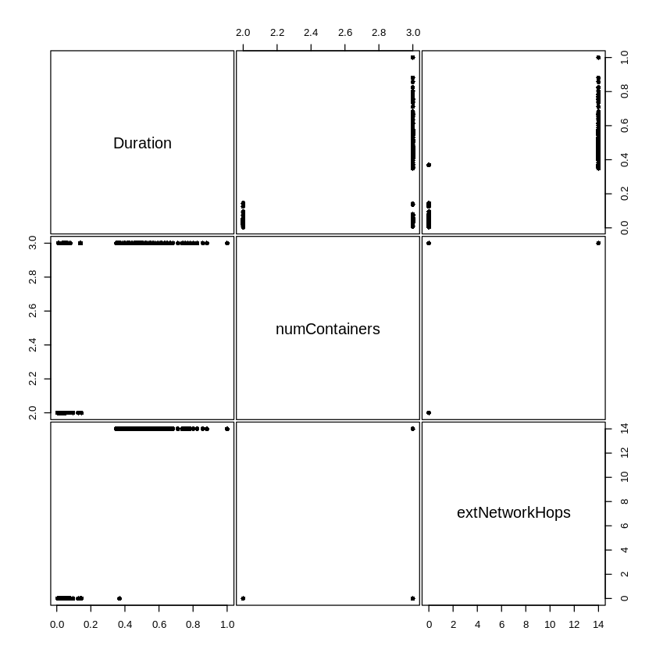

### Transformation of Clean Metrics

#### Sqrt, Log, and Cube Transformations

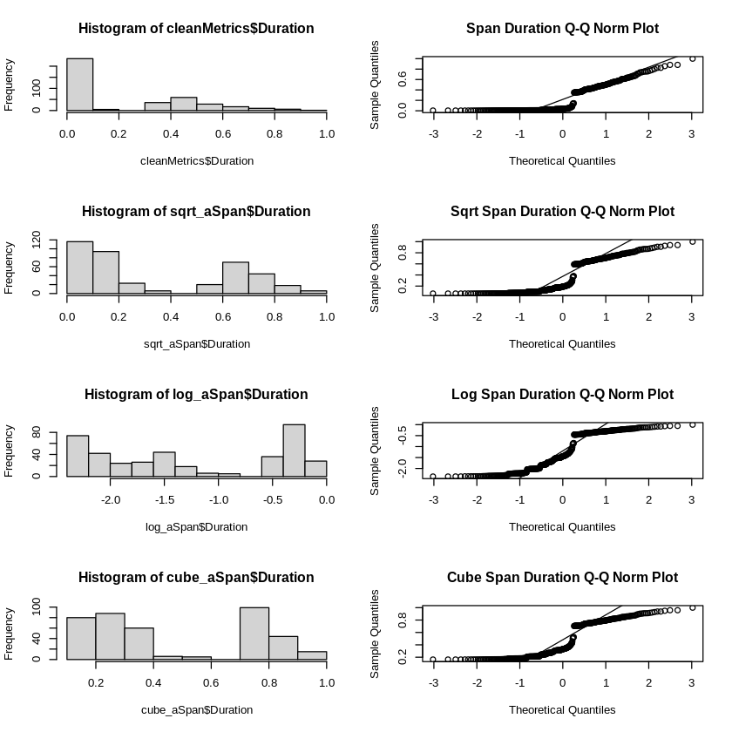

None of these transformation yield distributions that would be considered normal. Most likely due to access to external and internal services with differing latency. Lets try another transformation.

#### Box-Cox Transformation

Box and Cox (1964) developed a family of transformations designed to reduce nonnormality of the errors in a linear model. Applying this transform often reduces non-linearity as well, and heteroscedascity.

The idea is to transform the response variable to a replacement response variable , leaving the right-hand side of the regression model unchanged, so that the regression residuals become normally-distributed. Note that the regression coefficients will also change, because the response variable has changed; therefore, the regression coefficients must be interpreted with respect to the transformed variable. Also, any predictions made with the model have to be back-transformed, to be interpreted in the original units.

The standard (simple) Box-Cox transform is:

*Box, G. E. P., & Cox, D. R. (1964). An Analysis of Transformations. Journal of the Royal Statistical Society, Series B (Metholodogical), 26(2), 211-252.*

http://www.css.cornell.edu/faculty/dgr2/_static/files/R_html/Transformations.html

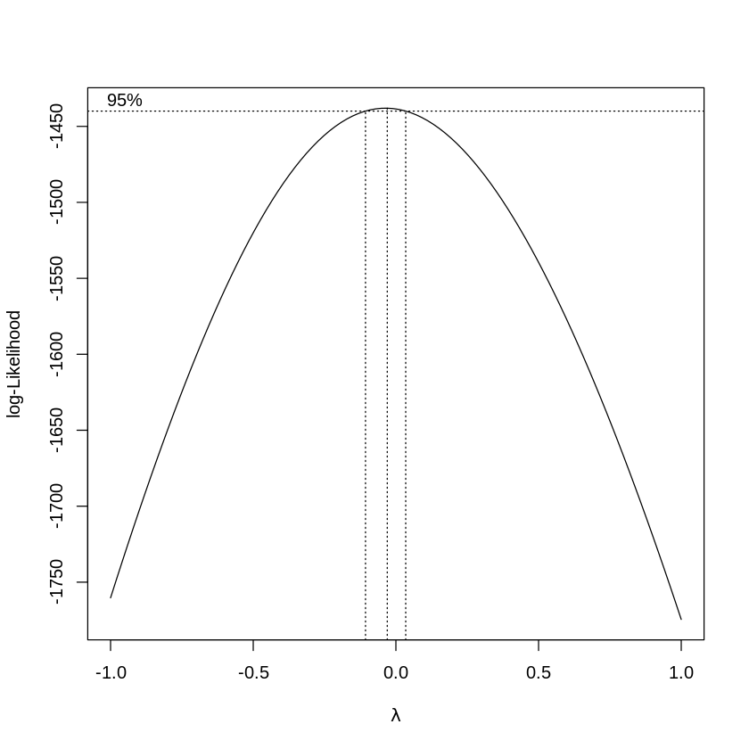

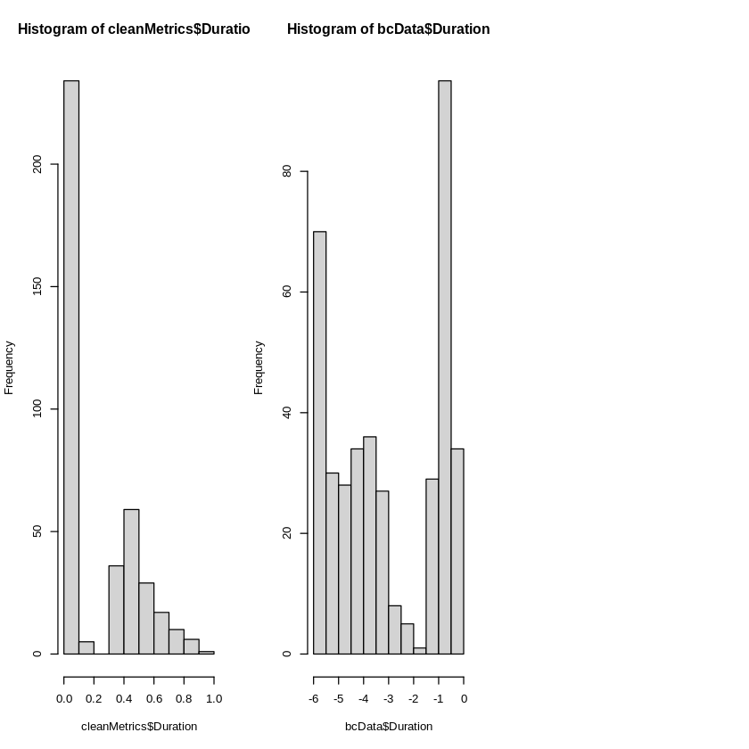

### Normality Testing of the Trasformation

#### Shapiro-Wilk

The null-hypothesis of this test is that the population is normally distributed. Thus, if the p value is less than the chosen alpha level, then the null hypothesis is rejected and there is evidence that the data tested are not normally distributed. On the other hand, if the p value is greater than the chosen alpha level, then the null hypothesis (that the data came from a normally distributed population) can not be rejected (e.g., for an alpha level of .05, a data set with a p value of less than .05 rejects the null hypothesis that the data are from a normally distributed population).

https://en.wikipedia.org/wiki/Shapiro–Wilk_test

Shapiro-Wilk normality test  
  
data: bcData$Duration  
W = 0.86181, p-value < 2.2e-16

With p-value of 2.852e-08 < 0.05 we reject the null hypothesis that the data are from a normally distributed population. But we’ll also do a Q-Q Norm plot to visually see the results.

*“if the p value is greater than the chosen alpha level, then the null hypothesis (that the data came from a normally distributed population) can not be rejected”*

#### Q-Q Norm

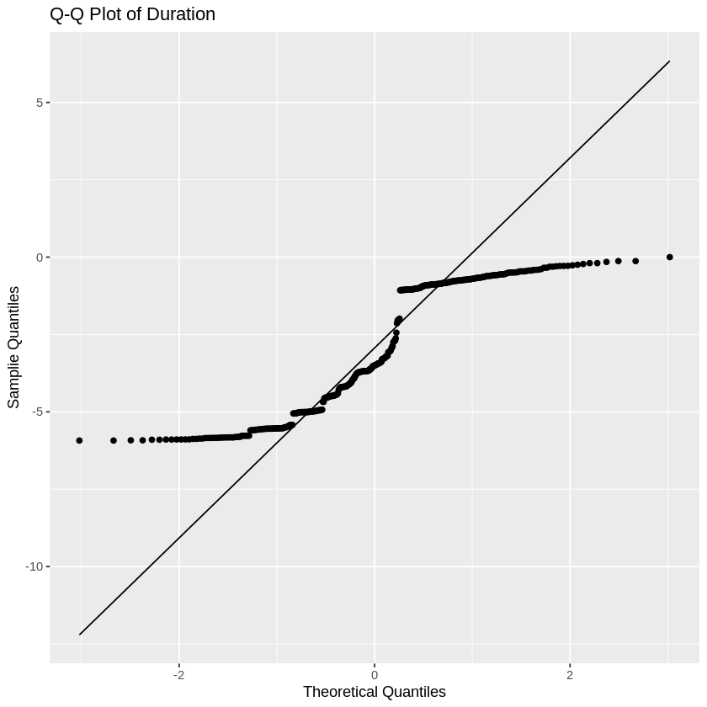

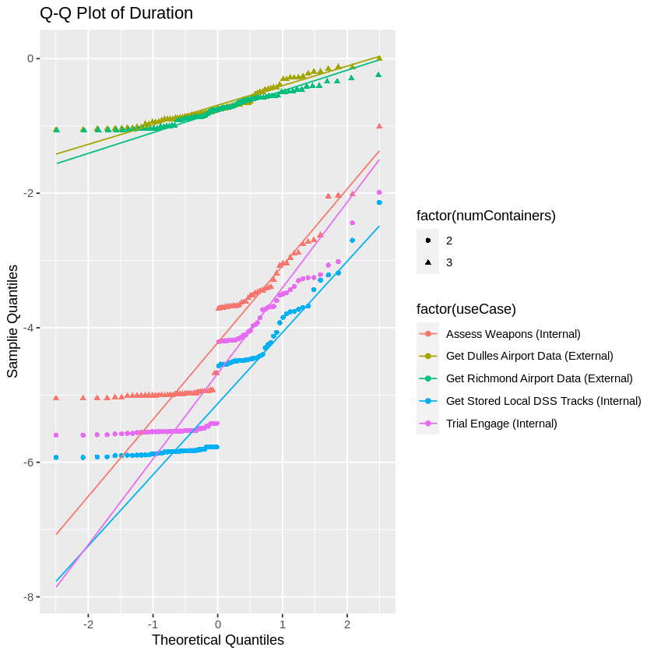

Our assumption here is that the separation of **Sample Quantiles** is from the difference between internal and external span durations (e.g. latency). Let’s see what happens when we split the samples.

## Separating “Original” Internal from External Data

### Internal Data

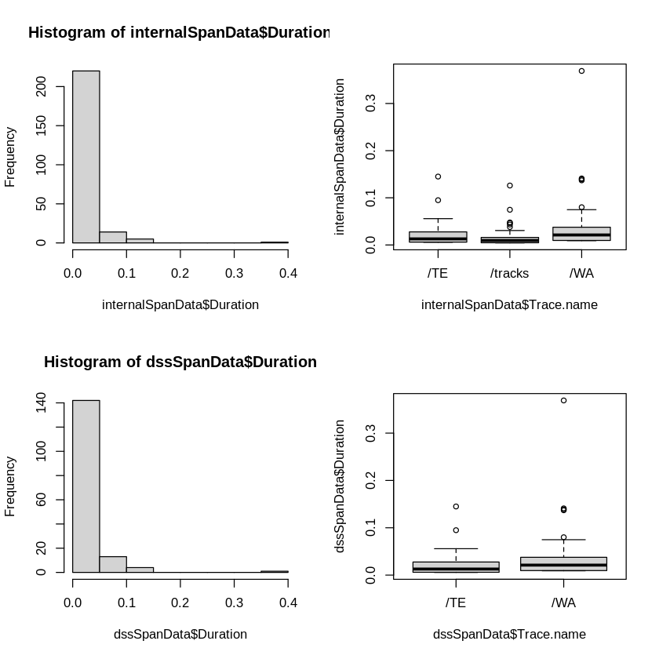

This result looks much better. However, we’ll remove internal span outliers.

1. 0.126
2. 0.0746
3. 0.0949
4. 0.145
5. 0.139
6. 0.0707
7. 0.0748
8. 0.369
9. 0.08
10. 0.137
11. 0.0729
12. 0.141

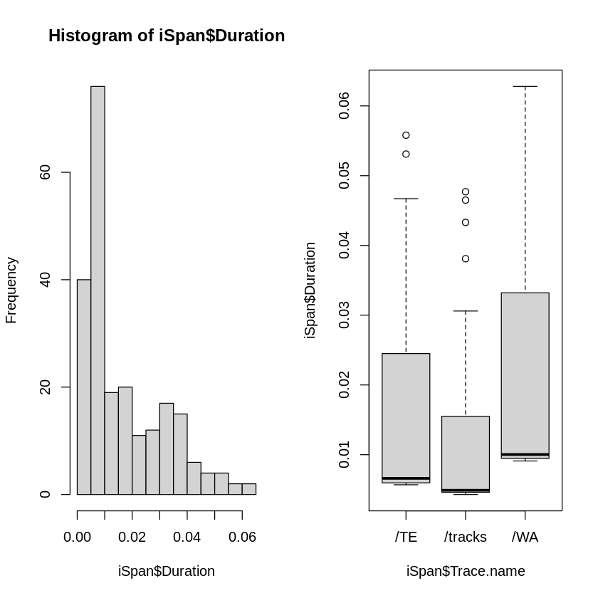

#### Q-Q Norm Plot of “Clean” Internal Span Data

We’ll look a the Q-Q Norm Plot and Shapiro-Wilk Test

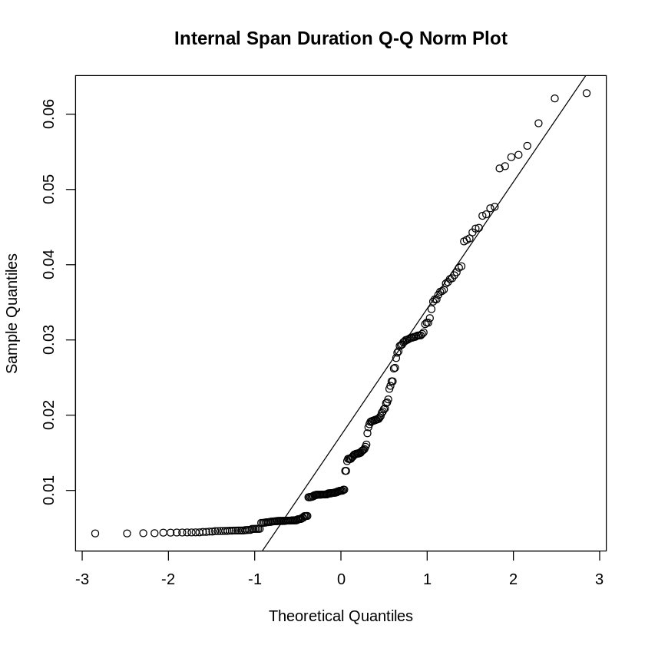

#### Autocorrelation

Autocorrelation plots are a commonly-used tool for checking randomness in a data set. This randomness is ascertained by computing autocorrelations for data values at varying time lags. If random, such autocorrelations should be near zero for any and all time-lag separations. If non-random, then one or more of the autocorrelations will be significantly non-zero.

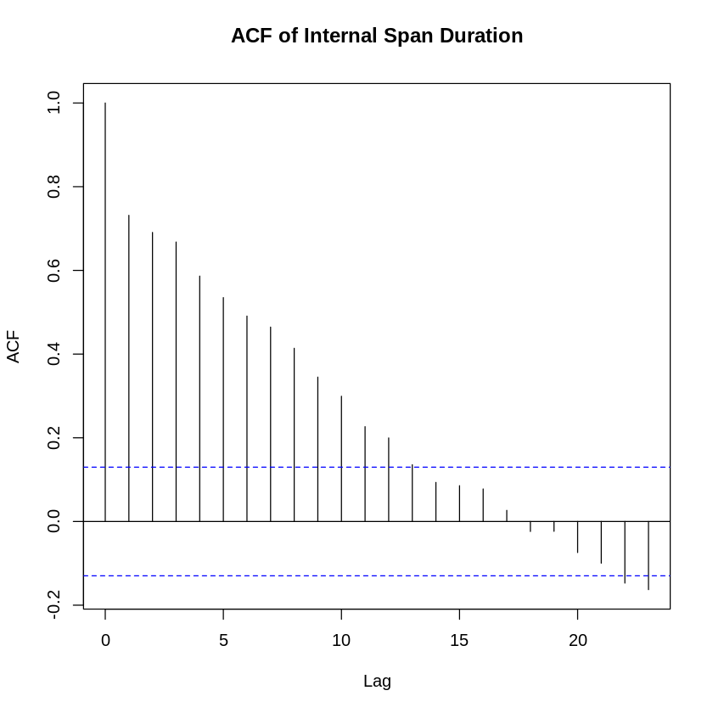

#### Shapiro-Wilk Normality Test

Shapiro-Wilk normality test  
  
data: iSpan$Duration  
W = 0.8393, p-value = 1.24e-14

With p-value of 0.002321 < 0.05 we reject the null hypothesis that the data are from a normally distributed population.

*“if the p value is greater than the chosen alpha level, then the null hypothesis (that the data came from a normally distributed population) can not be rejected”*

#### Data Transformations

##### Sqrt-Log-Cube Transformations

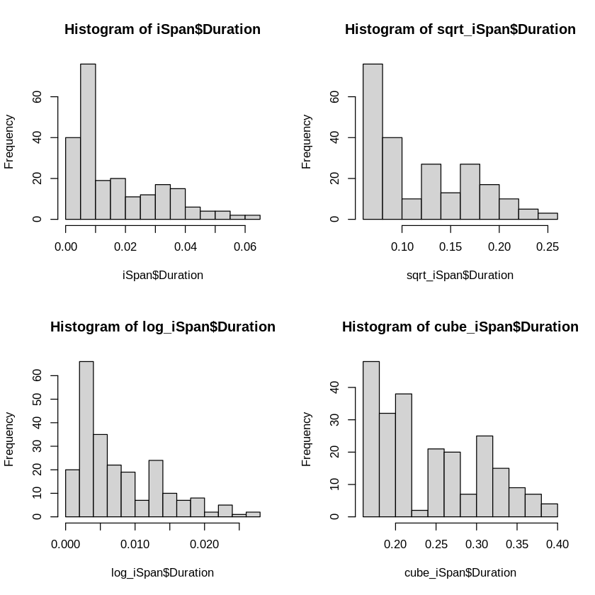

##### Q-Q Norm Sqrt-Log-Cube

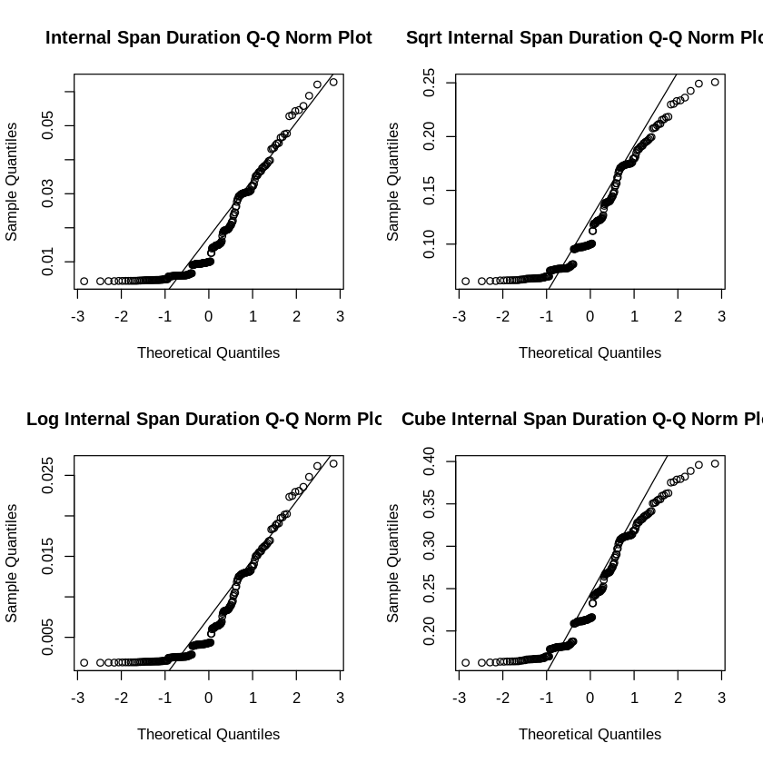

##### Shapiro-Wilk Testing Sqrt-Log-Cube

Shapiro-Wilk normality test  
  
data: sqrt_iSpan$Duration  
W = 0.89519, p-value = 1.643e-11

Shapiro-Wilk normality test  
  
data: log_iSpan$Duration  
W = 0.84173, p-value = 1.627e-14

Shapiro-Wilk normality test  
  
data: cube_iSpan$Duration  
W = 0.90743, p-value = 1.107e-10

The **cube transformation** seems to provide the best q-q plot fit. With a p-value of 0.3593 > 0.05 we fail to reject the null hypothesis and assume we now have a normal distribution.

*“if the p value is greater than the chosen alpha level, then the null hypothesis (that the data came from a normally distributed population) can not be rejected”*

#### Autocorrelation

Autocorrelation plots are a commonly-used tool for checking randomness in a data set. This randomness is ascertained by computing autocorrelations for data values at varying time lags. If random, such autocorrelations should be near zero for any and all time-lag separations. If non-random, then one or more of the autocorrelations will be significantly non-zero.

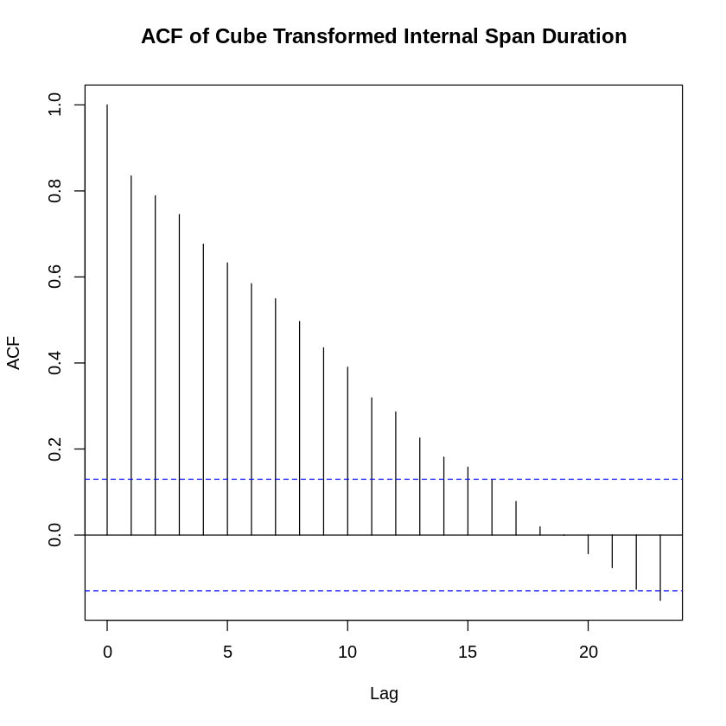

The ACF indicates that the data is random since the results are near zero.

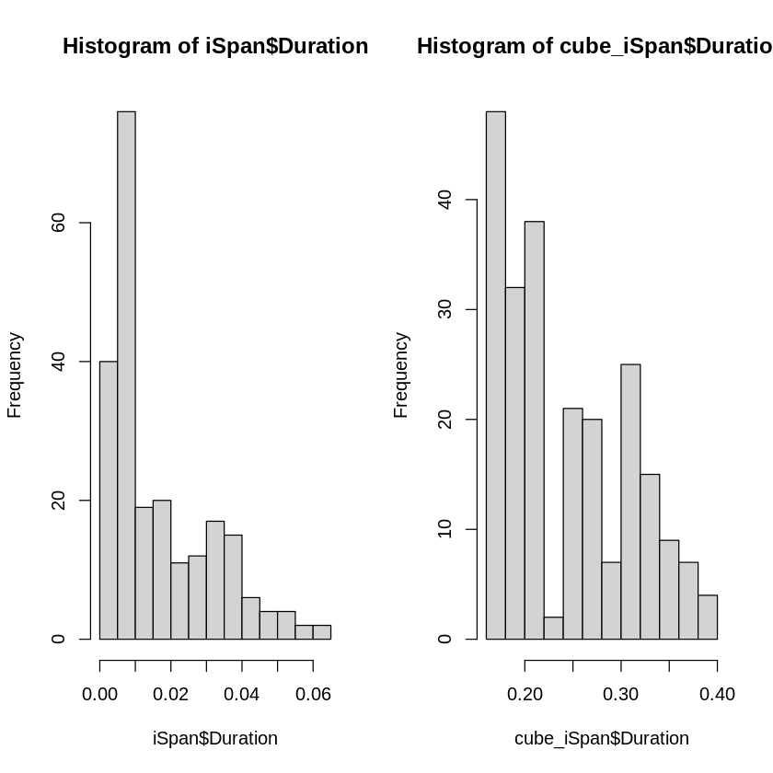

#### Hypothesis Testing

We will use a Student’s t-Test to test the hypothesis on **normal** internal span data. Our mean is 500 ms (e.g.  seconds) and our null hypthesis is less than 500 ms.

One Sample t-test  
  
data: x  
t = -125.89, df = 227, p-value = 1  
alternative hypothesis: true mean is greater than 0.7937005  
95 percent confidence interval:  
 0.234548 Inf  
sample estimates:  
mean of x   
0.2417889

One Sample t-test  
  
data: x  
t = -513.79, df = 227, p-value = 1  
alternative hypothesis: true mean is greater than 0.5  
95 percent confidence interval:  
 0.01589937 Inf  
sample estimates:  
 mean of x   
0.01745053

With a original and transformation with a p-value of 1 > 0.05 we fail to reject the null hypothesis, i.e. we assume that latency will be less than 500 ms.

*“If the p value is greater than the chosen alpha level, then the null hypothesis (that latency is < 500 ms) can not be rejected”*

### External Data

Trace.ID Trace.name Start.time Duration   
 Length:160 Length:160 Min. :1.651e+09 Min. :0.3490   
 Class :character Class :character 1st Qu.:1.654e+09 1st Qu.:0.4100   
 Mode :character Mode :character Median :1.655e+09 Median :0.4735   
 Mean :1.654e+09 Mean :0.5308   
 3rd Qu.:1.655e+09 3rd Qu.:0.5767   
 Max. :1.655e+09 Max. :2.0000   
 platform useCase numContainers extNetworkHops  
 Length:160 Length:160 Min. :3 Min. :14   
 Class :character Class :character 1st Qu.:3 1st Qu.:14   
 Mode :character Mode :character Median :3 Median :14   
 Mean :3 Mean :14   
 3rd Qu.:3 3rd Qu.:14   
 Max. :3 Max. :14

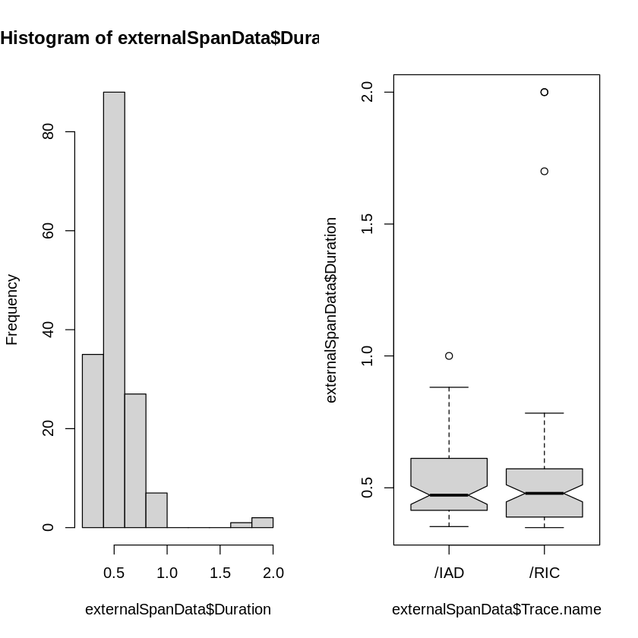

1. 2
2. 2
3. 1.7
4. 0.881
5. 0.881
6. 0.857
7. 1

Trace.ID Trace.name Start.time Duration   
 Length:153 Length:153 Min. :1.651e+09 Min. :0.3490   
 Class :character Class :character 1st Qu.:1.651e+09 1st Qu.:0.4100   
 Mode :character Mode :character Median :1.655e+09 Median :0.4680   
 Mean :1.654e+09 Mean :0.4942   
 3rd Qu.:1.655e+09 3rd Qu.:0.5620   
 Max. :1.655e+09 Max. :0.8240   
 platform useCase numContainers extNetworkHops  
 Length:153 Length:153 Min. :3 Min. :14   
 Class :character Class :character 1st Qu.:3 1st Qu.:14   
 Mode :character Mode :character Median :3 Median :14   
 Mean :3 Mean :14   
 3rd Qu.:3 3rd Qu.:14   
 Max. :3 Max. :14

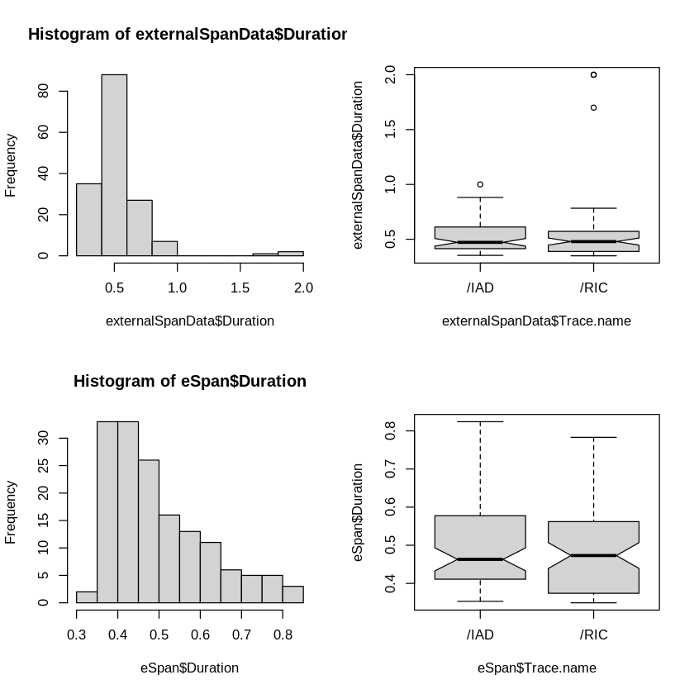

#### Q-Q Norm Plot of “Clean” External Span Data

We’ll look a the Q-Q Norm Plot and Shapiro-Wilk Test

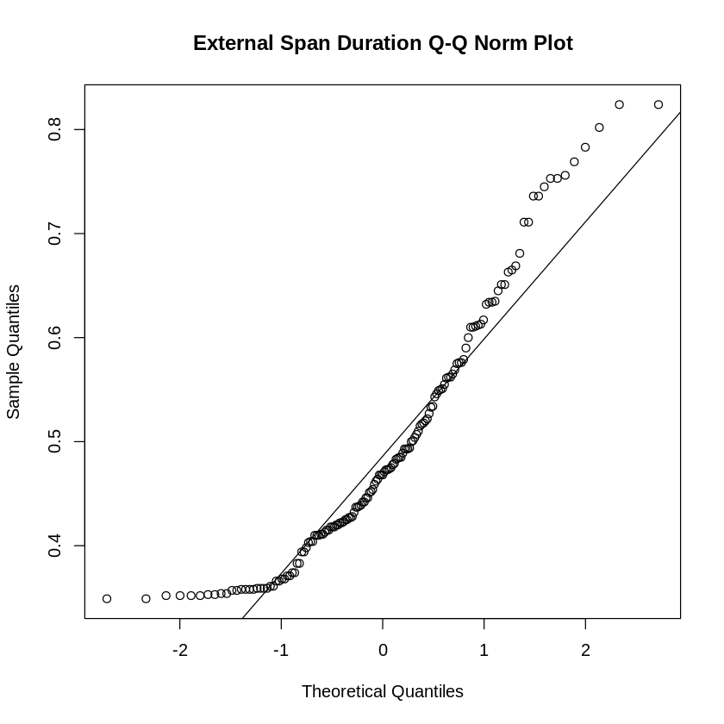

#### Shapiro-Wilk Normality Test

Shapiro-Wilk normality test  
  
data: eSpan$Duration  
W = 0.91392, p-value = 6.907e-08

With a p-value of 0.2878 > 0.05 we fail to reject the null hypothesis, i.e. we assume that we have a normal distribution.

*“if the p value is greater than the chosen alpha level, then the null hypothesis (that the data came from a normally distributed population) can not be rejected”*

#### Autocorrelation

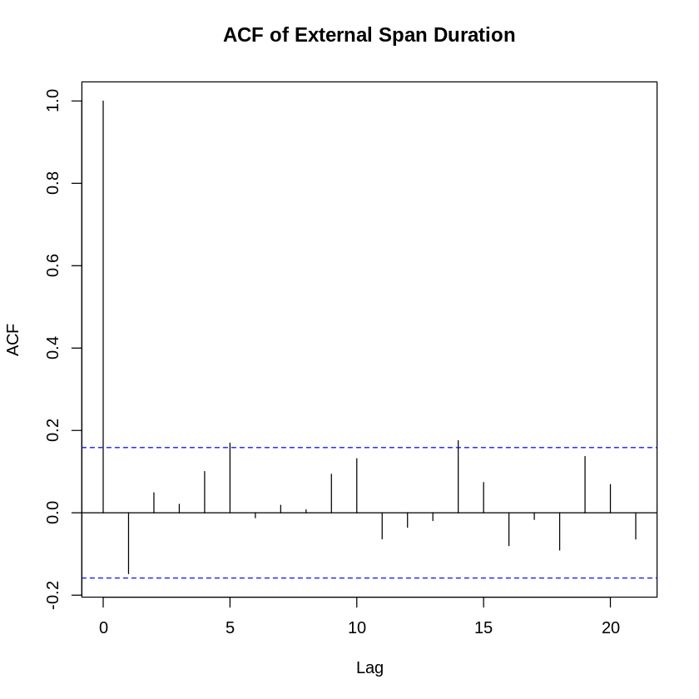

The ACF indicates that the data is random since the results are near zero.

#### Hypothesis Testing

We will use a Student’s t-Test to test the hypothesis on external span data. Our mean is 500 ms (e.g.  seconds) and our null hypthesis is less than 500 ms.

One Sample t-test  
  
data: x  
t = -0.59764, df = 152, p-value = 0.7245  
alternative hypothesis: true mean is greater than 0.5  
95 percent confidence interval:  
 0.4781488 Inf  
sample estimates:  
mean of x   
0.4942026

With a p-value of 0.1336 > 0.05 we fail to reject the null hypothesis, i.e. we assume that 500 ms can be maintained for external service requests.

*“If the p value is greater than the chosen alpha level, then the null hypothesis (that latency is < 500 ms) can not be rejected”*

## Observations

### General Discussion of Normality

It was required to separate external data from internal to establish normality of the data samples. The internal data set required transformation to establish normality, while the external data did not require a transformation.

### Hypothesis Results

Hypothesis testing using the Student’s t-Test indicates that latency constraints of 500 ms can be maintained internally and external. However, serveral external samples were greater than 500 ms. This is most likely due to the non-deterministic nature of internet (e.g. http) requests. Within the internal environment, data is directly routed between microservices within the Docker environment within a private network. The data shows that a container based microservice architecture can meet the requirement; however, care must be taken to manage processing per container that may increase container response times.