# Decision Support System (DSS) Span Analysis

https://github.com/jupyter/docker-stacks  
https://hub.docker.com/r/jupyter/r-notebook/tags/

*(optional) docker pull jupyter/r-notebook:latest*

We want to make the DDS Prototype ~/analysis/ directory linked to the Juypter container. Use the following to mount the analysis directory (i.e. current working directory) as a volume in the Juypter container. Note that the directory needed to be added via the Docker Desktop Dashboard on Mac.

*docker run -it –rm -d -p 10000:8888 -v ${PWD}:/home/jovyan/work –name notebook jupyter/r-notebook:latest*

To find the token from the container:  
*docker exec -it notebook jupyter server list*

Navigate to the container UI and enter the token: http://localhost:10000

## DSS System Context

The following diagram depicts the context for the DSS. The DSS operator interacts with the DSS Prototype for decision assitance. The DSS relies on a aircraft database to gather real-time flight data to review in decision support algorithms.

## DSS Container Architecture

Nine containers are instantiated as part of the DSS architecuture. Six provide the DSS implementation while the additional 3 support collection and calculation of metrics. Each application container was designed around the 12-Factor Application “Single Responsibility Principle”; e.g. each app has one purpose to enable rapid insertion of new capabilities with low cohesion to other functionality. At this time, all responses are canned without underlying calculation to focus on meeting the 500 ms hypothesis pryor to buddening the app with calculation latency.

### DSS Applications

* opensky-int: Provides the OpenSky API for flight data. The app provides data about aircraft within 60 NM of Richmond (RIC) or Dulles (IAD) airports.
* tm-server: Provides sensor track data (e.g. OpenSky) and system tracks to support DSS services. System tracks represents the system-wide common understand of a track objects state for decisions.
* wa-app: The Weapon Assessment Application determines which weapons are capable to successfully engage a target. The wa-app use the tm-server api to get track data.
* te-app: The Trail Engage Application determines the success rate of an engagement with a specific weapon target pairing. The predicted track kinematic data at engagement time is provided; therefore, the current track kinematics from the tm-server are not queried prior to providing a response.
* test-app: Provides and ability to generate automated test. the test-app uses the dss-ui to call dss-ui endpoint to replicate operator interactions with the DSS Prototype.
* dss-ui: Provides a simple graphical interface to launch DSS services.

### DSS Tools

* telem-jaeger: The open source Jaeger containter collects “span” data from the DSS applications. Spans collection duration data for service call to over container; e.g. latency. This the fundamental data that is being analysed here.
* grafana: The open source Grafana container connects to the telem-jaeger container to create visualization dashboard. Also, Grafana faciliates the export of data as a .csv file for analysis.
* notebook: The Jupyter Notebook container support analysis of the data exported by Grafana. It is the core datafile use by this tool.

### Hypothesis

Hypothesis is “innocent until proven guilty.” We’ll assume that SpaceX and others have proven that DevSecOps tech can meet hard-real-time requirements but nothing available in the body of knowledge documents this.

**Hypothesis:** Modern DevSecOps architectures can be designed to meet hard-real-time latency ($μ$) requirements using modern computing environments and computing infrastructure.

$H_{0}:μ≤500ms$ with jitter within latency bounds $H_{a}:μ>500ms$ 
 with jitter exceeding latency bounds

*Murphy, Alvin C. and Moreland Jr, James D. ‘Integrating AI Microservices into Hard-Real-Time SoS to Ensure Trustworthiness of Digital Enterprise Using Mission Engineering’. 1 Jan. 2021 : 38 – 54.*

options(warn=-1)

install.packages("stringr") # Install packages and libraries in R  
library("stringr", quietly = T)   
  
install.packages("dplyr")  
library("dplyr", quietly = T)  
  
install.packages("ggplot2")   
install.packages("GGally")  
library("ggplot2", quietly = T)   
library("GGally", quietly = T)

Updating HTML index of packages in '.Library'  
  
Making 'packages.html' ...  
 done  
  
Updating HTML index of packages in '.Library'  
  
Making 'packages.html' ...  
 done  
  
Updating HTML index of packages in '.Library'  
  
Making 'packages.html' ...  
 done  
  
Updating HTML index of packages in '.Library'  
  
Making 'packages.html' ...  
 done

setwd('/home/jovyan/work/data')

options(warn=-1)  
spanData <- read.csv('DSS Span Data-data-2022-05-02 18_38_26.csv', header = TRUE)  
attach(spanData)

# Exploratory Data Analysis

head(spanData)

A data.frame: 6 × 4

|  | Trace.ID <chr> | Trace.name <chr> | Start.time <chr> | Duration <chr> |
| --- | --- | --- | --- | --- |
| 1 | 9ee3577fb1b427bc4fc17fecc5154d7d | dss-prototype: /TE | 2022-05-02 10:25:01.366 | 36.0 ms |
| 2 | f05ddc4dc13aff5c3098011b2a402401 | dss-prototype: /tracks | 2022-05-02 10:25:00.309 | 43.3 ms |
| 3 | 2bd901fbbfc9ee8dfa7c9629d93a1567 | dss-prototype: /IAD | 2022-05-02 10:24:58.818 | 464 ms |
| 4 | 69a48381a14e79da08aaa2353f7db4b2 | dss-prototype: /RIC | 2022-05-02 10:24:57.307 | 494 ms |
| 5 | e83037dcb9438c04dc12fba373b5502f | dss-prototype: /WA | 2022-05-02 10:24:56.128 | 139 ms |
| 6 | 7e381cd880adb670bb9627ca47020938 | dss-prototype: /TE | 2022-05-02 10:24:55.081 | 30.3 ms |

summary(spanData)

Trace.ID Trace.name Start.time Duration   
 Length:100 Length:100 Length:100 Length:100   
 Class :character Class :character Class :character Class :character   
 Mode :character Mode :character Mode :character Mode :character

## Convert Data into Useable Metrics

## Dictionary for converting data  
  
DSSoperations <- c(  
 "dss-prototype: /IAD" = "Get Dulles Airport Data (External)",  
 "dss-prototype: /RIC" = "Get Richmond Airport Data (External)",  
 "dss-prototype: /tracks" = "Get Stored Local DSS Tracks (Internal)",  
 "dss-prototype: /TE" = "Trial Engage (Internal)",  
 "dss-prototype: /WA" = "Assess Weapons (Internal)"  
)  
  
DSSnumContainers <- c(  
 "dss-prototype: /IAD" = 3,  
 "dss-prototype: /RIC" = 3,  
 "dss-prototype: /tracks" = 2,  
 "dss-prototype: /TE" = 2,  
 "dss-prototype: /WA" = 3  
)  
  
# Used docker run -it --rm gophernet/traceroute opensky-network.org  
# to determine hops from Docker network to OpenSky -- number may change in different environments  
  
DSStraceRoute <- c(  
 "dss-prototype: /IAD" = 14,  
 "dss-prototype: /RIC" = 14,  
 "dss-prototype: /tracks" = 0,  
 "dss-prototype: /TE" = 0,  
 "dss-prototype: /WA" = 0  
)

# Convert character data into numeric metrics  
  
spanMetrics <- spanData  
  
# spanMetrics = cbind(spanMetrics, operation, containers)  
  
for(i in 1:nrow(spanMetrics)) { # for-loop over rows  
   
 # Add operation and container data  
 spanMetrics$useCase = DSSoperations[Trace.name]  
 spanMetrics$numContainers = DSSnumContainers[Trace.name]  
 spanMetrics$extNetworkHops = DSStraceRoute[Trace.name]  
   
 # Convert span duration  
   
 char = spanMetrics[i,4]  
 len = str_length(char)  
 duration = str_sub(char,1,(len-3))  
 units = str_sub(char,(len-1),len)  
 duration = as.numeric(duration)  
   
 # print(duration)  
 # print(units)  
  
 if(units == 'ms') {  
 duration = duration / 1000 # Convert to ms  
 } else if (units == 'µs') {  
 duration = duration / 1000000 # Convert to µs  
 } else if (units == ' s') {  
 duration = duration  
 } else {  
 print ('Unable to find specified units')  
 print (units)  
 }  
 spanMetrics[i,4] = duration  
   
 # Convert time  
  
 time = spanMetrics[i,3]  
 epoch <- as.POSIXct(time)  
 epoch_int <- as.integer(epoch)  
 spanMetrics[i,3] = epoch_int  
}  
  
# Convert columns for char to numeric  
  
spanMetrics$Duration = as.numeric(spanMetrics$Duration)  
spanMetrics$Start.time = as.numeric(spanMetrics$Start.time)  
  
head(spanMetrics)  
summary(spanMetrics)

A data.frame: 6 × 7

|  | Trace.ID <chr> | Trace.name <chr> | Start.time <dbl> | Duration <dbl> | useCase <chr> | numContainers <dbl> | extNetworkHops <dbl> |
| --- | --- | --- | --- | --- | --- | --- | --- |
| 1 | 9ee3577fb1b427bc4fc17fecc5154d7d | dss-prototype: /TE | 1651487101 | 0.0360 | Trial Engage (Internal) | 2 | 0 |
| 2 | f05ddc4dc13aff5c3098011b2a402401 | dss-prototype: /tracks | 1651487100 | 0.0433 | Get Stored Local DSS Tracks (Internal) | 2 | 0 |
| 3 | 2bd901fbbfc9ee8dfa7c9629d93a1567 | dss-prototype: /IAD | 1651487098 | 0.4640 | Get Dulles Airport Data (External) | 3 | 14 |
| 4 | 69a48381a14e79da08aaa2353f7db4b2 | dss-prototype: /RIC | 1651487097 | 0.4940 | Get Richmond Airport Data (External) | 3 | 14 |
| 5 | e83037dcb9438c04dc12fba373b5502f | dss-prototype: /WA | 1651487096 | 0.1390 | Assess Weapons (Internal) | 3 | 0 |
| 6 | 7e381cd880adb670bb9627ca47020938 | dss-prototype: /TE | 1651487095 | 0.0303 | Trial Engage (Internal) | 2 | 0 |

Trace.ID Trace.name Start.time Duration   
 Length:100 Length:100 Min. :1.651e+09 Min. :0.01390   
 Class :character Class :character 1st Qu.:1.651e+09 1st Qu.:0.03275   
 Mode :character Mode :character Median :1.651e+09 Median :0.07375   
 Mean :1.651e+09 Mean :0.25404   
 3rd Qu.:1.651e+09 3rd Qu.:0.48450   
 Max. :1.651e+09 Max. :2.00000   
 useCase numContainers extNetworkHops  
 Length:100 Min. :2.0 Min. : 0.0   
 Class :character 1st Qu.:2.0 1st Qu.: 0.0   
 Mode :character Median :3.0 Median : 0.0   
 Mean :2.6 Mean : 5.6   
 3rd Qu.:3.0 3rd Qu.:14.0   
 Max. :3.0 Max. :14.0

## Exploratory Analysis Plots

spanMetrics %>%  
 select(Duration, numContainers, extNetworkHops) %>%  
 ggpairs(spanMetrics)

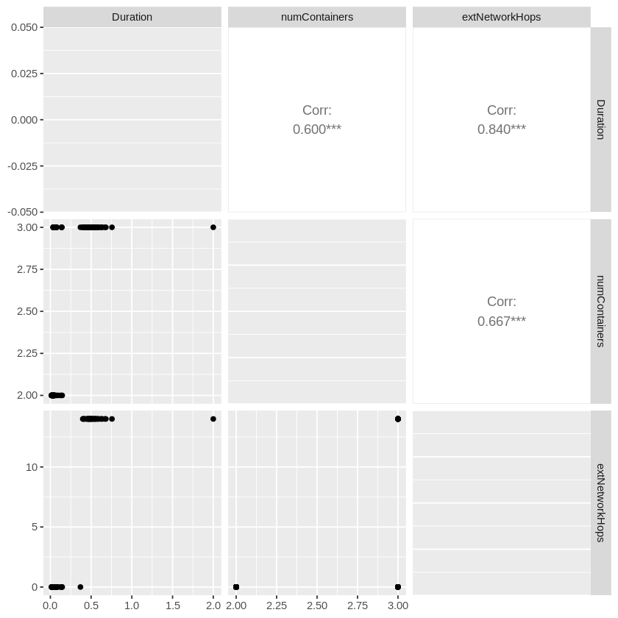

spanMetrics %>%  
 ggplot(aes(Trace.name, Duration)) +   
 geom_boxplot() + geom_point() +  
 ggtitle("Duration of Endpoint Responses from 'Trace'")

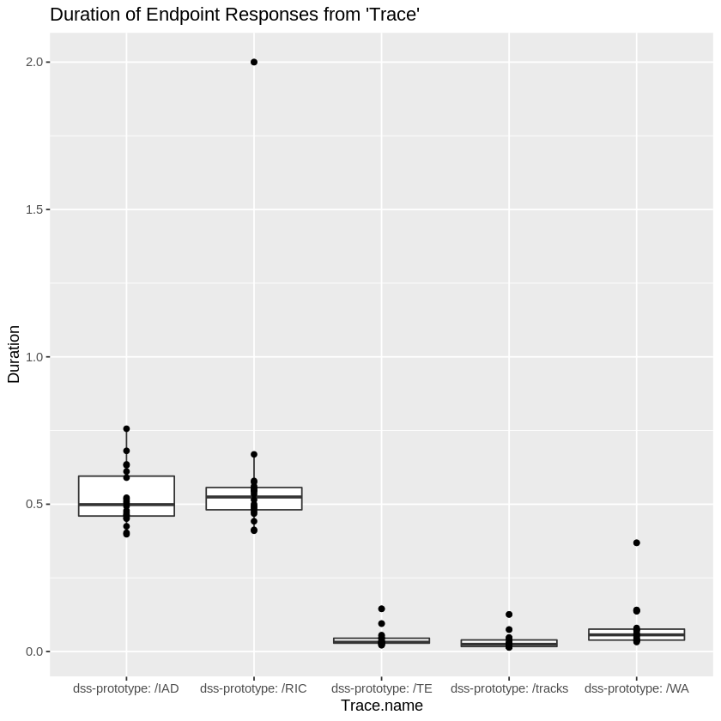

spanMetrics %>%  
 ggplot(aes(Duration)) +   
 geom_histogram(binwidth = 0.1) +   
 geom_freqpoly(binwidth = 0.1) +  
 ggtitle("Histogram and Frequency of Durations")

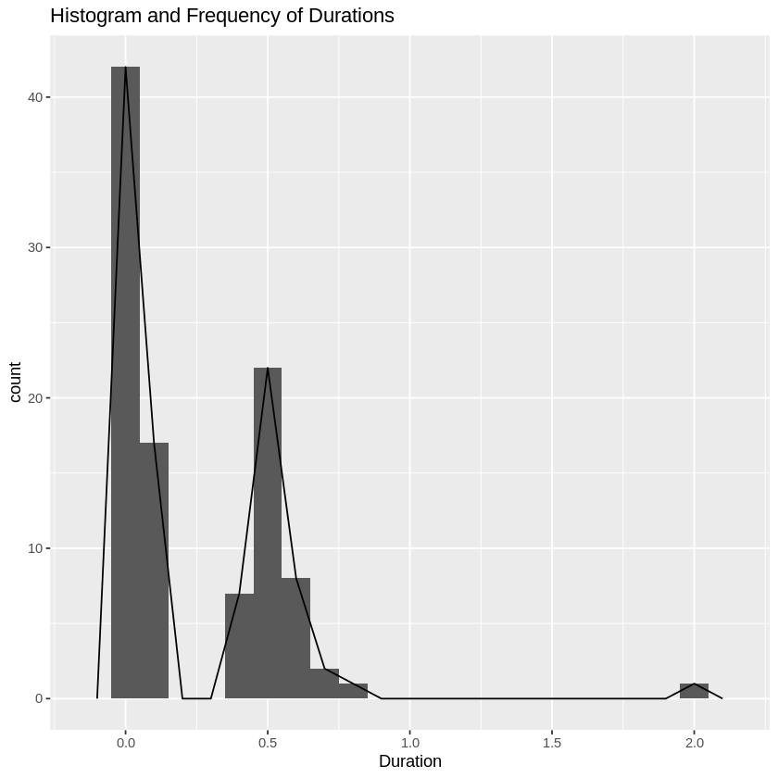

## Q-Q Normality Test

qqnorm(spanMetrics$Duration,main="Span Duration Q-Q Norm Plot")  
qqline(spanMetrics$Duration)

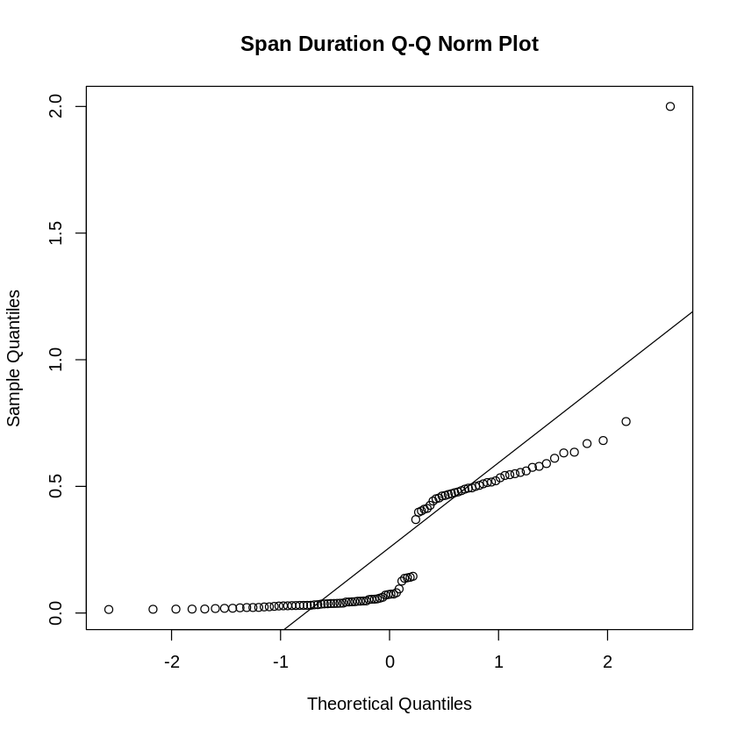

A transformation is needed to apply statistical analysis.

# Clean the Data

## Search for outliers

# Use this to get the values of the statistical outliers in trk_update_data from R  
outliers <- boxplot(spanMetrics$Duration, plot = FALSE)$out  
outliers  
  
cleanMetrics <- spanMetrics  
cleanMetrics <- cleanMetrics[-which(cleanMetrics$Duration %in% outliers),]

2

par(mfrow=c(1,2))  
hist(cleanMetrics$Duration)  
boxplot(cleanMetrics$Duration~cleanMetrics$Trace.name)

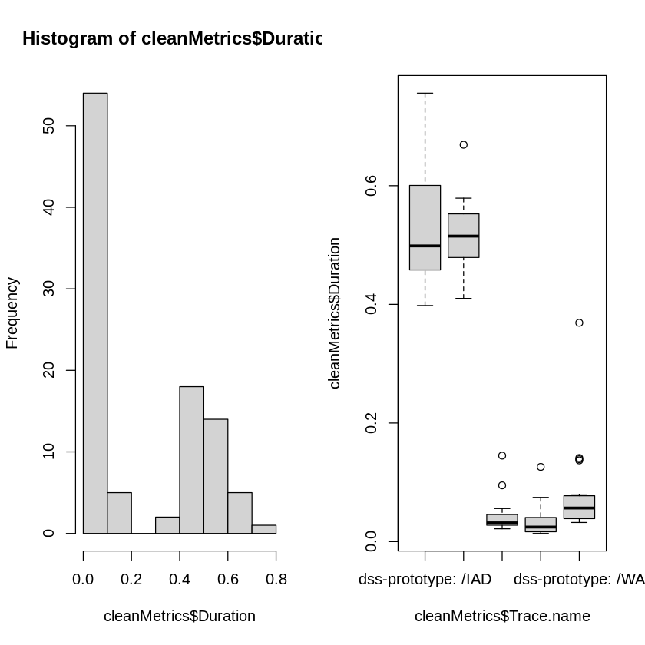

cleanMetrics %>%  
 ggplot(aes(Trace.name, Duration)) +   
 geom_boxplot() + geom_point() +  
 ggtitle("Duration of Endpoint Responses from 'useCase'")

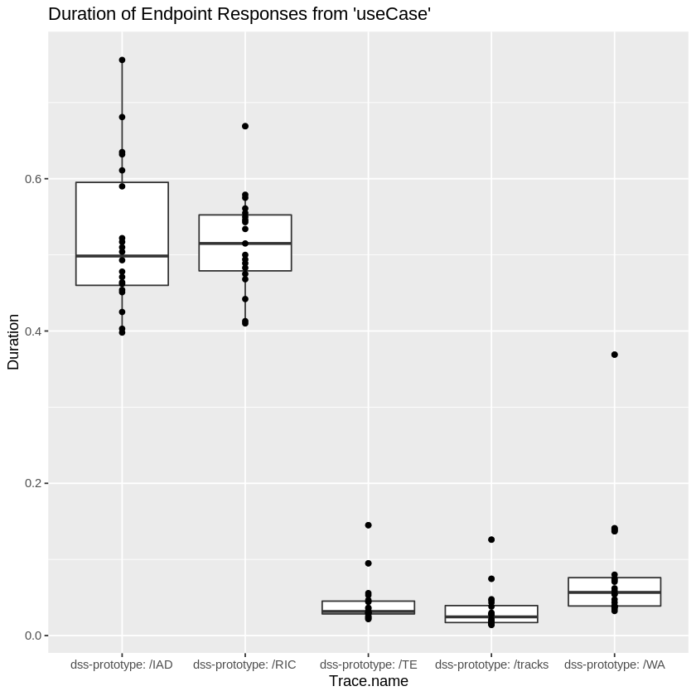

## Transformation of Clean Metrics

### Sqrt, Log, and Cube Transformations

sqrt_aSpan <- cleanMetrics  
sqrt_aSpan$Duration=sqrt(sqrt_aSpan$Duration)  
log_aSpan <- cleanMetrics  
log_aSpan$Duration=log10(log_aSpan$Duration)  
cube_aSpan <- cleanMetrics  
cube_aSpan$Duration=cube_aSpan$Duration^(1/3)  
  
par(mfrow=c(4,2))  
hist(cleanMetrics$Duration)  
qqnorm(cleanMetrics$Duration,main="Span Duration Q-Q Norm Plot")  
qqline(cleanMetrics$Duration)  
hist(sqrt_aSpan$Duration)  
qqnorm(sqrt_aSpan$Duration,main="Sqrt Span Duration Q-Q Norm Plot")  
qqline(sqrt_aSpan$Duration)  
hist(log_aSpan$Duration)  
qqnorm(log_aSpan$Duration,main="Log Span Duration Q-Q Norm Plot")  
qqline(log_aSpan$Duration)  
hist(cube_aSpan$Duration)  
qqnorm(cube_aSpan$Duration,main="Cube Span Duration Q-Q Norm Plot")  
qqline(cube_aSpan$Duration)

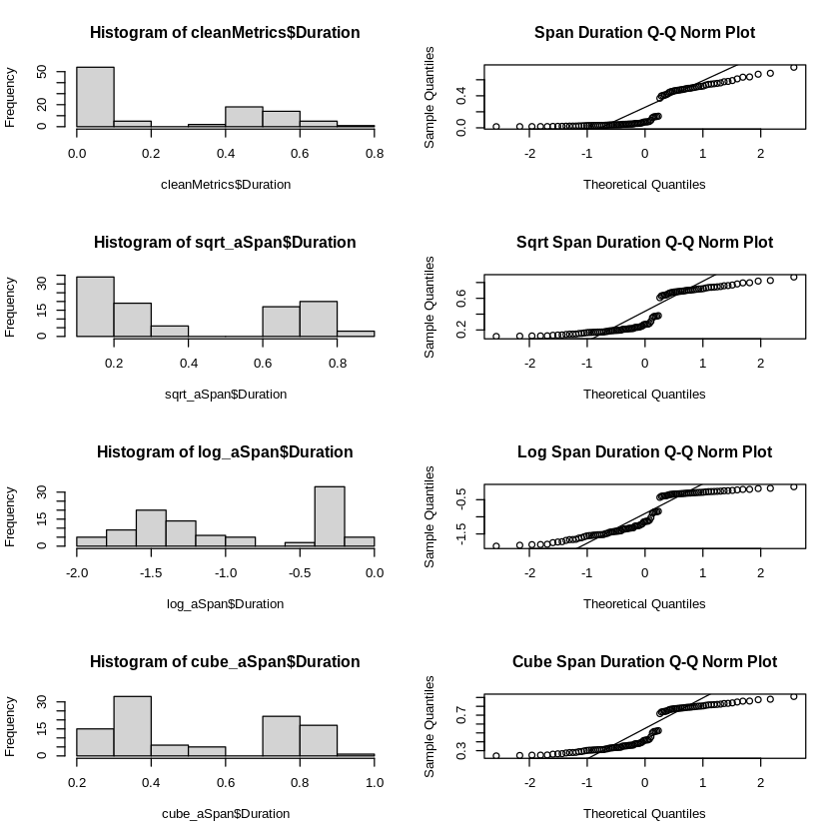

None of these transformation yield distributions that would be considered normal. Most likely due to access to external and internal services with differing latency. Let try another transformation.

### Box-Cox Transformation

Box and Cox (1964) developed a family of transformations designed to reduce nonnormality of the errors in a linear model. Applying this transform often reduces non-linearity as well, and heteroscedascity.

The idea is to transform the response variable $Y$ to a replacement response variable $Y_{i}^{\left(λ\right)}$, leaving the right-hand side of the regression model unchanged, so that the regression residuals become normally-distributed. Note that the regression coefficients will also change, because the response variable has changed; therefore, the regression coefficients must be interpreted with respect to the transformed variable. Also, any predictions made with the model have to be back-transformed, to be interpreted in the original units.

The standard (simple) Box-Cox transform is:

$$Y_{i}^{\left(λ\right)}=\left\{\begin{matrix}\frac{Y_{i}^{λ}−1}{λ}, & \left(λ≠0\right) \\ log\left(Y_{i}\right), & \left(λ=0\right)\end{matrix}\right.$$

Box, G. E. P., & Cox, D. R. (1964). An Analysis of Transformations. Journal of the Royal Statistical Society, Series B (Metholodogical), 26(2), 211-252.

http://www.css.cornell.edu/faculty/dgr2/_static/files/R_html/Transformations.html

library(MASS)

Attaching package: ‘MASS’  
  
  
The following object is masked from ‘package:dplyr’:  
  
 select

bcData = cleanMetrics  
x <- bcData$Duration  
bc = boxcox(lm(x ~ 1), seq(-1,1,.1))  
#bc = boxcox(lm(x ~ 1))  
lambda <- bc$x[which.max(bc$y)]  
new_x_exact <- (x ^ lambda - 1) / lambda

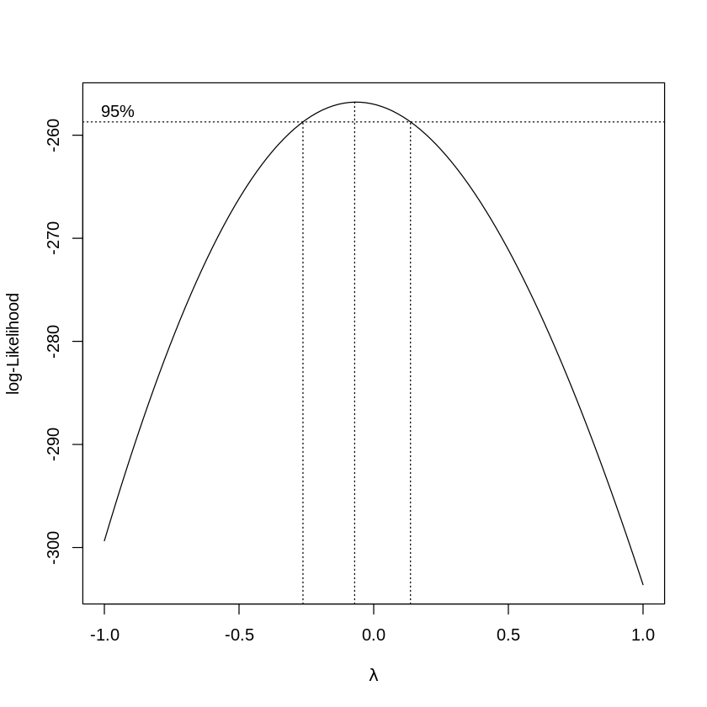

bcData$Duration = new_x_exact  
par(mfrow=c(1,3))  
hist(cleanMetrics$Duration)  
hist(bcData$Duration)

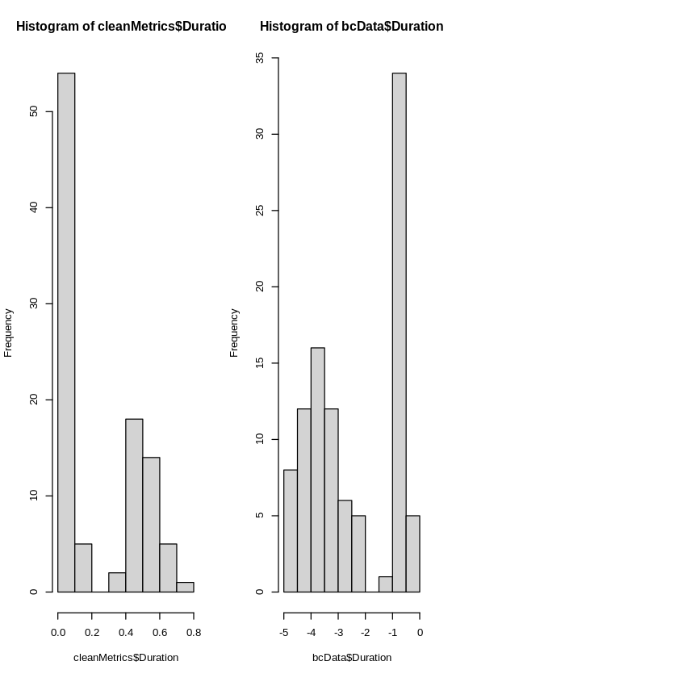

## Normality Testing of the Trasformation

### Shapiro-Wilk

The null-hypothesis of this test is that the population is normally distributed. Thus, if the p value is less than the chosen alpha level, then the null hypothesis is rejected and there is evidence that the data tested are not normally distributed. On the other hand, if the p value is greater than the chosen alpha level, then the null hypothesis (that the data came from a normally distributed population) can not be rejected (e.g., for an alpha level of .05, a data set with a p value of less than .05 rejects the null hypothesis that the data are from a normally distributed population).

https://en.wikipedia.org/wiki/Shapiro–Wilk_test

shapiro.test(bcData$Duration)

Shapiro-Wilk normality test  
  
data: bcData$Duration  
W = 0.85873, p-value = 2.852e-08

With p-value of 2.852e-08 < 0.05 we reject the null hypothesis that the data are from a normally distributed population. But we’ll also do a Q-Q Norm plot to visually see the results.

*“if the p value is greater than the chosen alpha level, then the null hypothesis (that the data came from a normally distributed population) can not be rejected”*

### Q-Q Norm

bcData %>%  
 ggplot(aes(sample = Duration)) +  
 stat_qq() +  
 stat_qq_line() +  
 labs(title="Q-Q Plot of Duration",  
 x = "Theoretical Quantiles", y = "Samplie Quantiles")  
  
bcData %>%  
 ggplot(aes(sample = Duration, colour = factor(useCase), shape = factor(numContainers))) +  
 stat_qq() +  
 stat_qq_line() +  
 labs(title="Q-Q Plot of Duration",  
 x = "Theoretical Quantiles", y = "Samplie Quantiles")

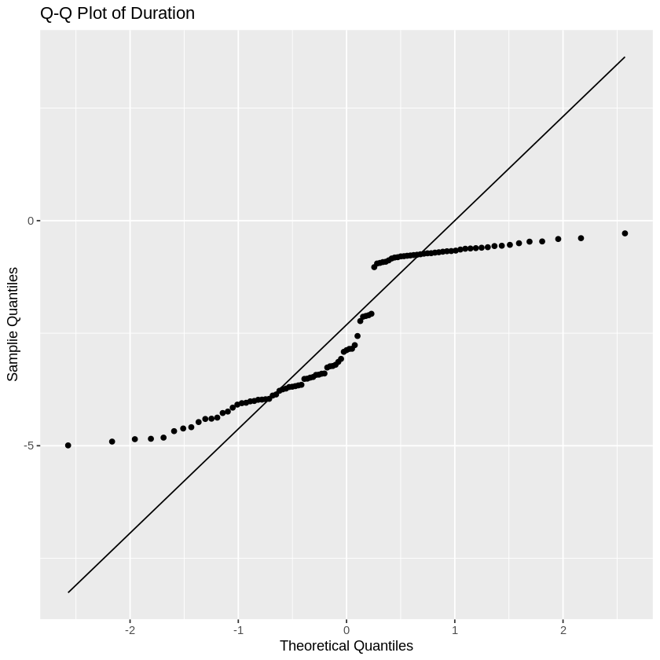

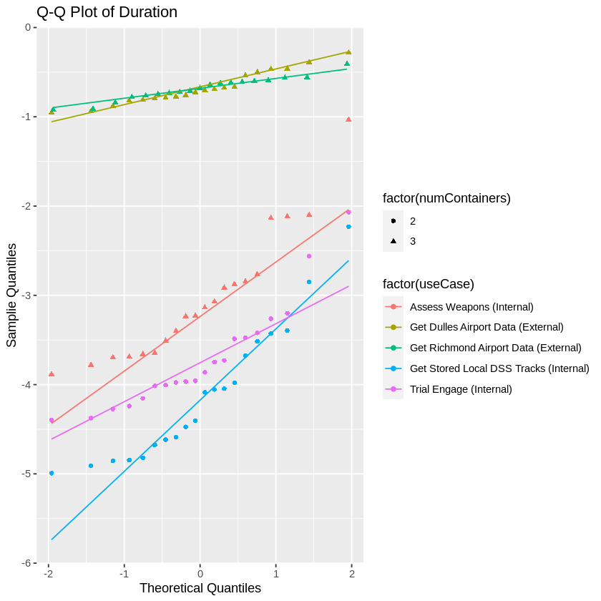

Our assumption here is that the separation of **Sample Quantiles** is from the difference between internal and external span durations (e.g. latency). Let’s see what happens when we split the samples.

# Separating “Original” Internal from External Data

## Internal Data

tracksSpanData = subset(spanMetrics, Trace.name == "dss-prototype: /tracks")  
TE_SpanData = subset(spanMetrics, Trace.name == "dss-prototype: /TE")  
WA_SpanData = subset(spanMetrics, Trace.name == "dss-prototype: /WA")  
  
internalSpanData <- rbind(tracksSpanData, TE_SpanData, WA_SpanData)  
dssSpanData <- rbind(TE_SpanData, WA_SpanData)  
  
# head(tracksSpanData)  
# head(TE_SpanData)  
# head(WA_SpanData)  
# head(internalSpanData)  
  
par(mfrow=c(2,2))  
hist(internalSpanData$Duration)  
boxplot(internalSpanData$Duration~internalSpanData$Trace.name)  
hist(dssSpanData$Duration)  
boxplot(dssSpanData$Duration~dssSpanData$Trace.name)

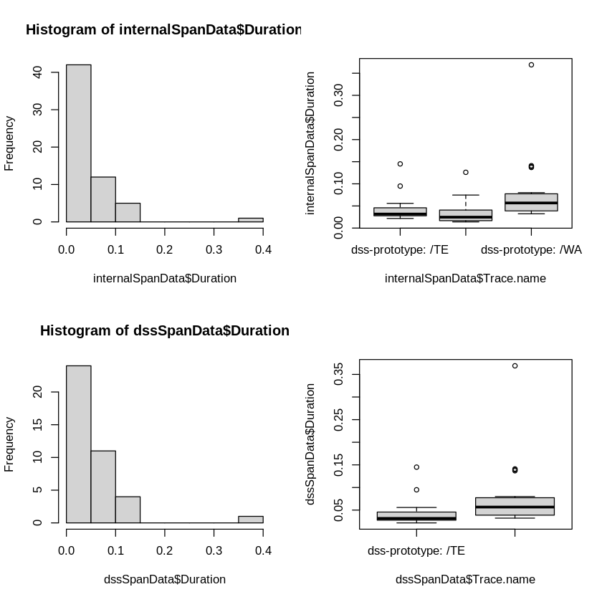

This result looks much better. However, we’ll remove internal span outliers.

outliers <- boxplot(internalSpanData$Duration, plot = FALSE)$out  
outliers  
  
iSpan <- internalSpanData  
iSpan <- iSpan[-which(iSpan$Duration %in% outliers),]  
  
par(mfrow=c(1,2))  
hist(iSpan$Duration)  
boxplot(iSpan$Duration~iSpan$Trace.name)

1. 0.126
2. 0.145
3. 0.139
4. 0.369
5. 0.137
6. 0.141

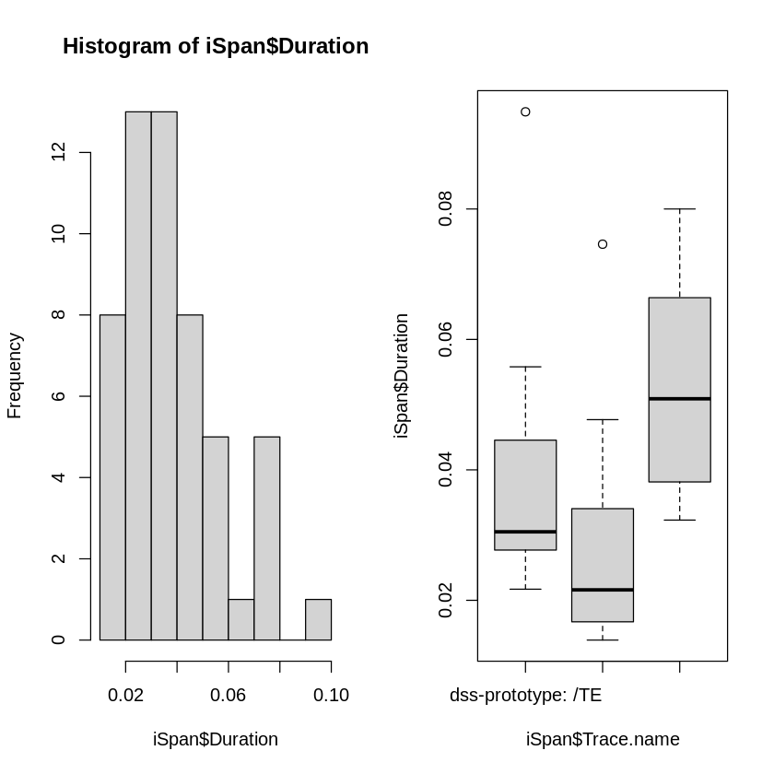

### Q-Q Norm Plot of “Clean” Internal Span Data

We’ll look a the Q-Q Norm Plot and Shapiro-Wilk Test

qqnorm(iSpan$Duration, main="Internal Span Duration Q-Q Norm Plot")  
qqline(iSpan$Duration)

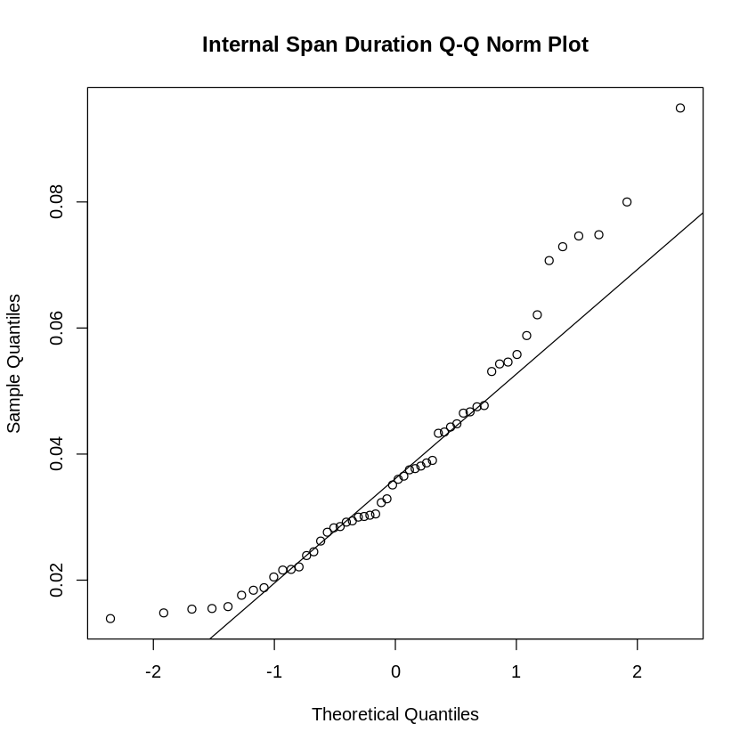

### Autocorrelation

Autocorrelation plots are a commonly-used tool for checking randomness in a data set. This randomness is ascertained by computing autocorrelations for data values at varying time lags. If random, such autocorrelations should be near zero for any and all time-lag separations. If non-random, then one or more of the autocorrelations will be significantly non-zero.

acf(iSpan$Duration, main="ACF of Internal Span Duration")

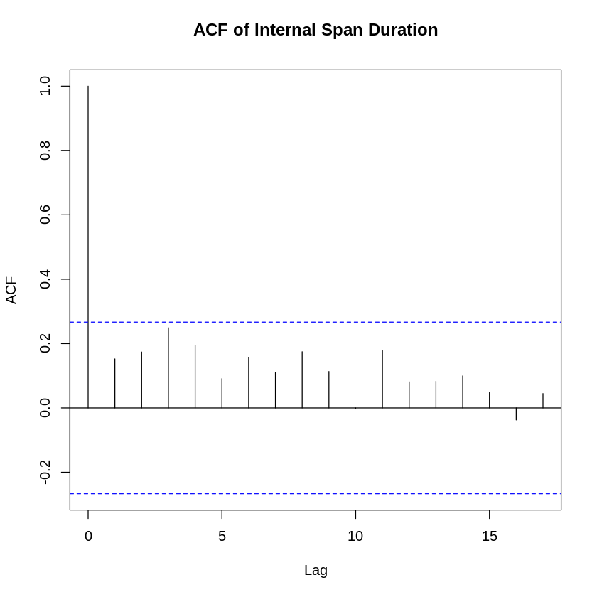

### Shapiro-Wilk Normality Test

shapiro.test(iSpan$Duration)

Shapiro-Wilk normality test  
  
data: iSpan$Duration  
W = 0.92499, p-value = 0.002321

With p-value of 0.002321 < 0.05 we reject the null hypothesis that the data are from a normally distributed population.

*“if the p value is greater than the chosen alpha level, then the null hypothesis (that the data came from a normally distributed population) can not be rejected”*

### Data Transformations

#### Sqrt-Log-Cube Transformations

sqrt_iSpan <- iSpan  
sqrt_iSpan$Duration=sqrt(sqrt_iSpan$Duration)  
log_iSpan <- iSpan  
log_iSpan$Duration=log10(log_iSpan$Duration + 1)  
cube_iSpan <- iSpan  
cube_iSpan$Duration=cube_iSpan$Duration^(1/3)  
  
par(mfrow=c(2,2))  
hist(iSpan$Duration)  
hist(sqrt_iSpan$Duration)  
hist(log_iSpan$Duration)  
hist(cube_iSpan$Duration)

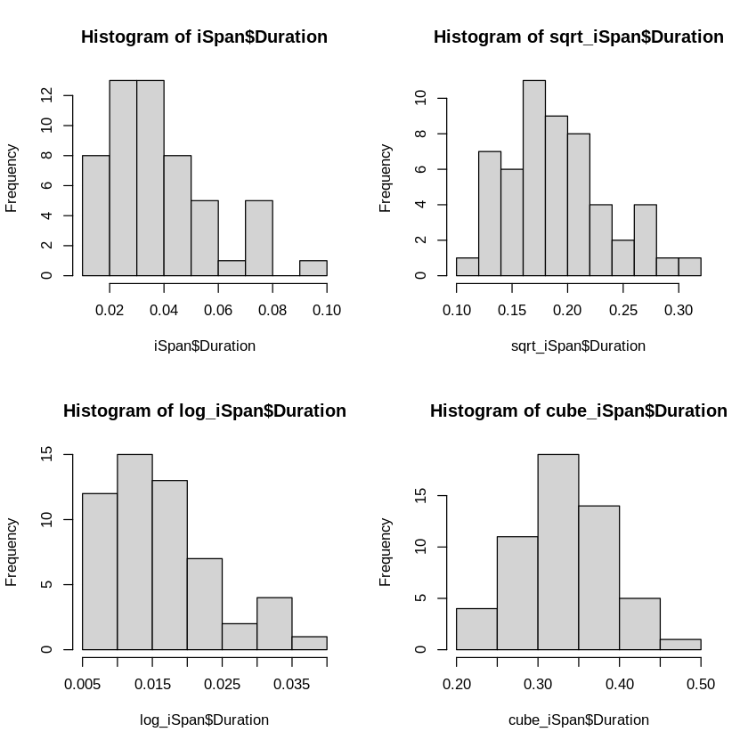

#### Q-Q Norm Sqrt-Log-Cube

par(mfrow=c(2,2))  
qqnorm(iSpan$Duration,main="Internal Span Duration Q-Q Norm Plot")  
qqline(iSpan$Duration)  
qqnorm(sqrt_iSpan$Duration,main="Sqrt Internal Span Duration Q-Q Norm Plot")  
qqline(sqrt_iSpan$Duration)  
qqnorm(log_iSpan$Duration,main="Log Internal Span Duration Q-Q Norm Plot")  
qqline(log_iSpan$Duration)  
qqnorm(cube_iSpan$Duration,main="Cube Internal Span Duration Q-Q Norm Plot")  
qqline(cube_iSpan$Duration)

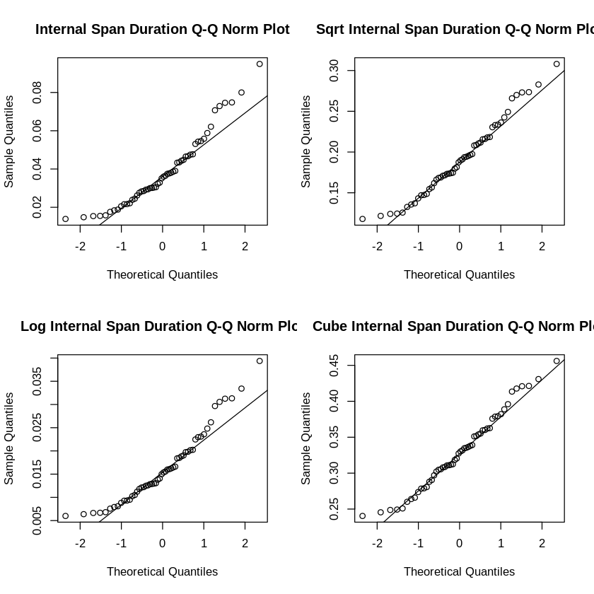

#### Shapiro-Wilk Testing Sqrt-Log-Cube

shapiro.test(sqrt_iSpan$Duration)  
shapiro.test(log_iSpan$Duration)  
shapiro.test(cube_iSpan$Duration)

Shapiro-Wilk normality test  
  
data: sqrt_iSpan$Duration  
W = 0.9683, p-value = 0.1621

Shapiro-Wilk normality test  
  
data: log_iSpan$Duration  
W = 0.92922, p-value = 0.003398

Shapiro-Wilk normality test  
  
data: cube_iSpan$Duration  
W = 0.97633, p-value = 0.3593

The **cube transformation** seems to provide the best q-q plot fit. With a p-value of 0.3593 > 0.05 we fail to reject the null hypothesis and assume we now have a normal distribution.

*“if the p value is greater than the chosen alpha level, then the null hypothesis (that the data came from a normally distributed population) can not be rejected”*

### Autocorrelation

Autocorrelation plots are a commonly-used tool for checking randomness in a data set. This randomness is ascertained by computing autocorrelations for data values at varying time lags. If random, such autocorrelations should be near zero for any and all time-lag separations. If non-random, then one or more of the autocorrelations will be significantly non-zero.

acf(cube_iSpan$Duration, main="ACF of Cube Transformed Internal Span Duration")

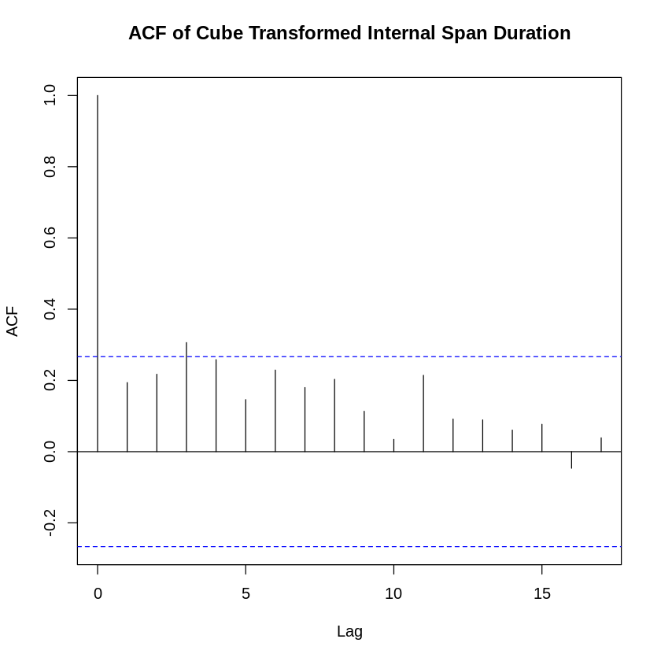

The ACF indicates that the data is random since the results are near zero.

par(mfrow=c(1,2))  
hist(iSpan$Duration)  
hist(cube_iSpan$Duration)

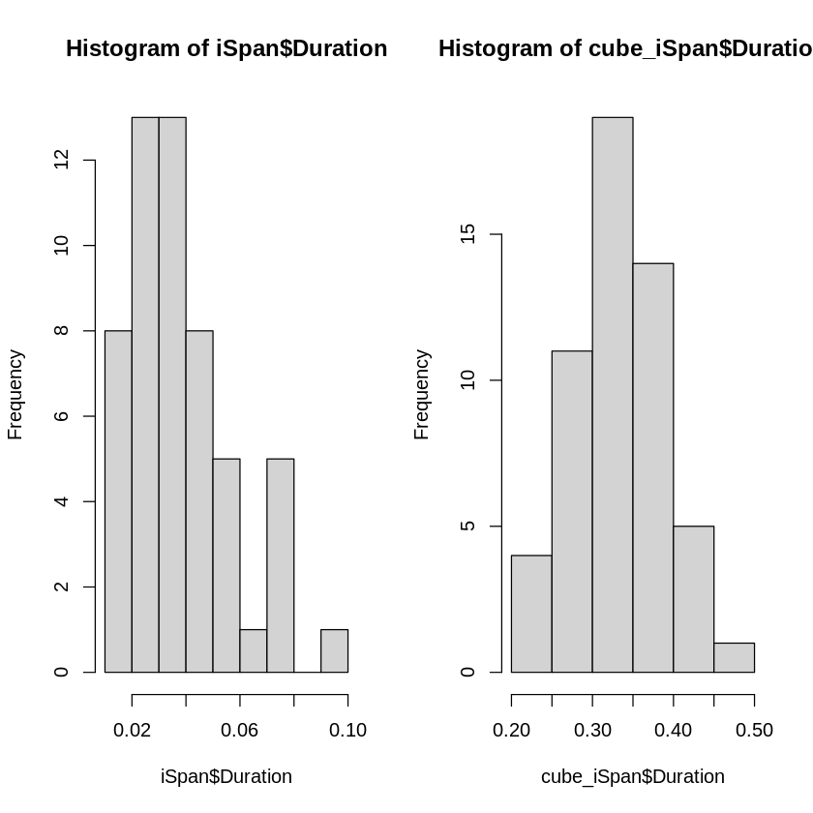

### Hypothesis Testing of Transformed Internal Data

We will use a Student’s t-Test to test the hypothesis on **normal** internal span data. Our mean is 500 ms (e.g. $μ=0.5$  seconds) and our null hypthesis is less than 500 ms.

mu = 0.5  
x = cube_iSpan$Duration  
cube_mu = mu^(1/3)  
t.test(x=x, mu=cube_mu, alternative = 'greater')

One Sample t-test  
  
data: x  
t = -64.323, df = 53, p-value = 1  
alternative hypothesis: true mean is greater than 0.7937005  
95 percent confidence interval:  
 0.3178723 Inf  
sample estimates:  
mean of x   
0.3299424

mu = 0.5  
x = iSpan$Duration  
t.test(x=x, mu=mu, alternative = 'greater')

One Sample t-test  
  
data: x  
t = -180.44, df = 53, p-value = 1  
alternative hypothesis: true mean is greater than 0.5  
95 percent confidence interval:  
 0.03440894 Inf  
sample estimates:  
 mean of x   
0.03868889

With a original and transformation with a p-value of 1 > 0.05 we fail to reject the null hypothesis, i.e. we assume that latency will be less than 500 ms.

*“If the p value is greater than the chosen alpha level, then the null hypothesis (that latency is < 500 ms) can not be rejected”*

## External Data

RIC_SpanData = subset(spanMetrics, Trace.name == "dss-prototype: /RIC")  
IAD_SpanData = subset(spanMetrics, Trace.name == "dss-prototype: /IAD")  
  
externalSpanData <- rbind(RIC_SpanData, IAD_SpanData)  
  
# head(RIC_SpanData)  
# head(IAD_SpanData)  
  
summary(externalSpanData)  
  
par(mfrow=c(1,2))  
hist(externalSpanData$Duration)  
boxplot(externalSpanData$Duration~externalSpanData$Trace.name)

Trace.ID Trace.name Start.time Duration   
 Length:40 Length:40 Min. :1.651e+09 Min. :0.3980   
 Class :character Class :character 1st Qu.:1.651e+09 1st Qu.:0.4670   
 Mode :character Mode :character Median :1.651e+09 Median :0.5070   
 Mean :1.651e+09 Mean :0.5565   
 3rd Qu.:1.651e+09 3rd Qu.:0.5645   
 Max. :1.651e+09 Max. :2.0000   
 useCase numContainers extNetworkHops  
 Length:40 Min. :3 Min. :14   
 Class :character 1st Qu.:3 1st Qu.:14   
 Mode :character Median :3 Median :14   
 Mean :3 Mean :14   
 3rd Qu.:3 3rd Qu.:14   
 Max. :3 Max. :14

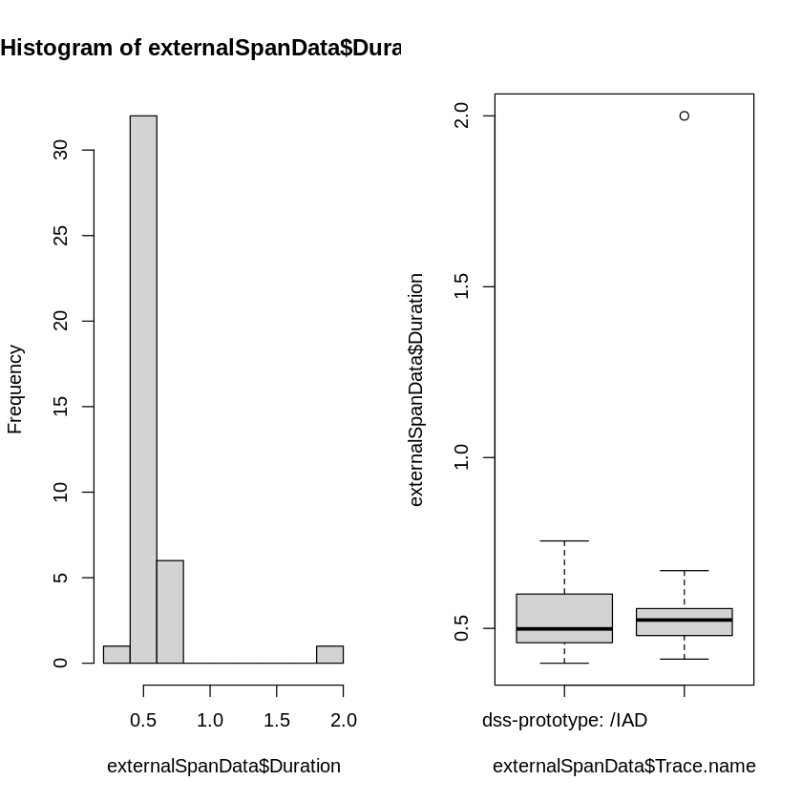

outliers <- boxplot(externalSpanData$Duration, plot = FALSE)$out  
outliers  
  
eSpan <- externalSpanData  
eSpan <- eSpan[-which(eSpan$Duration %in% outliers),]  
  
summary(eSpan)  
  
par(mfrow=c(2,2))  
hist(externalSpanData$Duration)  
boxplot(externalSpanData$Duration~externalSpanData$Trace.name)  
hist(eSpan$Duration)  
boxplot(eSpan$Duration~eSpan$Trace.name)

1. 2
2. 0.756

Trace.ID Trace.name Start.time Duration   
 Length:38 Length:38 Min. :1.651e+09 Min. :0.3980   
 Class :character Class :character 1st Qu.:1.651e+09 1st Qu.:0.4650   
 Mode :character Mode :character Median :1.651e+09 Median :0.5020   
 Mean :1.651e+09 Mean :0.5132   
 3rd Qu.:1.651e+09 3rd Qu.:0.5537   
 Max. :1.651e+09 Max. :0.6810   
 useCase numContainers extNetworkHops  
 Length:38 Min. :3 Min. :14   
 Class :character 1st Qu.:3 1st Qu.:14   
 Mode :character Median :3 Median :14   
 Mean :3 Mean :14   
 3rd Qu.:3 3rd Qu.:14   
 Max. :3 Max. :14

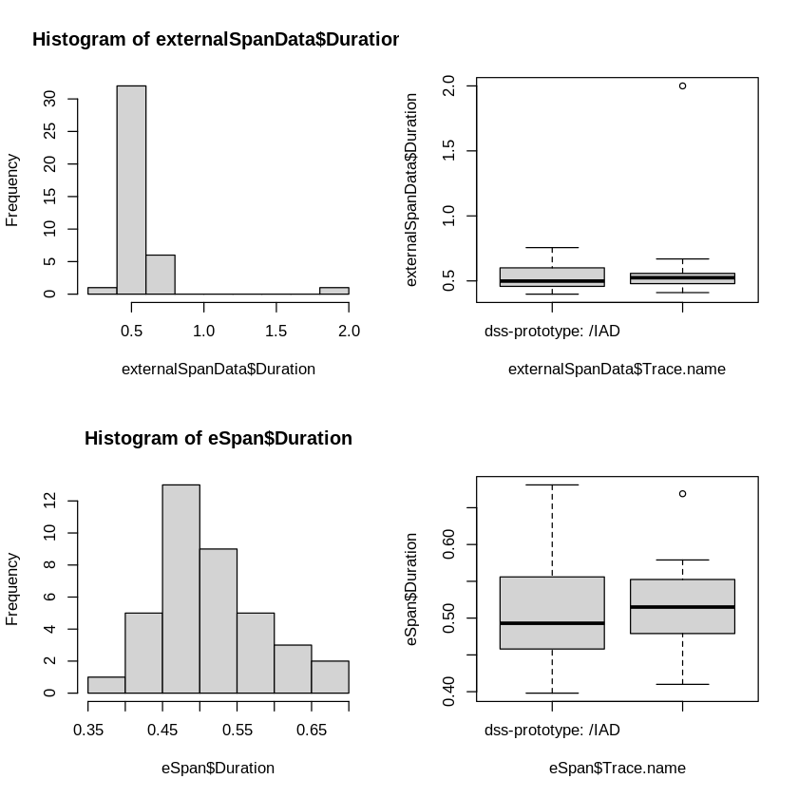

### Q-Q Norm Plot of “Clean” External Span Data

We’ll look a the Q-Q Norm Plot and Shapiro-Wilk Test

qqnorm(eSpan$Duration, main="External Span Duration Q-Q Norm Plot")  
qqline(eSpan$Duration)

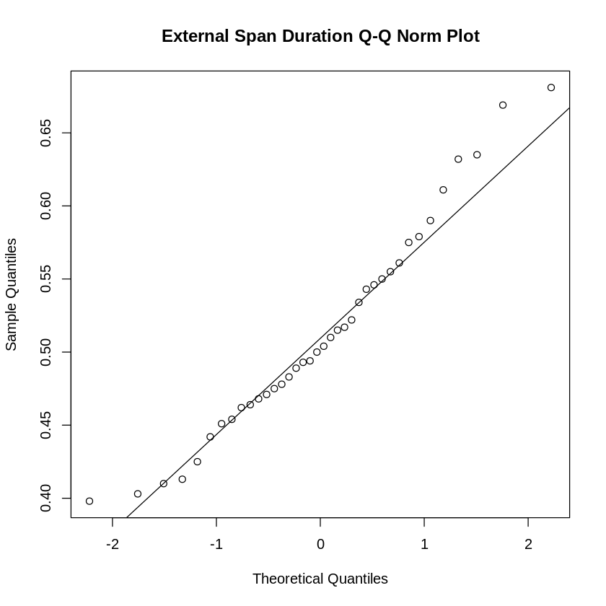

### Shapiro-Wilk Normality Test

shapiro.test(eSpan$Duration)

Shapiro-Wilk normality test  
  
data: eSpan$Duration  
W = 0.96564, p-value = 0.2878

With a p-value of 0.2878 > 0.05 we fail to reject the null hypothesis, i.e. we assume that we have a normal distribution.

### Autocorrelation

acf(eSpan$Duration, main="ACF of External Span Duration")

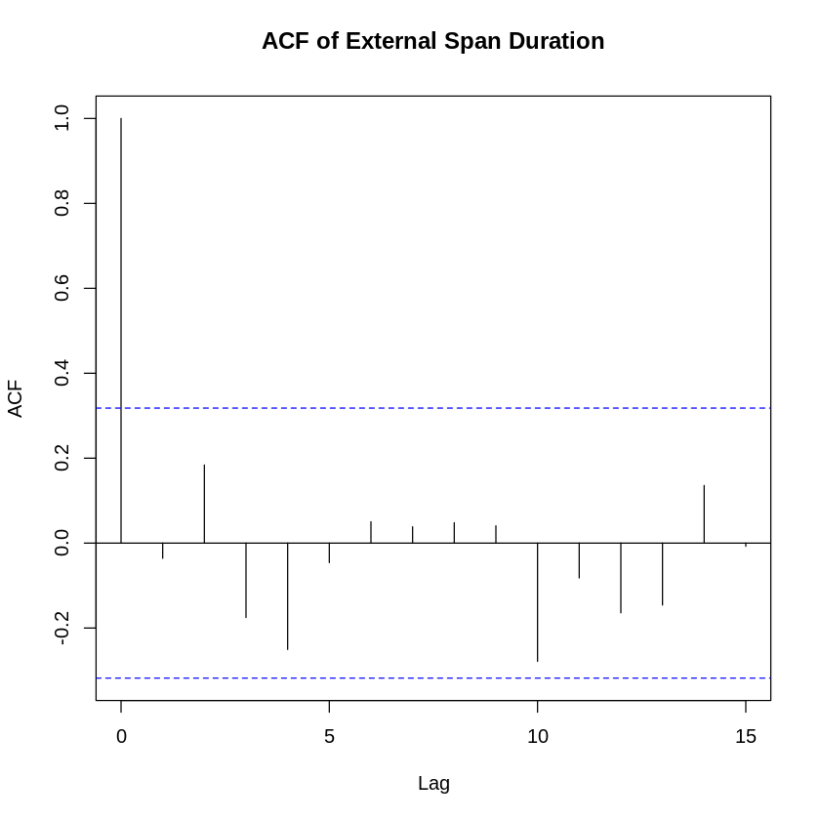

The ACF indicates that the data is random since the results are near zero.

### Hypothesis Testing

We will use a Student’s t-Test to test the hypothesis on external span data. Our mean is 500 ms (e.g. $μ=0.5$  seconds) and our null hypthesis is less than 500 ms.

mu = 0.5

x = eSpan$Duration  
t.test(x=x, mu=mu, alternative = 'greater')

One Sample t-test  
  
data: x  
t = 1.1267, df = 37, p-value = 0.1336  
alternative hypothesis: true mean is greater than 0.5  
95 percent confidence interval:  
 0.4934287 Inf  
sample estimates:  
mean of x   
0.5132105

With a p-value of 0.1336 > 0.05 we fail to reject the null hypothesis, i.e. we assume that 500 ms can be maintained for external service requests.

*“If the p value is greater than the chosen alpha level, then the null hypothesis (that latency is < 500 ms) can not be rejected”*

# Observations

## General Discussion of Normality

It was required to separate external data from internal to establish normality of the data samples. The internal data set required transformation to establish normality, while the external data did not require a transformation.

## Hypothesis Results

Hypothesis testing using the Student’s t-Test indicates that latency constraints of 500 ms can be maintained internally and external. However, serveral external samples were greater than 500 ms. This is most likely due to the non-deterministic nature of internet (e.g. http) requests. Within the internal environment, data is directly routed between microservices within the Docker environment within a private network. The data shows that a container based microservice architecture can meet the requirement; however, care must be taken to manage processing per container that may increase container response times.