Final Project

Adnan Mustafic

1.

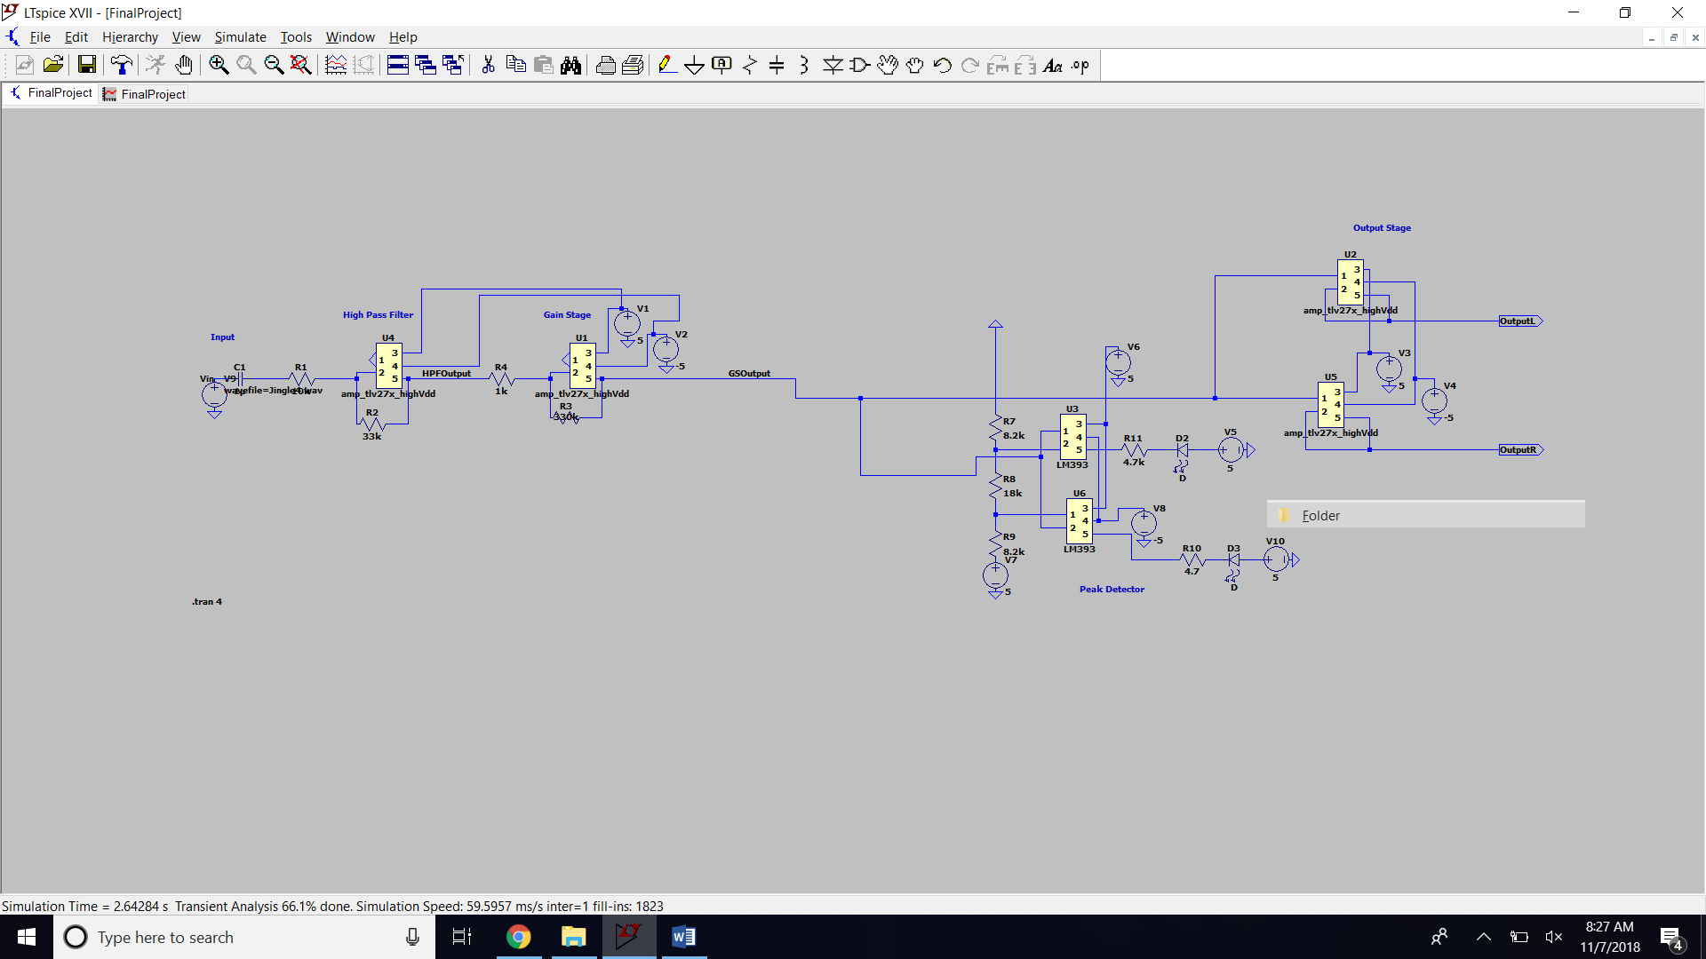

Item 1: LTSpice Schematics

2.

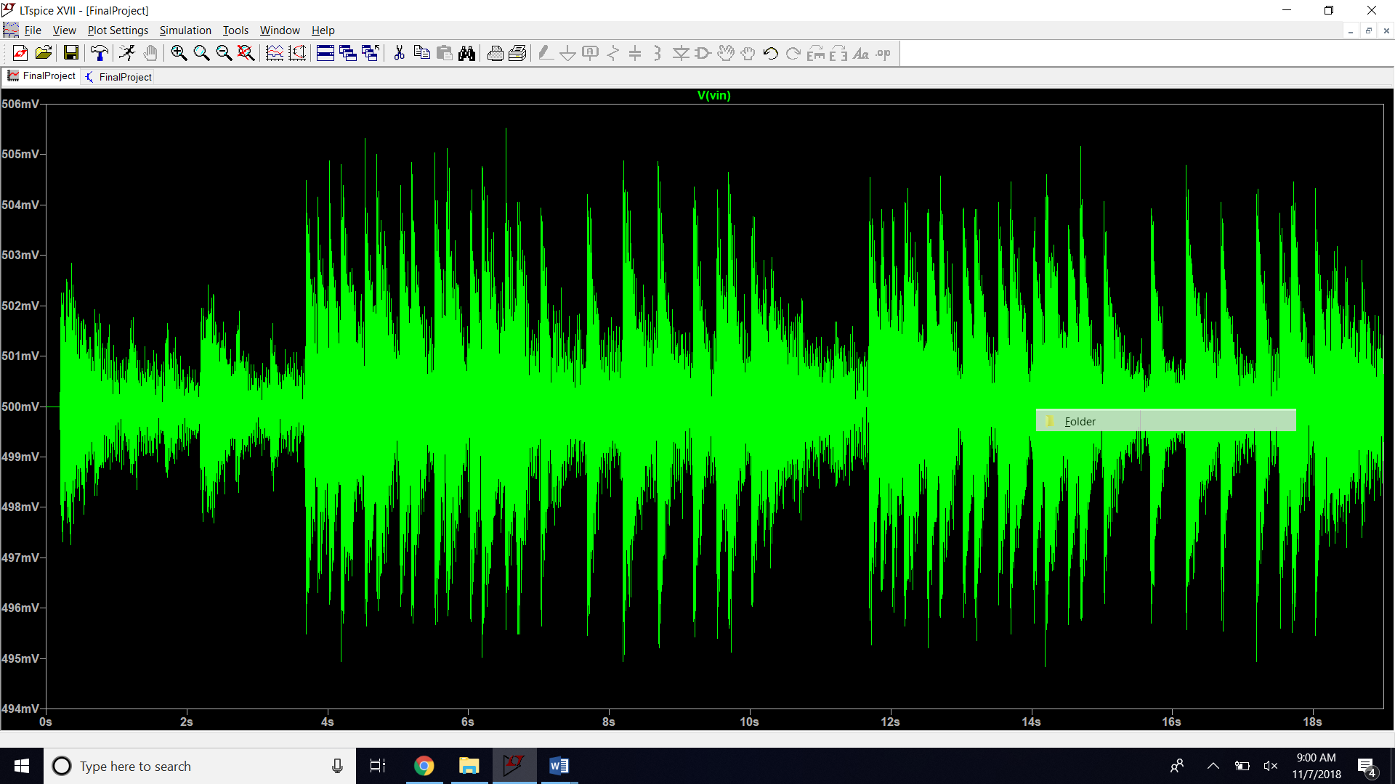

Item 2: Input plot

3.

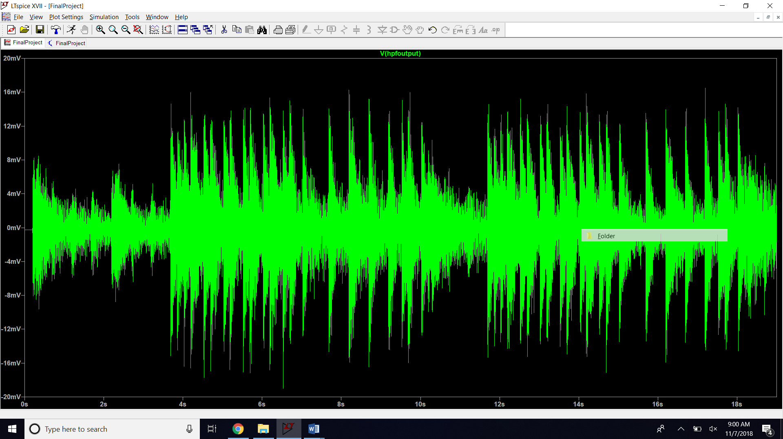

Item 3: High pass filter output plot

4.

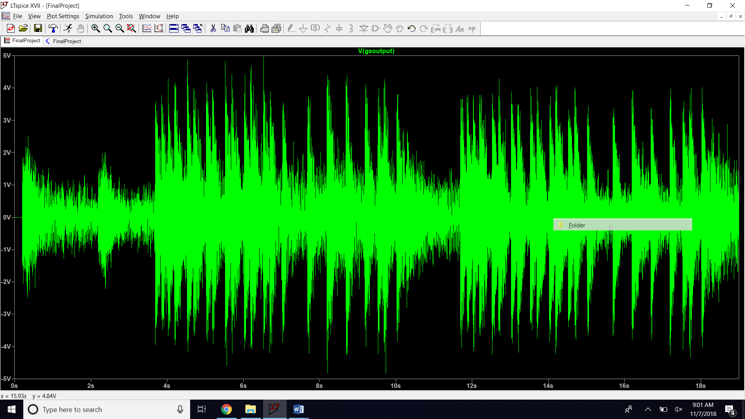

Item 4: Variable gain amplifier plot

5.

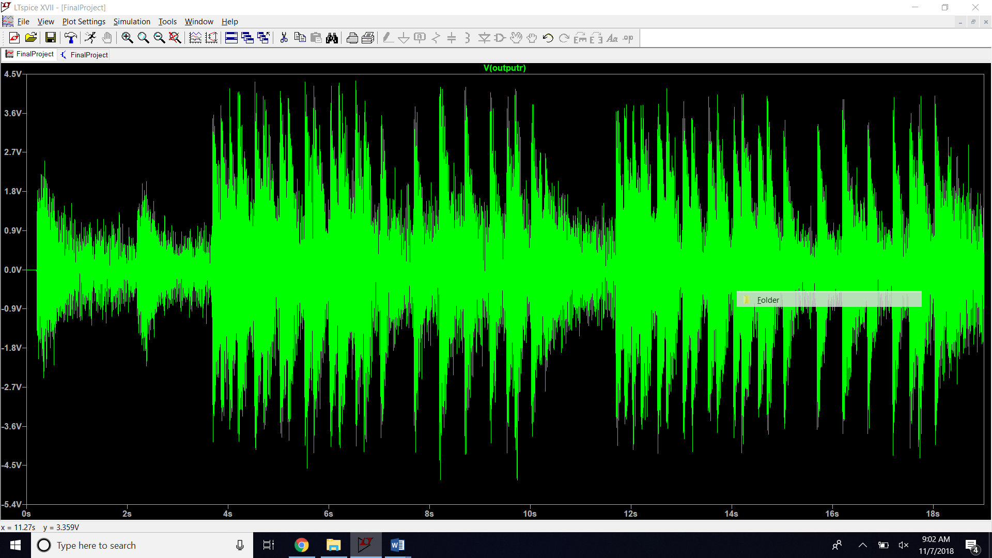

Item 5: Output of the buffer stage plot

6. 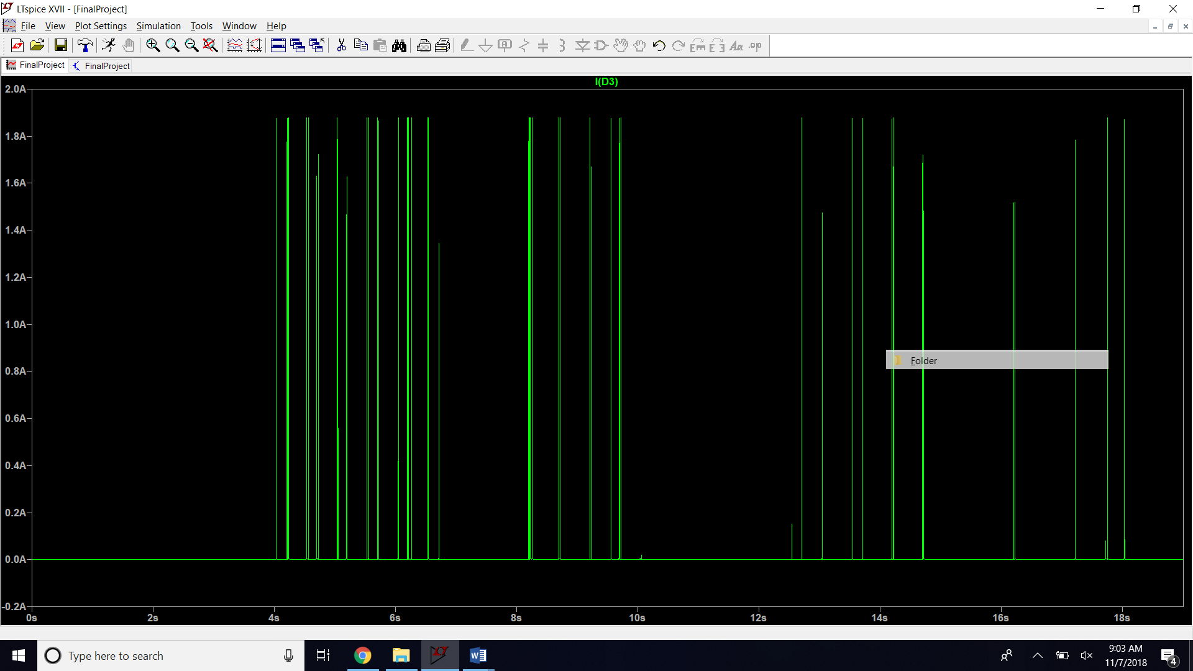

Item 6: Current through diode 1

7. 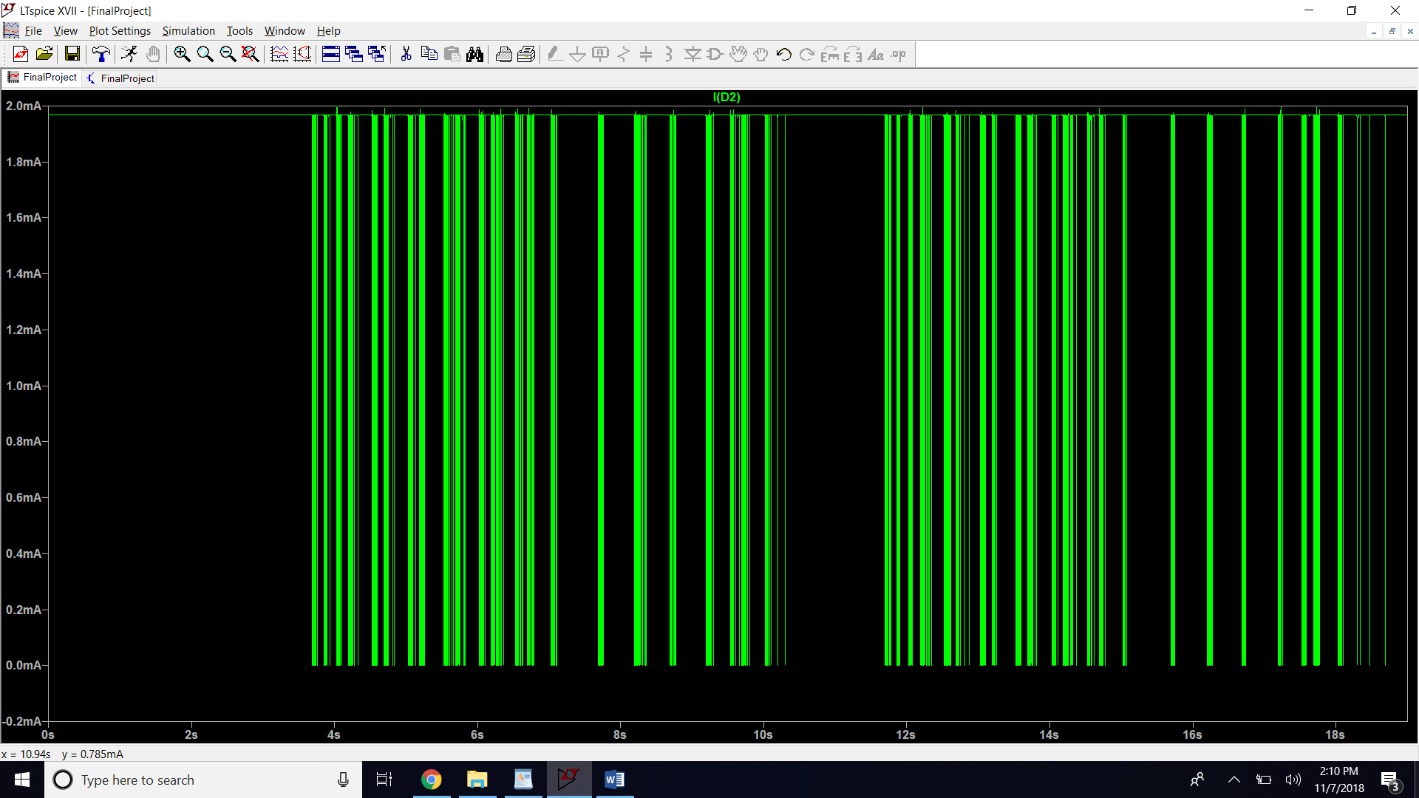

Item 7: Current through diode 2