Adnan Mustafic

11/20/2018

EEL3111C

**Final Project Report**

**Abstract**

The objective of the final project was to use our previous knowledge and the previous labs and to utilize them in the final project. The goal was to make the audio amplifier. Although it sounds complicated, the audio amplifier is consisted of high pass filter, gain stage, peak detector and output stage. Initially, input gets filtered through the filter stage, where the DC offset is removed. In the second stage the sound is amplified by the amplifier and the output goes to the output stage. In the same time peak detector is detecting if the output is in the optimal range.

**Procedure**

**High Filter Stage**

Capacitor, two resistors and an amplifier were used for the high filter stage. The high filter removes the DC offset from the input, AC coupling the signal to the system. It also amplifies the input because the gain had to be very high. Its output was forwarded to the gain stage.

-5V

+5V

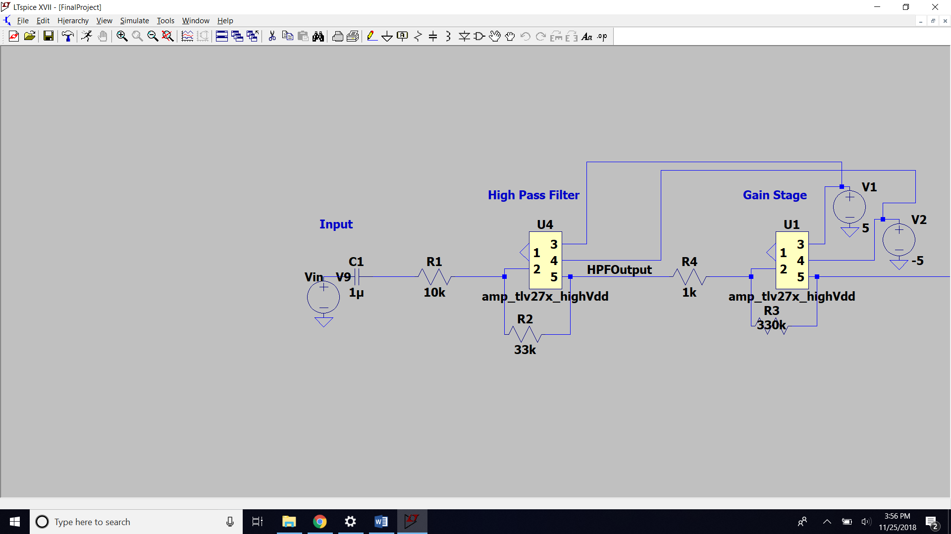Item 1: Block diagram of the High pass filter

**Gain stage**

An amplifier and resistors were used in the block diagram. However, on the breadboard, the potentiometer was used instead of the resistor. This resistor has a big gain, as it has to input the millivolts and output volts. It is also helped by the High pass filter stage, as it has certain smaller gain as well. The output of this stage is forwarded to the output stage and to the peak detector.

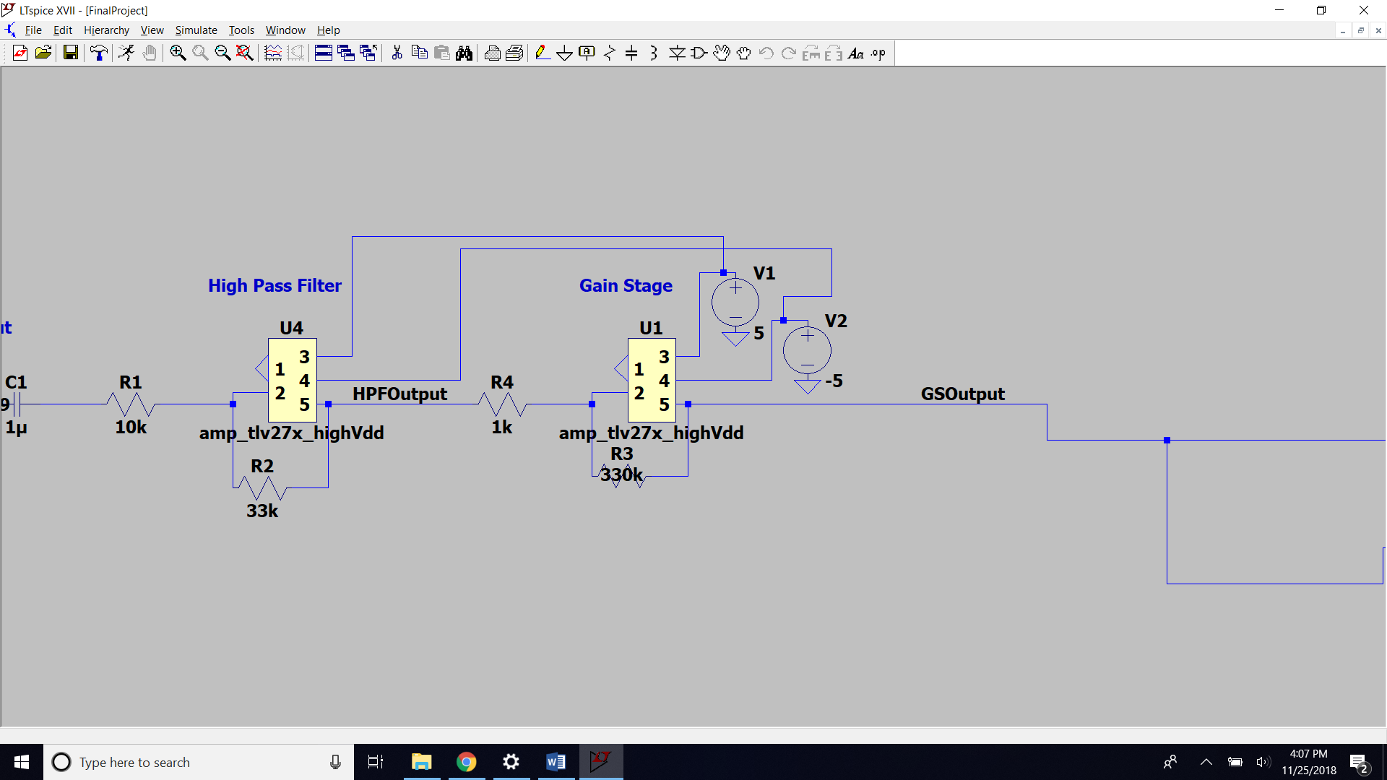Item 2: Block diagram of the gain stage

**Peak Detector**

For the peak detector comparator, resistors and LEDs were used. The voltage was divided using resistors. The division was made in that way to divide 5V and have thresholds at 4V and 1V. The comparators were connected to the voltage divider. When the voltage in the circuit is bigger than 1V one of the LEDs will light and when the voltage is higher than 4V, both LEDs will light and the output is about to start clipping.

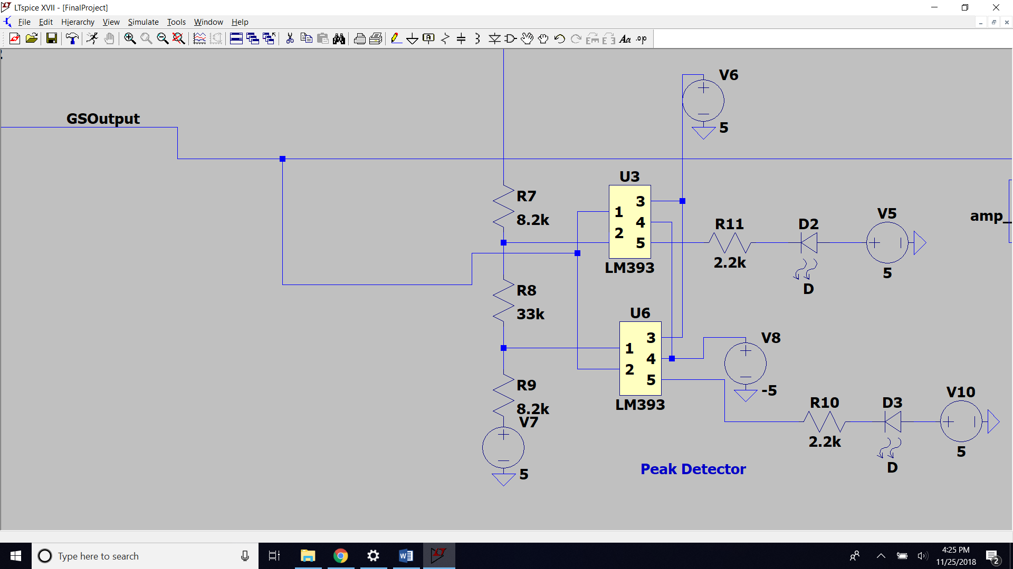  
Item 3: Block diagram of the peak detector

**Output stage**

The output stage was very trivial. Only an amplifier was used in it. The output stage was consisted of one amplifier with no gain, where negative input was connected with the output. The final version had two outputs, one for each side of the speaker.

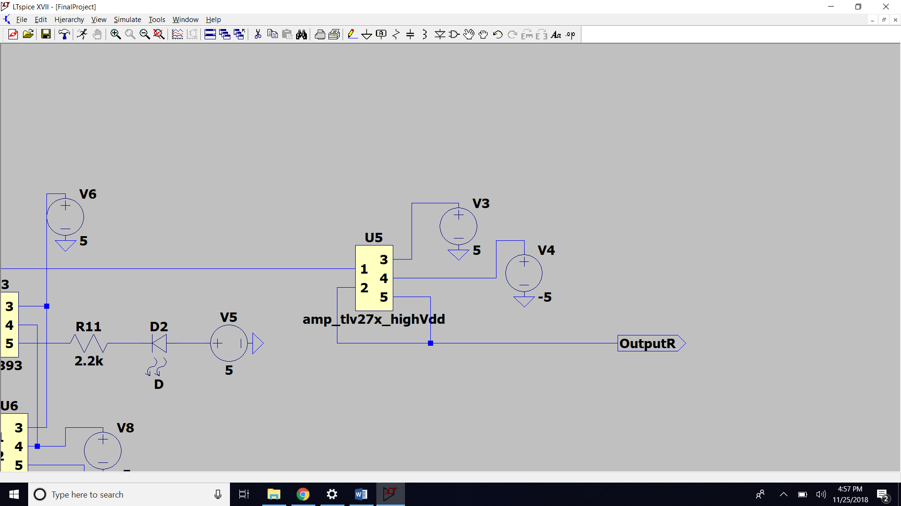Item 4: Block diagram of the output stage

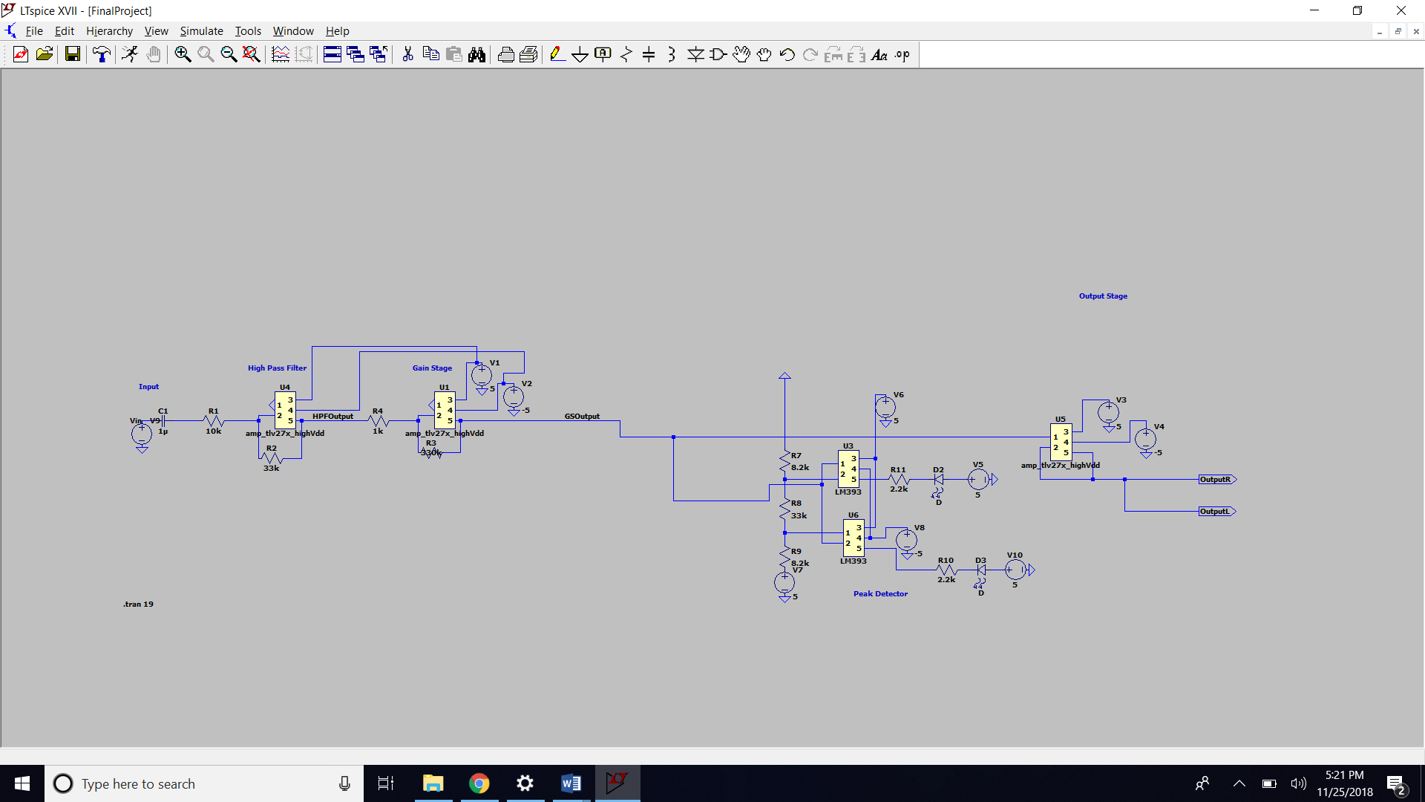

Item 5: Block Diagram of the circuit

**Results**

1.

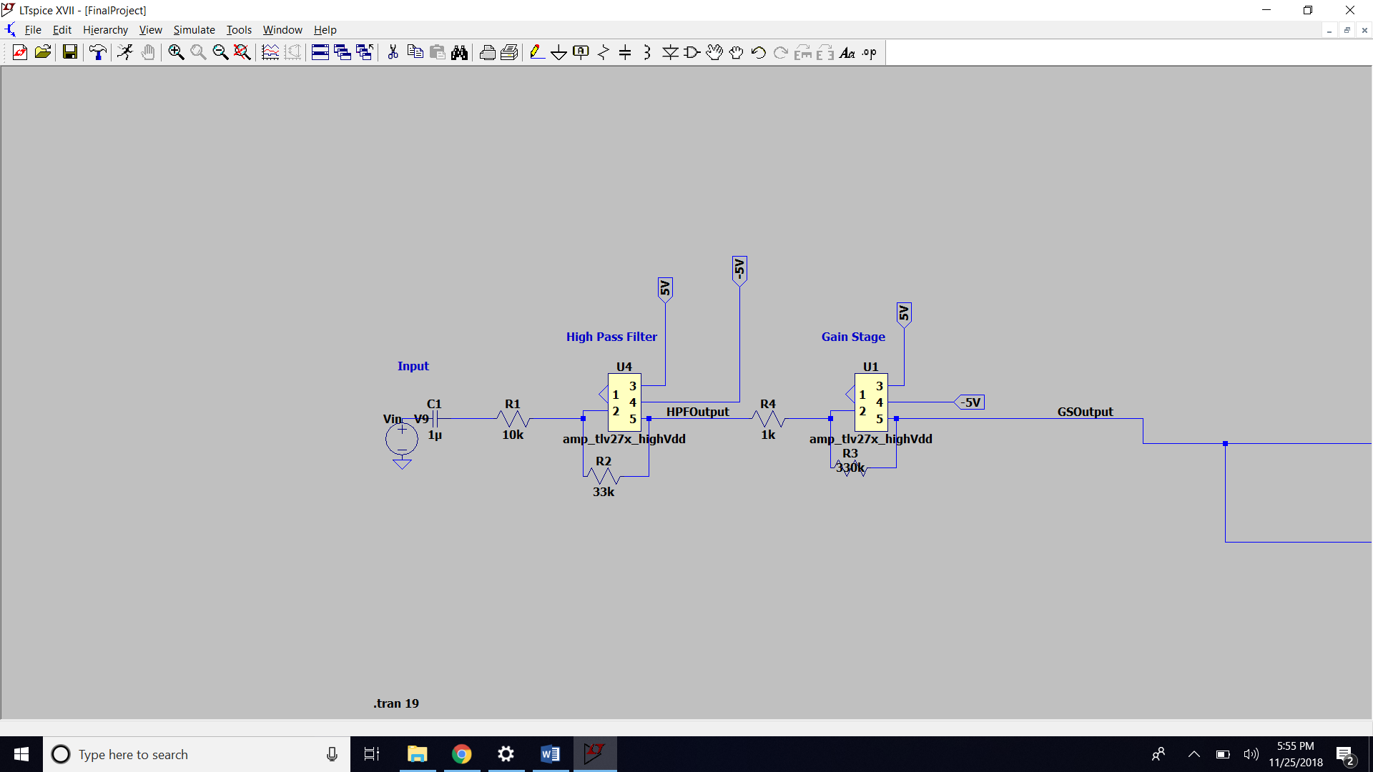

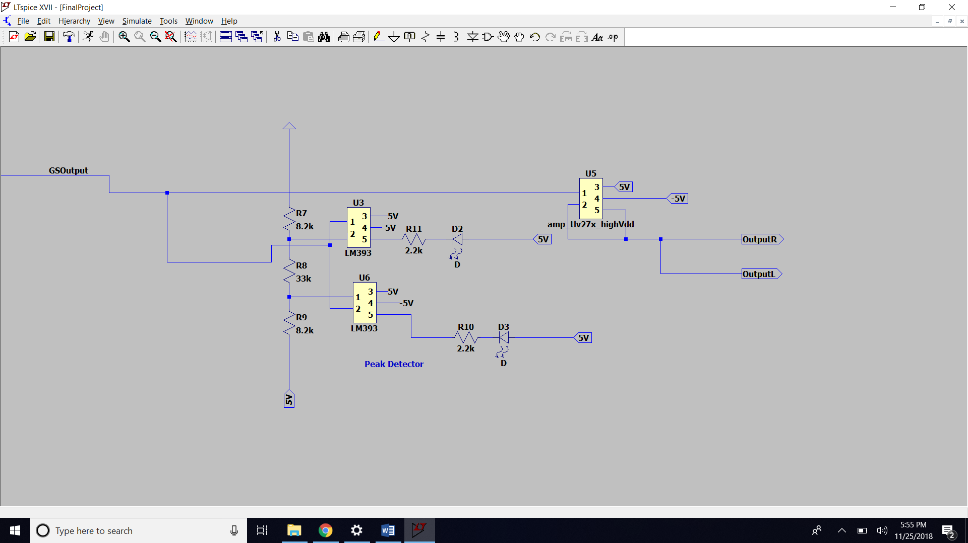Item 6: Block Diagram

2.

|  |  |  |  |  |
| --- | --- | --- | --- | --- |
| Components | Value | Quantity Used | Price($) | Total price($) |
| Capacitor | 0.1 uF | 1 | 1.95 | 1.95 |
| Resistors | 10k | 1 | 0.25 | 0.25 |
|  | 33k | 1 | 0.5 | 0.5 |
|  | 330k | 1 | 0.3 | 0.3 |
|  | 8.2k | 2 | 0.5 | 1 |
|  | 18k | 1 | 1 | 1 |
|  | 2.2k | 2 | 0.3 | 0.6 |
| LSM393 |  | 1 | 0.5 | 0.5 |
| TLV272 |  | 2 | 0.35 | 0.7 |
| LEDs |  | 2 | 0.6 | 1.2 |
| Potentiometer |  | 1 | 1.05 | 1.05 |

Item 7: Part list

3.

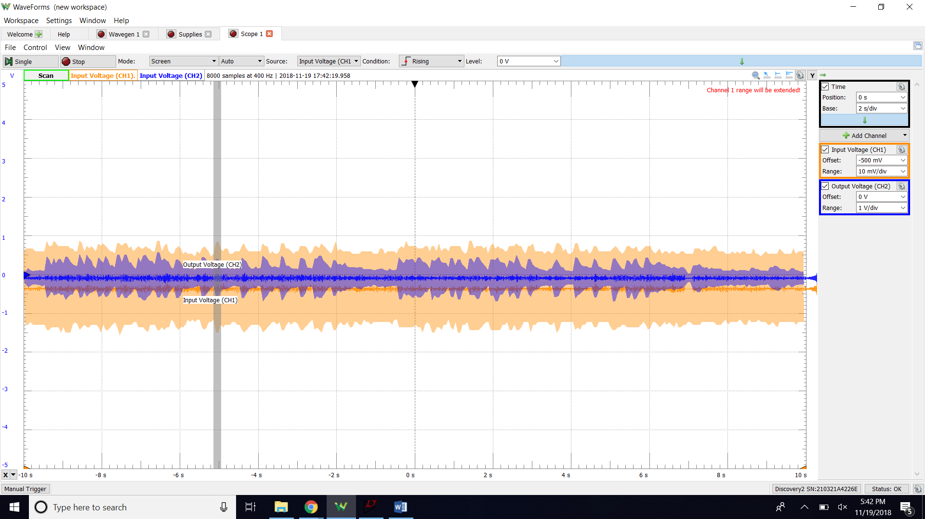  
Item 8: Scope Plot

4.

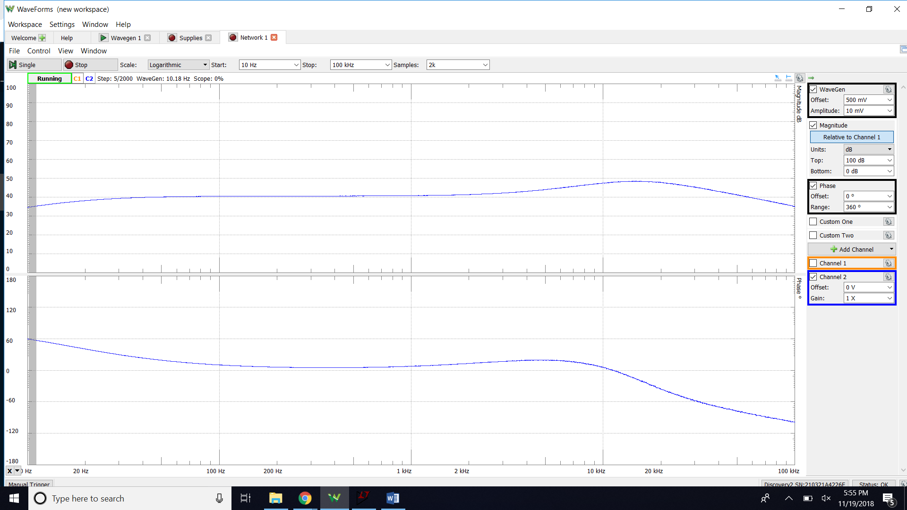

Item 9: Network Plot

5.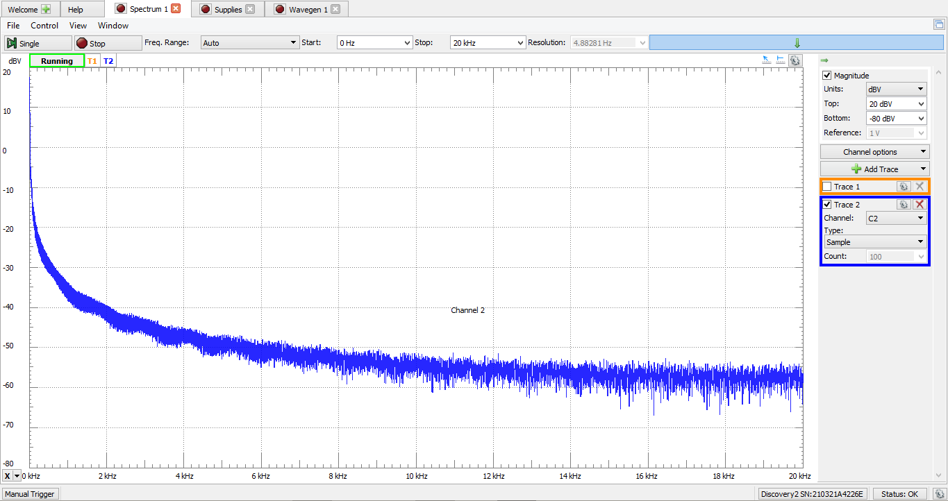  
Item 10: Specturm Plot

**Conclusion**

The audio amplifier was constructed in this project. The base for it were the earlier labs that were done through the semester. This circuit was built in four stages and those stages were high pass filter, gain stage, peak detector and output stage. The audio amplifier’s input, a jingle, is filtered through the filter stage, where the DC offset is removed. Then the sound is amplified by the amplifier and the output goes to the output stage. The gain stage’s output also goes to the peak detector, where it is detected whether the output is in the optimal range or not. The schematics from the previous parts of the write-up, were built on the breadboard and the audio amplifier worked.