Programming Exercise
Alex Mutebe MSc. Data Science
15 June 2023

_____________________________________________________________________________________________

Part 1:

Exploratory analysis

importing marketing data from a csv file into R studio
m_date <- read.csv("MMA marketing_data_sample.csv",header = TRUE)

Getting started with Data Pre-porcessing
- Add necessary libraries, particularly tidyverse, for processing and visualizing data
#Import the tidyverse package for data visualisation and wrangling
library(tidyverse)
library(corrplot)
## corrplot 0.92 loaded

Exploratory Data Analysis
#Checking in with the first 10 records
knitr:: kable(
m_date[1:10,], caption = "10 row preview of the marketing data subset"
)
10 row preview of the marketing data subset
age | job | marital | k | default | housing | loan | contact | month | day_of_week | duration | campaign | pdays | previous | poutcome | emp.var.rate | cons.price.idx | cons.conf.idx | euribor3m | nr.employed | y
30 | blue-collar | married | basic.9y | no | yes | no | cellular | may | fri | 487 | 2 | 999 | 0 | nonexistent | -1.8 | 92.893 | -46.2 | 1.313 | 5099.1 | no
39 | services | single | high.school | no | no | no | telephone | may | fri | 346 | 4 | 999 | 0 | nonexistent | 1.1 | 93.994 | -36.4 | 4.855 | 5191.0 | no
25 | services | married | high.school | no | yes | no | telephone | jun | wed | 227 | 1 | 999 | 0 | nonexistent | 1.4 | 94.465 | -41.8 | 4.962 | 5228.1 | no
38 | services | married | basic.9y | no | unknown | unknown | telephone | jun | fri | 17 | 3 | 999 | 0 | nonexistent | 1.4 | 94.465 | -41.8 | 4.959 | 5228.1 | no
47 | admin. | married | university.degree | no | yes | no | cellular | nov | mon | 58 | 1 | 999 | 0 | nonexistent | -0.1 | 93.200 | -42.0 | 4.191 | 5195.8 | no
32 | services | single | university.degree | no | no | no | cellular | sep | thu | 128 | 3 | 999 | 2 | failure | -1.1 | 94.199 | -37.5 | 0.884 | 4963.6 | no
32 | admin. | single | university.degree | no | yes | no | cellular | sep | mon | 290 | 4 | 999 | 0 | nonexistent | -1.1 | 94.199 | -37.5 | 0.879 | 4963.6 | no
41 | entrepreneur | married | university.degree | unknown | yes | no | cellular | nov | mon | 44 | 2 | 999 | 0 | nonexistent | -0.1 | 93.200 | -42.0 | 4.191 | 5195.8 | no
31 | services | divorced | professional.course | no | no | no | cellular | nov | tue | 68 | 1 | 999 | 1 | failure | -0.1 | 93.200 | -42.0 | 4.153 | 5195.8 | no
35 | blue-collar | married | basic.9y | unknown | no | no | telephone | may | thu | 170 | 1 | 999 | 0 | nonexistent | 1.1 | 93.994 | -36.4 | 4.855 | 5191.0 | no

Base R sampling of 10 entries from the dataset
knitr:: kable(
sampled <- m_date[sample(1:nrow(m_date), 10), ], caption = "Sampling 10 records" )
Sampling 10 records
 | age | job | marital | k | default | housing | loan | contact | month | day_of_week | duration | campaign | pdays | previous | poutcome | emp.var.rate | cons.price.idx | cons.conf.idx | euribor3m | nr.employed | y
856 | 30 | technician | single | university.degree | no | yes | yes | cellular | aug | tue | 433 | 2 | 999 | 0 | nonexistent | 1.4 | 93.444 | -36.1 | 4.966 | 5228.1 | no
4037 | 38 | technician | single | professional.course | unknown | yes | no | telephone | jun | fri | 111 | 5 | 999 | 0 | nonexistent | 1.4 | 94.465 | -41.8 | 4.967 | 5228.1 | no
2840 | 35 | blue-collar | single | basic.9y | unknown | yes | no | cellular | may | mon | 83 | 2 | 999 | 1 | failure | -1.8 | 92.893 | -46.2 | 1.299 | 5099.1 | no
3311 | 37 | technician | single | university.degree | no | no | no | telephone | jun | mon | 182 | 2 | 999 | 0 | nonexistent | 1.4 | 94.465 | -41.8 | 4.960 | 5228.1 | no
3791 | 28 | self-employed | single | university.degree | no | yes | no | cellular | mar | fri | 186 | 2 | 999 | 0 | nonexistent | -1.8 | 92.843 | -50.0 | 1.640 | 5099.1 | no
4079 | 52 | blue-collar | married | basic.9y | unknown | yes | no | telephone | may | fri | 346 | 3 | 999 | 0 | nonexistent | 1.1 | 93.994 | -36.4 | 4.855 | 5191.0 | no
662 | 34 | technician | married | university.degree | no | yes | no | cellular | nov | wed | 686 | 1 | 999 | 0 | nonexistent | -0.1 | 93.200 | -42.0 | 4.120 | 5195.8 | yes
2506 | 35 | management | married | university.degree | no | yes | no | cellular | nov | mon | 121 | 1 | 999 | 0 | nonexistent | -0.1 | 93.200 | -42.0 | 4.191 | 5195.8 | no
3609 | 39 | blue-collar | divorced | basic.6y | unknown | yes | yes | telephone | may | wed | 32 | 1 | 999 | 0 | nonexistent | 1.1 | 93.994 | -36.4 | 4.856 | 5191.0 | no
2095 | 42 | housemaid | married | university.degree | no | no | no | cellular | nov | mon | 176 | 1 | 999 | 0 | nonexistent | -0.1 | 93.200 | -42.0 | 4.191 | 5195.8 | no

Data formats for variables are examined
str(m_date)
## 'data.frame': 4100 obs. of 21 variables:
## $ age : int 30 39 25 38 47 32 32 41 31 35 ...
## $ job : chr "blue-collar" "services" "services" "services" ...
## $ marital : chr "married" "single" "married" "married" ...
## $ k : chr "basic.9y" "high.school" "high.school" "basic.9y" ...
## $ default : chr "no" "no" "no" "no" ...
## $ housing : chr "yes" "no" "yes" "unknown" ...
## $ loan : chr "no" "no" "no" "unknown" ...
## $ contact : chr "cellular" "telephone" "telephone" "telephone" ...
## $ month : chr "may" "may" "jun" "jun" ...
## $ day_of_week : chr "fri" "fri" "wed" "fri" ...
## $ duration : int 487 346 227 17 58 128 290 44 68 170 ...
## $ campaign : int 2 4 1 3 1 3 4 2 1 1 ...
## $ pdays : int 999 999 999 999 999 999 999 999 999 999 ...
## $ previous : int 0 0 0 0 0 2 0 0 1 0 ...
## $ poutcome : chr "nonexistent" "nonexistent" "nonexistent" "nonexistent" ...
## $ emp.var.rate : num -1.8 1.1 1.4 1.4 -0.1 -1.1 -1.1 -0.1 -0.1 1.1 ...
## $ cons.price.idx: num 92.9 94 94.5 94.5 93.2 ...
## $ cons.conf.idx : num -46.2 -36.4 -41.8 -41.8 -42 -37.5 -37.5 -42 -42 -36.4 ...
## $ euribor3m : num 1.31 4.86 4.96 4.96 4.19 ...
## $ nr.employed : num 5099 5191 5228 5228 5196 ...
## $ y : chr "no" "no" "no" "no" ...

Database structure
- 4100 records
- 21 Variables
  - 5 intergers
  - 11 categorical
  - 2 numeric variables

Missing data
sum(is.na(m_date))
## [1] 0

Observation
- Since the sum() function returns 0, there are no missing entries in the dataset.

Converting categorical variables to factors
- Working with factors during analysis and ML modeling is simpler.
m_date$job <- as.factor(m_date$job)
m_date$marital <- as.factor(m_date$marital)
m_date$k <- as.factor(m_date$k)
m_date$default <- as.factor(m_date$default)
m_date$housing <- as.factor(m_date$housing)
m_date$loan <- as.factor(m_date$loan)
m_date$contact <- as.factor(m_date$contact)
m_date$month <- as.factor(m_date$month)
m_date$day_of_week <- as.factor(m_date$day_of_week)
m_date$poutcome <- as.factor(m_date$poutcome)
m_date$y <- as.factor(m_date$y)

a sample of the dataset upon conversion
str(m_date)
## 'data.frame': 4100 obs. of 21 variables:
## $ age : int 30 39 25 38 47 32 32 41 31 35 ...
## $ job : Factor w/ 12 levels "admin.","blue-collar",..: 2 8 8 8 1 8 1 3 8 2 ...
## $ marital : Factor w/ 4 levels "divorced","married",..: 2 3 2 2 2 3 3 2 1 2 ...
## $ k : Factor w/ 8 levels "basic.4y","basic.6y",..: 3 4 4 3 7 7 7 7 6 3 ...
## $ default : Factor w/ 3 levels "no","unknown",..: 1 1 1 1 1 1 1 2 1 2 ...
## $ housing : Factor w/ 3 levels "no","unknown",..: 3 1 3 2 3 1 3 3 1 1 ...
## $ loan : Factor w/ 3 levels "no","unknown",..: 1 1 1 2 1 1 1 1 1 1 ...
## $ contact : Factor w/ 2 levels "cellular","telephone": 1 2 2 2 1 1 1 1 1 2 ...
## $ month : Factor w/ 10 levels "apr","aug","dec",..: 7 7 5 5 8 10 10 8 8 7 ...
## $ day_of_week : Factor w/ 5 levels "fri","mon","thu",..: 1 1 5 1 2 3 2 2 4 3 ...
## $ duration : int 487 346 227 17 58 128 290 44 68 170 ...
## $ campaign : int 2 4 1 3 1 3 4 2 1 1 ...
## $ pdays : int 999 999 999 999 999 999 999 999 999 999 ...
## $ previous : int 0 0 0 0 0 2 0 0 1 0 ...
## $ poutcome : Factor w/ 3 levels "failure","nonexistent",..: 2 2 2 2 2 1 2 2 1 2 ...
## $ emp.var.rate : num -1.8 1.1 1.4 1.4 -0.1 -1.1 -1.1 -0.1 -0.1 1.1 ...
## $ cons.price.idx: num 92.9 94 94.5 94.5 93.2 ...
## $ cons.conf.idx : num -46.2 -36.4 -41.8 -41.8 -42 -37.5 -37.5 -42 -42 -36.4 ...
## $ euribor3m : num 1.31 4.86 4.96 4.96 4.19 ...
## $ nr.employed : num 5099 5191 5228 5228 5196 ...
## $ y : Factor w/ 2 levels "no","yes": 1 1 1 1 1 1 1 1 1 1 ...

Checking the distribution and presence of outliers
- Descriptive statistics and data visualization
- EDA, or exploratory data analysis

Age
- Using a box plot to see outliers
boxplot(m_date$age)
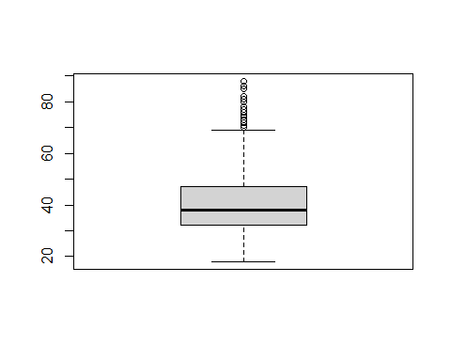
ggplot(m_date,mapping = aes(age)) + geom_histogram(binwidth = 5)
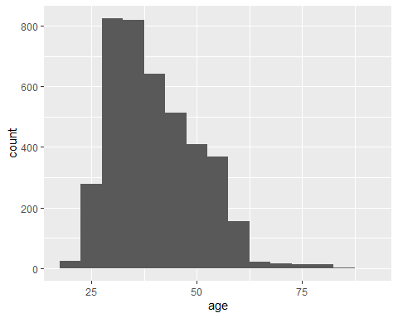
summary(m_date$age)
## Min. 1st Qu. Median Mean 3rd Qu. Max.
## 18.00 32.00 38.00 40.12 47.00 88.00
- A box plot, according to Mike (2021), employs boxes and lines to show how the distributions of one or more sets of numerical data. To visualize the differences between the variable features of categorical and continuous data types, bar charts and histograms can be combined (Indratmo et al., 2014).
- Observation
  - About 50% of the age distribution falls between 32 and 47, according to the boxplot.
  - The average age is 40.
  - After age 75, there have been several observed outliers.
  - Overall, the hitogram displays a normal age distribution.

Duration
boxplot(m_date$duration)
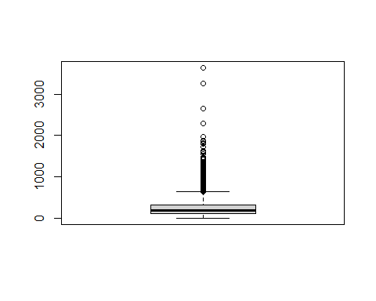
ggplot(m_date,mapping = aes(duration)) + geom_histogram(binwidth = 100)
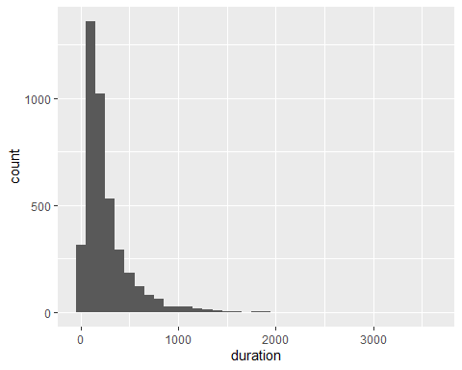
summary(m_date$duration)
## Min. 1st Qu. Median Mean 3rd Qu. Max.
## 0.0 103.0 181.0 256.8 317.0 3643.0
- Observation
  - The boxplot shows that about 50% of the duration ranges between 103 to 317.
  - The average duration is 256.8
  - There is an observation of some outliers after 800
  - A left skew in the data is visible in the histogram.
#Summary statistics for pdays
summary(m_date$pdays)
## Min. 1st Qu. Median Mean 3rd Qu. Max.
## 0.0 999.0 999.0 960.2 999.0 999.0
- Observation
  - Abnormality in the data distribution
  - detailed attention is needed
    - Both graphs show two values that are far apart i.e 0 and 1000
- We notice that the pday variable is numeric
  - 999 represents missing values
  - 999 values is misleading the analysis
- The accuracy of machine learning models might be decreased by missing data (Tejashree, 2022). A model that has been trained with all missing values removed, in accordance with Satyam (2020), produces a robust model.
- The code below updates the entries containg missing values i.e 999 to missing (Na)
m_date <- mutate(m_date,pdays5 = ifelse(pdays == 999,'',pdays))
- Updating the pdays variable
m_date$pdays <- m_date$pdays5
- Summary statistics
summary(m_date$pdays)
## Length Class Mode
## 4100 character character
- Observation
  - After removing 999 value from pdays data
    - 3940 out of 4100 records contained missing data, as we can see.

Previous
boxplot(m_date$previous)
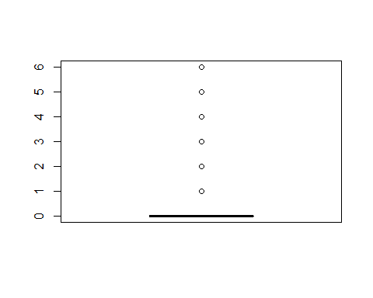
summary(m_date$previous)
## Min. 1st Qu. Median Mean 3rd Qu. Max.
## 0.0000 0.0000 0.0000 0.1907 0.0000 6.0000
ggplot(m_date,mapping = aes(previous)) + geom_histogram()
## `stat_bin()` using `bins = 30`. Pick better value with `binwidth`.
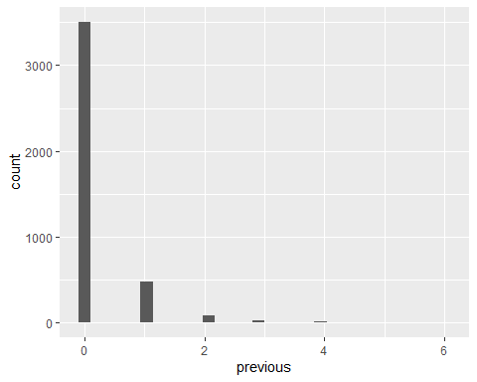
- Observation
  - The boxplot and historgram show that mostly there were no contacts performed before this campaign

cons.conf.idx consumer confidence index
boxplot(m_date$cons.conf.idx)
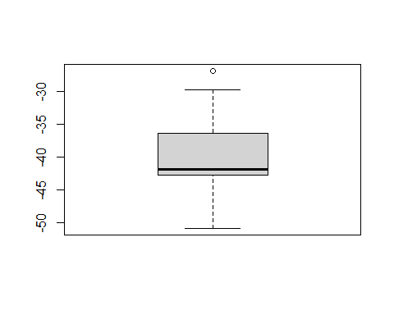
ggplot(m_date,mapping = aes(cons.conf.idx)) + geom_histogram(binwidth = 10)
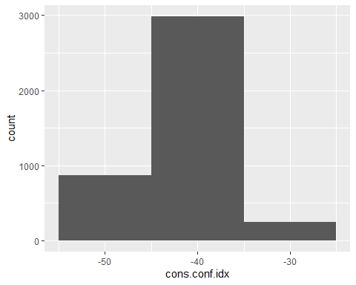
summary(m_date$cons.conf.idx)
## Min. 1st Qu. Median Mean 3rd Qu. Max.
## -50.8 -42.7 -41.8 -40.5 -36.4 -26.9
- Observation
  - the con.conf.idx contains negative values.
- One of the best methods for handling negative numbers in data analysis transformations is the log transformation (Rick, 2011).
  - Step 1
    - Shifting values to positive range
m_date <- mutate(m_date,shifted_cons.conf.idx = m_date$cons.conf.idx - min(m_date$cons.conf.idx) + 1)
- Applying log transformation using log()
m_date <- mutate(m_date,log_cons.conf.idx = log(m_date$shifted_cons.conf.idx))
summary(m_date$log_cons.conf.idx)
## Min. 1st Qu. Median Mean 3rd Qu. Max.
## 0.000 2.208 2.303 2.326 2.734 3.215
- Observation
  - All of our values are now positive following data transformation.

euribor3m
boxplot(m_date$euribor3m)
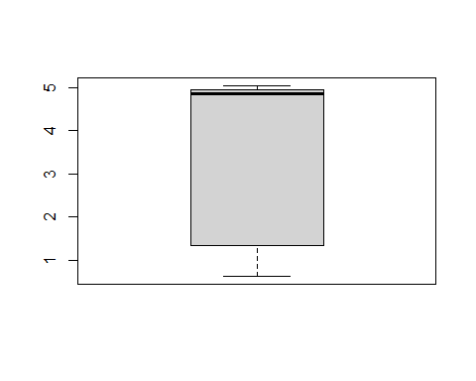
ggplot(m_date,mapping = aes(euribor3m)) + geom_histogram(binwidth = 1)
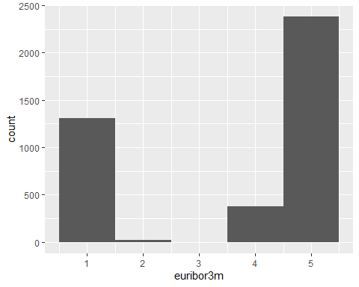
summary(m_date$euribor3m)
## Min. 1st Qu. Median Mean 3rd Qu. Max.
## 0.635 1.334 4.857 3.621 4.961 5.045

nr.employed
boxplot(m_date$nr.employed)
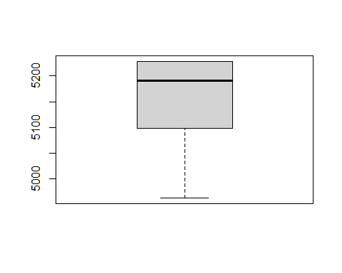
ggplot(m_date,mapping = aes(nr.employed)) + geom_histogram(binwidth = 100)
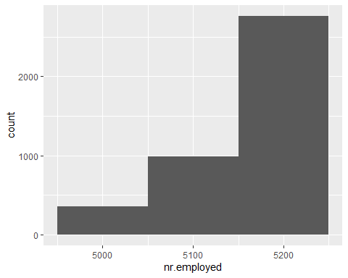

Descriptive Statistics
- numeric variables
m_date %>% summarize_if(is.numeric, mean)
## age duration campaign previous emp.var.rate cons.price.idx
## 1 40.11707 256.7546 2.538537 0.1907317 0.08517073 93.58012
## cons.conf.idx euribor3m nr.employed shifted_cons.conf.idx log_cons.conf.idx
## 1 -40.49846 3.621421 5166.473 11.30154 2.325588
- Examining the relationship between age and duration
plot(age ~ duration, data = m_date, col = "dodgerblue", pch = 20, cex = 1.5,
main = "age vs duration")
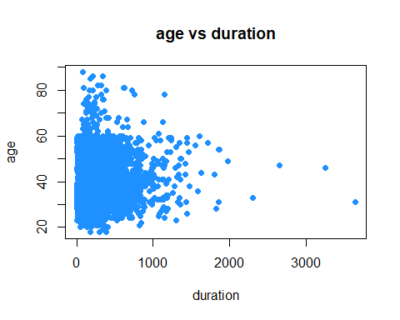

Analysis of categorical variables
ggplot(m_date, mapping=(aes(y=job,fill=job))) + geom_bar()
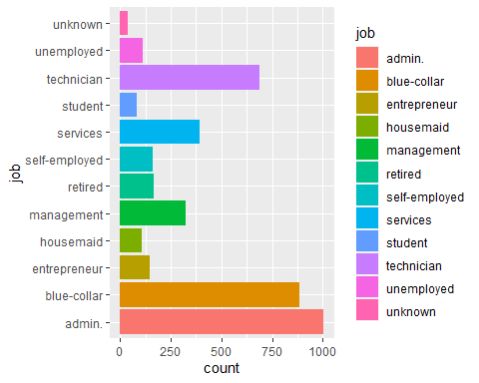
ggplot(m_date, mapping=(aes(x=marital,fill=marital))) + geom_bar()
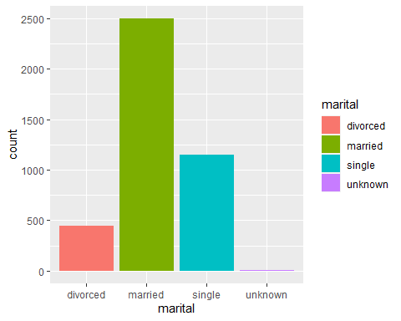
ggplot(m_date, mapping=(aes(y=k,fill=k))) + geom_bar()
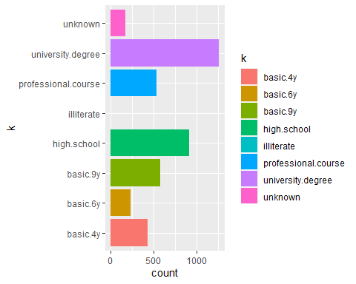
ggplot(m_date, mapping=(aes(y=k,fill=k))) + geom_bar()
- K
summary(m_date$k)
## basic.4y basic.6y basic.9y high.school
## 428 226 572 914
## illiterate professional.course university.degree unknown
## 1 533 1259 167
- Observation
  - most clients have a level of university education
  - 1 record of illiterate customers
    - The record will be eliminated to ensure reliable and accurate model estimation.
m_date2 <- subset(m_date, k!="illiterate")

Housing
ggplot(m_date, mapping=(aes(x=housing,fill=housing))) + geom_bar()
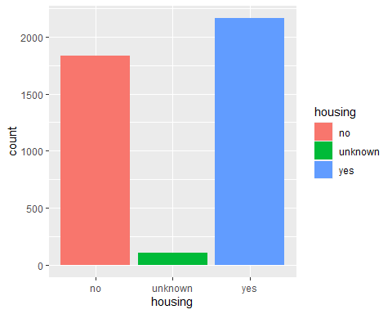
summary(m_date$housing)
## no unknown yes
## 1832 104 2164

loan
ggplot(m_date, mapping=(aes(x=loan,fill=loan))) + geom_bar()
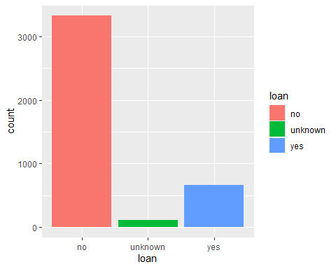
summary(m_date$loan)
## no unknown yes
## 3334 104 662

loan contact
ggplot(m_date, mapping=(aes(x=contact,fill=contact))) + geom_bar()
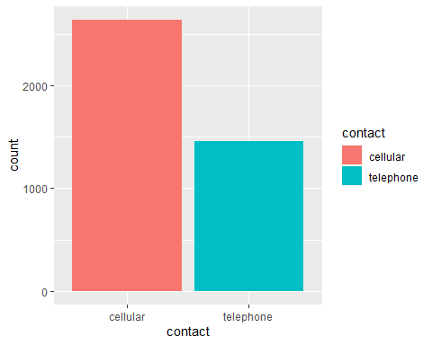
summary(m_date$contact)
## cellular telephone
## 2639 1461
- Observation
  - The graph demonstrates that there were more cellular customer contacts.

loan month
ggplot(m_date, mapping=(aes(x=month,fill=month))) + geom_bar()
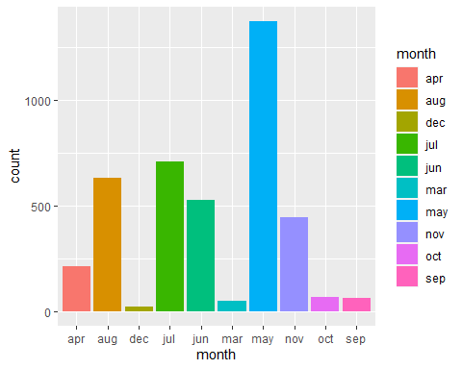
- Observation
  - The month of May saw the most contacts.
  - Decembar saw the fewest contacts made overall.
summary(m_date$month)
## apr aug dec jul jun mar may nov oct sep
## 214 633 22 707 528 48 1373 443 68 64

loan day_of_week
ggplot(m_date, mapping=(aes(x=day_of_week,fill=day_of_week))) + geom_bar()
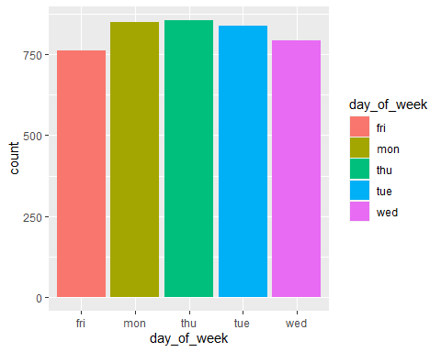
summary(m_date$day_of_week)
## fri mon thu tue wed
## 762 851 856 839 792
- Observation
  - Normal distribution of numbers throughout the week on all days

Part 2 Statistical modelling
- The strength and direction of correlations between variables can be examined using a correlation matrix (Giuseppe, 2022).
mm_cor_matrix <- select_if(m_date, is.numeric)
# Compute the correlation matrix
cor_matrix <- cor(mm_cor_matrix)
# Plot the correlation matrix
corrplot(cor_matrix, method = "color", type = "lower", tl.cex = 1)
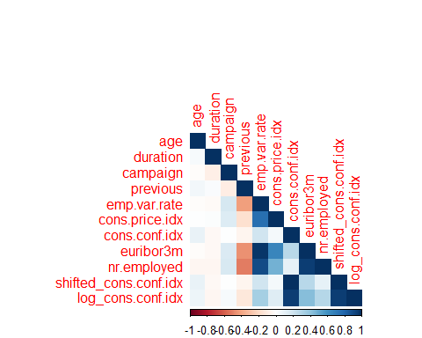
- Observation
  - Multicollinearity can be observed in redundant columns created during data pre-procesing
- shifted_cons.conf.idx,cons.conf.idx & pdays5 will be dropped
#final_mm_dataset <- select(m_date,-c(shifted_cons.conf.idx,pdays5,cons.conf.idx,marital,poutcome))
final_mm_dataset <- select(m_date,-c(shifted_cons.conf.idx,pdays5,cons.conf.idx))
df <- select_if(final_mm_dataset, is.numeric)
# Compute the correlation matrix
mm_cor_matrix <- cor(df)
# Plot the correlation matrix
corrplot(mm_cor_matrix, method = "color", type = "lower", tl.cex = 1)
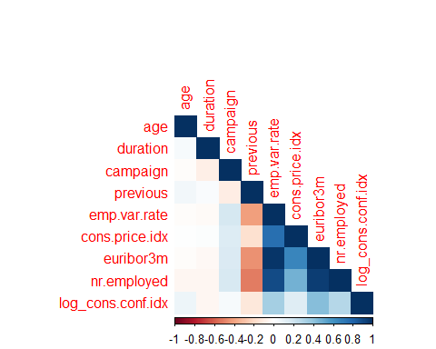

logistic modeling
- Note that we are using logisitic regression because our outcome is binary i.e yes or no
library(caret)
## Loading required package: lattice
##
## Attaching package: 'caret'
## The following object is masked from 'package:purrr':
##
## lift
- Spliting the dataset into a train set and a test set
set.seed(350)
#partitioning the dataset i.e 70% train set and 30% for test set
mm_train = createDataPartition(y = final_mm_dataset$y, times = 1, p = 0.7, list = FALSE)
- Defining the training and testing datasets
train_set = slice(final_mm_dataset, mm_train)
test_set = slice(final_mm_dataset, -mm_train)
- Creating a logistic regression model
model <- glm(y ~ ., data = train_set, family = binomial)
# Print the summary of the model
summary(model)
##
## Call:
## glm(formula = y ~ ., family = binomial, data = train_set)
##
## Deviance Residuals:
## Min 1Q Median 3Q Max
## -5.0927 -0.2810 -0.1650 -0.1039 2.9060
##
## Coefficients: (1 not defined because of singularities)
## Estimate Std. Error z value Pr(>|z|)
## (Intercept) 6.441e+01 1.500e+02 0.429 0.66765
## age 6.630e-03 1.022e-02 0.649 0.51651
## jobblue-collar 9.245e-02 3.166e-01 0.292 0.77026
## jobentrepreneur -1.259e+00 6.772e-01 -1.860 0.06295 .
## jobhousemaid 2.672e-01 5.445e-01 0.491 0.62356
## jobmanagement -1.780e-02 3.469e-01 -0.051 0.95908
## jobretired 1.997e-01 4.303e-01 0.464 0.64251
## jobself-employed -7.838e-01 5.403e-01 -1.451 0.14689
## jobservices -1.728e-02 3.595e-01 -0.048 0.96167
## jobstudent -7.994e-02 4.940e-01 -0.162 0.87144
## jobtechnician 2.058e-01 2.884e-01 0.714 0.47532
## jobunemployed 7.067e-01 4.552e-01 1.553 0.12051
## jobunknown -2.183e+00 1.311e+00 -1.665 0.09591 .
## maritalmarried 1.837e-01 2.999e-01 0.612 0.54028
## maritalsingle 1.952e-01 3.442e-01 0.567 0.57056
## maritalunknown 5.258e-01 1.254e+00 0.419 0.67487
## kbasic.6y -7.036e-02 4.867e-01 -0.145 0.88507
## kbasic.9y 1.106e-01 3.704e-01 0.299 0.76521
## khigh.school 1.823e-01 3.601e-01 0.506 0.61280
## killiterate -1.456e+01 2.400e+03 -0.006 0.99516
## kprofessional.course 9.146e-02 4.053e-01 0.226 0.82146
## kuniversity.degree 1.219e-01 3.645e-01 0.334 0.73807
## kunknown 1.638e-01 4.946e-01 0.331 0.74057
## defaultunknown 1.052e-02 2.568e-01 0.041 0.96734
## defaultyes -1.202e+01 2.400e+03 -0.005 0.99600
## housingunknown -5.955e-01 6.227e-01 -0.956 0.33896
## housingyes -1.554e-01 1.719e-01 -0.904 0.36594
## loanunknown NA NA NA NA
## loanyes -1.584e-01 2.312e-01 -0.685 0.49327
## contacttelephone -6.727e-01 3.218e-01 -2.091 0.03656 *
## monthaug -1.318e-01 5.442e-01 -0.242 0.80863
## monthdec 1.249e+00 8.301e-01 1.504 0.13256
## monthjul 6.227e-02 4.474e-01 0.139 0.88929
## monthjun 9.601e-01 5.640e-01 1.702 0.08870 .
## monthmar 1.709e+00 6.359e-01 2.688 0.00720 **
## monthmay -7.572e-01 3.706e-01 -2.043 0.04106 *
## monthnov -1.000e+00 5.256e-01 -1.903 0.05708 .
## monthoct 1.819e-01 6.898e-01 0.264 0.79199
## monthsep -1.149e-01 7.841e-01 -0.147 0.88348
## day_of_weekmon 3.918e-01 2.726e-01 1.438 0.15055
## day_of_weekthu 3.857e-01 2.789e-01 1.383 0.16664
## day_of_weektue 1.849e-01 2.841e-01 0.651 0.51509
## day_of_weekwed 7.973e-01 2.838e-01 2.809 0.00497 **
## duration 5.520e-03 3.233e-04 17.074 < 2e-16 ***
## campaign -1.163e-01 5.795e-02 -2.006 0.04483 *
## pdays0 1.924e+01 2.400e+03 0.008 0.99360
## pdays1 -1.488e+01 1.582e+03 -0.009 0.99250
## pdays10 2.980e+00 1.532e+00 1.944 0.05184 .
## pdays11 -1.286e+01 2.400e+03 -0.005 0.99572
## pdays12 4.189e+00 2.743e+00 1.527 0.12679
## pdays13 -1.541e+01 1.482e+03 -0.010 0.99170
## pdays14 -1.621e+01 2.400e+03 -0.007 0.99461
## pdays15 -1.441e+01 2.400e+03 -0.006 0.99521
## pdays16 -1.481e+01 1.661e+03 -0.009 0.99288
## pdays17 -1.671e+01 2.400e+03 -0.007 0.99444
## pdays18 -7.879e-01 2.106e+00 -0.374 0.70830
## pdays19 1.721e+01 2.400e+03 0.007 0.99428
## pdays2 -1.339e+01 1.534e+03 -0.009 0.99304
## pdays21 1.412e+01 2.400e+03 0.006 0.99530
## pdays3 3.870e+00 1.618e+00 2.392 0.01676 *
## pdays4 2.234e+00 1.763e+00 1.267 0.20525
## pdays5 1.747e+01 1.370e+03 0.013 0.98983
## pdays6 2.845e+00 1.602e+00 1.776 0.07567 .
## pdays7 3.293e+00 1.622e+00 2.030 0.04235 *
## pdays9 -5.968e-01 1.536e+00 -0.389 0.69756
## previous 2.673e-01 2.544e-01 1.051 0.29333
## poutcomenonexistent 6.251e-01 4.043e-01 1.546 0.12211
## poutcomesuccess -9.209e-01 1.514e+00 -0.608 0.54308
## emp.var.rate -3.072e-01 6.017e-01 -0.511 0.60964
## cons.price.idx 3.202e-02 1.002e+00 0.032 0.97450
## euribor3m 3.230e-01 4.550e-01 0.710 0.47778
## nr.employed -1.437e-02 1.163e-02 -1.235 0.21693
## log_cons.conf.idx 9.495e-02 2.477e-01 0.383 0.70143
## ---
## Signif. codes: 0 '***' 0.001 '**' 0.01 '*' 0.05 '.' 0.1 ' ' 1
##
## (Dispersion parameter for binomial family taken to be 1)
##
## Null deviance: 1990.5 on 2870 degrees of freedom
## Residual deviance: 1068.9 on 2799 degrees of freedom
## AIC: 1212.9
##
## Number of Fisher Scoring iterations: 15
- Making predictions on the test set
predictions <- predict(model, newdata = test_set, type = "response")
## Warning in predict.lm(object, newdata, se.fit, scale = 1, type = if (type == :
## prediction from a rank-deficient fit may be misleading
- Convert predictions to binary values (0 or 1) using a threshold of 0.5
binary_predictions <- ifelse(predictions > 0.5, "yes", "no")
- Confusion matrix for the logisitic model
heart_glm <- confusionMatrix(data = as.factor(binary_predictions), reference = as.factor(test_set$y), positive = "yes")
heart_glm
## Confusion Matrix and Statistics
##
## Reference
## Prediction no yes
## no 1064 72
## yes 30 63
##
## Accuracy : 0.917
## 95% CI : (0.9002, 0.9318)
## No Information Rate : 0.8902
## P-Value [Acc > NIR] : 0.001074
##
## Kappa : 0.5086
##
## Mcnemar's Test P-Value : 4.916e-05
##
## Sensitivity : 0.46667
## Specificity : 0.97258
## Pos Pred Value : 0.67742
## Neg Pred Value : 0.93662
## Prevalence : 0.10985
## Detection Rate : 0.05126
## Detection Prevalence : 0.07567
## Balanced Accuracy : 0.71962
##
## 'Positive' Class : yes
##
- ROC construction using probabilities
library(pROC)
## Type 'citation("pROC")' for a citation.
##
## Attaching package: 'pROC'
## The following objects are masked from 'package:stats':
##
## cov, smooth, var
roc_GLM <- roc(test_set$y, predictions)
## Setting levels: control = no, case = yes
## Setting direction: controls < cases
print(roc_GLM)
##
## Call:
## roc.default(response = test_set$y, predictor = predictions)
##
## Data: predictions in 1094 controls (test_set$y no) < 135 cases (test_set$y yes).
## Area under the curve: 0.9091
plot(roc_GLM)
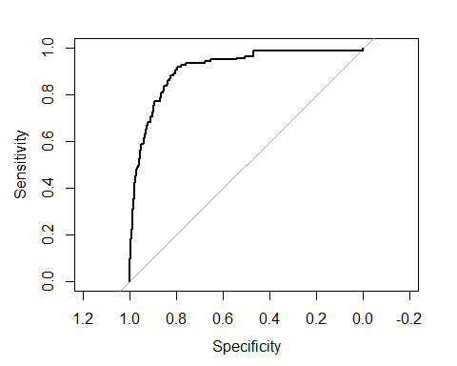

Decision tree
library(rpart)
library(rpart.plot)
decision_trees_mm <- rpart(y ~ ., data = train_set, method = "class")
predict_decisiontrees <- predict(decision_trees_mm, newdata = test_set, type = c("class"))
- Confusion matrix for the decision tree model
mm_DecisionTree <- confusionMatrix(data = as.factor(predict_decisiontrees), reference = as.factor(test_set$y), positive = "yes")
rpart.plot(decision_trees_mm)
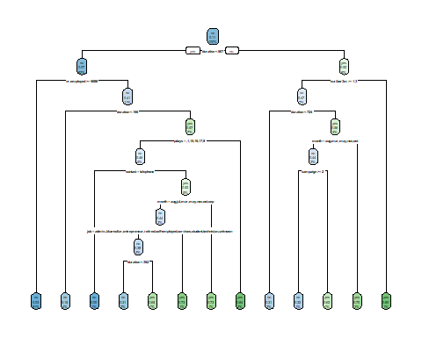
- Observation
  - The model considered duration for constructing the root node
    - to get a yes at 2% rate
      - duration is less than 807
      - nr.employed at more than 5088
      - pdays in within the 1st day or between 9 and 17 days after the client was last contacted from a previous campaign
- Decision tree model’s confusion matrix
mm_DecisionTree
## Confusion Matrix and Statistics
##
## Reference
## Prediction no yes
## no 1053 73
## yes 41 62
##
## Accuracy : 0.9072
## 95% CI : (0.8896, 0.9229)
## No Information Rate : 0.8902
## P-Value [Acc > NIR] : 0.028569
##
## Kappa : 0.4707
##
## Mcnemar's Test P-Value : 0.003691
##
## Sensitivity : 0.45926
## Specificity : 0.96252
## Pos Pred Value : 0.60194
## Neg Pred Value : 0.93517
## Prevalence : 0.10985
## Detection Rate : 0.05045
## Detection Prevalence : 0.08381
## Balanced Accuracy : 0.71089
##
## 'Positive' Class : yes
##
- Building the ROC for the decision tree
decision_tree.preds <- predict(decision_trees_mm, test_set, type="prob")[, 2]
decision_tree <- roc(test_set$y, decision_tree.preds)
## Setting levels: control = no, case = yes
## Setting direction: controls < cases
print(decision_tree)
##
## Call:
## roc.default(response = test_set$y, predictor = decision_tree.preds)
##
## Data: decision_tree.preds in 1094 controls (test_set$y no) < 135 cases (test_set$y yes).
## Area under the curve: 0.8459
plot(decision_tree)
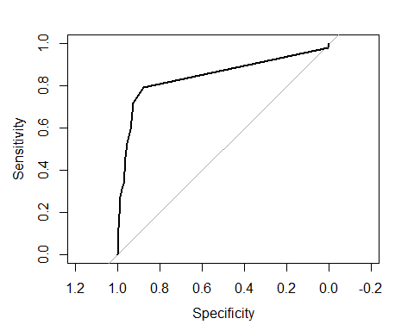

Conclusion.
- AUC is used to compare the performance of the two classifiers. Rahul (2019) suggests the AUC as the best statistic to support the bank’s telemarketing campaigns in our scenario of the MMA Marketing campaign.
  - Logisitic model
    - AUC = 0.9101
  - Decision tree
    - AUC = 0.8459
- Both models have close values, however the logistic model performed better at predicting the outcome of a phone call to sell long-term bank deposits (area under the curve: 0.9101 vs. 0.8459) than the decision tree.

References:
- Mike, Y. (2021) A Complete Guide to Box Plots. CHARTIO. Available from: https://chartio.com/learn/charts/box-plot-complete-guide/ [Accessed on 27 May 2023]
- Indratmo, L., Joyce, B., Ben, D. (2014) The efficacy of stacked bar charts in supporting single attribute and overall-attribute comparisons, Science Direct. Available from: https://www.sciencedirect.com/science/article/pii/S2468502X18300287 [Accessed on 18 June 2023]
- Satyam, K. (2020) 7 Ways to Handle Missing Values in Machine Learning. Towards Data Science Available from: https://towardsdatascience.com/7-ways-to-handle-missing-values-in-machine-learning-1a6326adf79e/ [Accessed on 20 June 2023]
- Tejashree, N. (2022) How to deal with Missing Values in Machine Learning. Geek Culture Available from: https://medium.com/geekculture/how-to-deal-with-missing-values-in-machine-learning-98e47f025b9c/ [Accessed on 22 June 2023]
- Rick, W. (2011) Log transformations: How to handle negative data values? sas Blogs Available from: https://blogs.sas.com/content/iml/2011/04/27/log-transformations-how-to-handle-negative-data-values.html/ [Accessed on 15 June 2023]
- Giuseppe, M. (2022) Correlation Matrix, Demystified. Correlation matrix: what is, how is it built and what is it used for Towards Data Science Available from: https://towardsdatascience.com/correlation-matrix-demystified-3ae3405c86c1 [Accessed on 19 June 2023]
- Rahul, A. (2019) The 5 Classification Evaluation metrics every Data Scientist must know Available from: https://towardsdatascience.com/the-5-classification-evaluation-metrics-you-must-know-aa97784ff226 [Accessed on 20 June 2023]

