**Prerequisites**

1. Azure subscription
2. Azure CLI
3. Azure Kubernetes cluster
4. Helm CLI

**Create AKS cluster**

Before configuration, we will need an AKS cluster if you don’t have an existing cluster you can use the below command to create a new AKS cluster. Also, you can use the azure portal, but we will use Azure CLI to create cluster.

$ az login  
$ az account list -o table  
$ az account set –subscription <subscription ID>  
$ az aks get-credentials -n <aks_name> -g <resource_group_name>

Once the cluster is setup you need to clone the repository below.

$ git clone https://github.com/maheshkvis/AKS-Monitoring-Tool.git

**Installing Prometheus Helm Chart**

Run the command below to install Prmetheus helm Chart and be sure to set “rbac.create=true” if RBAC is enabled inside your cluster.

$ cd AKS-Monitoring-ToolPrometheus  
$ kubectl create namespace monitoring  
$ helm install <chart_name_prometheus> . –namespace monitoring –set rbac.create=false  
$ SVC_IP=$(kubectl get svc –namespace monitoring -l "app=prometheus,component=server" -o jsonpath="{.items[0].spec.clusterIP}")

The $SVP_IP stores your Prometheus server IP we will be using this for configuring Grafana.

**Installing Grafana Chart**

Run the code below to install Grafana Chart:

$ cd ..grafana  
$ grafana_chart=<chart_name_grafana>  
$ helm install $grafana_chart . –set persistence.enabled=true –set persistence.accessModes={ReadWriteOnce} –set persistence.size=8Gi –namespace monitoring

Run the following command to acess the Grafana Dashboard:

$ kubectl get svc $grafana_chart

OR

$ export POD_NAME=$(kubectl get pods –namespace monitoring -l "app.kubernetes.io/name=grafana,app.kubernetes.io/instance=chart-1599858402" -o jsonpath="{.items[0].metadata.name}")  
$ kubectl –namespace monitoring port-forward $POD_NAME 3000

The Grafana dashboard **username** is ***admin*** and for password execute this command.

$ kubectl get secret –namespace monitoring $grafana_chart -o jsonpath="{.data.admin-password}" | base64 –decode ; echo

**Steps for setting up Grafana Dashboard**

1. Login inside the Grafana dashboard and add your data source.[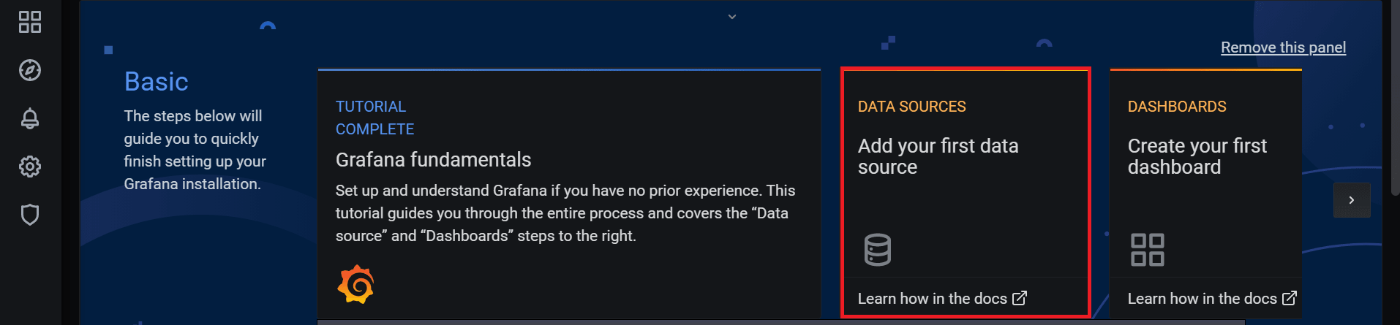](https://ifi.tech/wp-content/uploads/2020/09/configure-pro-and-graf-in-aks-1.png)
2. Select Prometheus as the data source.[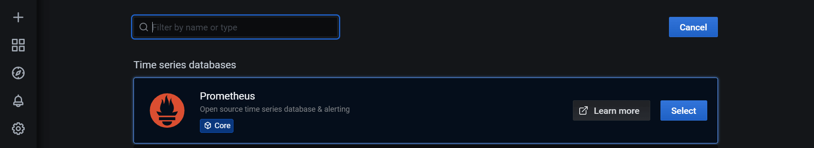](https://ifi.tech/wp-content/uploads/2020/09/configure-pro-and-graf-in-aks-2.png)
3. In the URL section add your Prometheus Server Cluster IP.[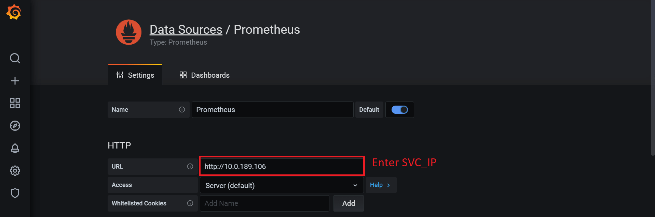](https://ifi.tech/wp-content/uploads/2020/09/configure-pro-and-graf-in-aks-3.png)
4. Import Dashboard[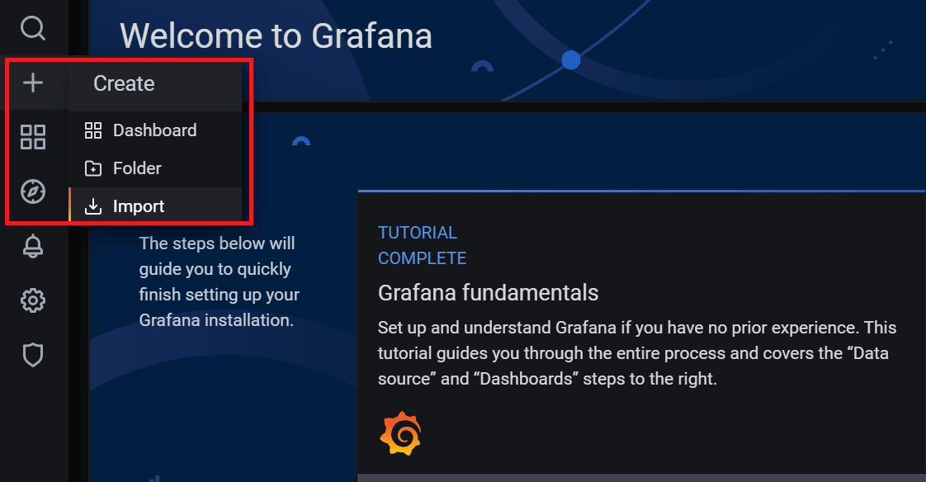](https://ifi.tech/wp-content/uploads/2020/09/configure-pro-and-graf-in-aks-4.png)
5. Add Dasboard ID[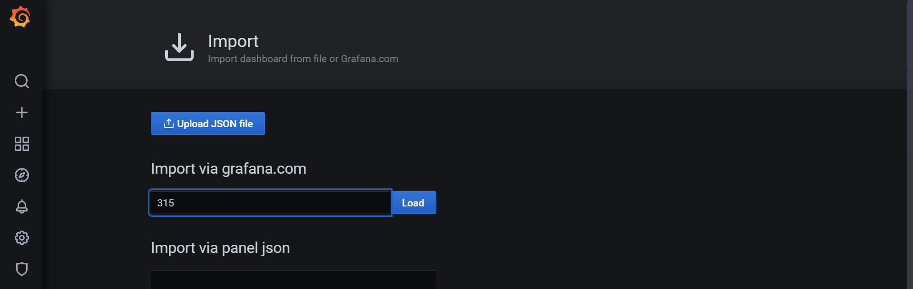](https://ifi.tech/wp-content/uploads/2020/09/configure-pro-and-graf-in-aks-5.png)
6. Select your data source for the dashboard[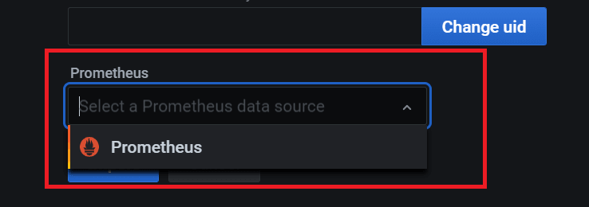](https://ifi.tech/wp-content/uploads/2020/09/configure-pro-and-graf-in-aks-6.png)
7. Your final outcome should look something like this.[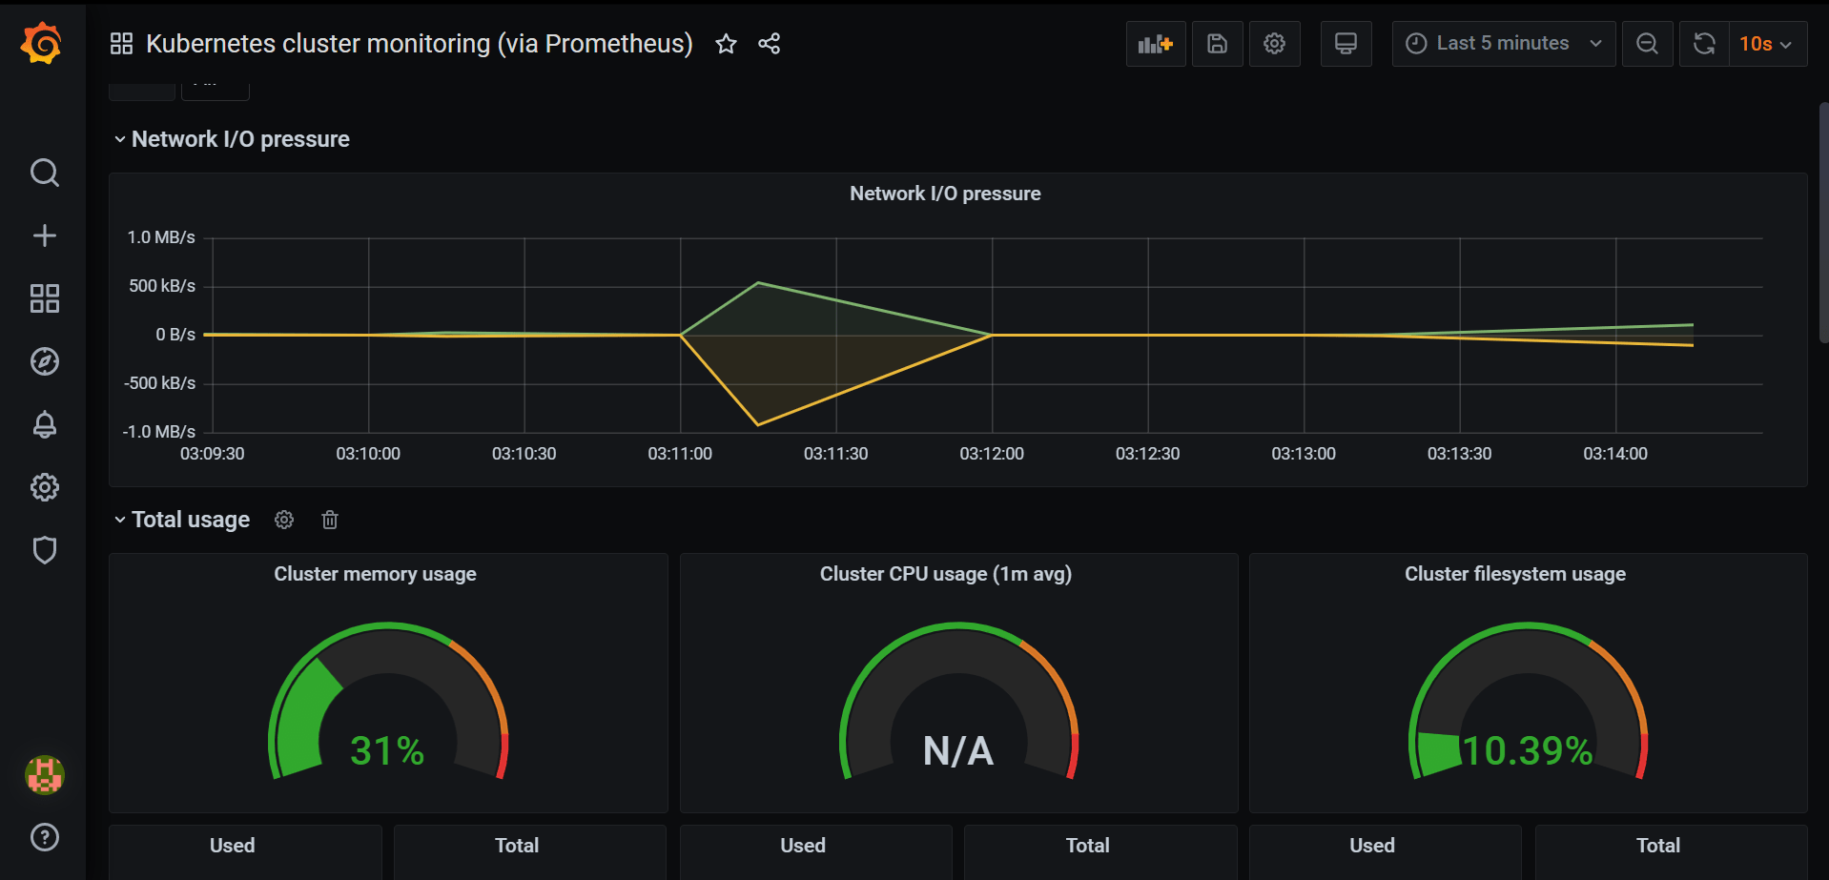](https://ifi.tech/wp-content/uploads/2020/09/configure-pro-and-graf-in-aks-7.png)

Here we have enabled monitoring for our Azure Kubernetes cluster using Prometheus and Grafana