**Muestra #:**

**Tipo:**

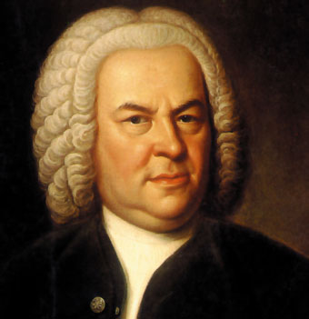 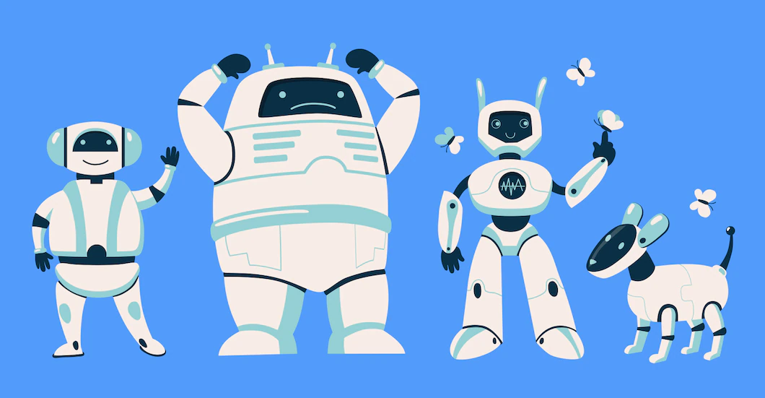

J.S.Bach. AI.

**1.** ________ ________

**2.** ________ ________

**3.** ________ ________

**4.** ________ ________

**5.** ________ ________

**6.** ________ ________

**7.** ________ ________

**8.** ________ ________