PERSONAL DATA

|  |  |
| --- | --- |
| **Name:** | Andrey Misyura |
| **Date of Birth:** | 12/09/1975 |
| **Location:** | Russia, Murmansk |
| **Mobile:** | +7 960 025 25 65 |
| **E-mail:** | amveng315@gmail.com |
| **Telegram:** | <https://t.me/AMveng> |

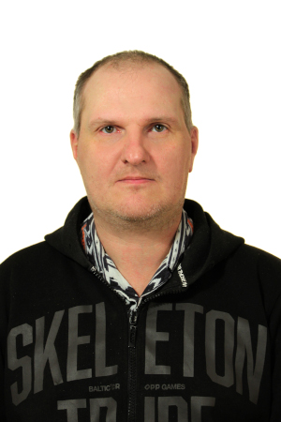

OBJECTIVE

|  |  |
| --- | --- |
| **Desired Position:** | Ruby on rails developer |

SUMMARY OF QUALIFICATION

|  |
| --- |
| Was working as sysadmin 5 years  Have experience with setting up servers (Red Hat, Fedora) for computer club with network optimisation.  Was administrating Russian Championship of cyber-sport of the city.  was writing bots for game industry  I have been working with Ruby on Rails framework since May 2020.  During this time I've released my project(<https://lineagetop.com/>) - application for advertisement game servers with ability for users to vote  and publish paid ads and banners. For admin users there is possibility to manage advertisements, servers, content on the pages, users, ability to see all payments and votes  Also this application provides access to API for server's owners by secret keys  My current stack of technologies is: Ruby, rails, Postgres, Sidekiq, Redis, Docker, git, Rspec, Unicorn, Active admin, sidekiq-scheduler, |

* LANGUAGES
* English – Beginner
* Russian – Native Speaker

EDUCATION

* 1993/ secondary (complete) education
* PROFESSIONAL EXPERIENCE

|  |
| --- |
| System administration 2001-2006.  Development of my own project with ruby on rails  <https://github.com/amveng/LT_ROR> |