Activity1:
Change the logo in the following files
1. manifest.json
2. appConfig.js
Open VS Code and import the project by navigating to File-New Window.
File-Open folder (Unpacked Folder)
Project code will display in VS Code
Select ‘Ask’ mode in Copilet within VS code bottom right corner
Give the prompt
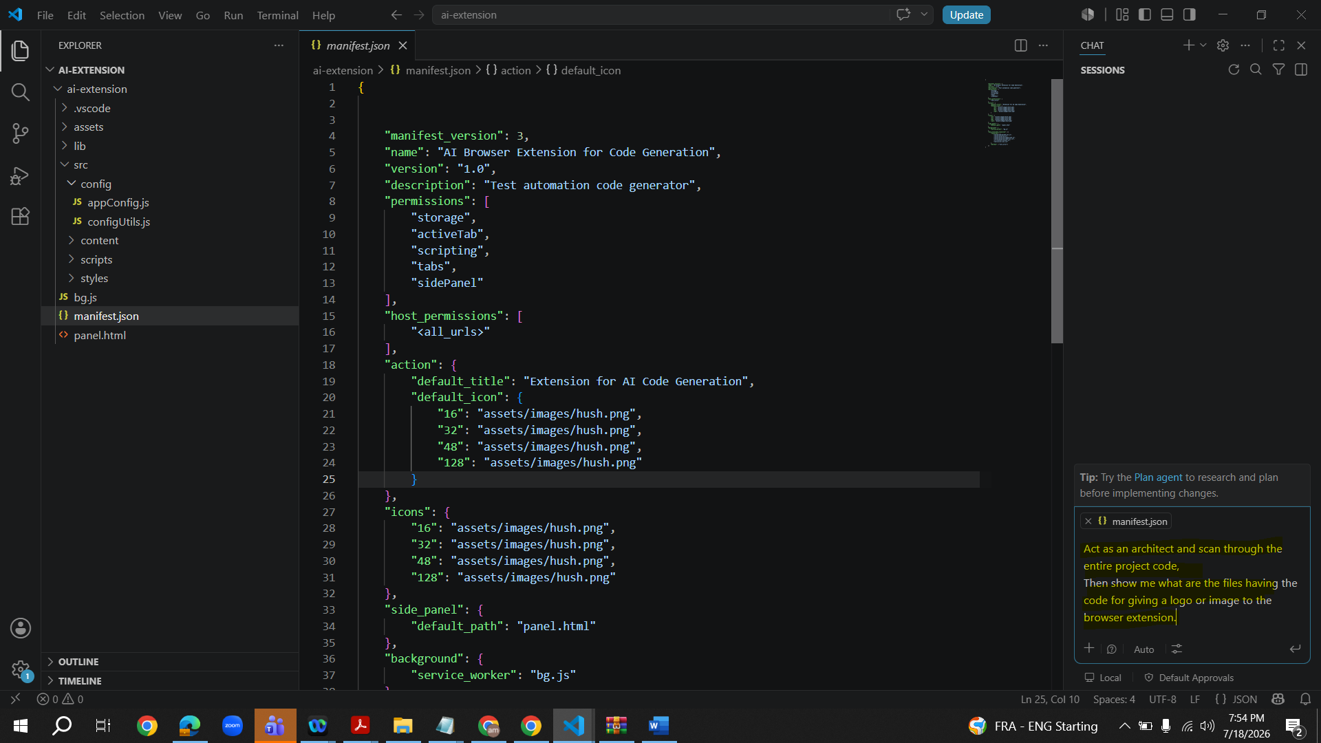

Prompt Response
In Manifest file we have hush.png in 8 places
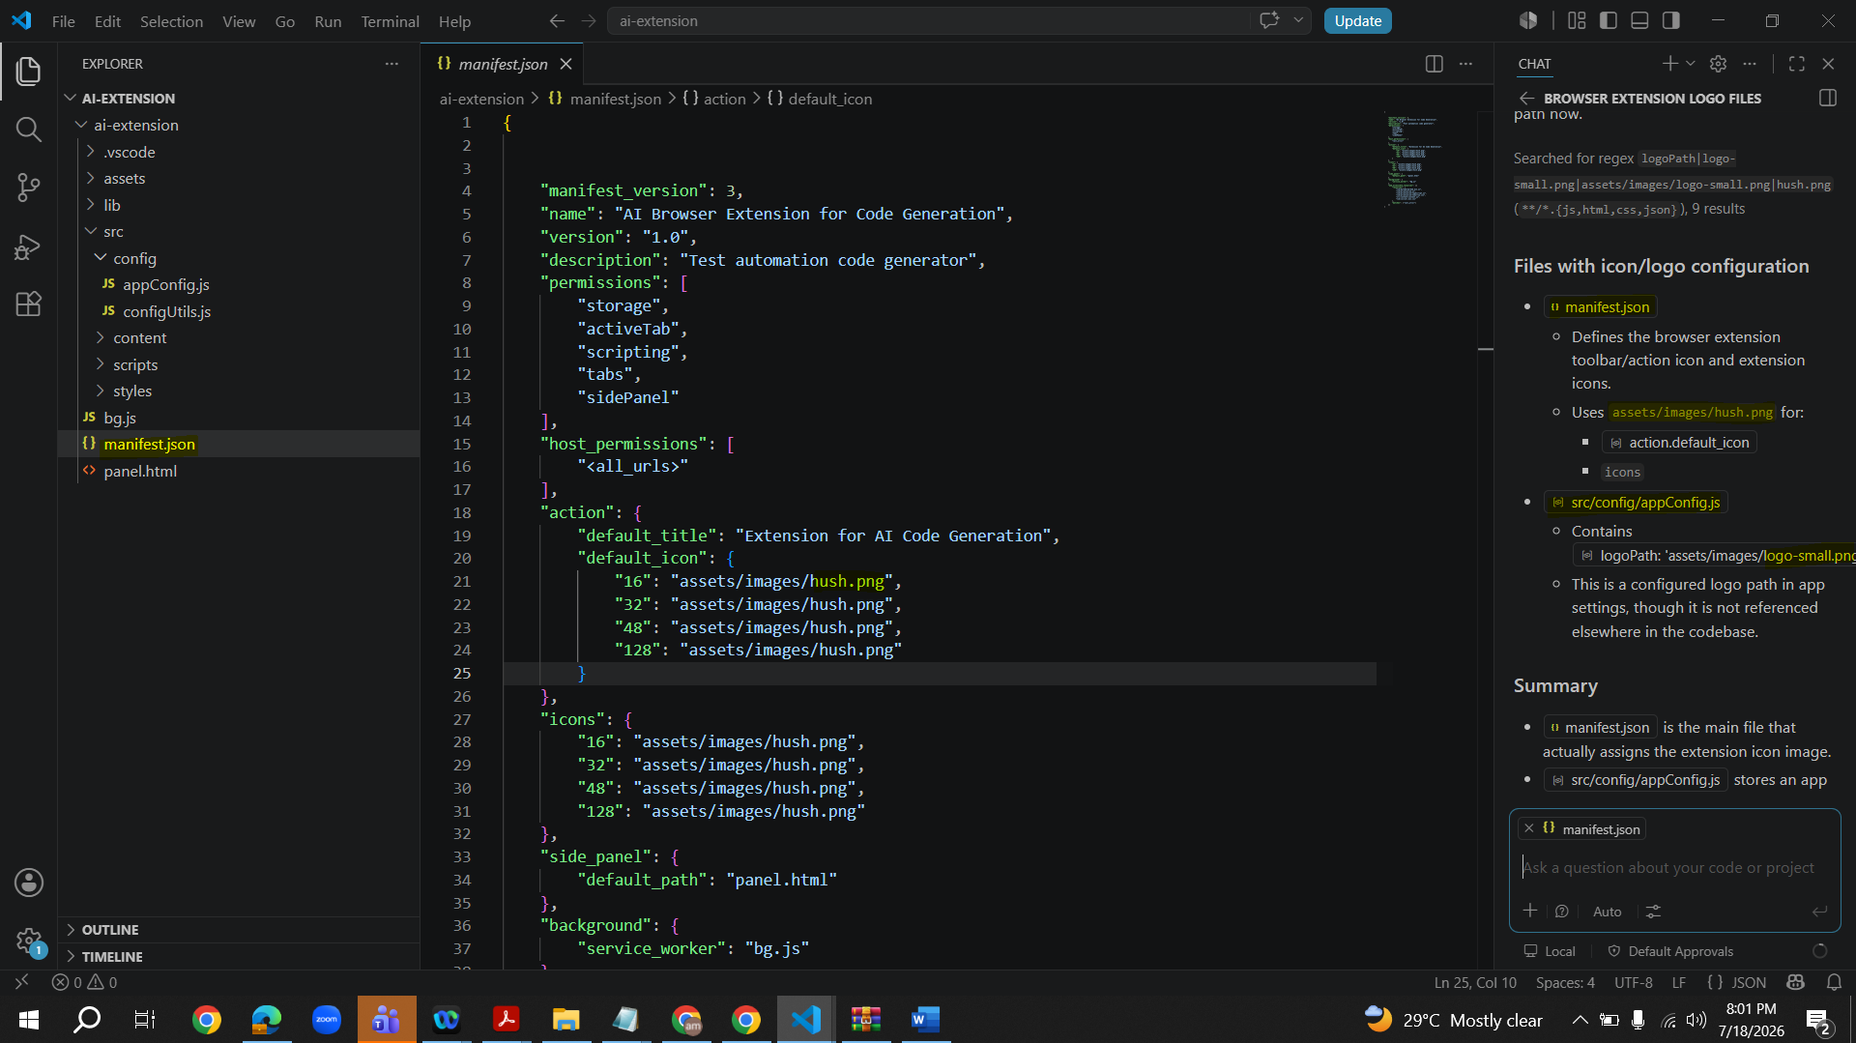
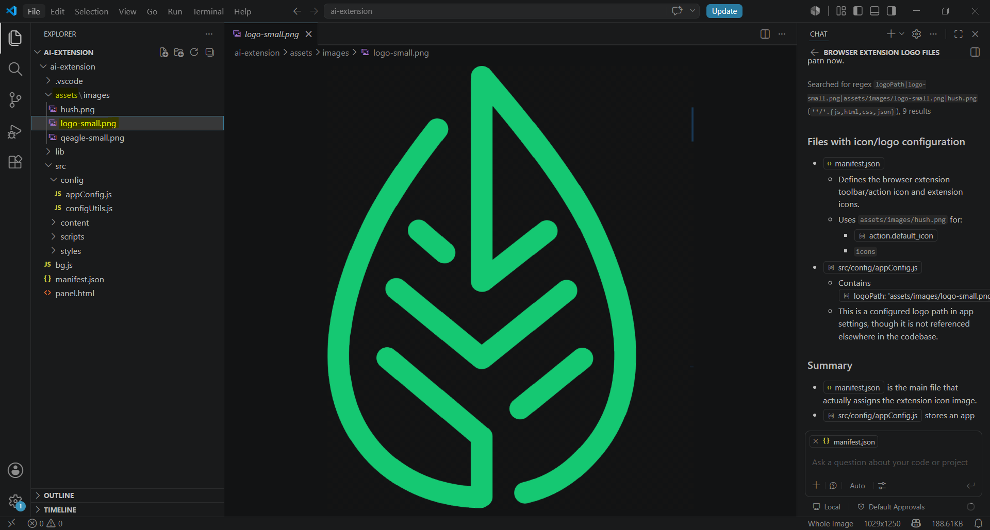
Go to Manifest file and update hush.png to logo-small.png. Select tick mark on left to reflect the changes wherever hush.png is there.
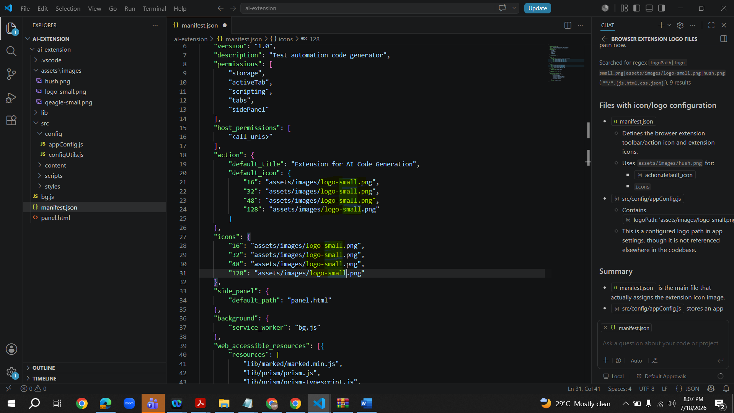
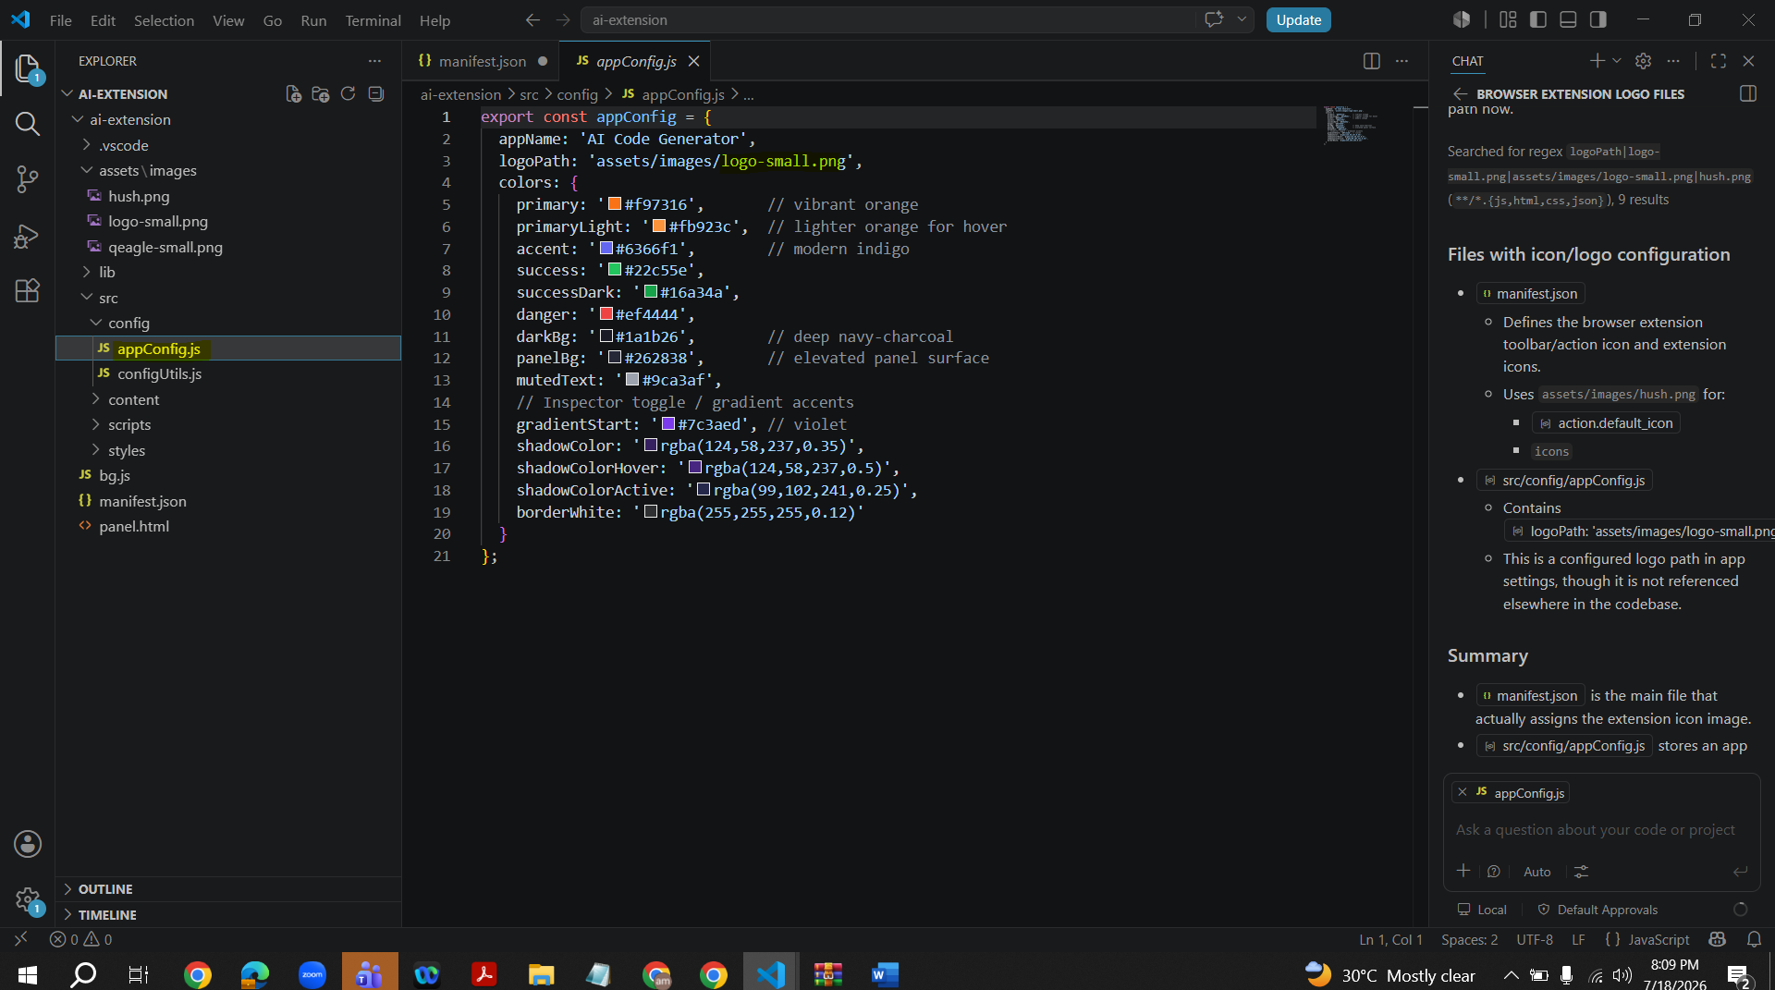
File-Save
Remove the extension
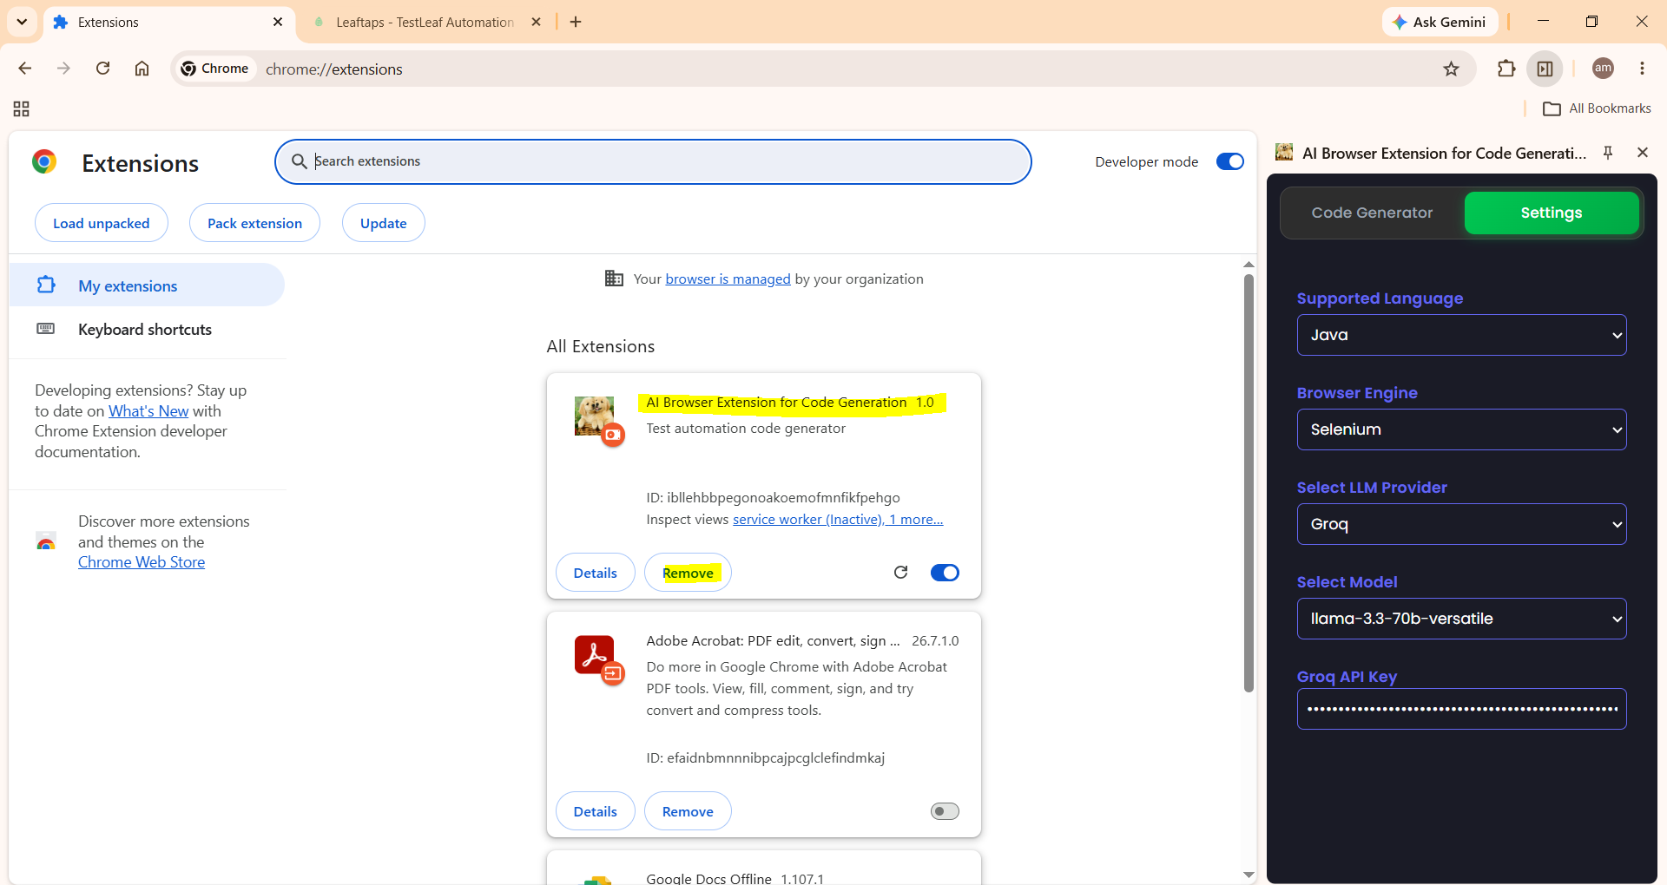

Add again. Make sure Manifest file is available in the selected folder or give the below path
C:\Users\rta\Documents\Vidhya_Assignment link\July 18th\ai-extension\ai-extension

