Activity2:
Add "openai/gpt-oss-120b" to the existing list
Note: update popup.js
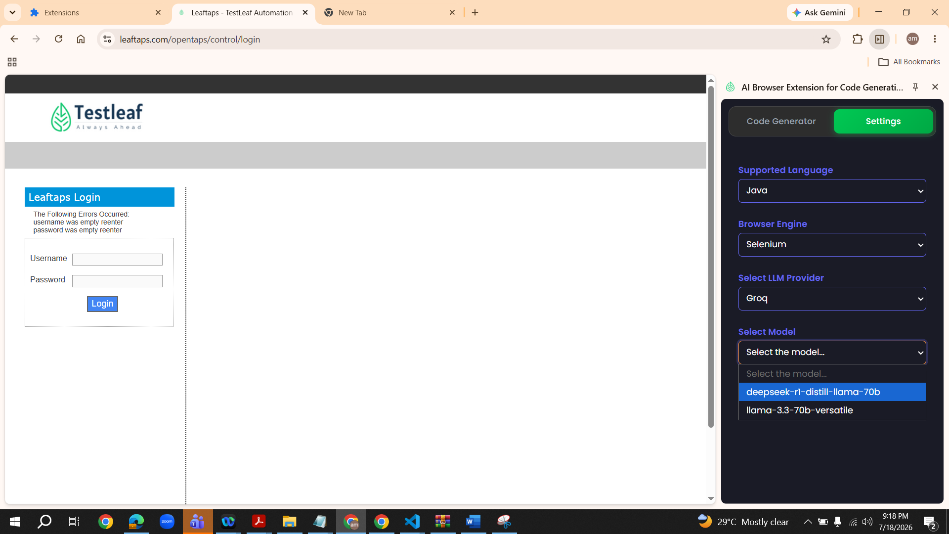
In VS Code, go to Ask mode in Copilet and enter the below prompt
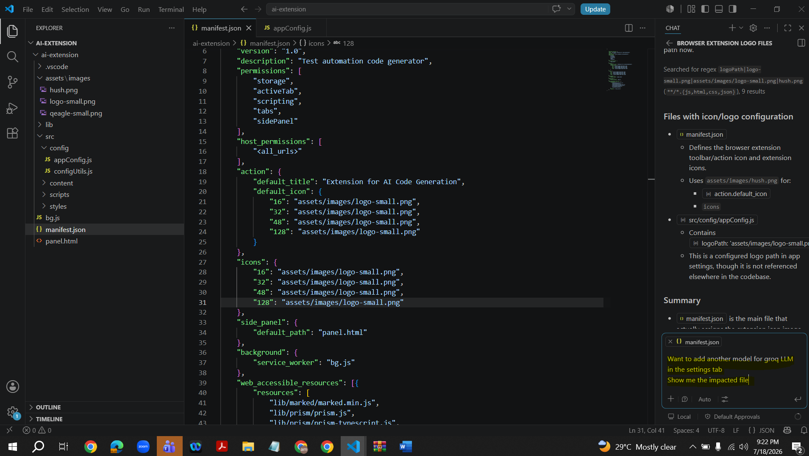
Response is received.pop.js is the class name and modelsByprovider.groq is the function name (Method). Click on this Method.It will directly go to pop.js file
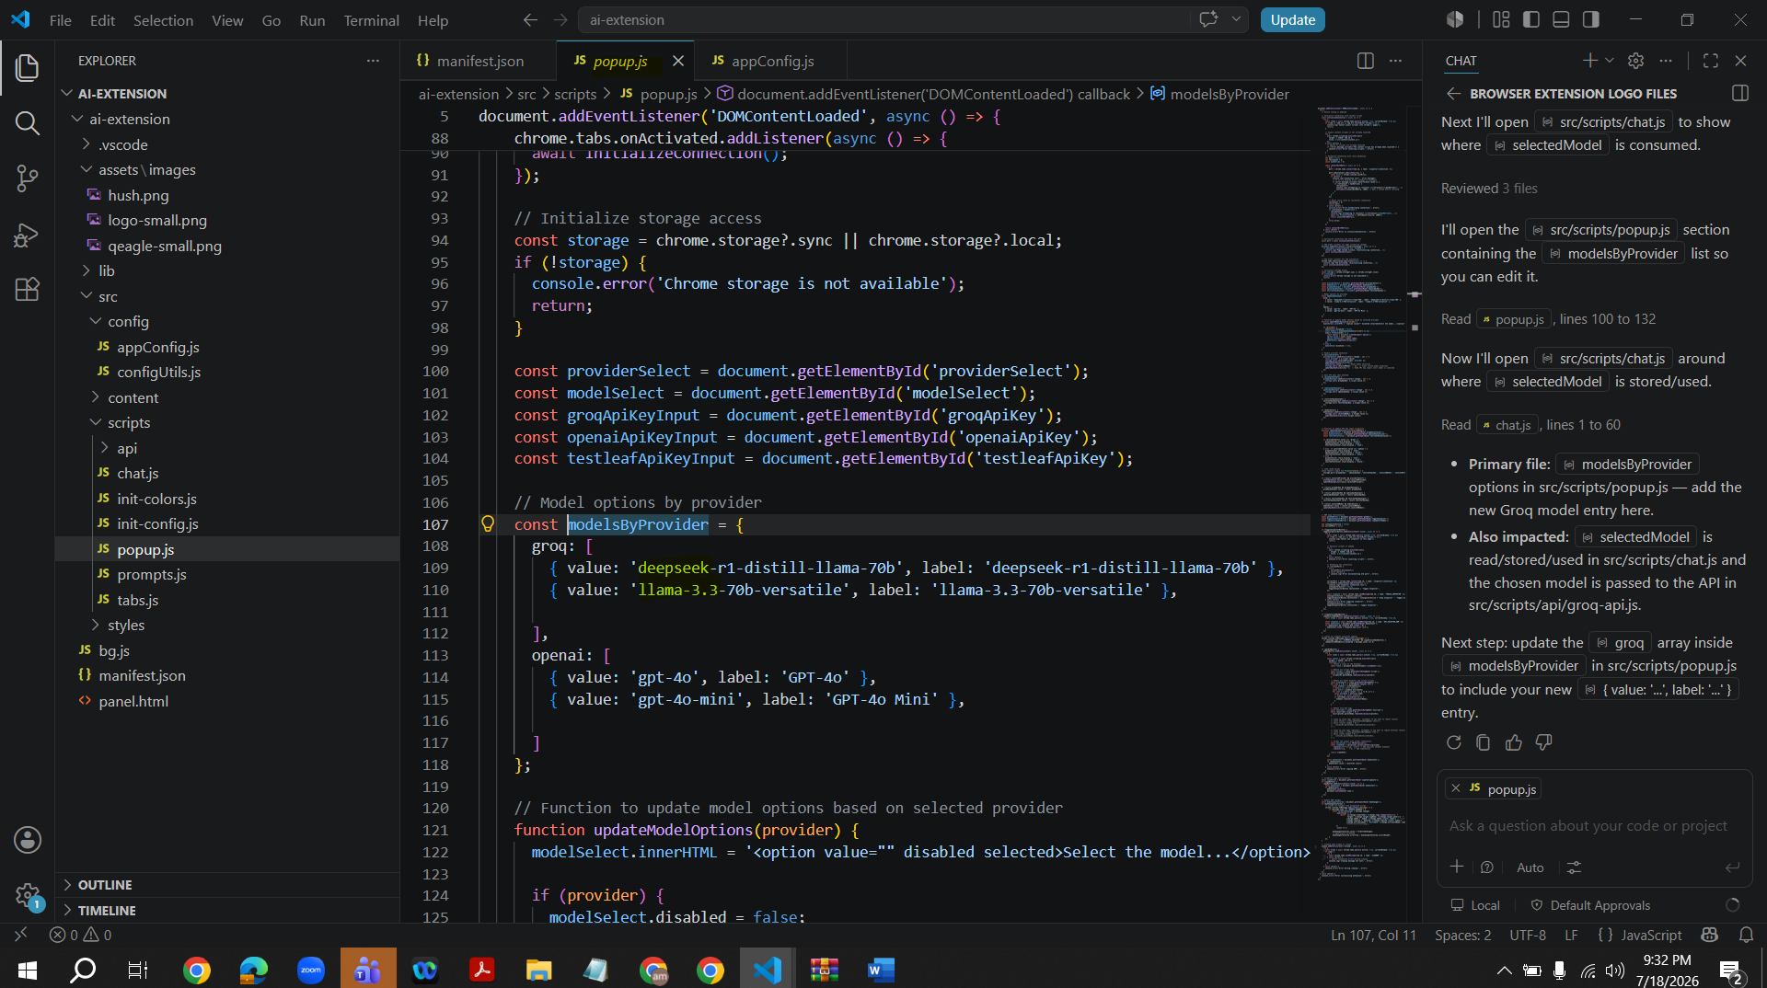
Go to Copilet and change to Agent mode
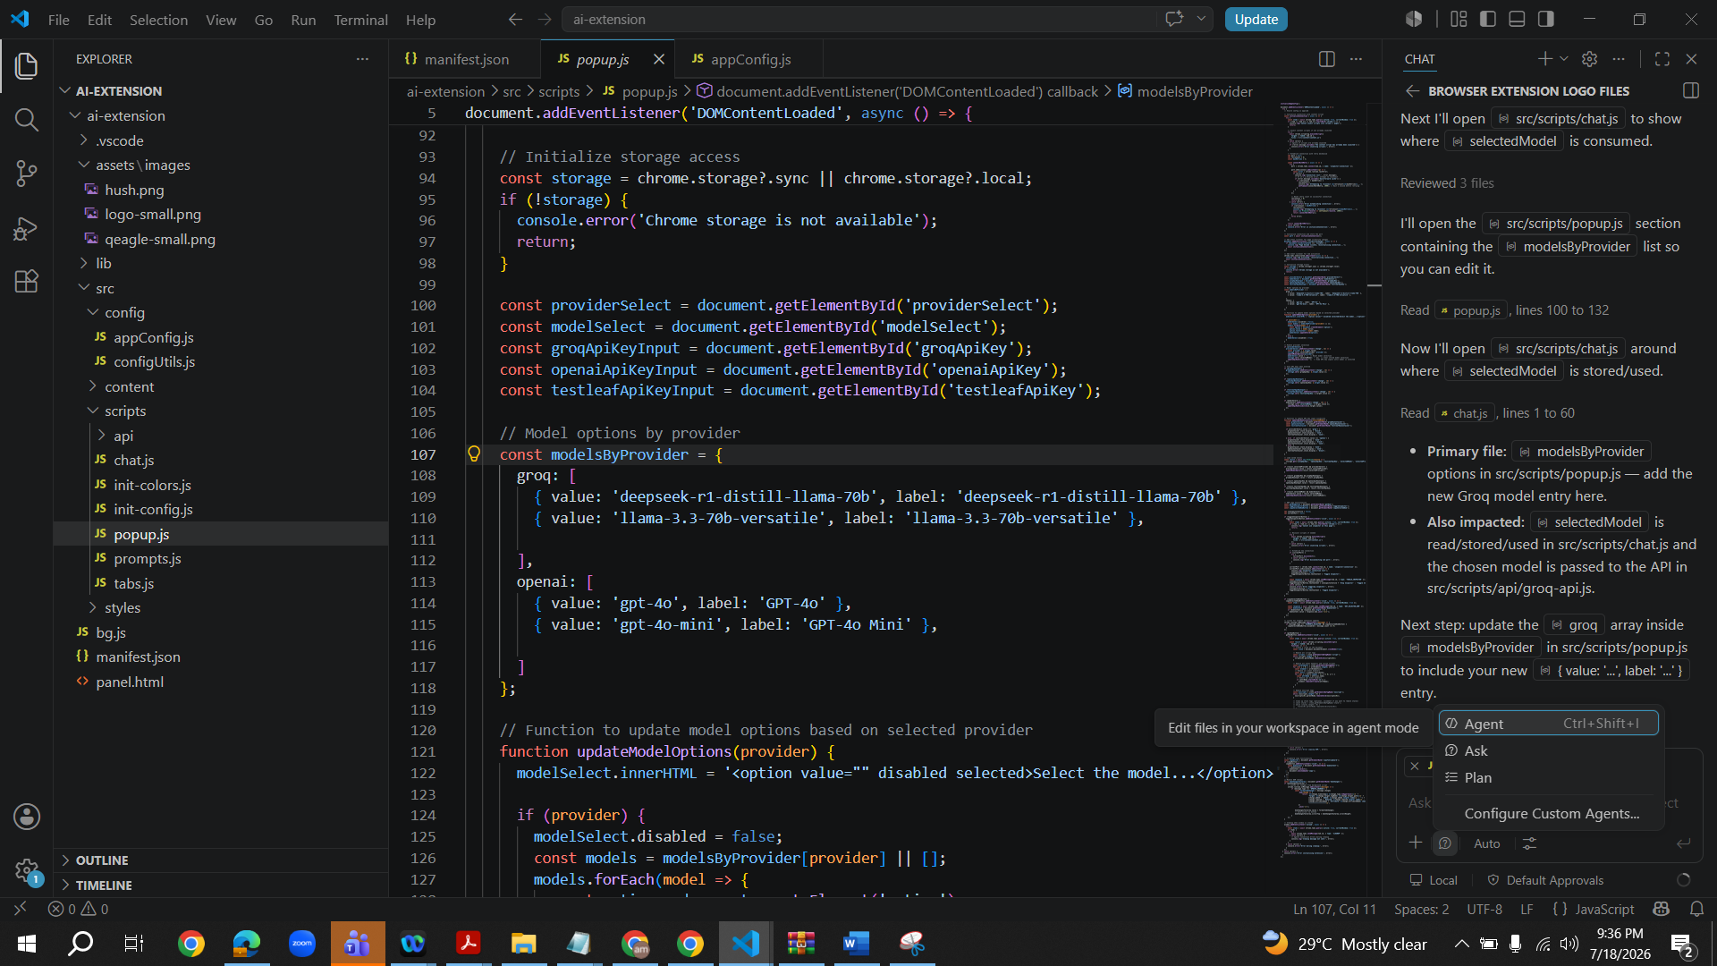
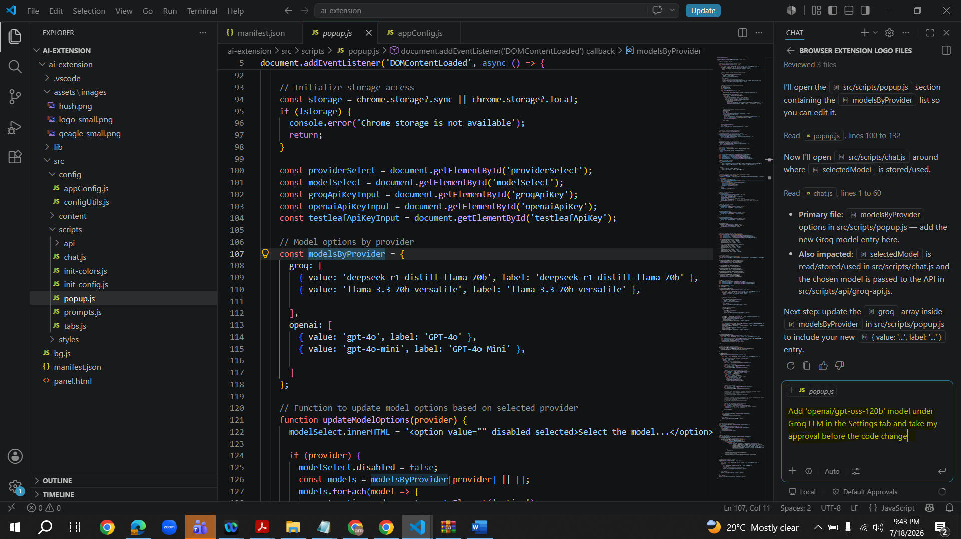
Response
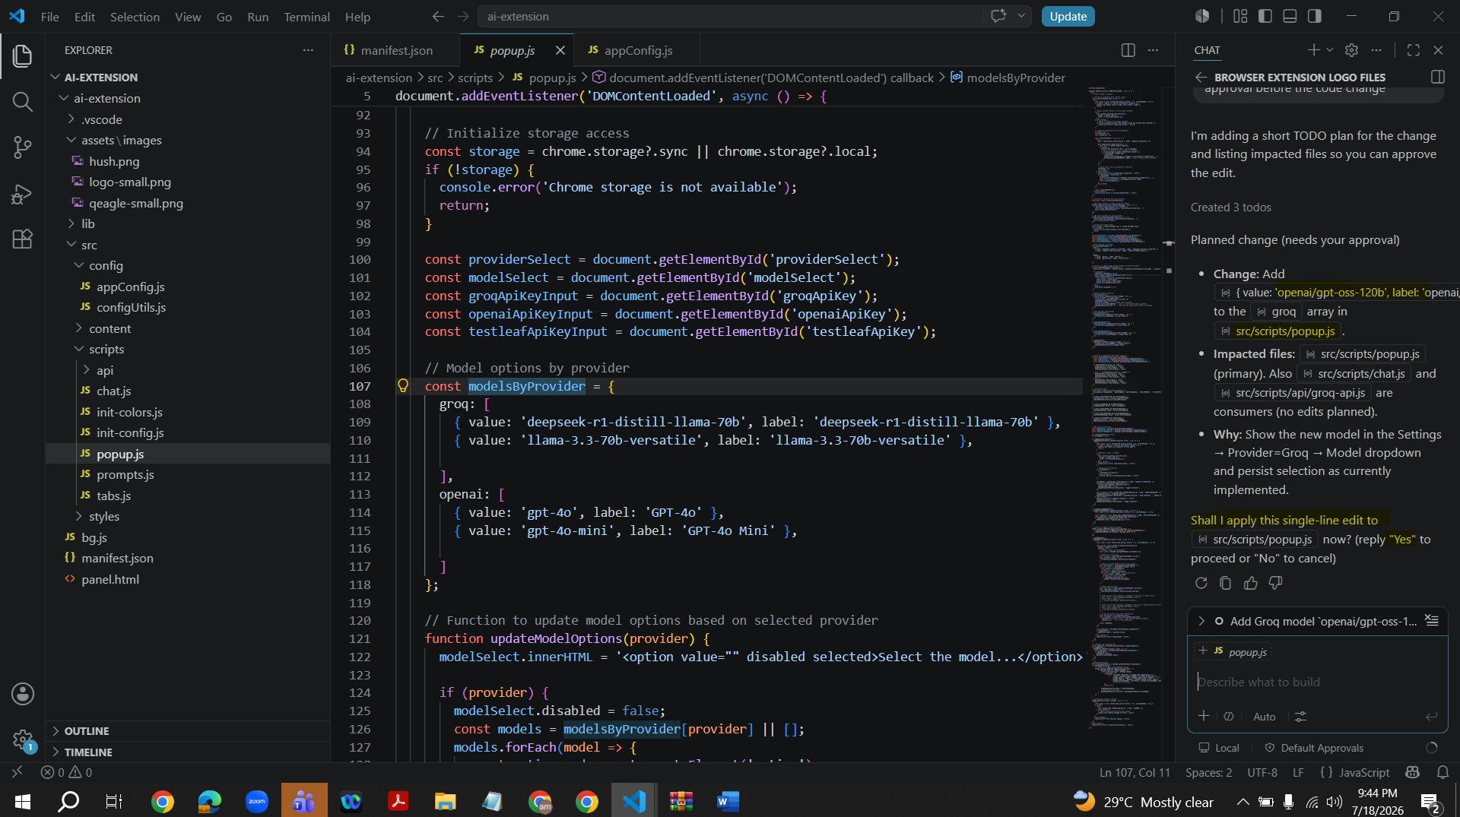
Type ‘Yes’, a row for ‘openai/gpt-oss-120b’ got added in the code as shown in the below screenshot
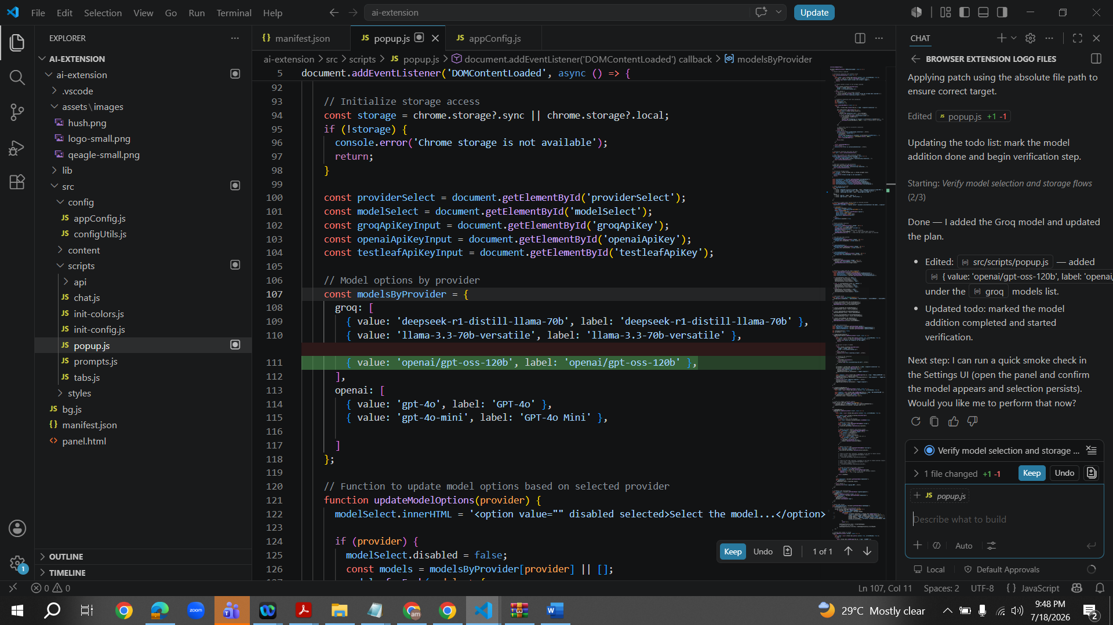
Click on ‘Keep’
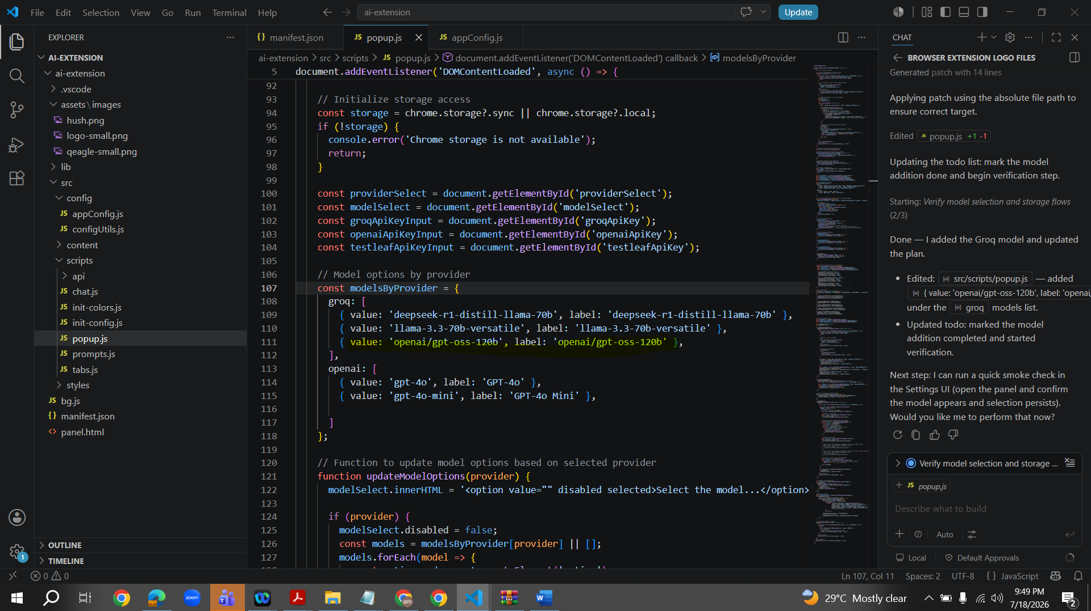
‘openai/gpt-oss-120b’ model got added as expected
