Connecting Jira to User Story
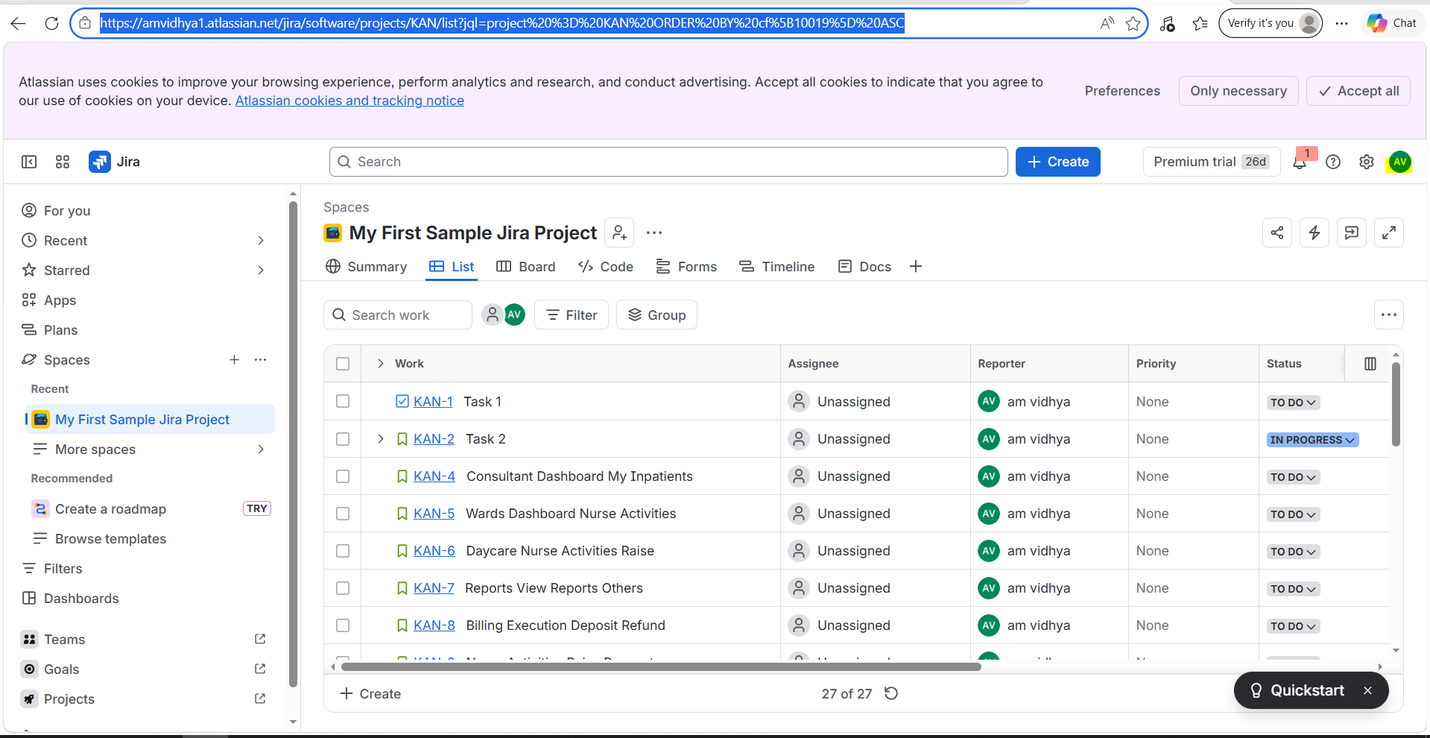
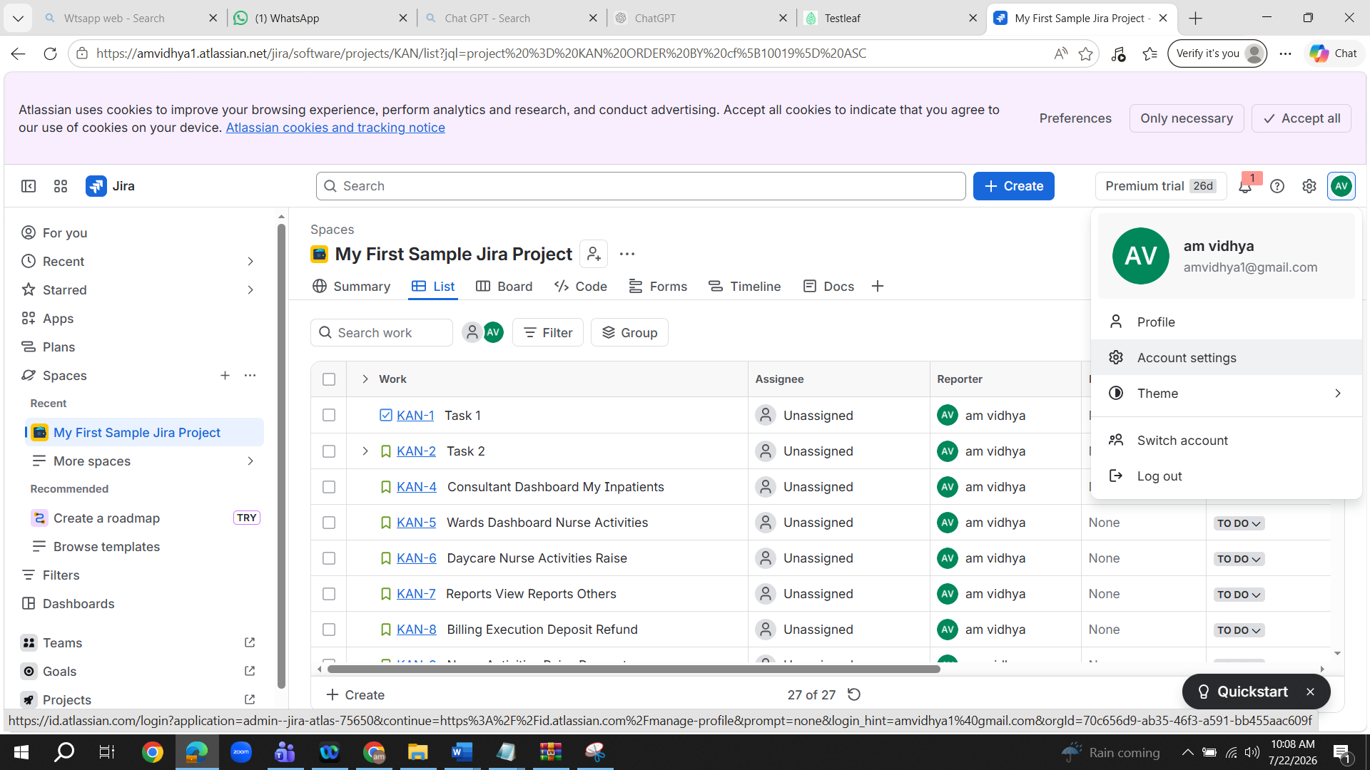
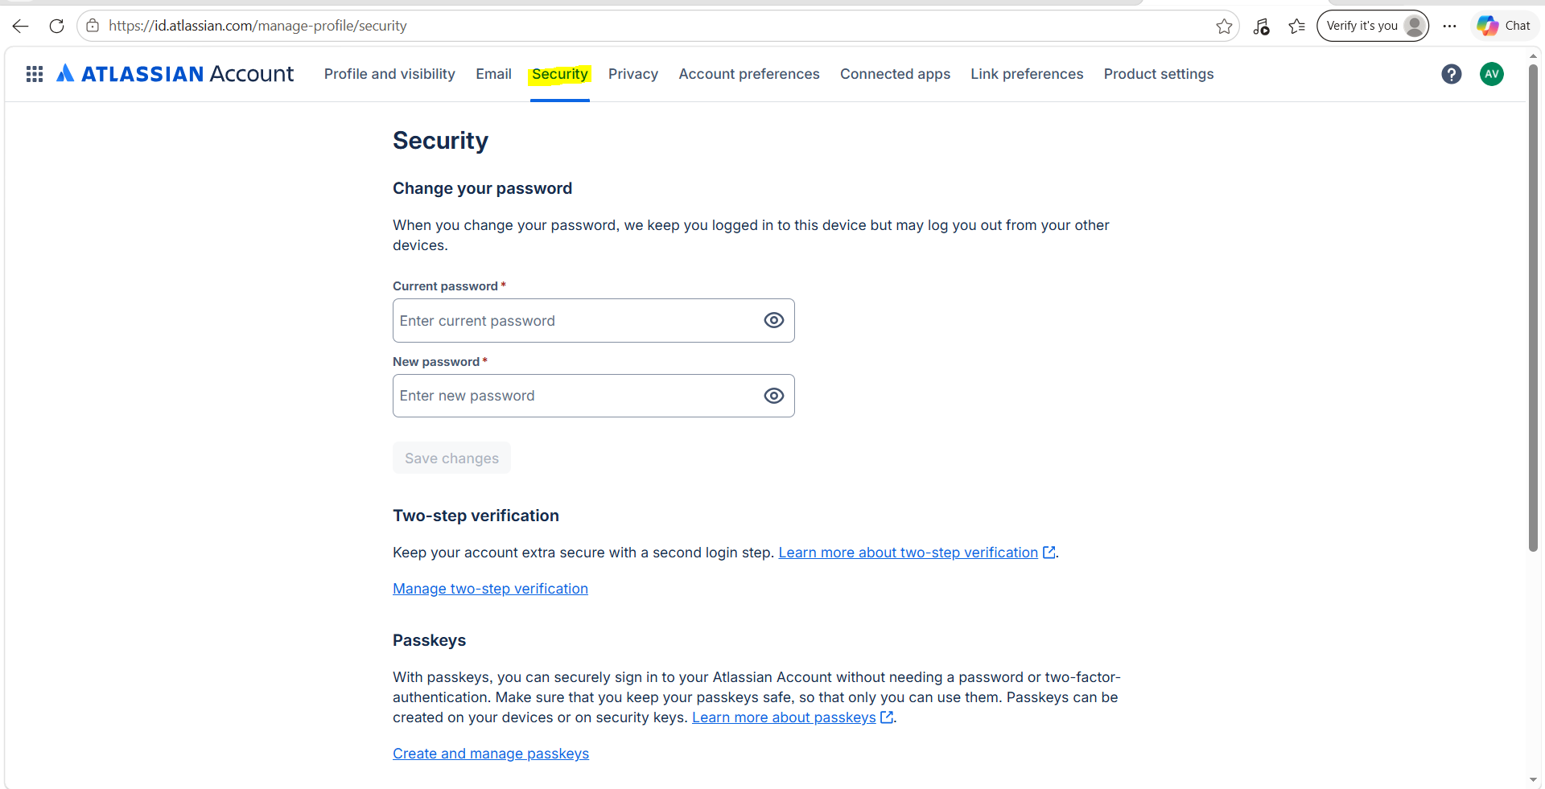

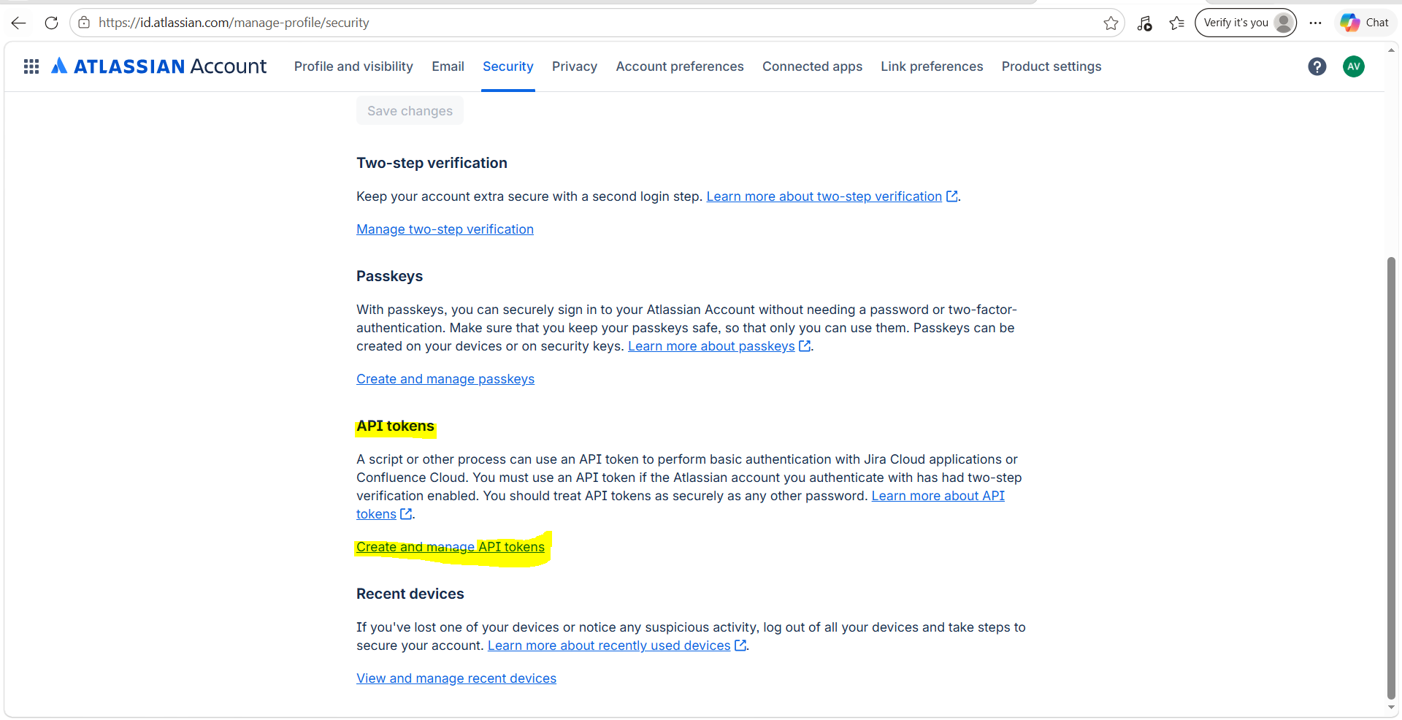
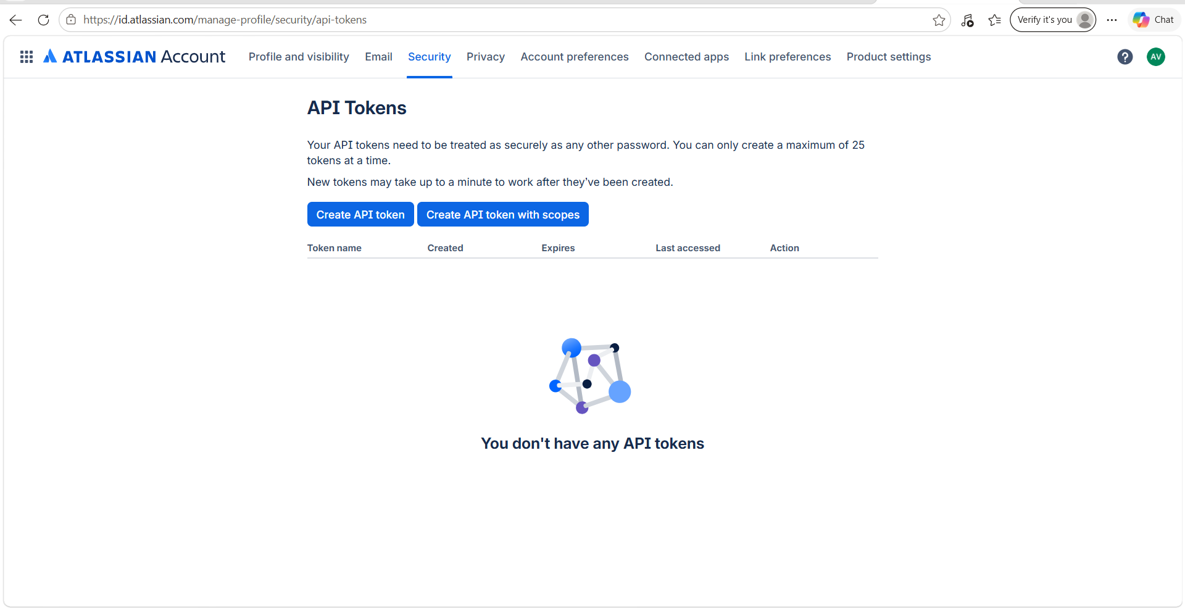

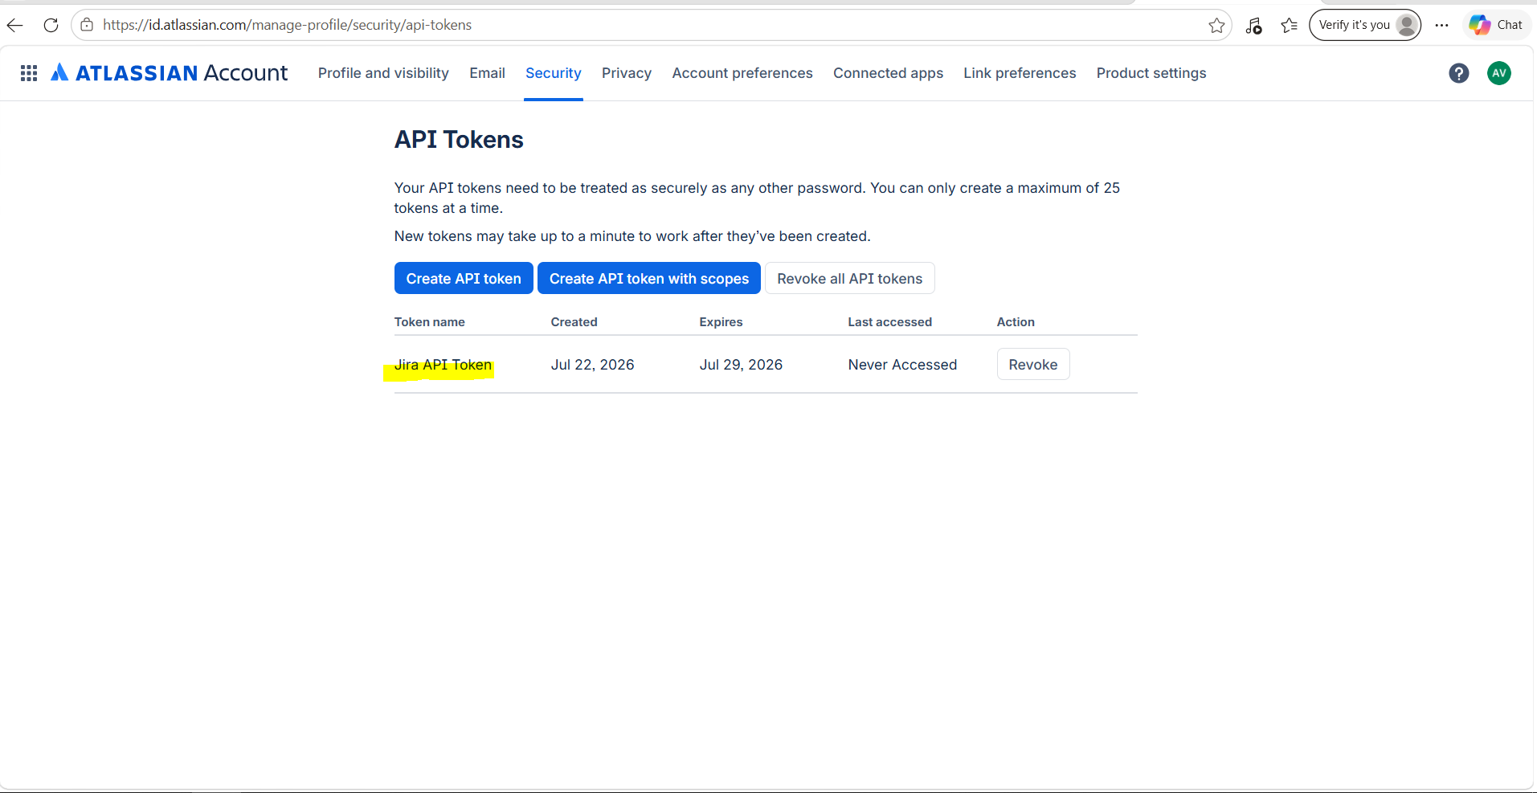
Open VS Code
File- New Window
File-Open folder.Give the below path where the User story folder is there
C:\Users\rta\Documents\Vidhya_Assignment link\July 19th\user-story-to-tests-updated-ui\user-story-to-tests-updated-ui
Right click on Front end and type ‘npm run dev’
Copy local url and paste it browser
Jira Instant Details :
Base url : https://amvidhya1.atlassian.net/jira/software/projects/KAN/list?jql=project%20%3D%20KAN%20ORDER%20BY%20cf%5B10019%5D%20ASC
Email id: amvidhya1@gmail.com
Jira API key : ATATT3xFfGF0tLV9F63R_PFSkAViFDZfv9BKWnFJ9nnqomcrb2YHt5J0HC3z-ZfWFWnD47Q8rL26Sh-246wBPXhS4Ht_fvYwvmJ_WE_eXorlLOvwR1fskd-XAWanOdw8vjkA_xVNzSoGKijyl321Ax0m3fs4v7YaKWWo9fJfN4nIXSG4n5Tz5vU=24DB36AD
Give the below prompt in Plan mode in Copilet
Front end:
Need to add "Connect Jira" button to establish the connection
Base url :
Email id:
Jira API key :
Add the variables in .env file
Give the below prompt in agent mode
Go ahead with the implementation

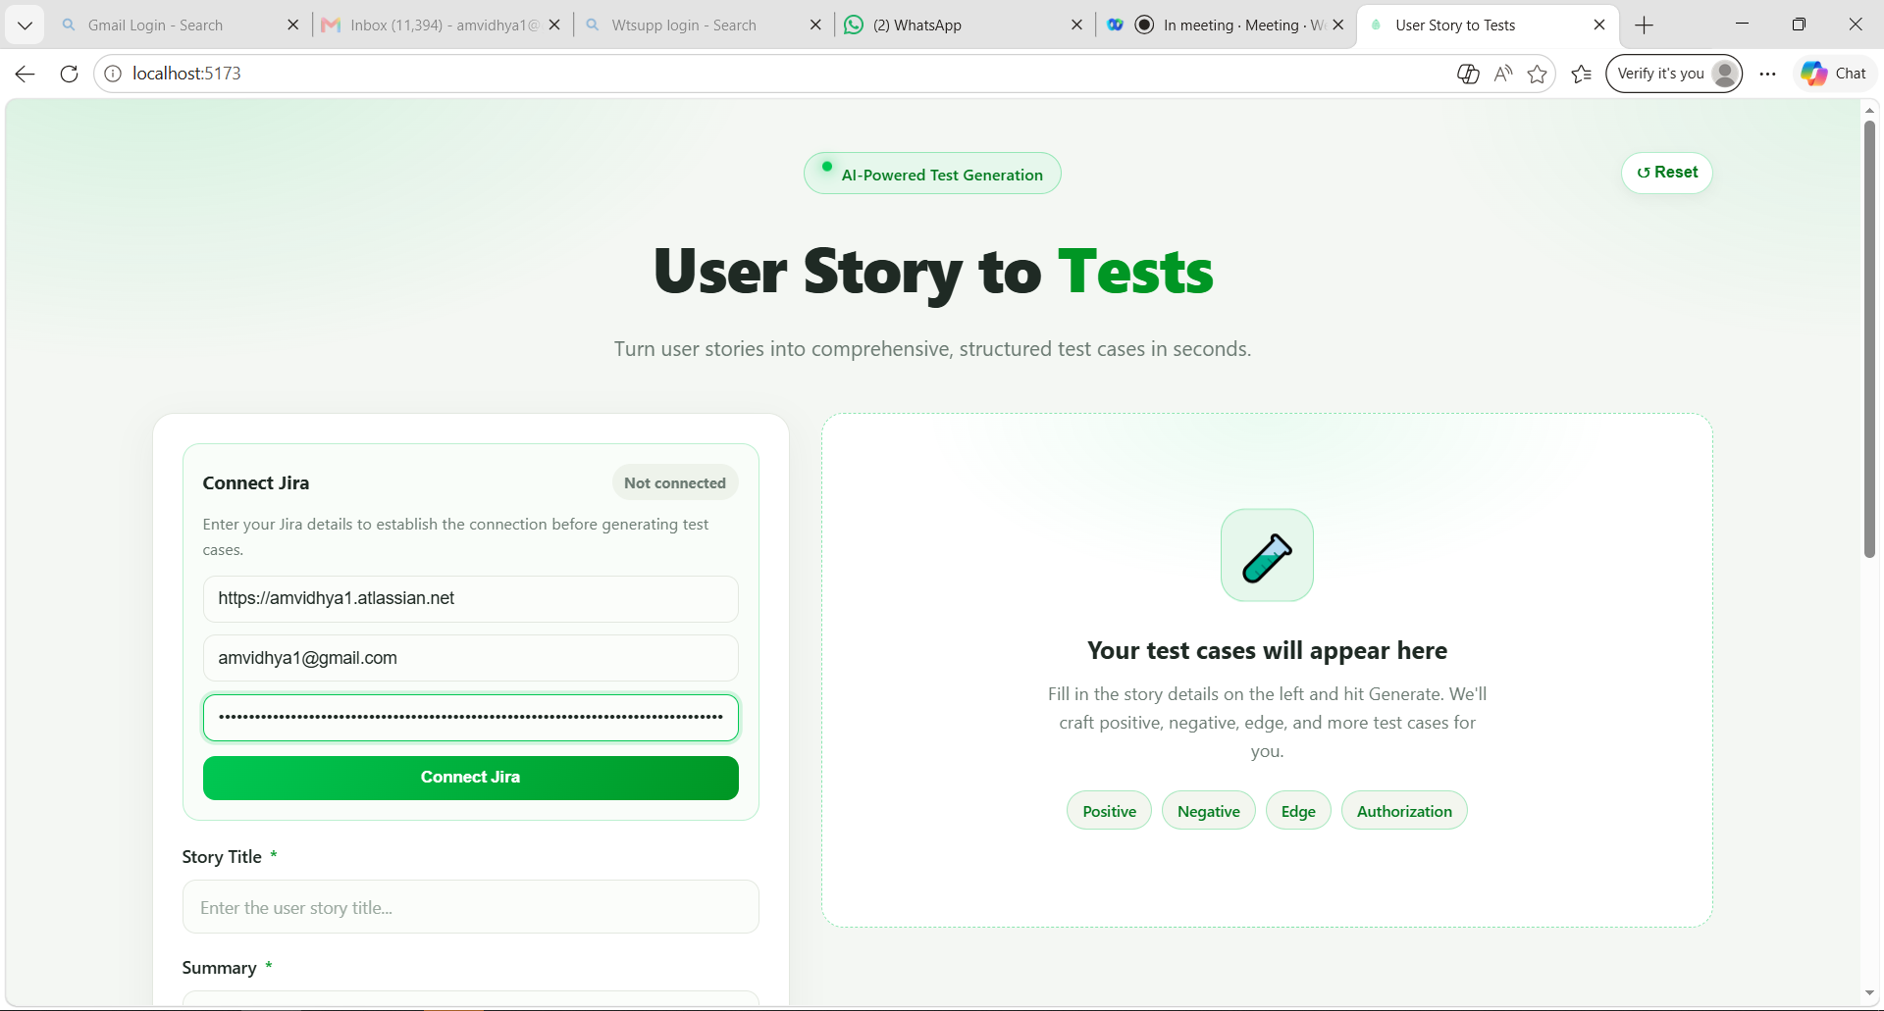
The following details needs to be entered in the field and click on ‘Connect Jira’
Base url : https://amvidhya1.atlassian.net
Email id: amvidhya1@gmail.com
Jira API key : ATATT3xFfGF0tLV9F63R_PFSkAViFDZfv9BKWnFJ9nnqomcrb2YHt5J0HC3z-ZfWFWnD47Q8rL26Sh-246wBPXhS4Ht_fvYwvmJ_WE_eXorlLOvwR1fskd-XAWanOdw8vjkA_xVNzSoGKijyl321Ax0m3fs4v7YaKWWo9fJfN4nIXSG4n5Tz5vU=24DB36AD

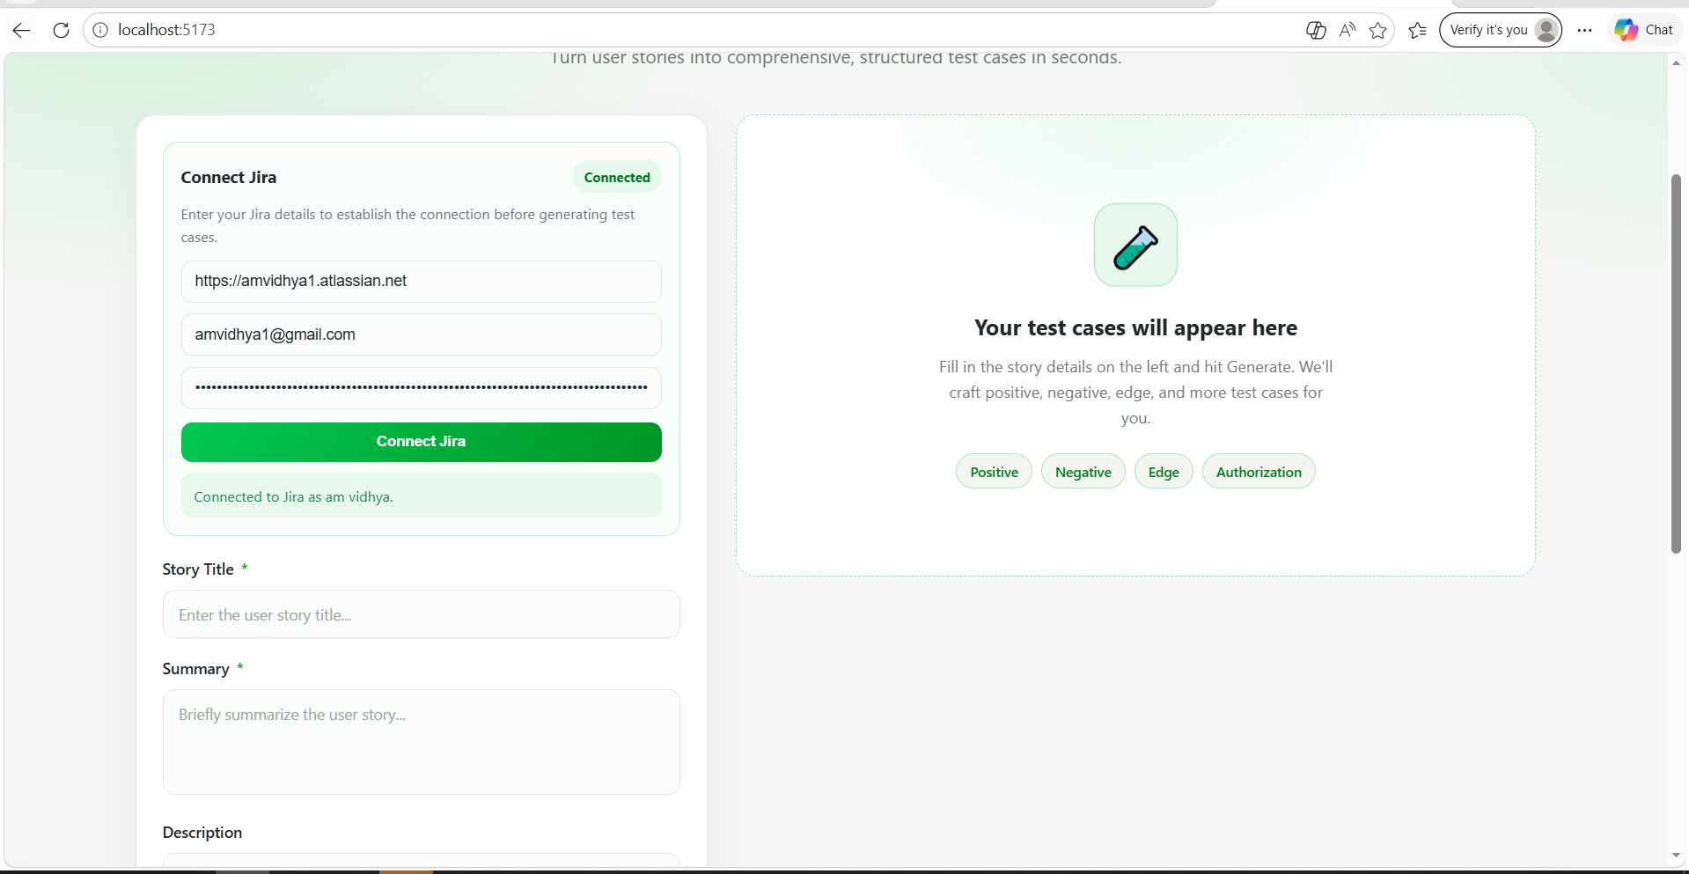

In plan mode give the below prompt
On clicking ‘Connect Jira’ button and it is connected to Jira, need to fetch all the user stories in a dropdown list. On selecting the User story ID, the details like Title, Summary, Description and acceptance Criteria from the User story should be loaded into the form. When I reselect another user story respective details should be populated in the form.
Analyze the entire code and come up with a plan to implement in frontend and blackened step by step. Document the plan in .md file
[STRICTLY] DO THE IMPLEMENTATION ONLY ON UI

In agent mode give the below prompt after reviewing the response for the above prompt
Go ahead with the implementation
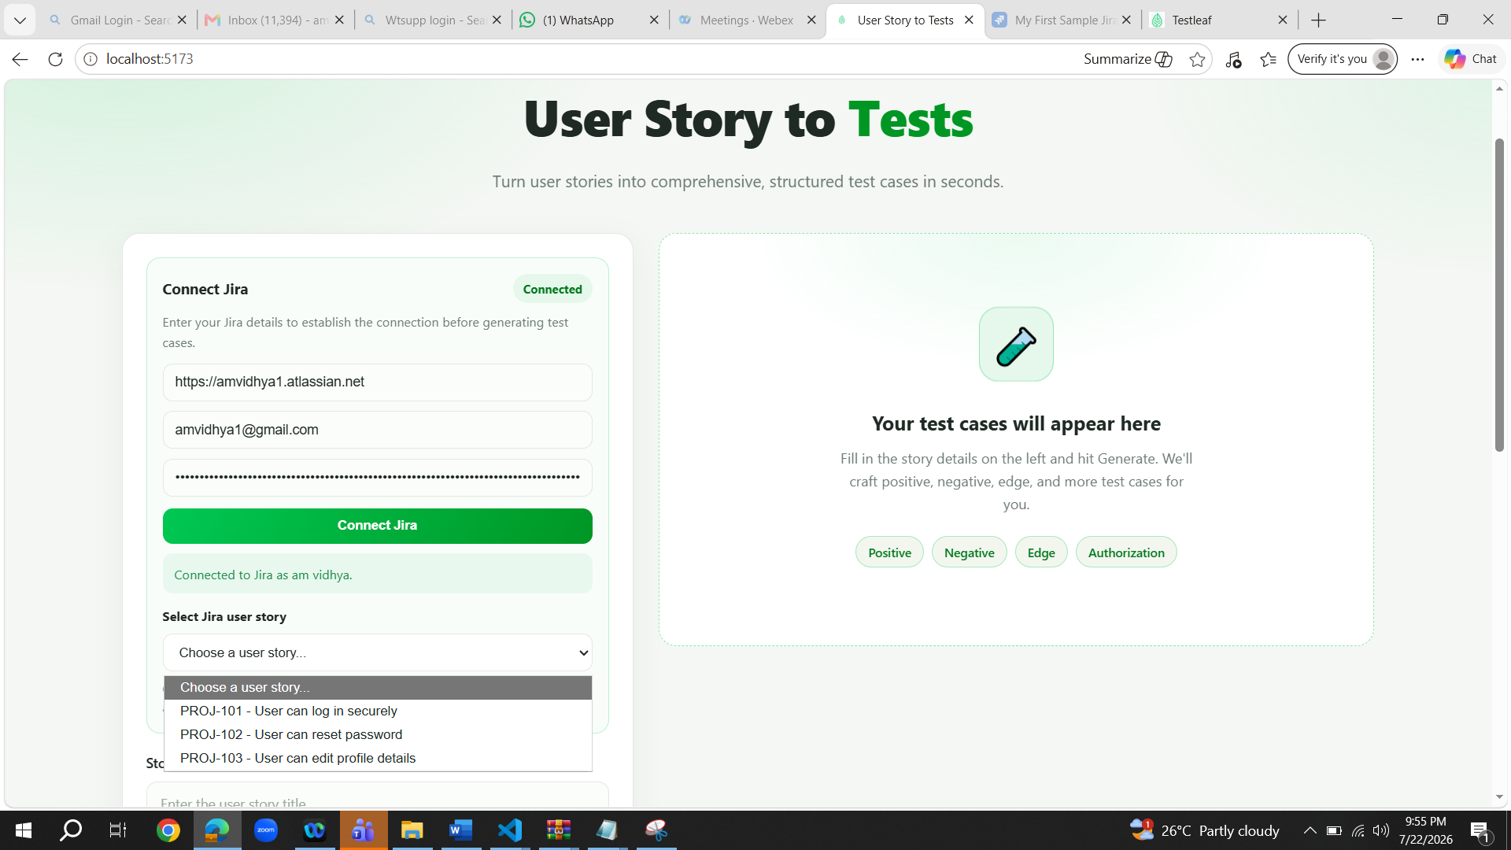
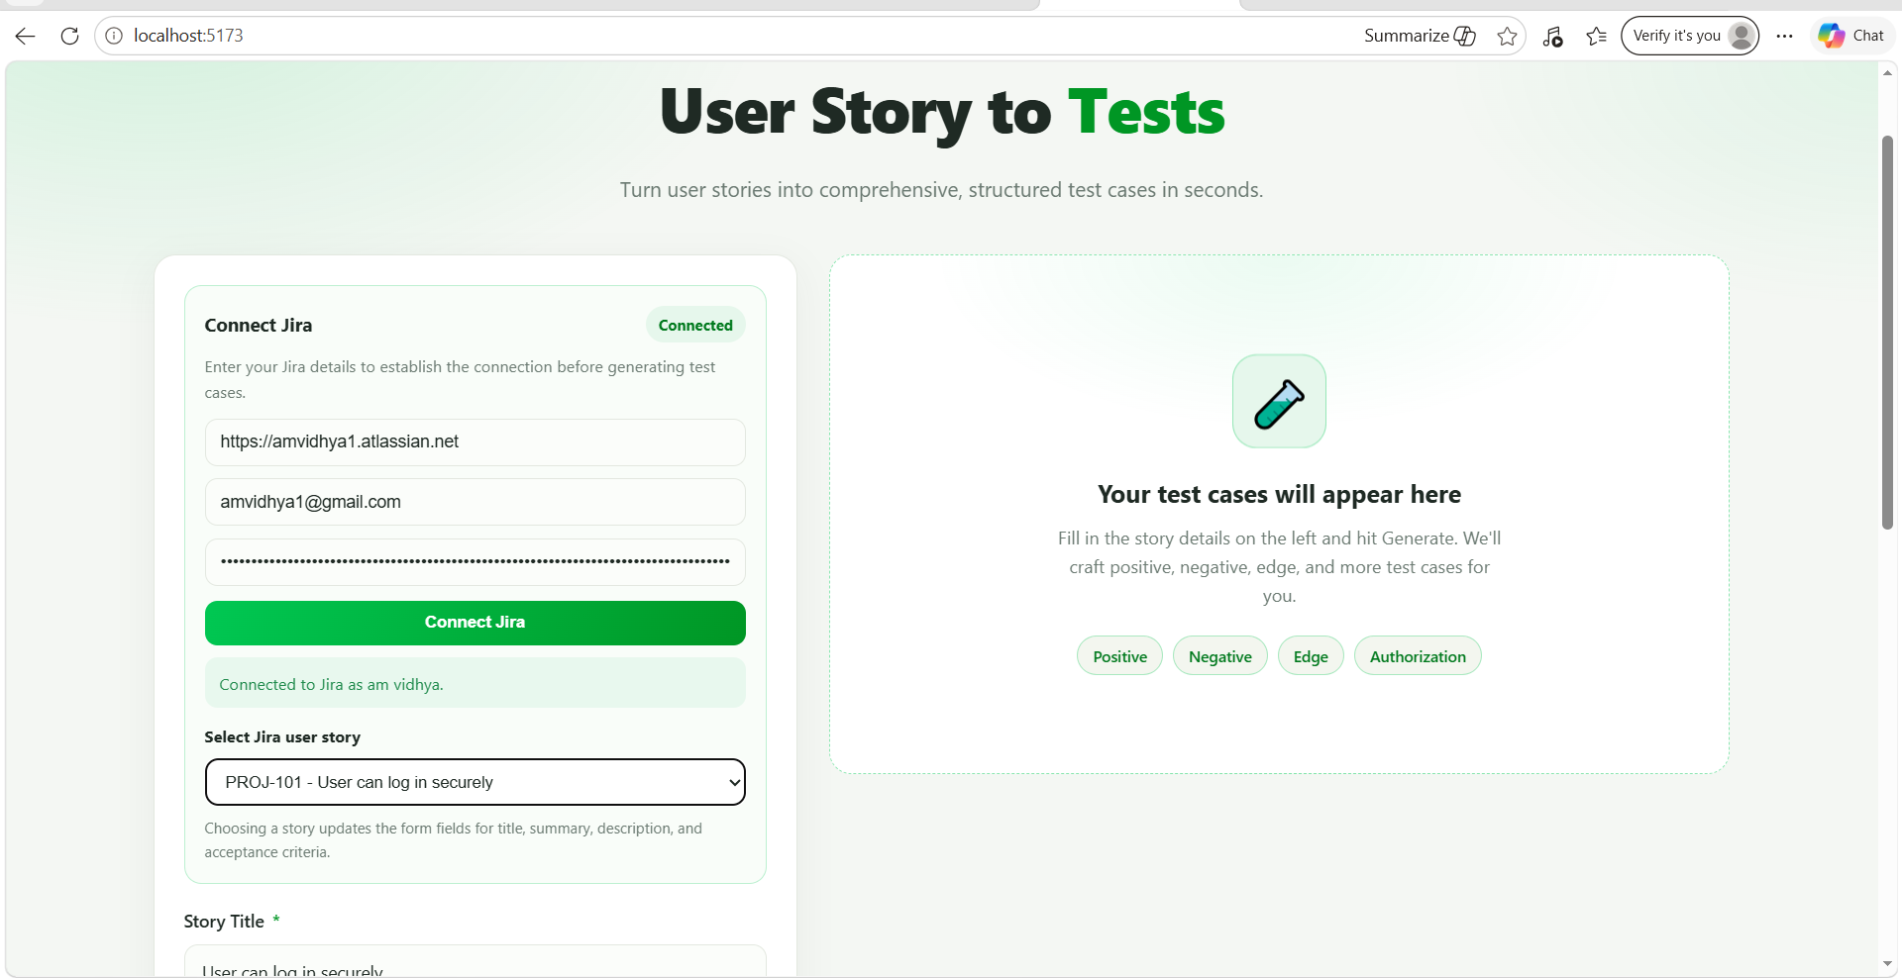

All fields are auto populated as expected
