Assignment:
Enhance the existing application by implementing a feature that automatically categorizes the generated test cases into standard testing types such as Smoke, Sanity, Regression, Functional.
Once the test cases are generated, the application should classify each test case into the most appropriate category and display the categorized results in a structured and user-friendly format
The new functionality should seamlessly integrate with the existing test case generation workflow without impacting current features
Steps followed :
Open VS Code and go to File-New Window
File-Open folder. Give the below path where you have saved the extracted Swagger file
C:\Users\rta\Documents\Vidhya_Assignment link\July 25th\swagger-api-testcase-generator-updated-ui\swagger-api-testcase-generator-updated-ui
Right click Backend folder and select Open in integrated terminal
Type ‘npn run dev’
Right click Frontend folder and select Open in integrated terminal
Type ‘npn run dev’
Copy the local URL and paste it in chrome browser.
http://localhost:5173/
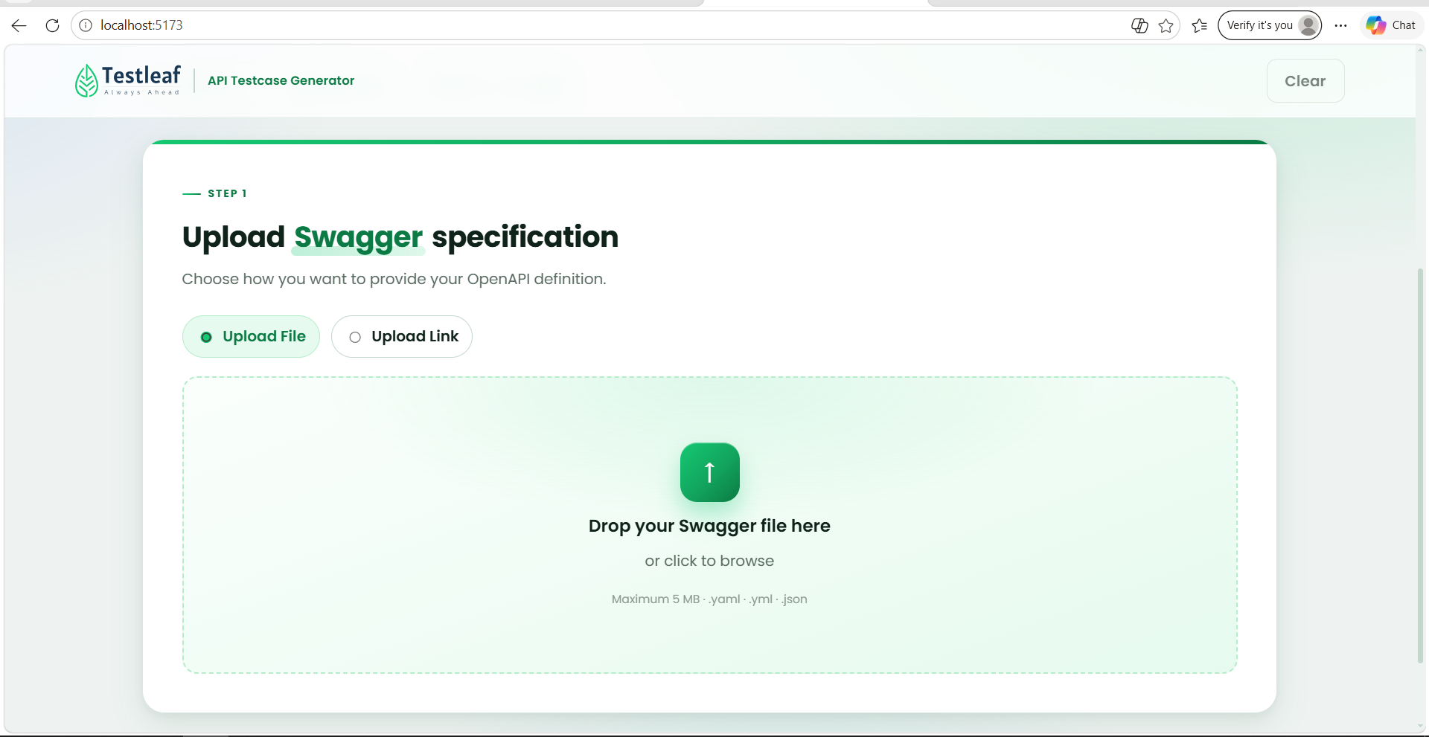

Give the below prompt in ‘Ask’ mode
Analyse my entire project as an API Architect.
Currently, on clicking ‘Generate Test cases’, test cases are generated based on the uploaded file or uploaded link. I want to introduce a new feature after generation of test cases by categorizing the generated test cases into standard testing types such as smoke, sanity, regression and functional. Once the test cases are generated, the application should classify each test case into the most appropriate category and display the categorized results in a structured and user-friendly format. The new functionality should seamlessly integrate with the existing test case generation workflow without impacting current features. Do not implement any changes. Provide only the list of impacted files. Ask for my approval before proceeding with the implementation.
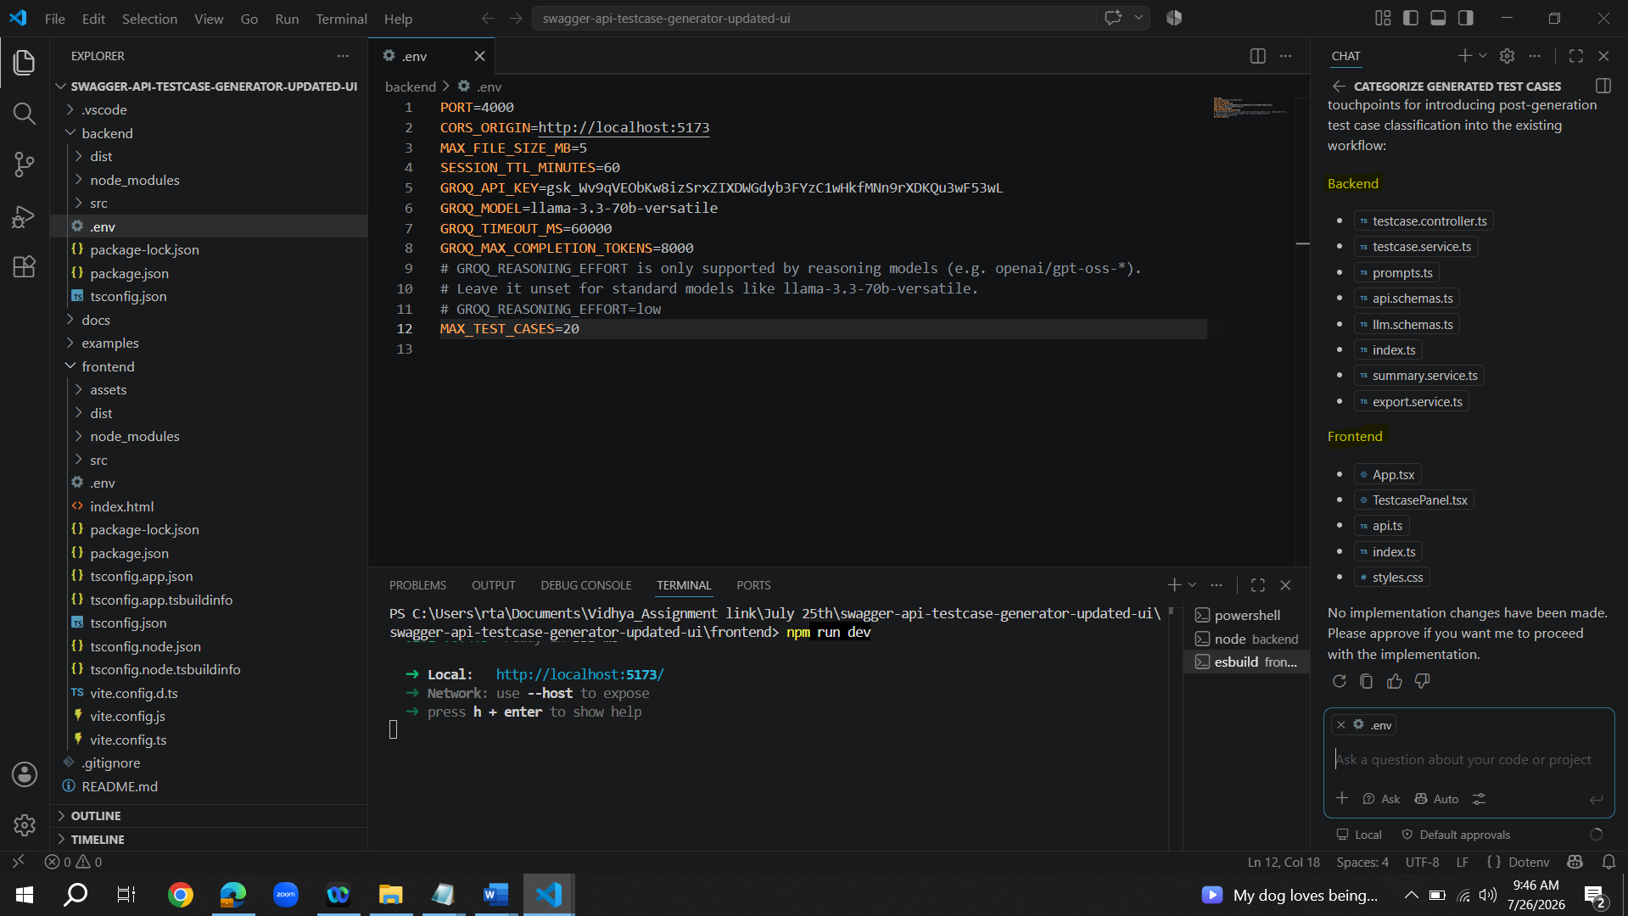
Agent Mode :
Go ahead with the implementation
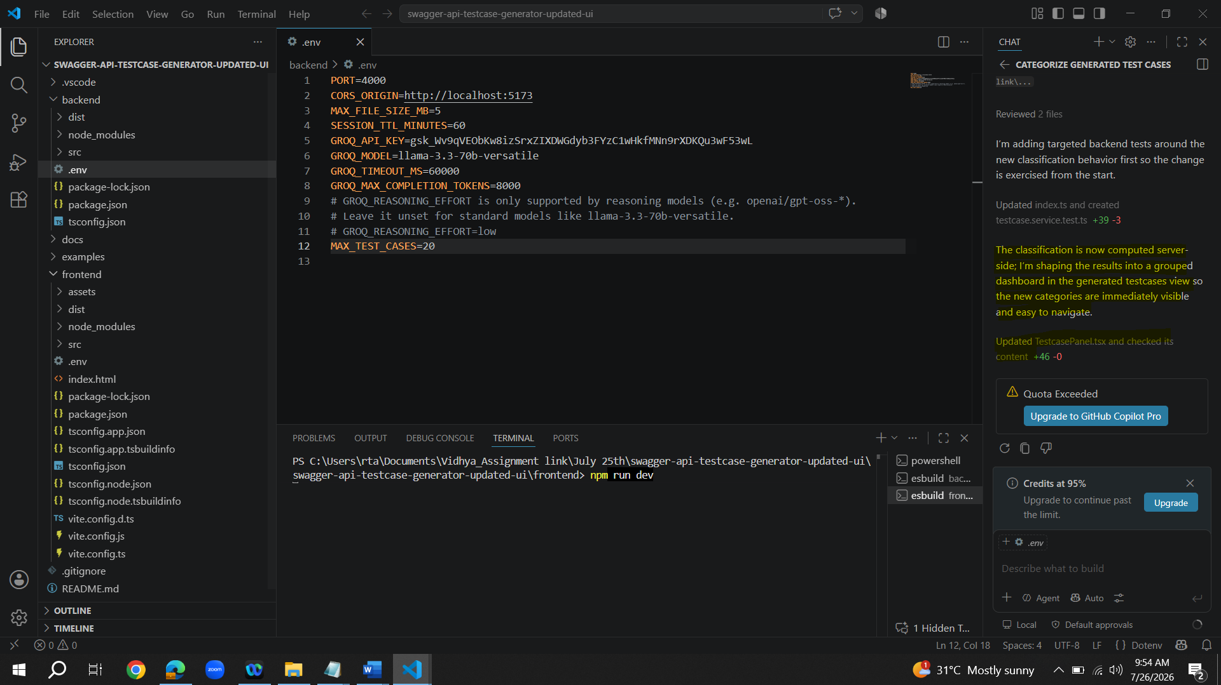
When selecting ‘Upload File’ radio button and selecting Restful API file from the path I have saved it. Test cases are generated along with the categorization as expected.
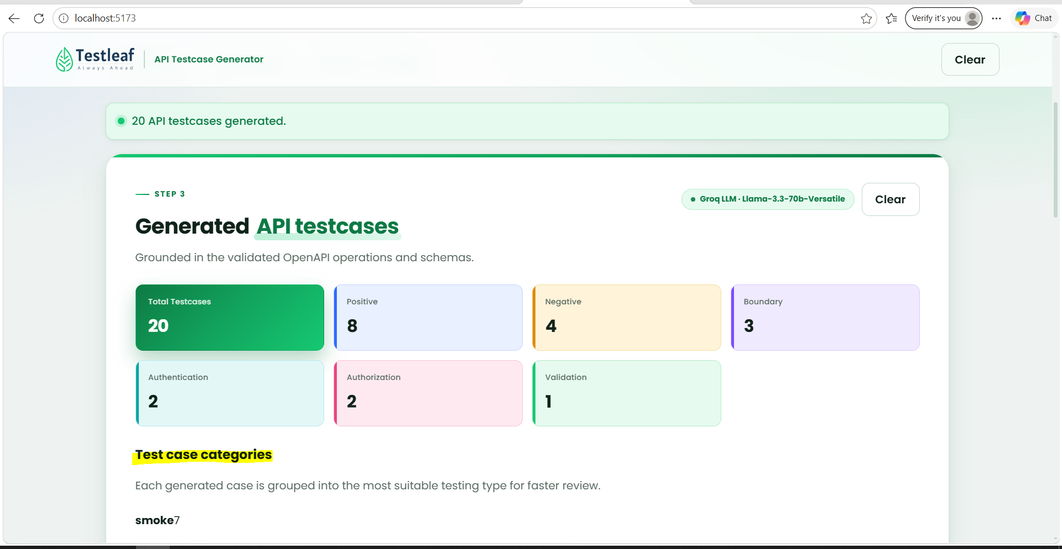
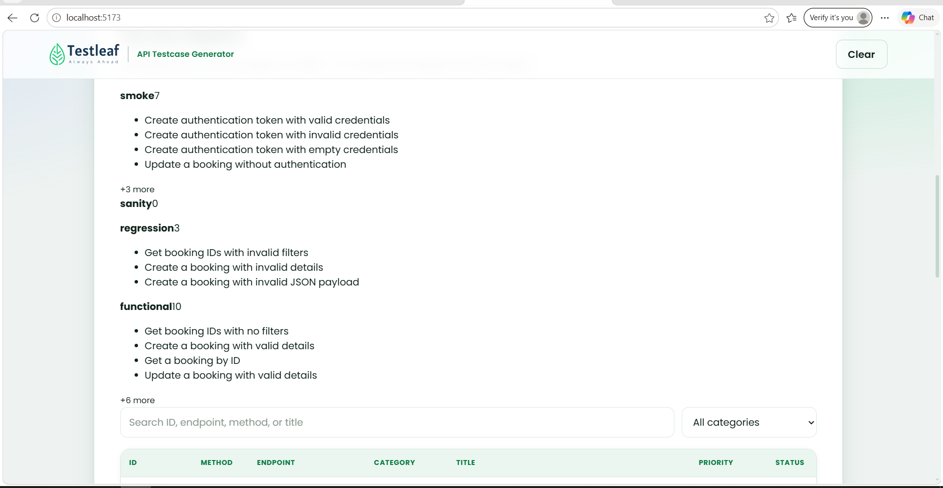
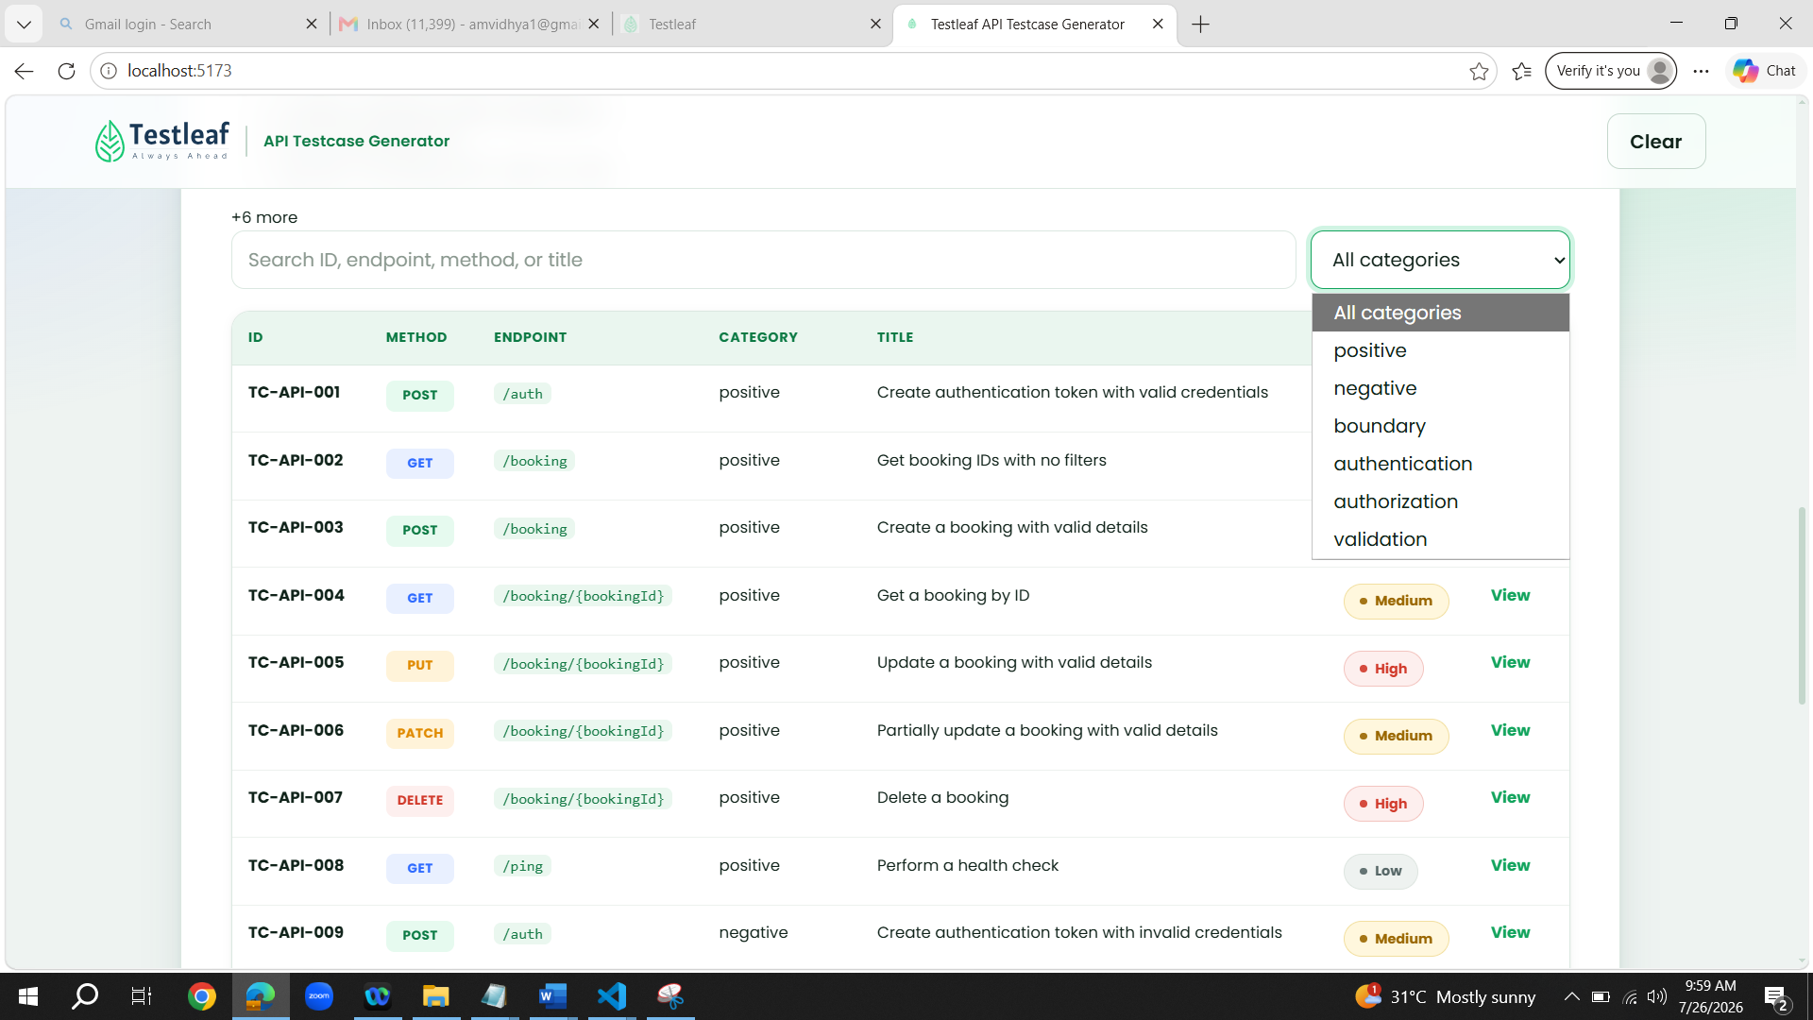
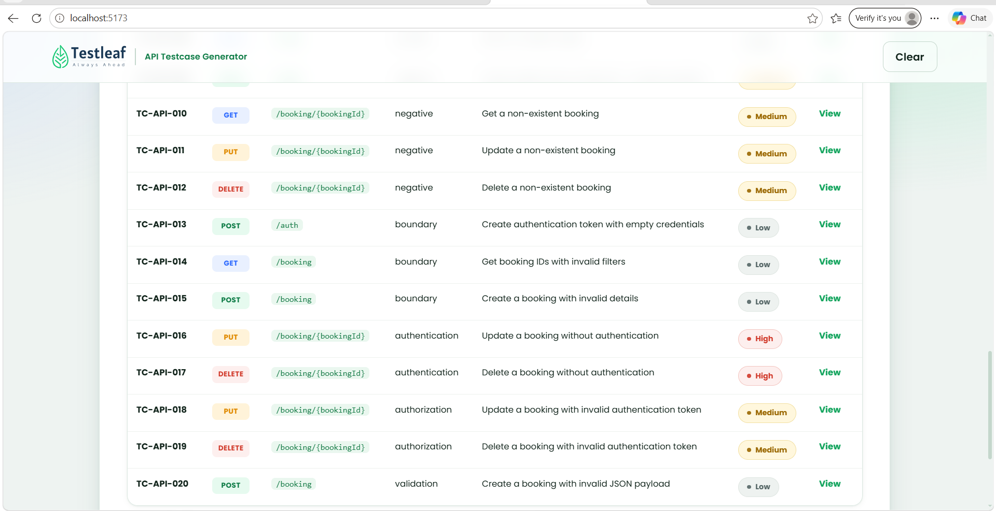
When selecting ‘Upload Link’ radio button, test cases are generated along with the categorization as expected. Copy the highlighted link from Google by searching ‘Swagger Petstore’
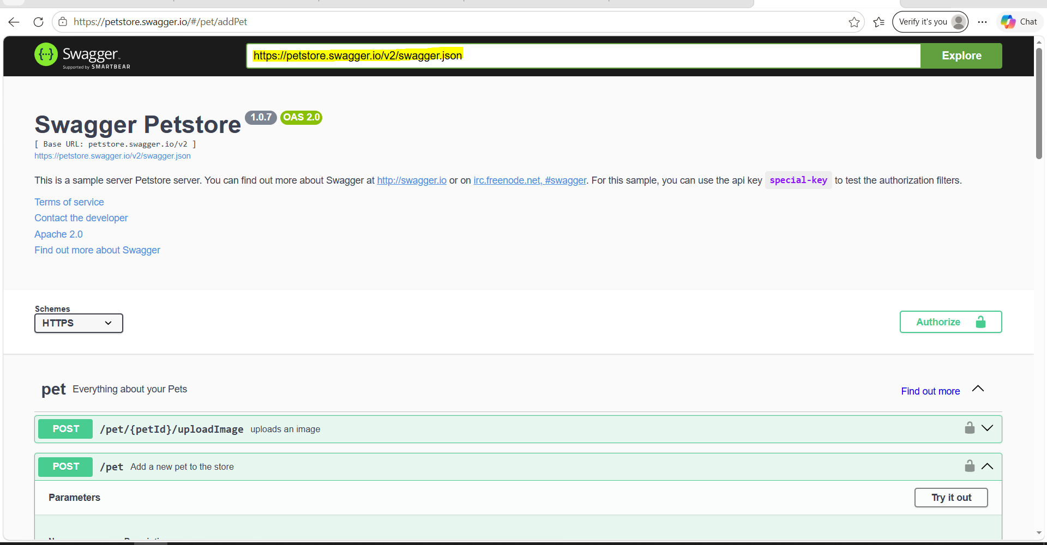
Go into Local URL and select ‘Upload Link’ radio button. Give the copied URL and click on ‘Import from URL’
