Write a prompt to create Frontend_Enhancement Architecture file in Chat GPT
# I — INSTRUCTION

I already completed my backend and Frontend implementation.

Now I want to add additional features to the existing frontend web application for the same project.I want to enhance existing frontend web application by implementing additional features

Please help me design the complete frontend architecture in Markdown format for the additional features

I want the response to be simple, clean, and easy to follow.

Do not assume I already know:
- frontend architecture
- API integration structure
- folder organization
- state management
- UI flow

Please decide everything based on my requirement.

Do not generate implementation code.

Generate only:
- frontend architecture
- frontend flow
- UI flow
- folder structure
- component planning
- state management planning
- API integration planning
- phase-wise implementation

The response should be easy to implement step-by-step.

Do not overcomplicate the explanation.

[STRICT] Dont change any existing functionality until I say something

[Mandatory] By going through the existing code base add the new phases for the folllowing additional features to enhance the existing frontend application.These additional features should be displayed under 'AI Enhancement' section in the UI
[Mandatory]- Re-ranking of retrieved resumes
[Mandatory]- Deduplication of repeated results
[Mandatory]- Summarization of the final results
[Mandatory]- Complete end-to-end pipeline integration
[Mandatory]- Display all relevant results clearly on the UI

[STRICT] The additional features should be displayed as seperate options in frontened application

[Important] Organization name should be displayed on right side top corner as 'Horizon Health'
[Important] Use standard brand theme and colours
[Important] Use Professional UI layout
[Important] Give me a responsive design
[Important] When user requests something in the application, before displaying the results it should be indicated in the application as 'Loading'
[Important] When results are displayed for the request,a success message should be displayed in the application
[Important] An error message should be displayed when expected result are not displayed.

[STRICT] After completing the implementation, test the complete end-to-end application.
---

# C — CONTEXT

I already completed:
- backend retrieval system
- backend ingestion system
- frontend web application

Now I want to enhance the existing frontend web application.

The frontend should support the following features along with existing features :

1. Re-ranking of retrieved resumes
2. Deduplication of repeated results
3. Summarization of the final results
4. Complete end-to-end pipeline integration
5. Display all relevant results clearly on the UI

ingestion flow frontend is already implemented.Retrieval/Search frontend is also already implemented inside the same application.

The application should:
- upload resume PDFs
- show upload progress
- show processing states
- show ingestion success
- allow searching resumes
- display candidate results
- open candidate details
- Re-rank the retrieved resumes
- De-duplicate the repeated results
- Summarize the final results
- Complete end-to-end pipeline integration
- Display all revant results clearly on the UI

The frontend should integrate with my existing backend APIs.

Technology Stack:

- React
- TypeScript
- Vite
- TailwindCSS

The frontend should be clean and modular.

---
# E — EXAMPLE

The application flow should work something like this:

Resume Upload
↓
Resume Processing
↓
Embedding Generation
↓
Resume Stored
↓
Resume Search
↓
Candidate Results
↓
Candidate Details
↓
Re-rank the retreived resumes
↓
De-Duplicate the repeated results
↓
Summarize the final results
↓
Complete end-to-end pipeline integration
↓
Display all relevant results clearly in UI

The frontend architecture should explain:
- what screens are needed
- what components are needed
- how frontend flow should work
- how API communication should happen
- how state should be managed
- how upload flow should work
- how search flow should work

The response should also explain:
- folder structure
- component responsibilities
- loading flow
- error handling
- validation flow

---
# P — PERSONA

Act like an experienced frontend architect designing a production-ready frontend application.

Keep the explanation:
- practical
- simple
- implementation-oriented
- beginner friendly
- cleanly organized

Avoid unnecessary technical complexity.

---
# O — OUTPUT FORMAT

Generate the response in Markdown format.

The response should contain:

1. Frontend Overview
2. Frontend Application Flow
3. Recommended Folder Structure
4. UI Screen Planning
5. Component Planning
6. State Management Flow
7. Upload Flow
8. Search Flow
9. Validation Handling
10. Error Handling
11. Loading States
12. Phase-wise Frontend Implementation
13. Final End-to-End Frontend Flow

Use:
- markdown headings
- flow diagrams
- tables where needed
- simple explanations

Do not generate implementation code.

---
# T — TASK

Design the additional features in the existing frontend architecture for a Resume ingestion and Resume Retrieval web application to enhance it.

The architecture should clearly explain:
- how the frontend should be organized
- how upload flow should work
- how retrieval flow should work
- how frontend and backend communicate
- how the UI should behave
- how the full frontend pipeline should be implemented phase-by-phase

Generate the final frontend architecture document now.
Create ‘Frontend Enhancement’ folder inside the below path and place the md file generated by Chat GPT
E:\Vidhya_Assignment link\Sep 6th\Home Assignment\Resume_Rag\Frontend
Open the VS code by opening the below folder path
E:\Vidhya_Assignment link\Sep 6th\Home Assignment\Resume_Rag
Write the below prompt in copilot within VS code and follow same steps followed by implementing phase by phase and check in Frontend

We have completed ingestion pipeline implementation,Retrieval pipeline implementation,Frontend web application implementation phase by phase. Now refer my Frontend enhancement architecture document ‘Frontend_Enhancement_Web_Instructions’ and do implementation phase by phase.
Once one phase is completed ,give me Request body and expected response to test in postman .once i tested, after my approval go
for phase 2.same to be followed for rest of the phases also

[STRICT]DONT GO FOR NEXT PHASE UNTIL I APPROVE
[STRICT]DO NOT HALLUCINATE .READ THE ARCHITECTURE CAREFULLY AND START IMPLEMENTATION
[STRICT] DON’T CHANGE ANY EXISTING FUNCTIONALITY UNTIL I SAY SOMETHING3

Debug Prompt for Phase 1 and Phase 2
separate options should be displayed under ‘AI Enhancement’ section
Re-Ranking
DE-DUPLICATION
SUMMARIZATION
[STRICT] Applicable for all type of search modes
[STRICT] Existing Search mode functions should remain unchanged
Vector Search
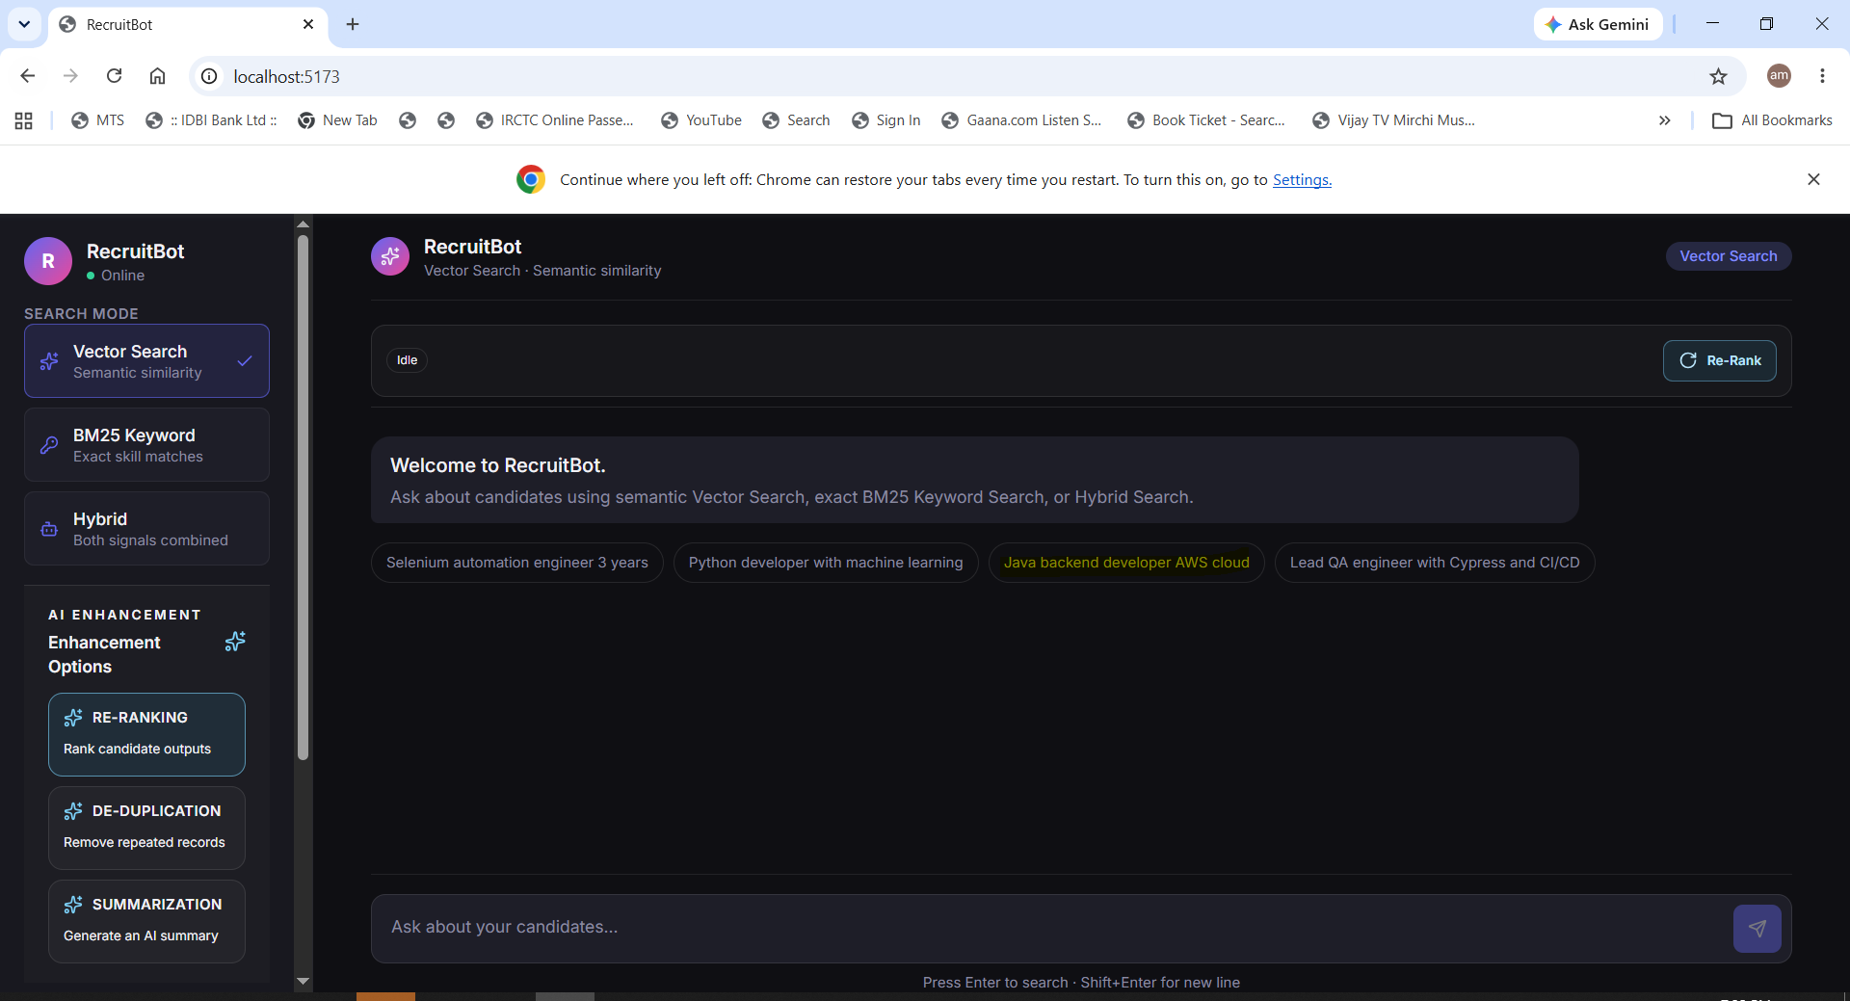
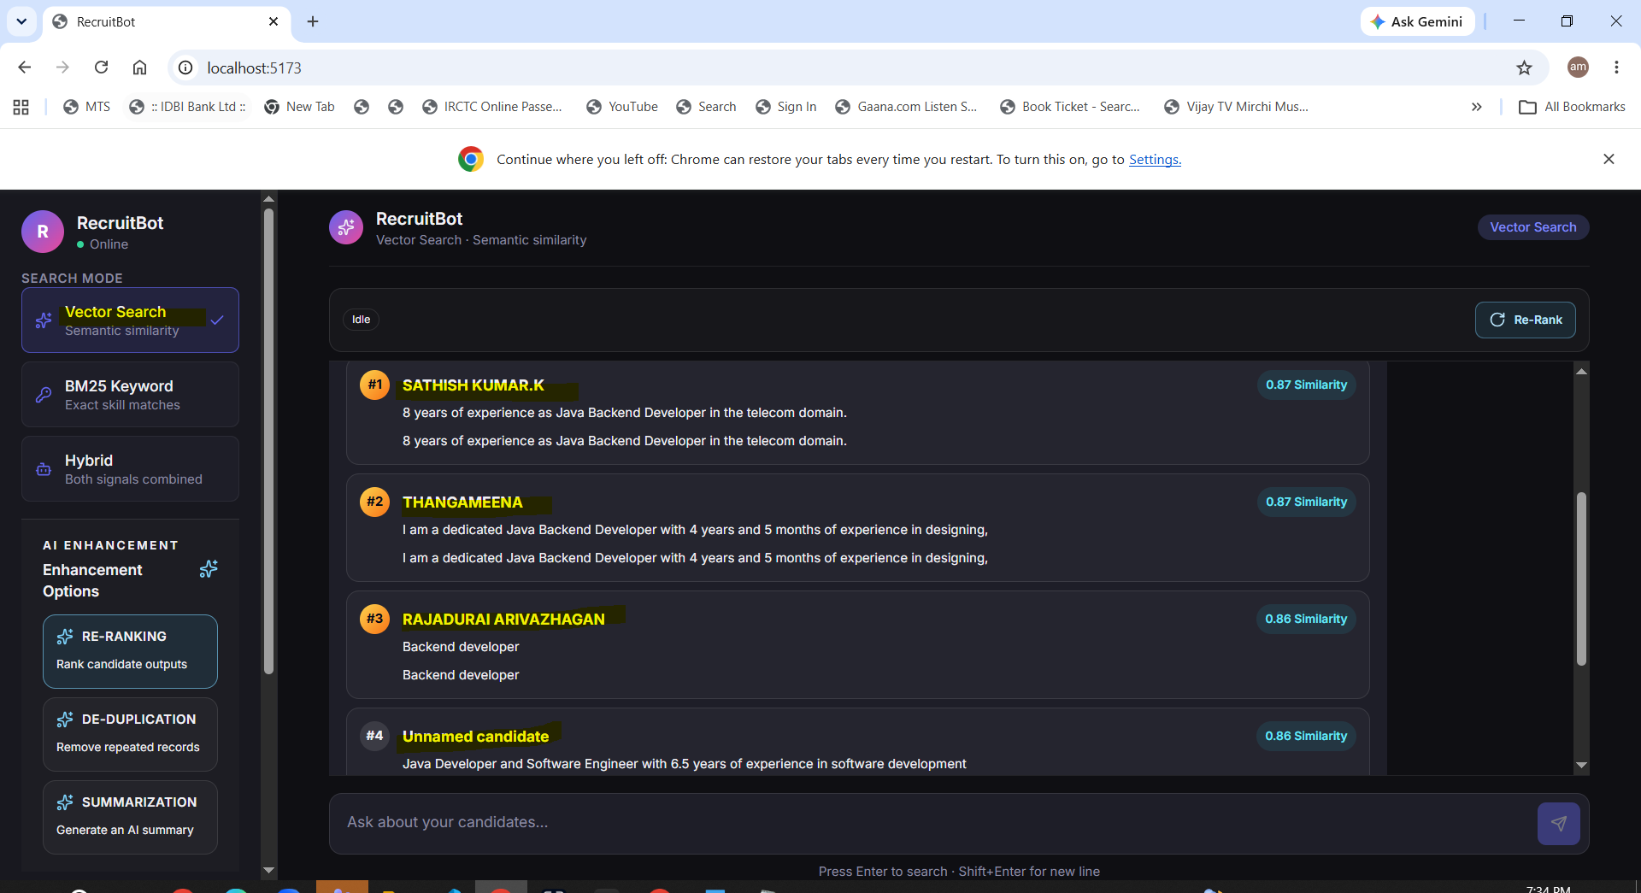
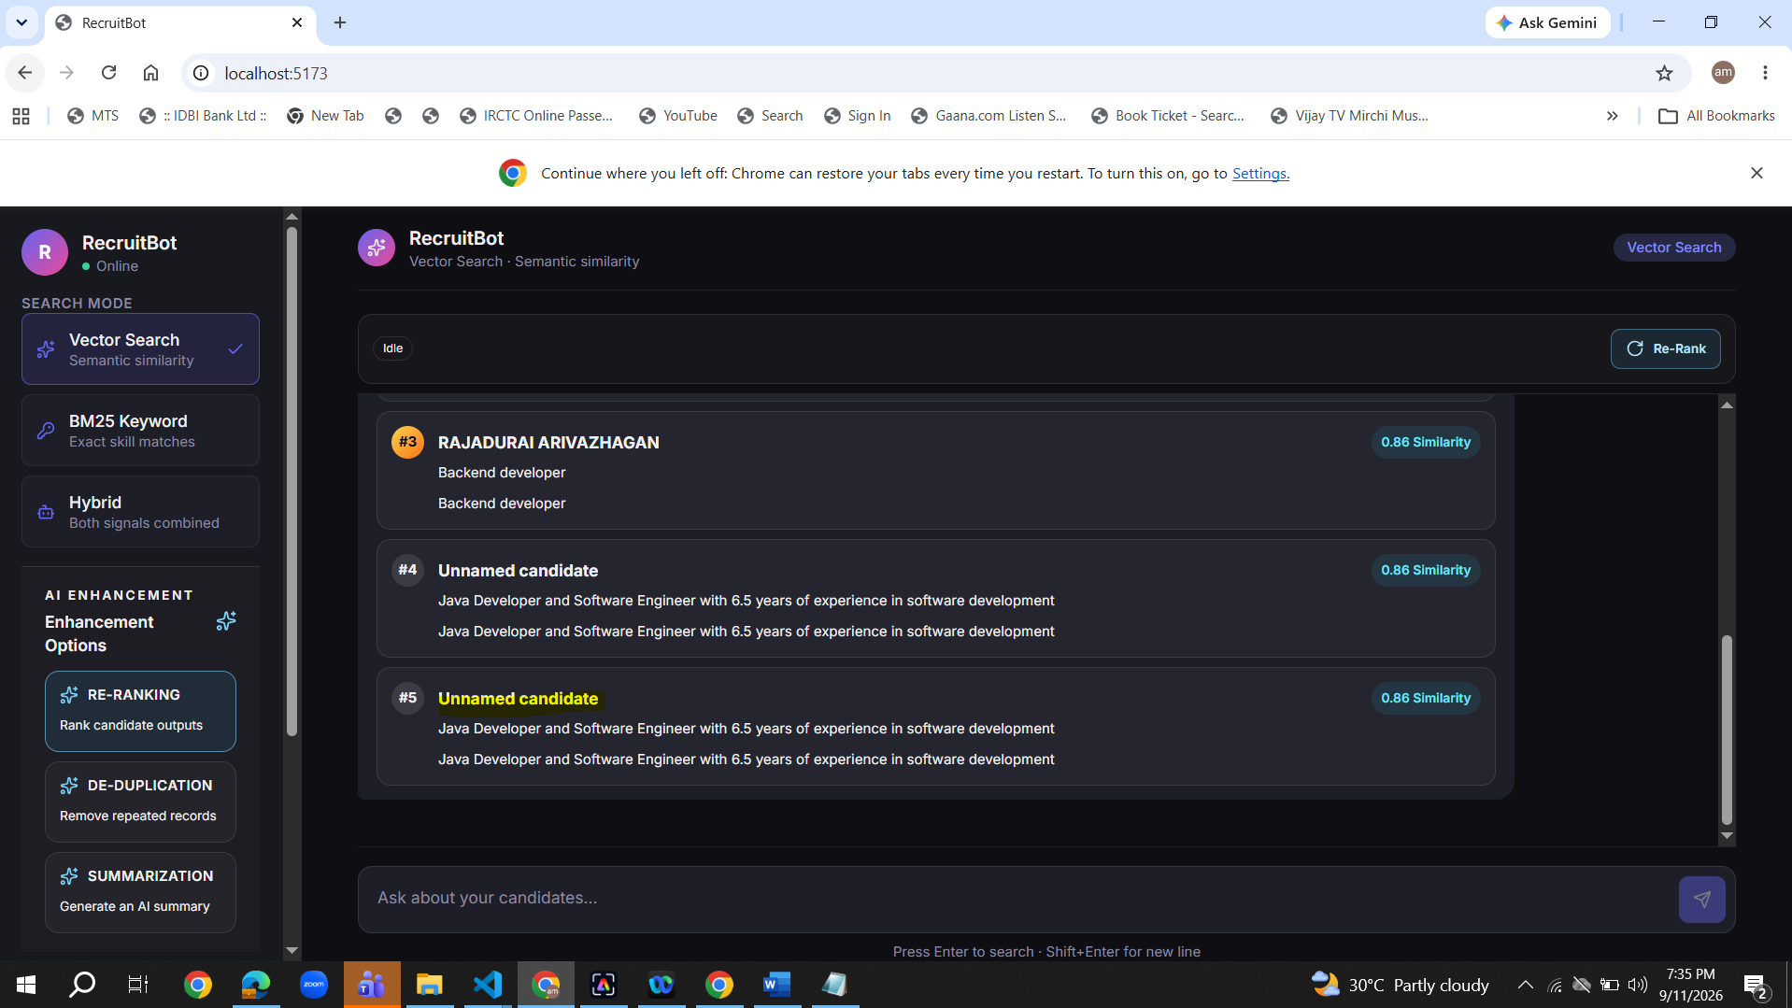

Re-Ranking
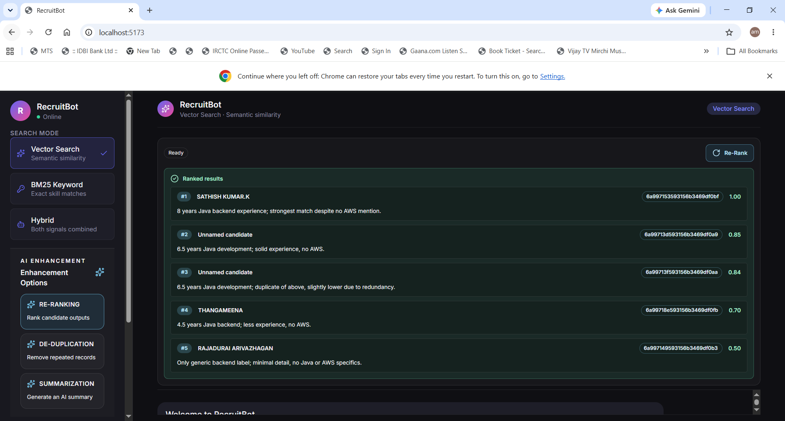
De-Duplication
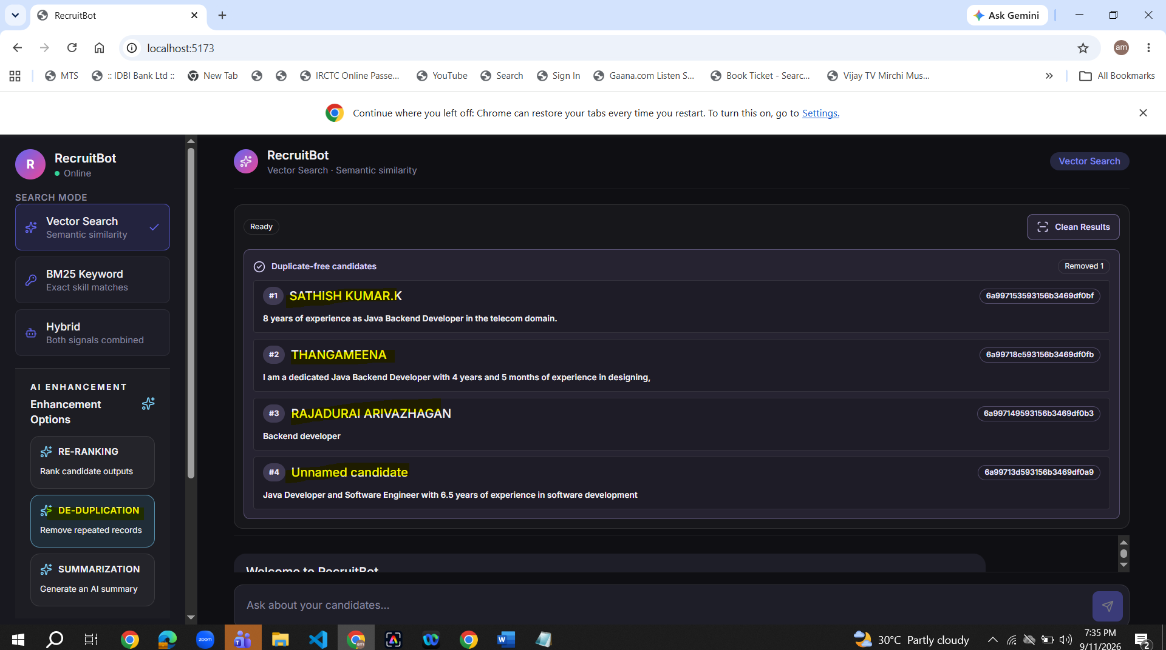
Summarization
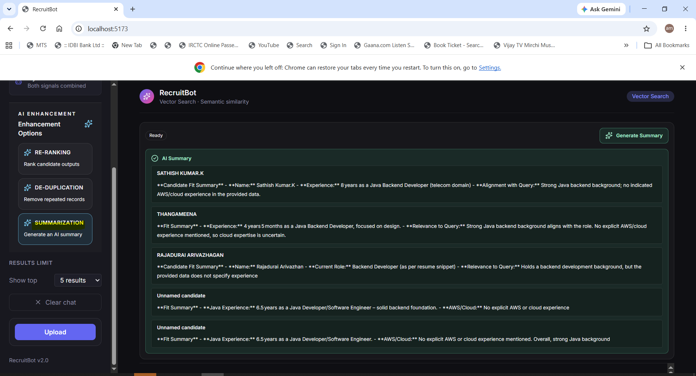
BM25
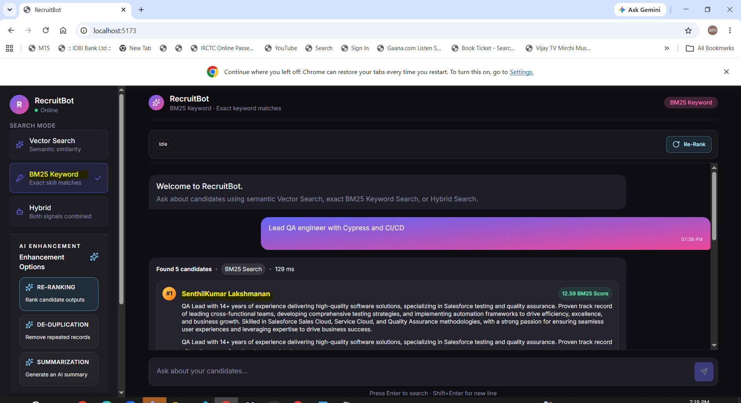
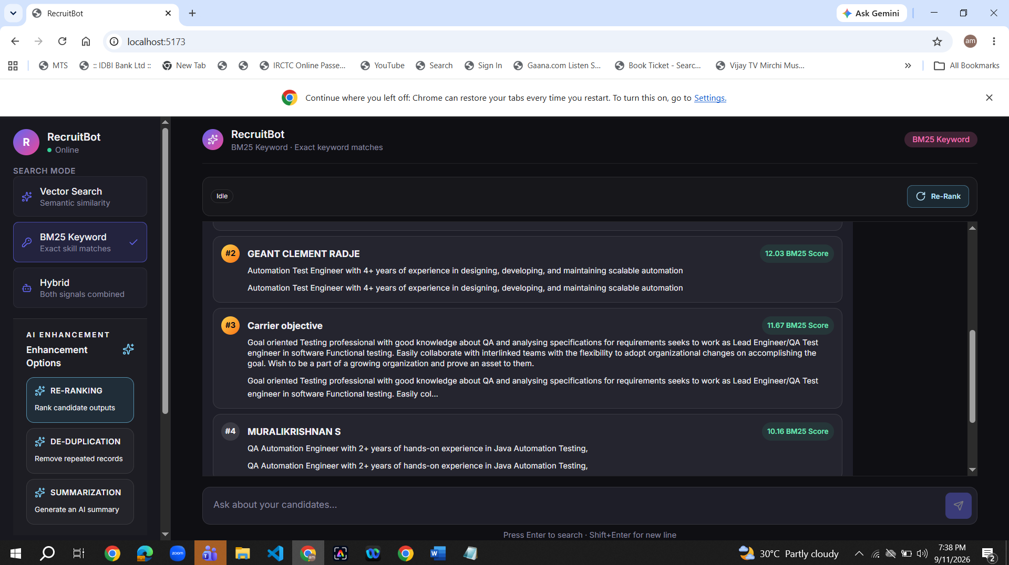
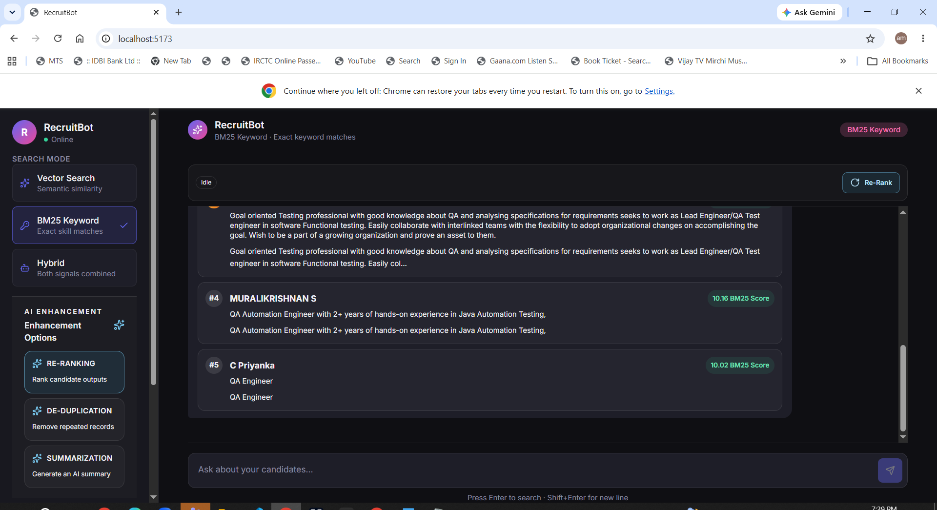

Re-Ranking
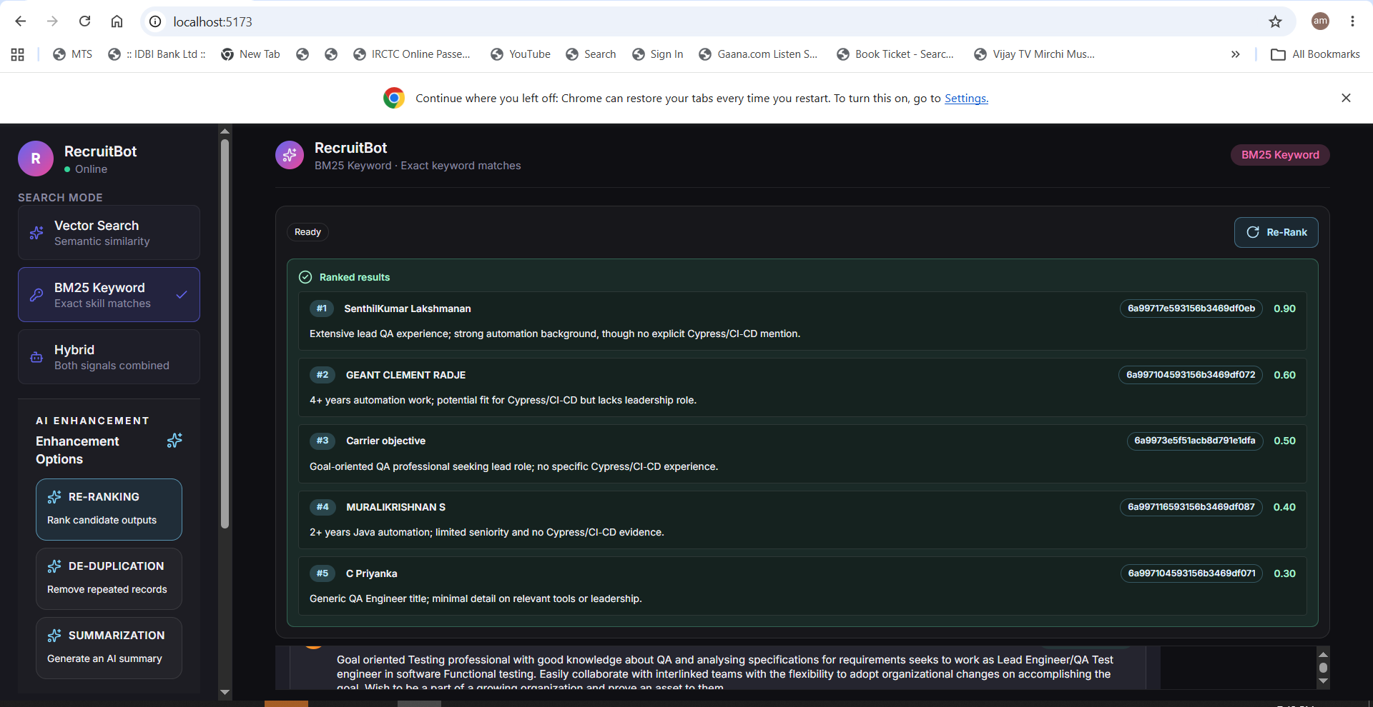

De-Duplication
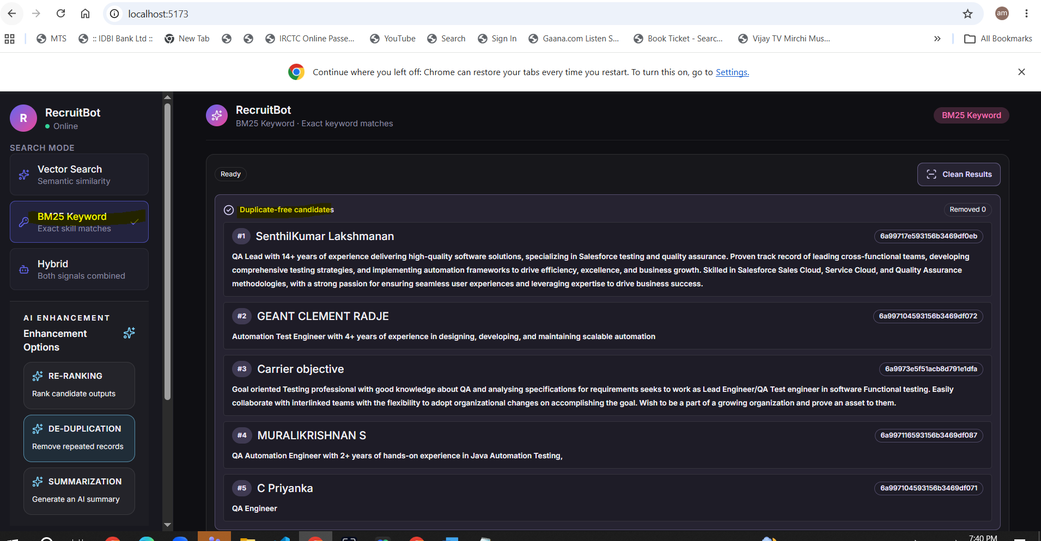

Summarization
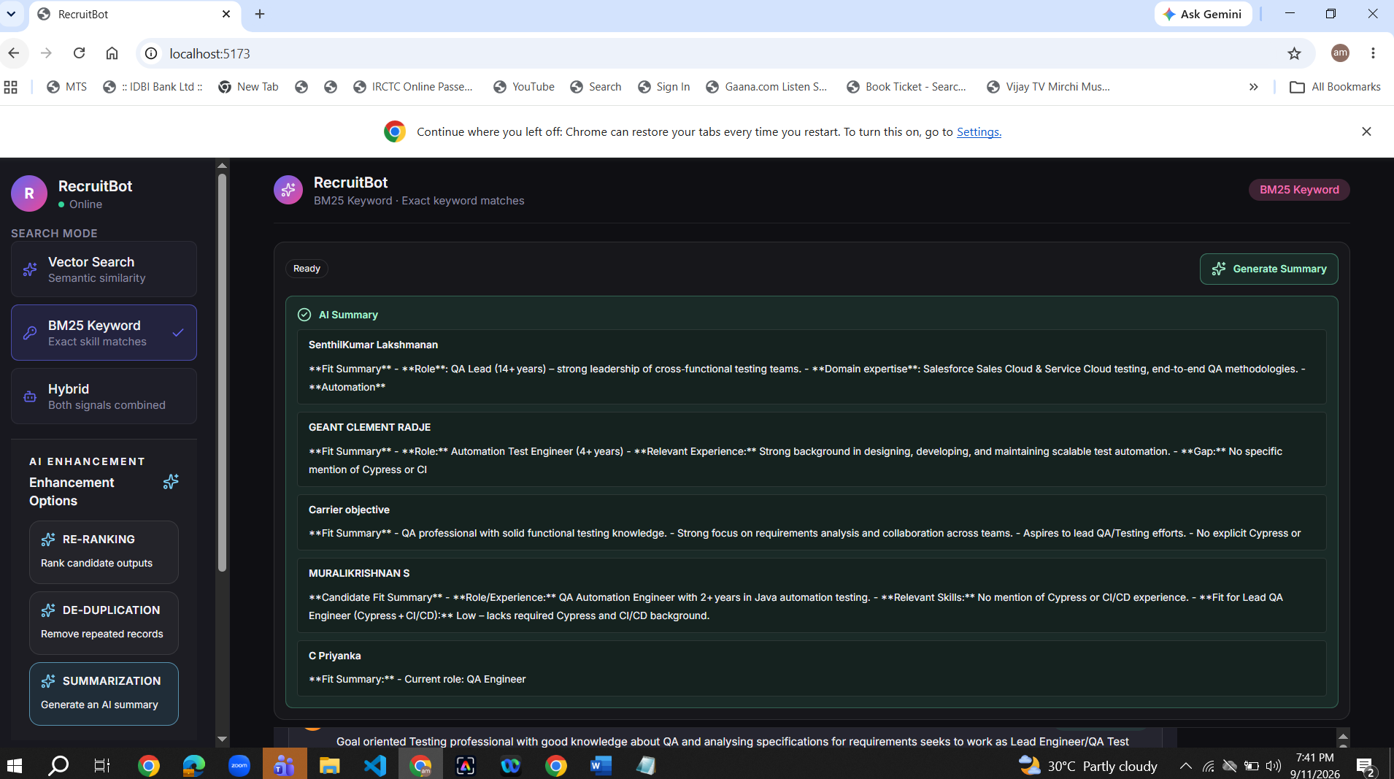
Hybrid
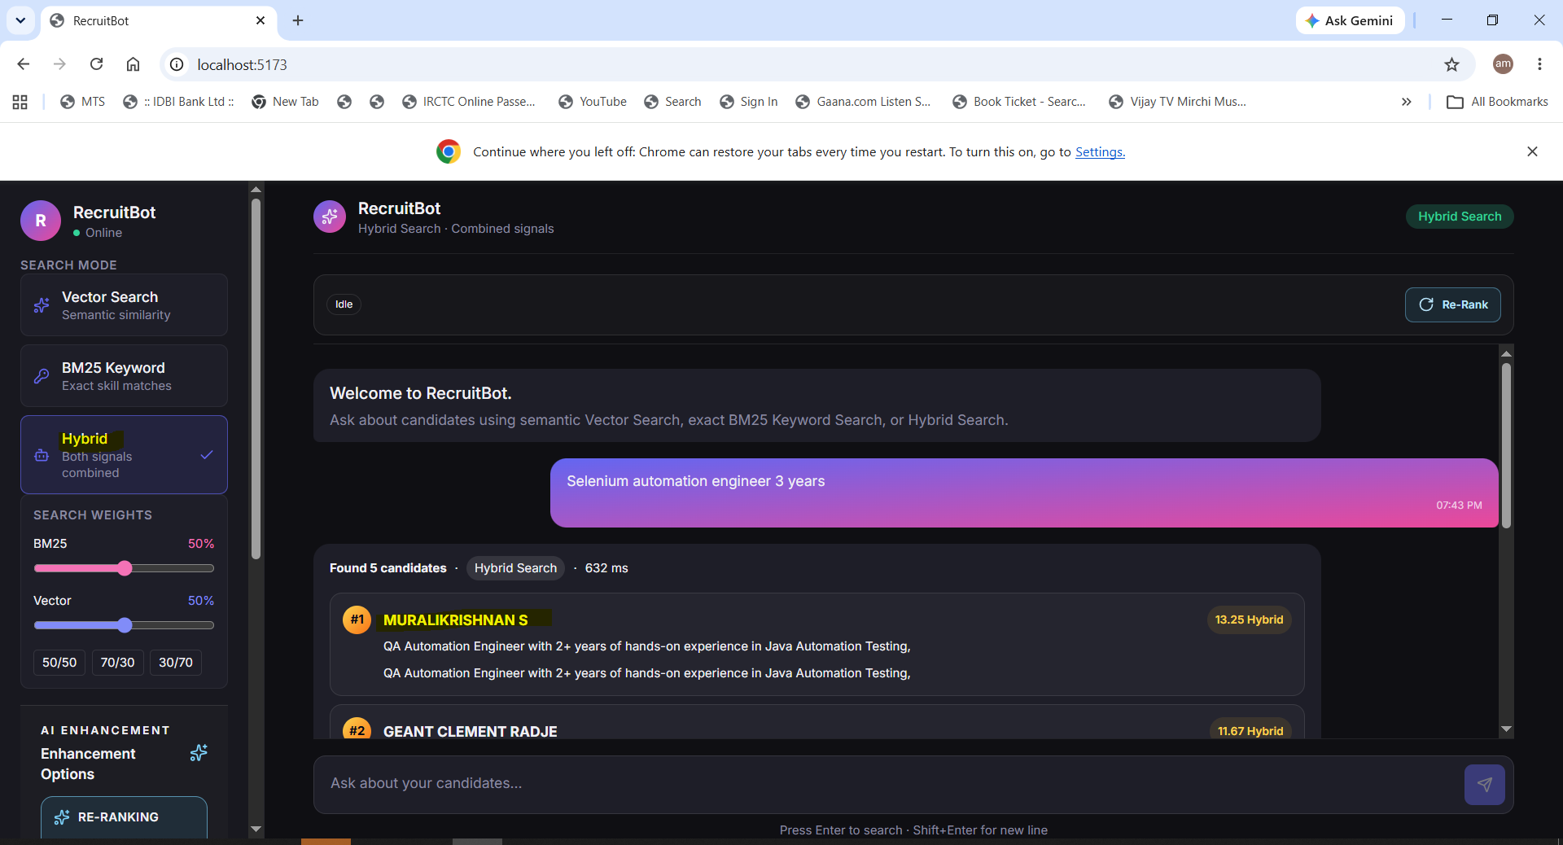
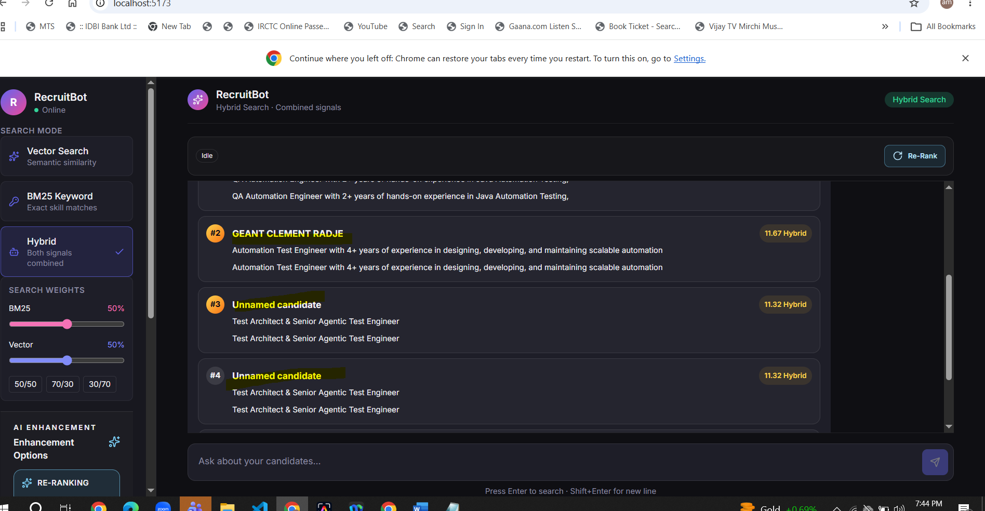
Re-Ranking
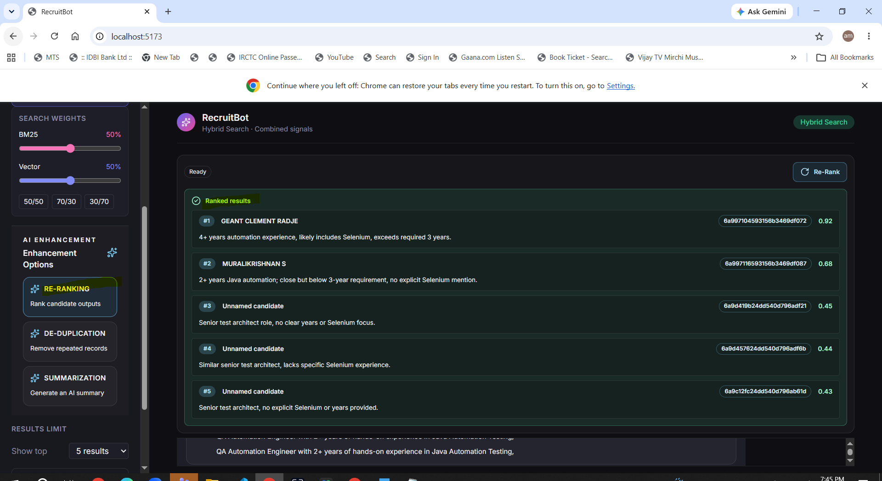
De-Duplication
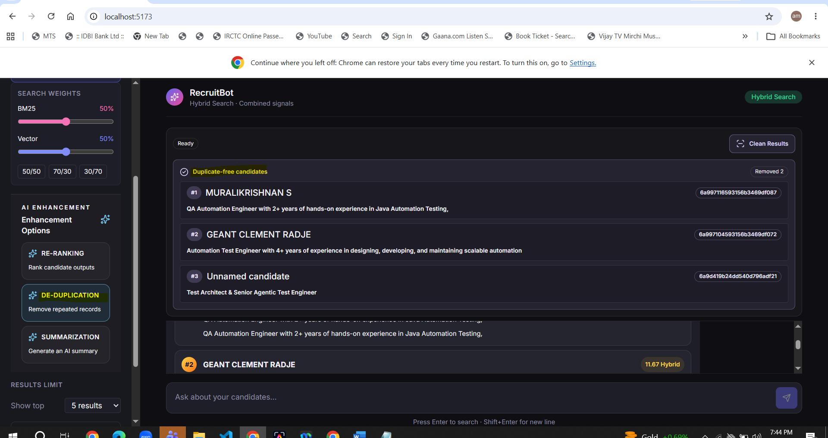
Summarization
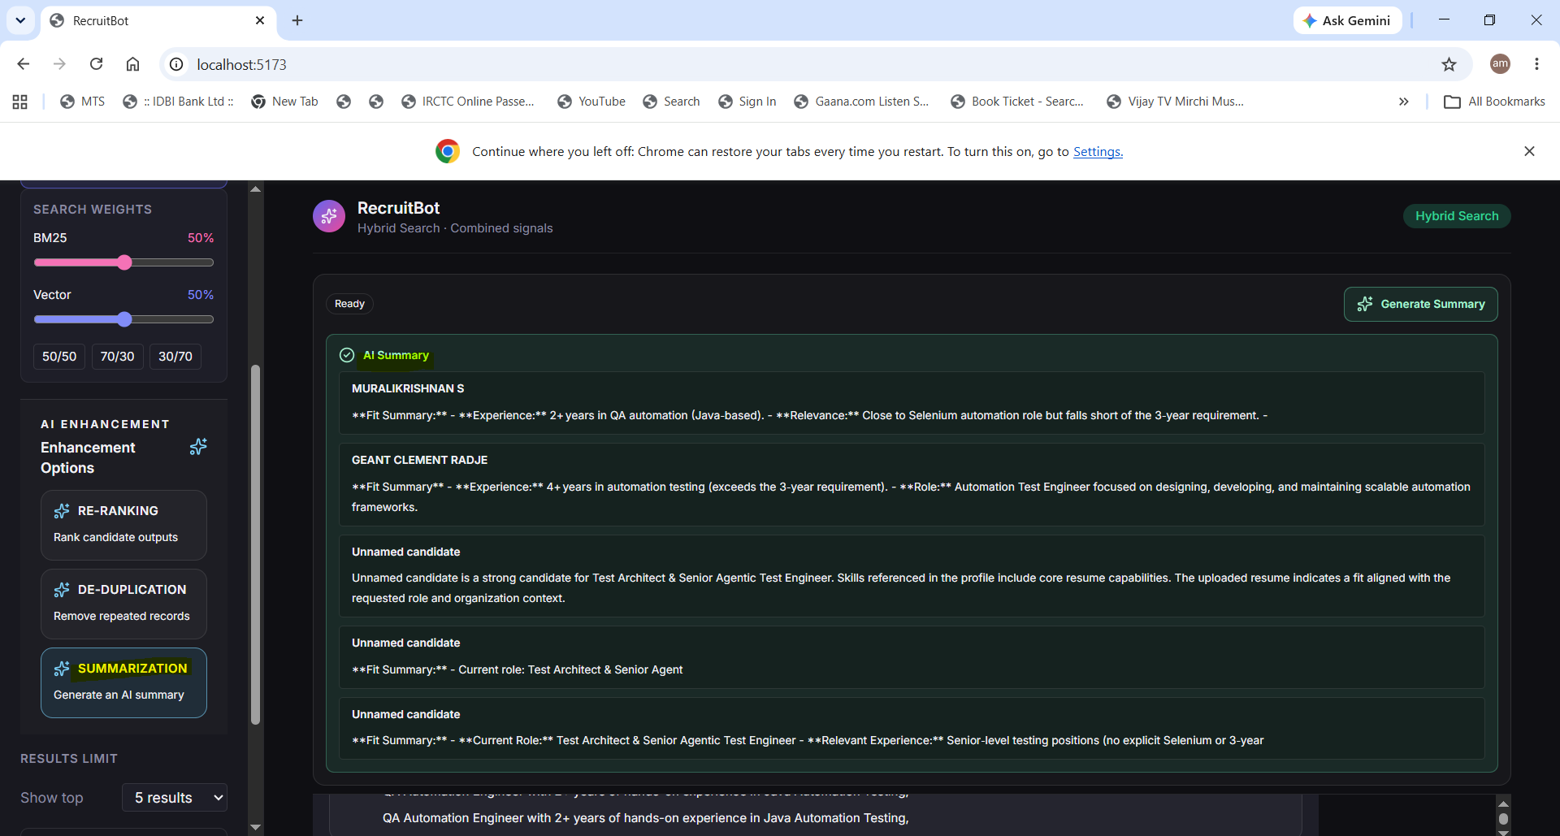
Uploading Resumes
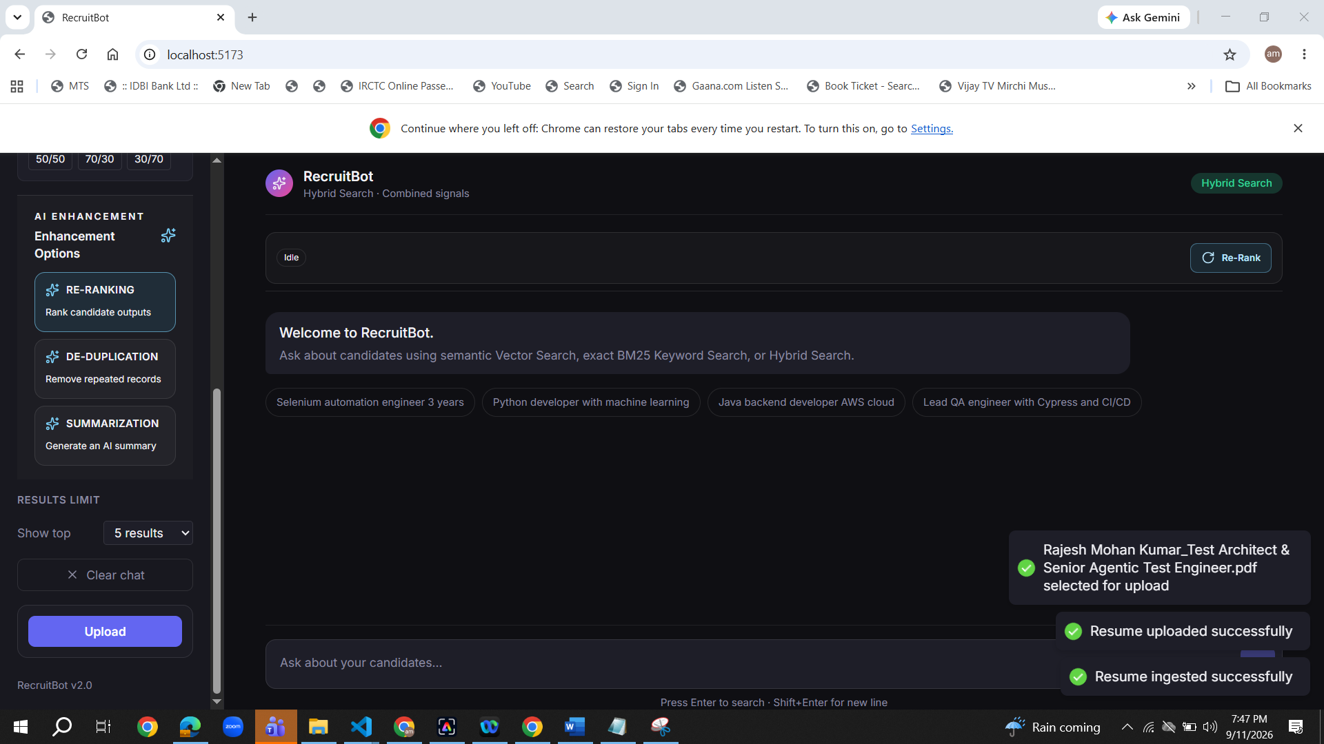
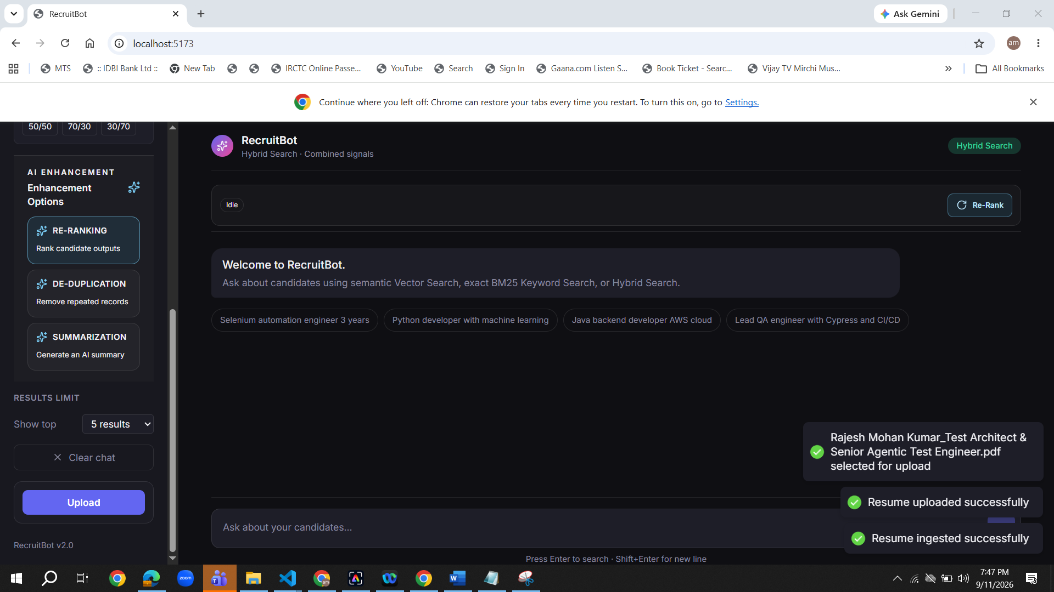
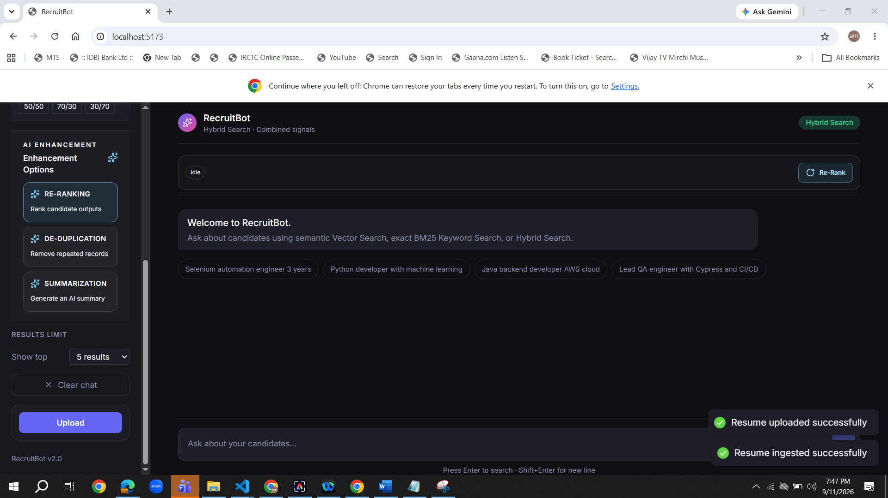
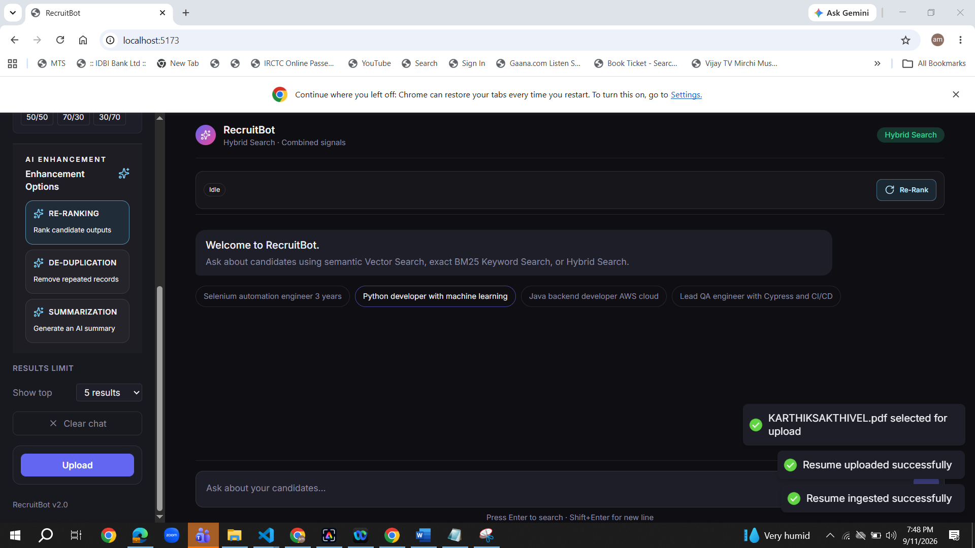
Re-Ranking for Uploaded Resumes
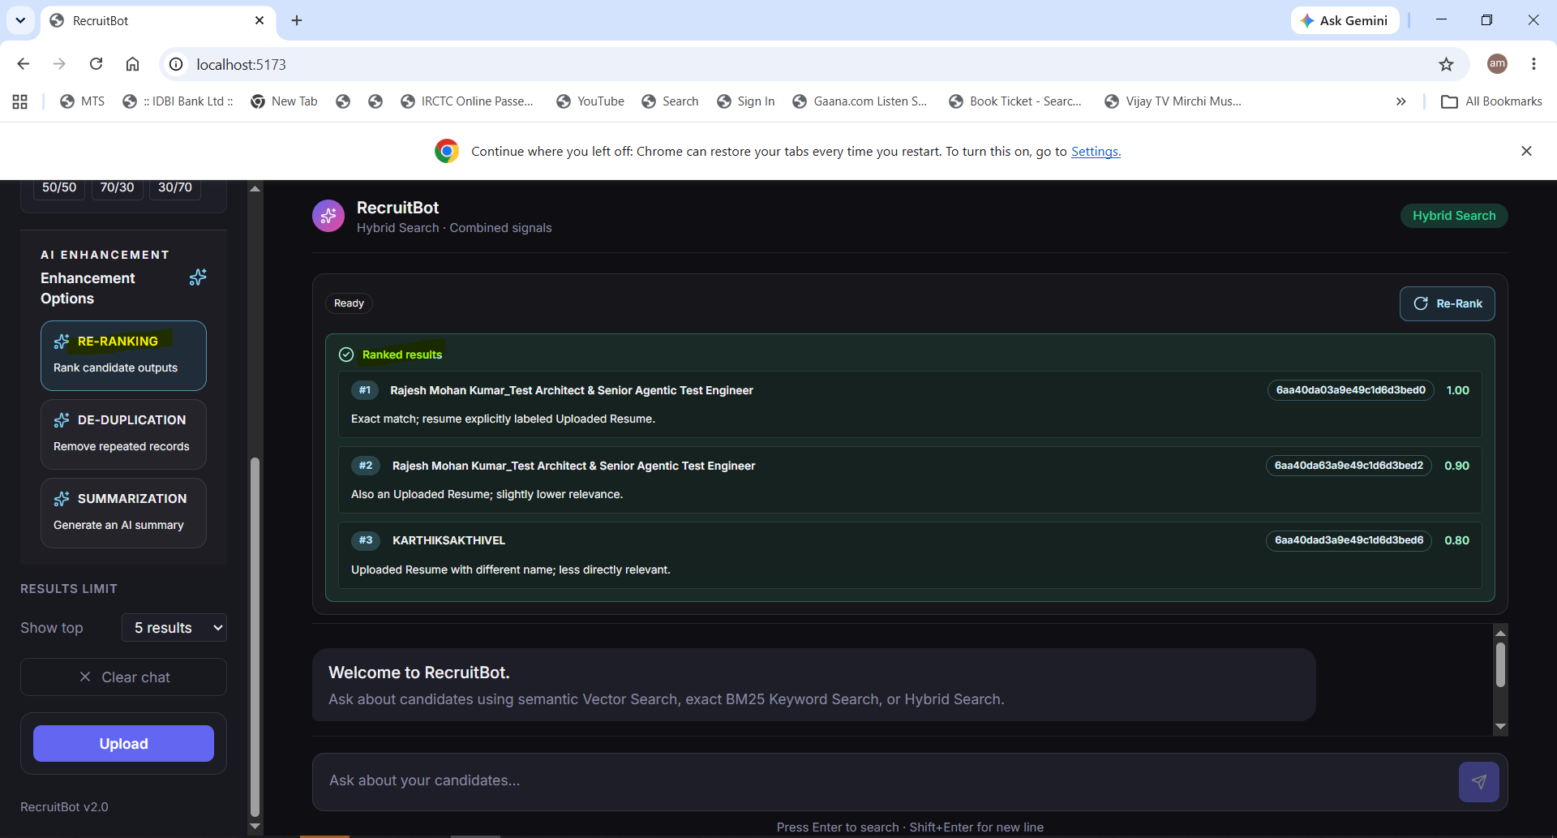

De-Duplication for Uploaded Resumes
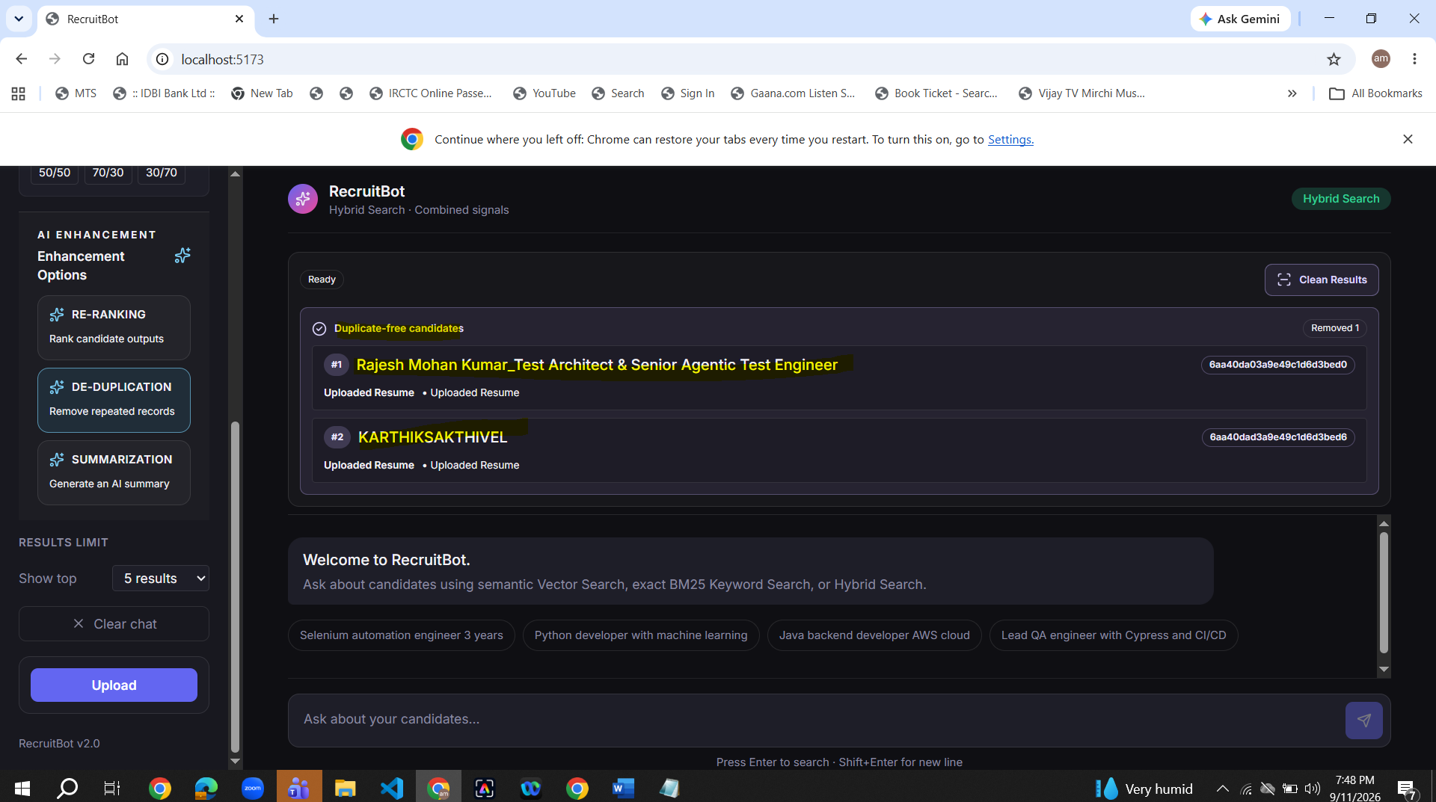
Summarization for Uploaded Resumes
