Home Assignment_Deepeval Metrics
Home Assignment: DeepEval Metrics

Explore the different evaluation metrics available in the DeepEval GitHub repository.

Practise the following metrics using multiple examples:

1. Faithfulness
2. Answer Relevancy

For each metric, create and test different examples that demonstrate:

- A good response with a high score
- A partially correct response with a medium score
- A poor response with a low score

Observe the generated scores and reasons, and understand why each response received its respective score. Share your examples, execution results, and screenshots after completing the assignment.

Faithfulness
A good response with a high score
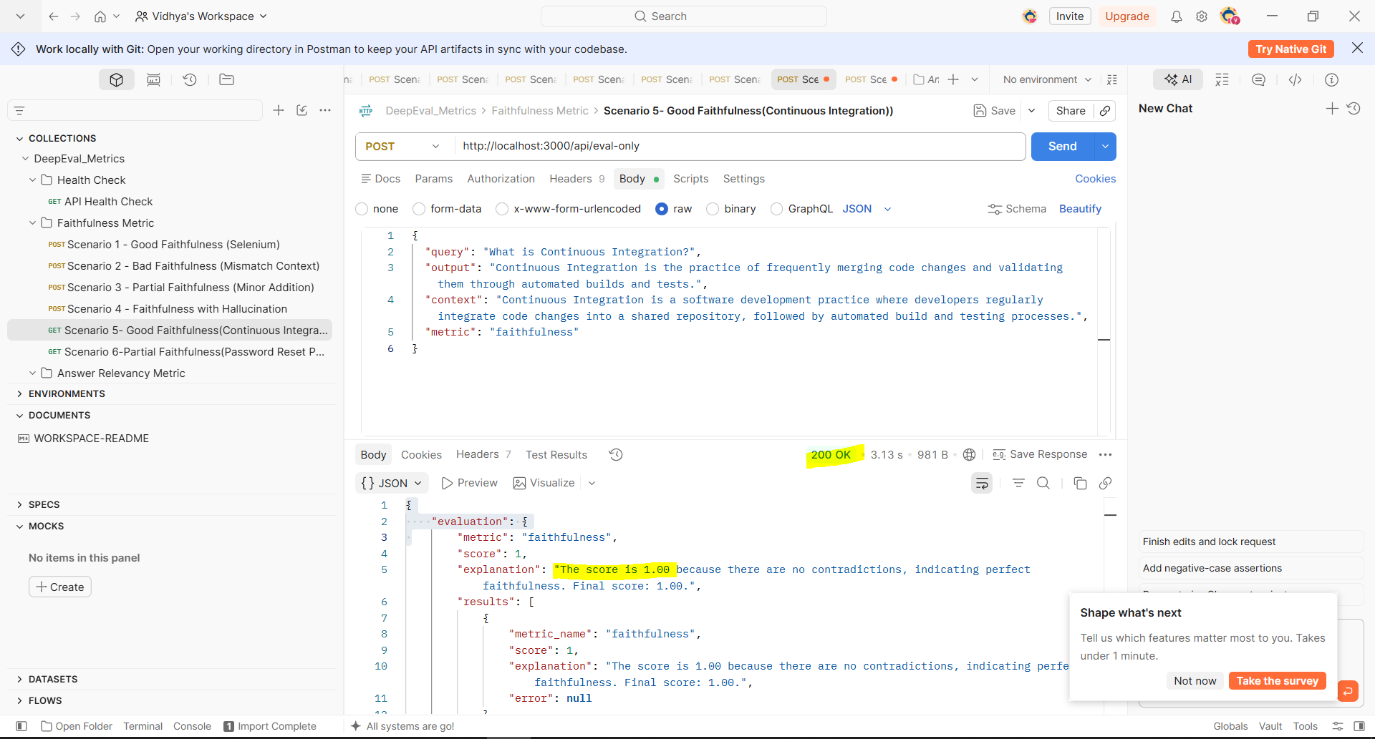
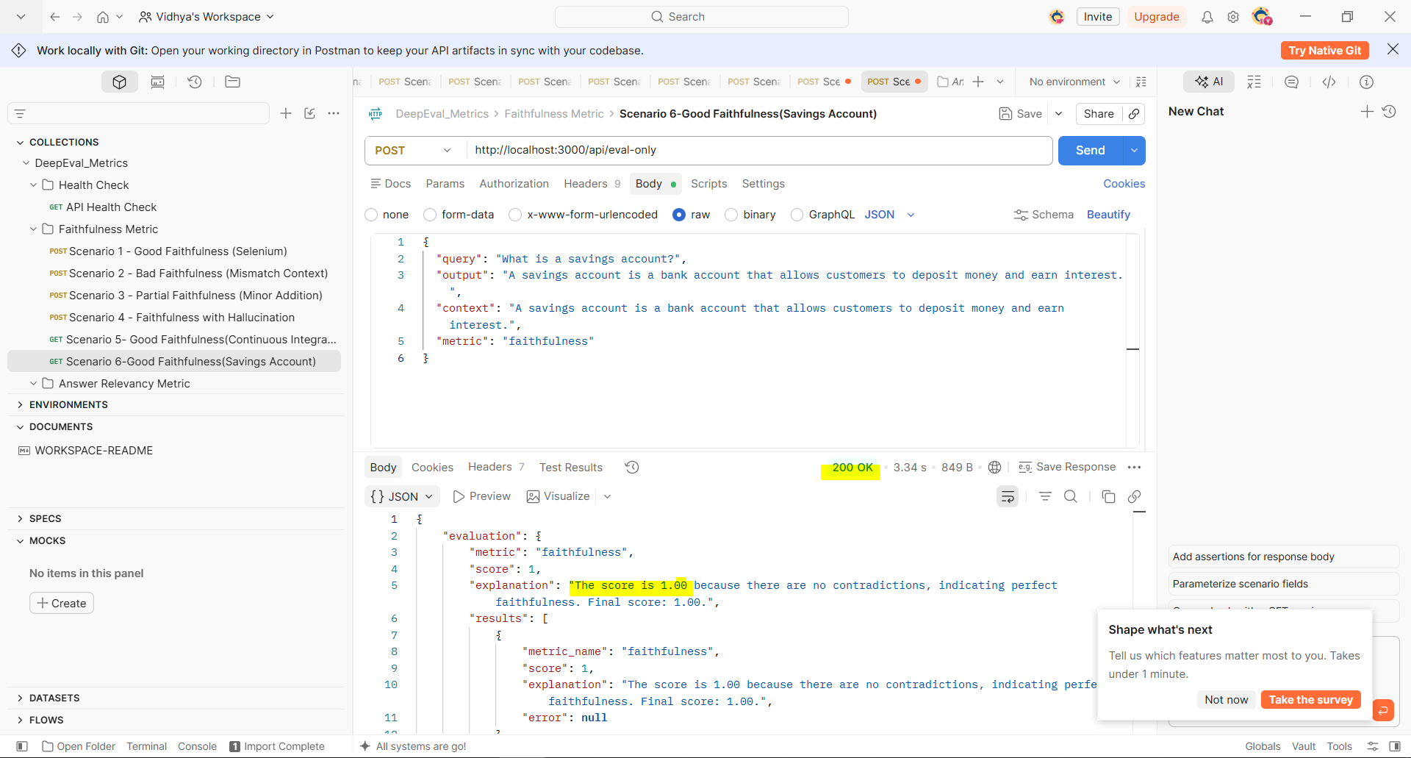

A partially correct response with a medium score
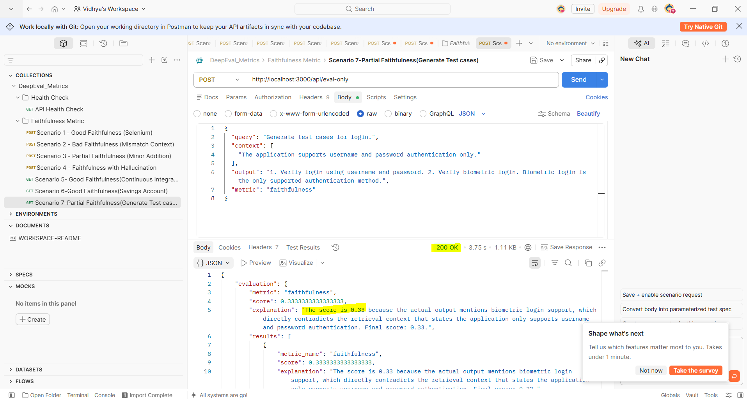
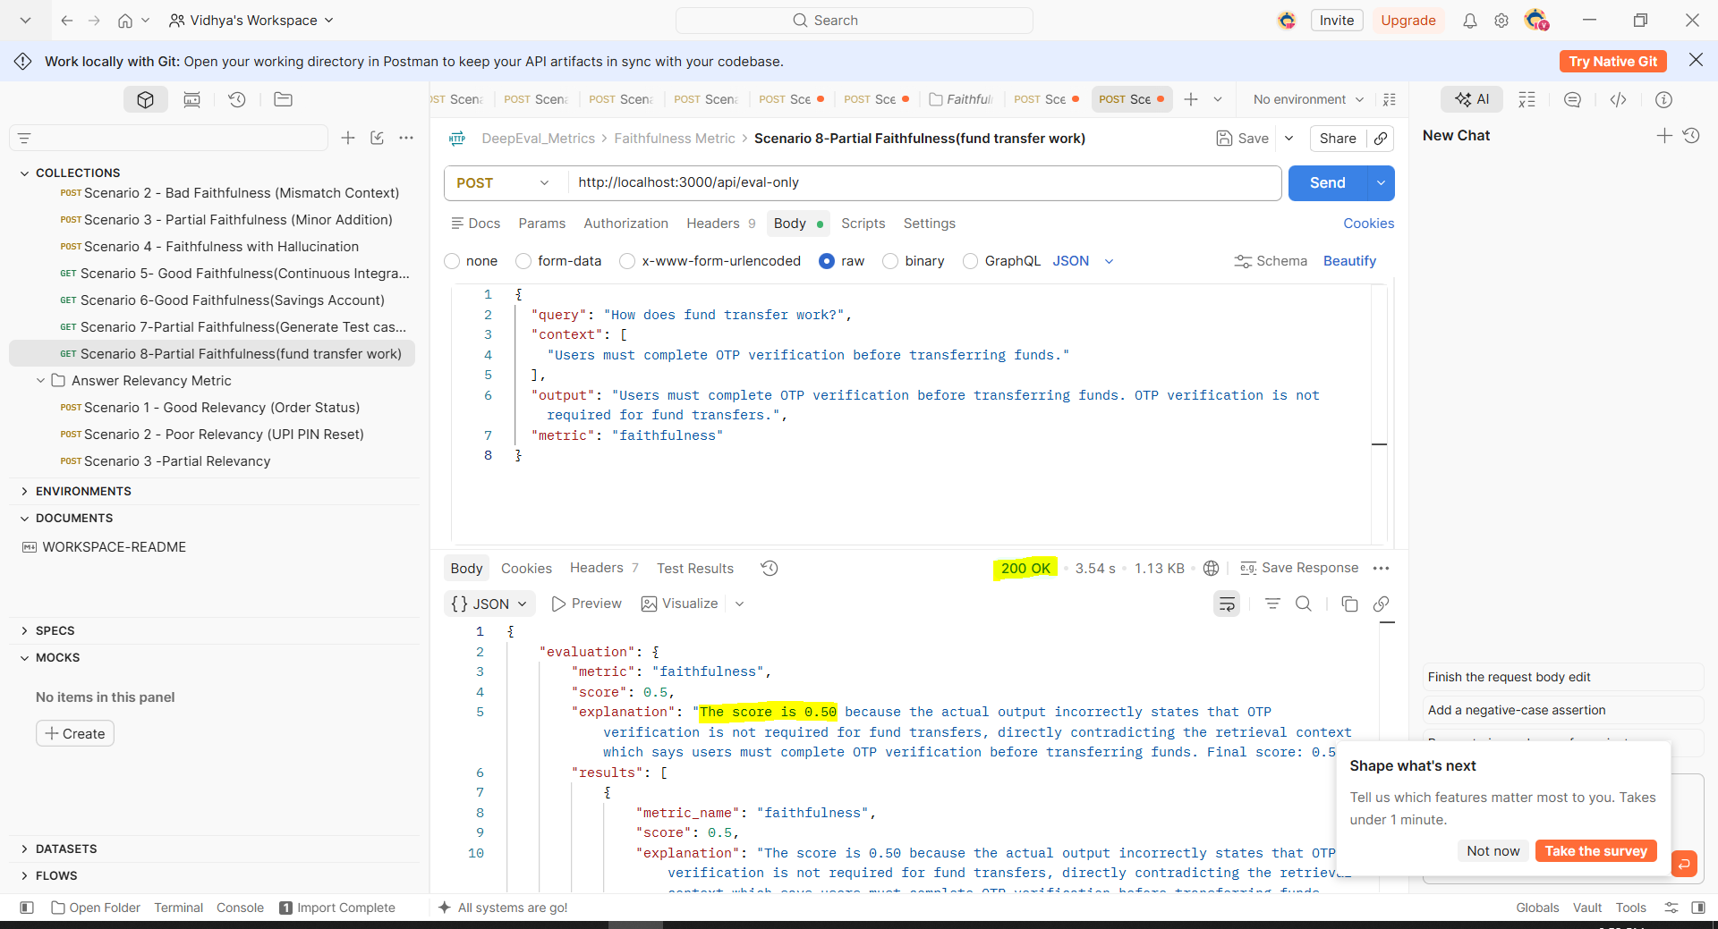

A poor response with a low score
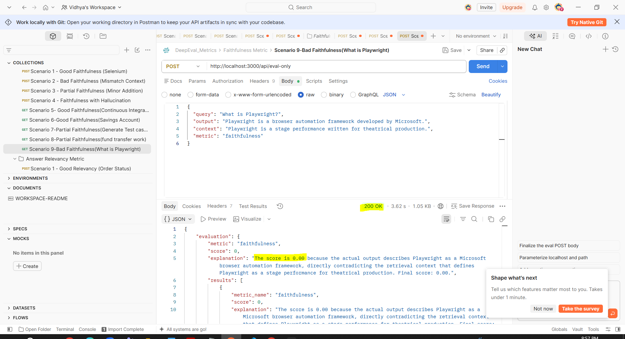
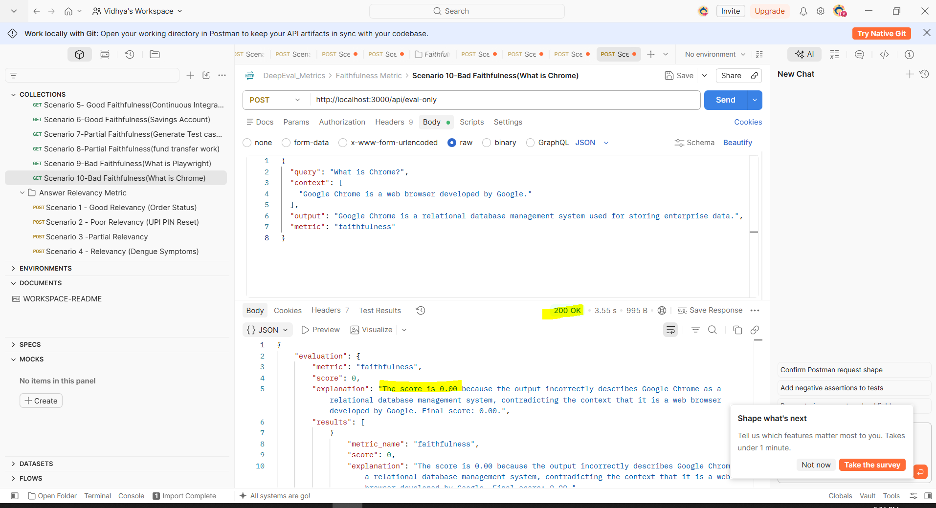
Answer Relevancy
A good response with a high score
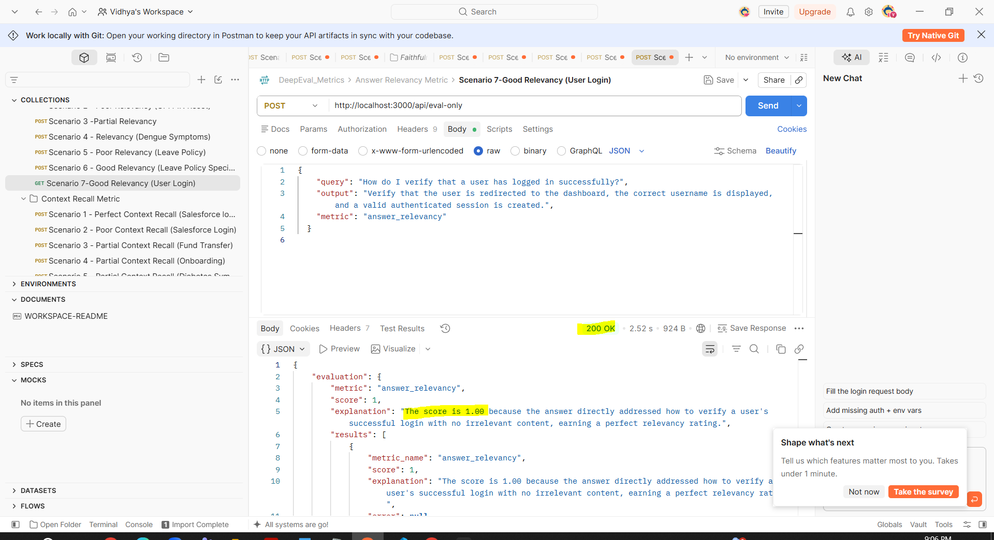
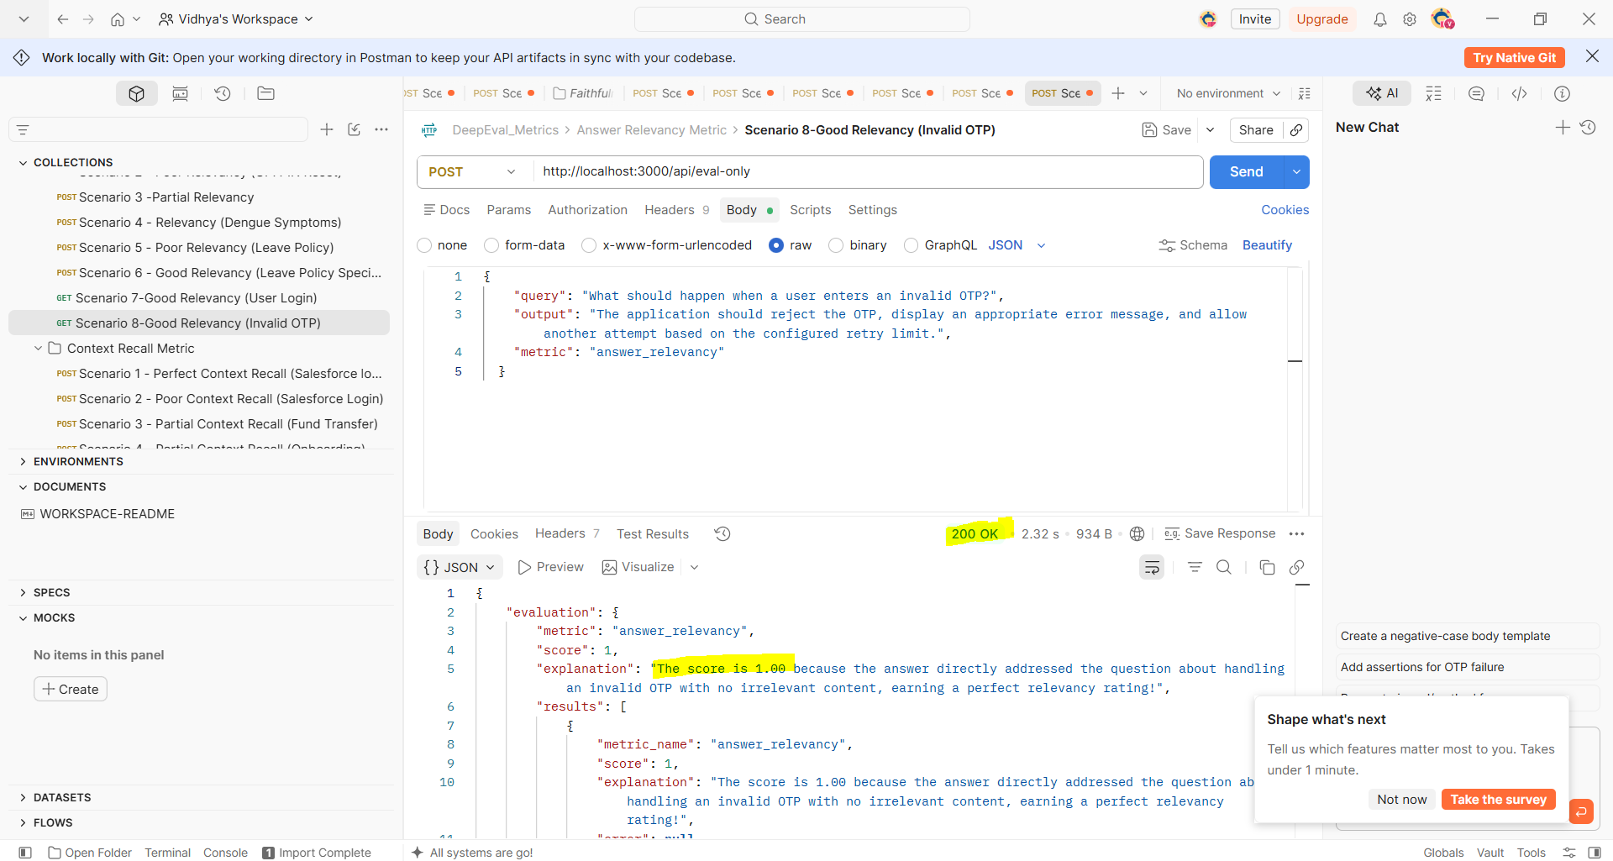

A partially correct response with a medium score
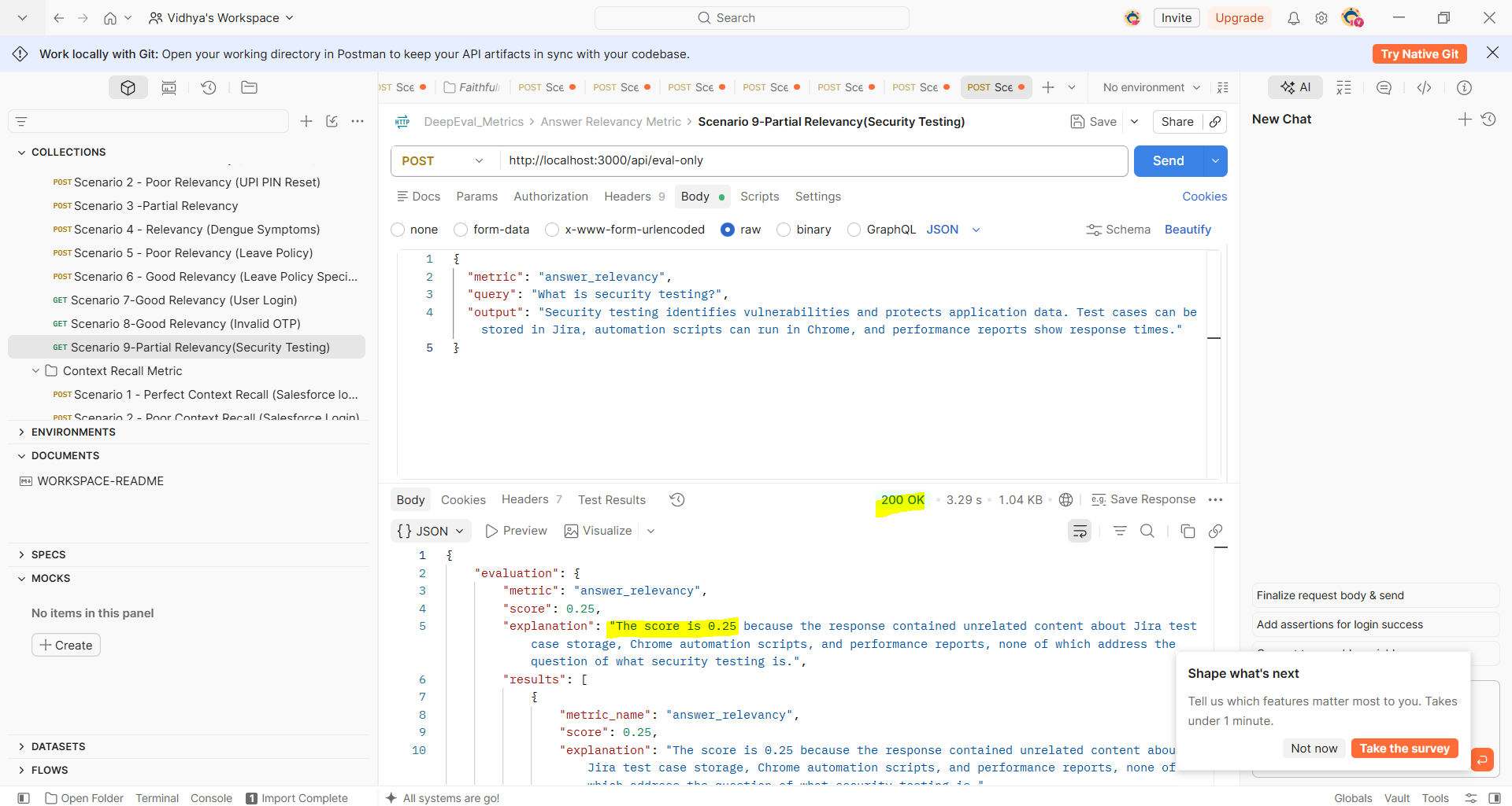
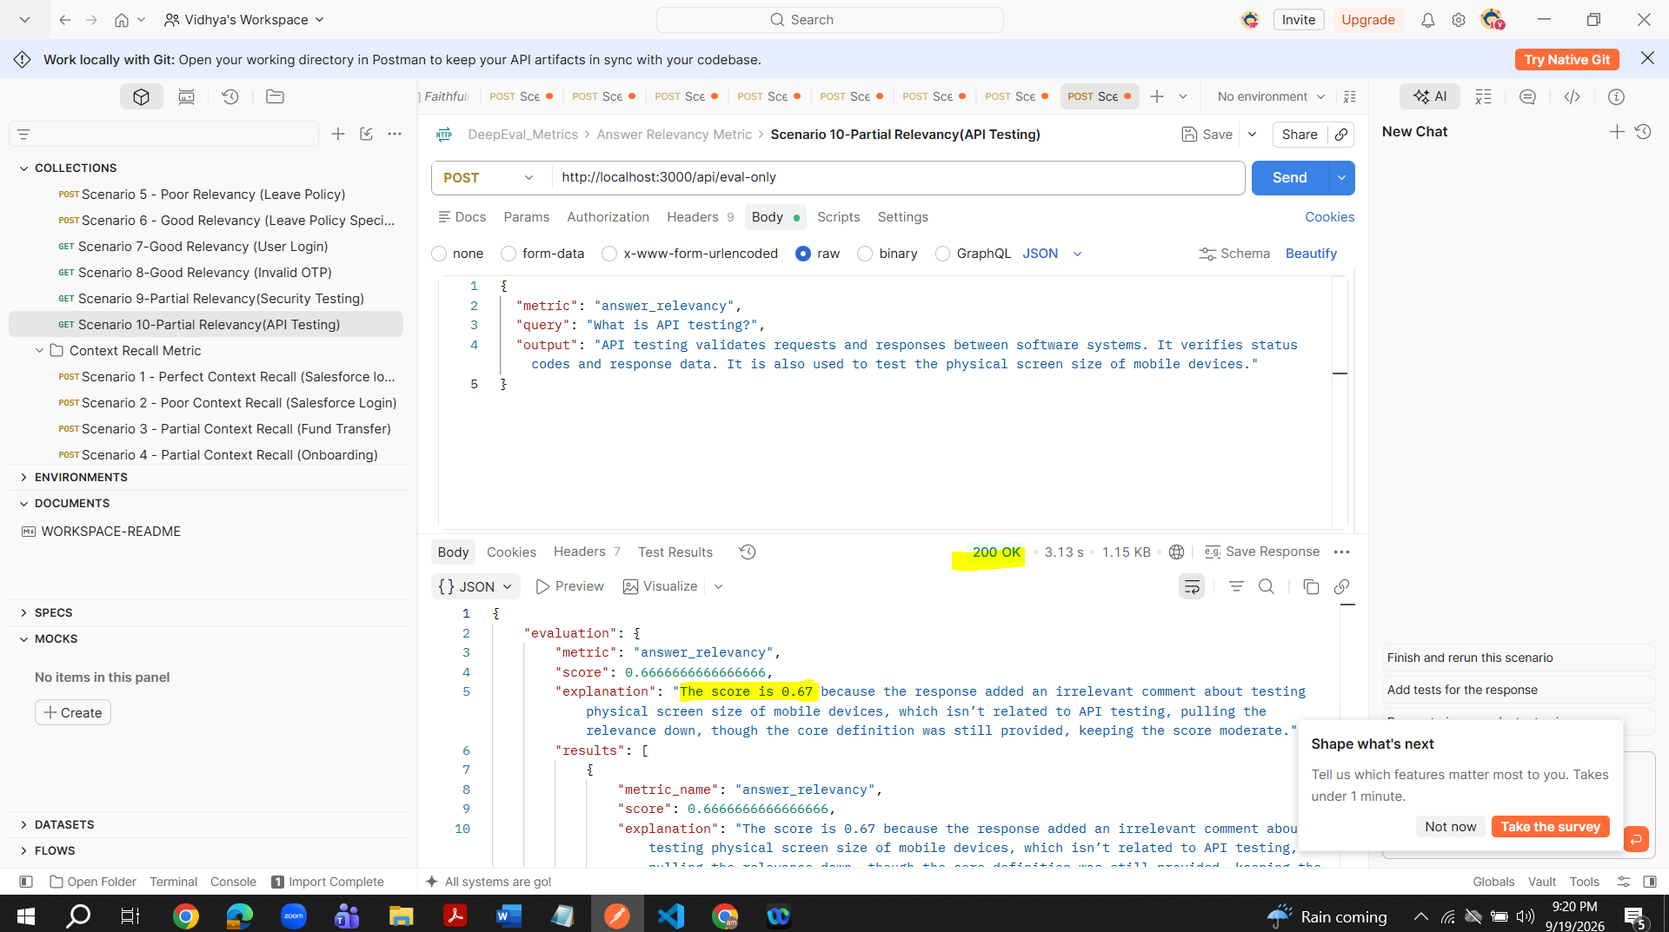

A poor response with a low score
