CHAPTER FOUR

CARBOXYLIC ACIDS

4.1 Introduction

Carboxylic acids are organic compounds that contain carbonyl and hydroxyl groups on the same carbon atom. They under go unique reactions due to interaction of the two groups.

There are three features that can be noted of the carboxylic group; that it is planar, polar and has increased number of lone pairs when compared with aldehydes and ketones.
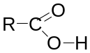

Carboxylic acids are important biologically and commercially. A few examples are mentioned.

Aspirin, the all round painkiller contains both carboxyl group and an ester group.
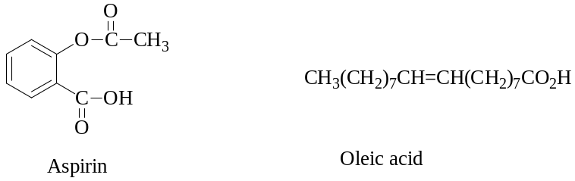

Oleic acid is a fatty acid, a component of fats and oils. Base hydrolysis of fats, a process known as saponification, leads to formation of soap and the fatty acid moiety is one involved.

Prostaglandrins are carboxylic acids or their derivatives. They are responsible of hormonal activity.

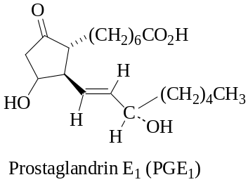
As the carboxyl group is generally non-hindered, its reactions are not usually affected to a great extent by the rest of the molecule. Therefore the acids undergo similar reactions.

Acid strength is the extent of ionization of a Brφnsted acid in water. That is the greater the ionization in water, the stronger is the acid and can be expressed in terms of Ka or pKa. Carboxylic acids are termed as weak acids, with an average pKa value of 5. Acids like Hydrochloric acid and nitric acid have a pKa value of 1.

pKa = -log Ka (Like pH = -log [H⁺]

Note: The lower the pKa value the stronger the acid.

This implies that when carboxylic acids aqueous media the three species, hydrogen ion, carboxylate ion and undissociated carboxylic acid molecules exist in equilibrium.
However, carboxylic acids are more acidic than phenol and alcohols. This is due to the fact that the resulting carboxylate ion is resonance stabilized.
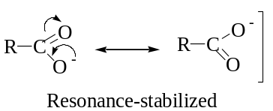

4.2 Nomenclature of carboxylic acids

In naming of carboxylic acids by IUPAC system, the suffix ‘e’ in alkane is replaced with ‘oic acid’ to lead alkanoic acid and is derived from the name of the longest carbon chain that contains the carboxyl group. However, the ‘e’ is retained in dicarboxylic acids and other polyfunctional acids.

HCO₂H CH₃CO₂H CH₃CH₂CO₂H
Methanoic acid Ethanoic acid Propanoic acid

The chain is numbered, beginning with the carbon atom of the carboxylic group. If the carboxylic acid contains a carbon-carbon double or triple bond, change of infix from ‘an’ to ‘en’ and ‘yn’ to indicate the presence of multiple bond. The location of the multiple bond is indicated by a number with reference to the carboxyl group.

CH₃CH=CHCO₂H CH₂=CHCH₂CO₂H
2-Butenoic acid 3-Butenoic acid

Note: Geometrical isomerism will be experienced in 2-butenoic acid.

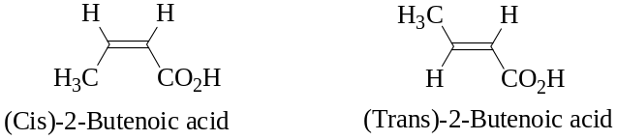
In IUPAC system, a carboxyl group takes precedence over most other functional groups. For that the other groups are indicated by prefixes.
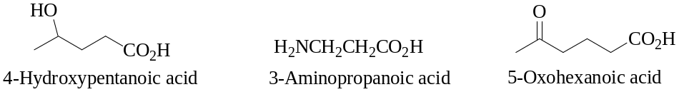

It will be noted that usage of trivial names has persisted in carboxylic acids such that the names are used for the simple carboxylic acids. These names were based on source of the acids. Table 1 below gives the IUPAC names, trivial names and occurrence of some selected acids.

Table 4.1. Some Carboxylic acids and their common names

Structure | IUPAC Name | Common Name | Occurrence/Derivation
HCO₂H | Methanoic acid | Formic acid | Formica (L), ant
CH₃CO₂H | Ethanoic acid | Acetic acid | Acetum (L), vinegar
CH₃CH₂CO₂H | Propanoic acid | Propionic acid | Propion (G), first fat
CH₃(CH₂)₂CO₂H | Butanoic acid | Butyric acid | Butyrum (L), butter
CH₃(CH₂)₃CO₂H | Pentanoic acid | Valeric acid | Valeriana (L), a flowering plant
CH₃(CH₂)₄CO₂H | Hexanoic acid | Caproic acid | Caper (L), goat
CH₃(CH₂)₆CO₂H | Octanoic acid | Caprylic acid | Caper (L), goat
CH₃(CH₂)₈CO₂H | Decanoic acid | Capric acid | Caper (L), goat
CH₃(CH₂)₁₀CO₂H | Dodecanoic acid | Lauric acid | Laurus (L), laurel plant
CH₃(CH₂)₁₂CO₂H | Tetradecanoic acid | Myristic acid | Myristikos (G) fragrant
CH₃(CH₂)₁₄CO₂H | Hexadecanoic acid | Palmitic acid | Palma (L), palm tree
CH₃(CH₂)₁₆CO₂H | Octadecanoic acid | Stearic acid | Stear (G), solid fat
CH₃(CH₂)₁₈CO₂H | Eicosanoic acid | Arachidonic acid | Arachis (G) peanut
KEY: G (Greek); L (Latin)

Note: Pure ethanoic acid is viscous liquid that solidifies into an ‘icy-looking solid and thus called ‘Glacial’ acetic acid.

As was mentioned earlier, in dicarboxylic acids the ‘e’ in alkane is retained and the suffix ‘-dioic’ acid added to the name of the longest carbon chain that contains both carboxylic groups. The numbers for the position of the carboxyl groups are not indicated because they can only be at the ends of the parent chain. Like monocarboxylic acids, trivial names have persisted and are based on the source of a given dicarboxylic acid.

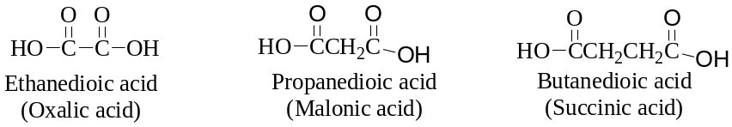
Tri- and higher carboxylic acids are named by using the suffixes ‘–tricarboxylic acid’, ‘-tetracarboxylic acid’, etc. Citric acid from citrus juices is a tricarboxylic acid.

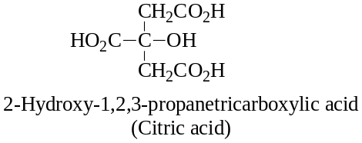
Carboxylic acid containing carboxyl group attached to a cycloalkane or cycloalkene ring is named by giving the name of the ring and adding the suffix ‘carboxylic acid’. The atoms are numbered beginning with the carbon with carbon bearing the carboxyl group.

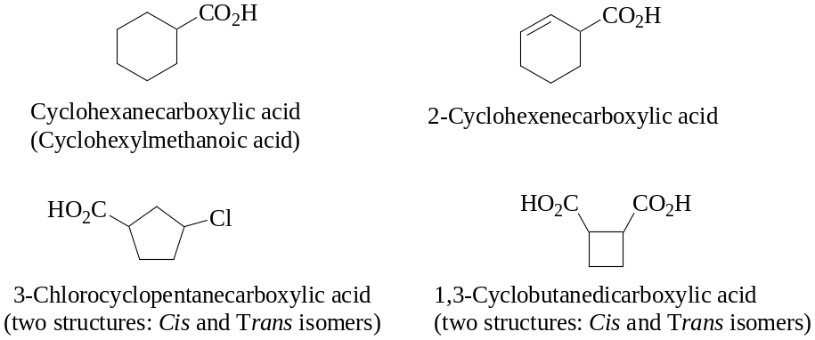
Benzoic acid is the simplest aromatic carboxylic acid. Derivatives are named by using numbers to show the location of substituents relative to the carboxyl group. Common names are also used for aromatic carboxylic acids. 2-Hydroxybenzoic acid is usually known as ‘salicylic acid’, name derived from the willow tree of the genus Salix.
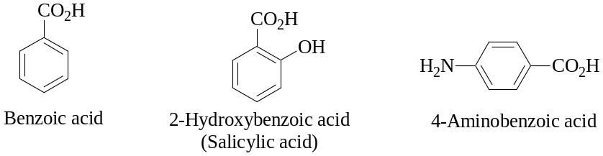

4-Aminobenzoic acid is a growth factor required by microorganisms for the synthesis of folic acid, complex group of compounds used in treatment of anaemia.

Aromatic dicarboxylic acids are named by adding the word ‘dicarboxylic acid’ to ‘benzene’. Again trivial names are commonly used.
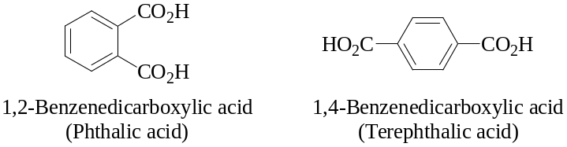

4.3 Physical Properties of carboxylic acids

Carboxylic acids with one to four carbon atoms are colourless liquids with sharp pungent (unpleasant) smell. Acids with five to nine carbon atoms may be liquids or solids depending on the isomeric forms. Those with more than ten carbon atoms are usually no-volatile solids and the odor diminishes due to low volatility.

Carboxylic acids interact with water molecules by hydrogen bonding through both hydroxyl and carbonyl groups. The solubility diminishes are the number of carbon atoms increases. This is because of increasing of the hydrophobic (‘water fearing’) hydrocarbon group. Thus lower members are highly miscible with water. The solubility of hexanoic acid in water is 1.0g/100mL water while that of decanoic acid is 0.2g/100 mL water.

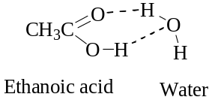

Normally carboxylic acids have high boiling points than other types of organic compounds of comparable molecular weight such as alcohols, aldehydes and ketones. In their liquid and solid states, carboxylic acids are associated by hydrogen bonding into dimeric structures as illustrated with acetic acid in liquid state.

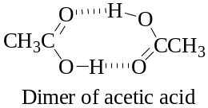
Carboxylic acids can be detected due to their odor. Hexanoic acid (caproic acid), for example, smells like goat (Goat sweat contains it). Dogs differentiate the odors of individual humans because of differing proportions of carboxylic acids in human sweat. Pentanoic acid (valeric acid) is a sex attractant of the sugar beet wireworm.

4.4 Spectroscopic Properties

4.4.1 Mass Spectrometry (MS)

The molecular peak from a carboxylic acid is generally observed, although it is often very weak. The most common fragmentation patterns are α-cleavage of the carboxyl group to give the ion [CO₂H]⁺ of m/z 45 and McLafferty rearrangement, which is very often the base peak. Example is illustrated with butanoic acid.

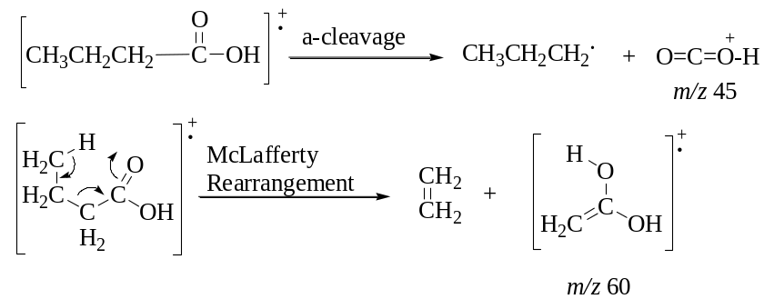
4.4.2 Infrared Spectroscopy (IR)

The carboxyl group gives rise to two characteristic absorptions in the infrared spectrum. One of these occurs in the regions 1700-1725 cm⁻¹ and is associated with the stretching vibration of the carbonyl group. Note that the absorption is essentially the same range of absorption as for the carbonyl group of aldehydes and ketones but the peak is usually broader in the case of the carboxyl carbonyl because of intermolecular hydrogen bonding. The other absorption of importance for carboxylic acids is a peak between 2400 and 3400 cm⁻¹ due to the stretching vibration of the O-H group. The absorption is generally very broad due to hydrogen bonding between molecules of the carboxylic acid.

4.4.3 Nuclear Magnetic Resonance (NMR)

Hydrogens on the α-carbon to a carboxyl group give a signal in the proton NMR spectrum in the range δ 2.0-2.5. The hydrogen of the carboxyl group appears in the range δ 10-13.

The carbon-13 absorption of the carboxyl carbon appears in the range δ 160-180 and is similar to that of carboxyl derivatives (esters, amides and acid anhydrides).

4.5 Preparation of Carboxylic Acids

Three main types of reactions are involved in preparation of carboxylic acids. They are: oxidation reactions, Grignard reactions and hydrolysis reactions of carboxylic acids derivatives.

4.5.1 Oxidation Reactions

Oxidation reactions of primary alcohols and aldehydes lead to formation of carboxylic acids. Various common oxidizing agents can be used. They include potassium permanganate (KMnO₄), potassium dichromate (K₂Cr₂O₇), chromic acid (H₂CrO₄), manganese dioxide (MnO₂) and even hydrogen peroxide (H₂O₂).
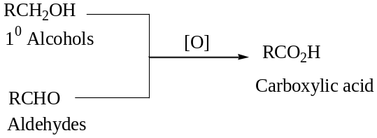

When alkenes react with strong oxidizing agent oxidative cleavage leads to formation of oxidized products like carboxylic acid through fragmentation. This depends on the structural feature of the alkene. When the carbon atoms of the double bond are bonded to hydrogen atoms carboxylic acids are formed through aldehydes. However, if they are substituted ketones are formed.
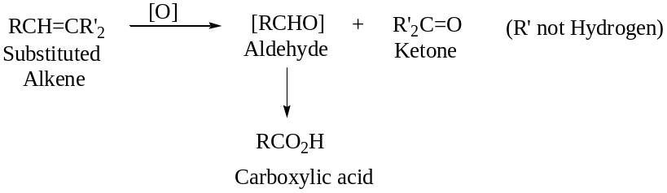

Haloform reactions of methyl ketones form carboxylic acid with one carbon atom less. (Refer to the iodoform/haloform reaction of aldehydes and ketones).
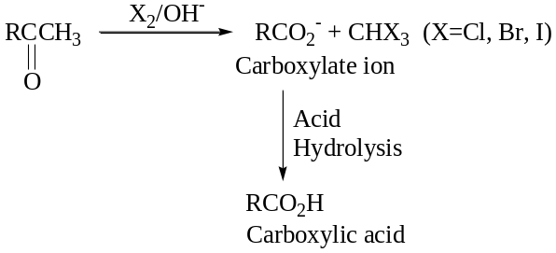

4.5.2 Grignard Reactions

When the Grignard reagent is reacted with carbon dioxide followed by acid hydrolysis, carboxylic acid is formed. The acid that is formed is one carbon atom more that the starting alkyl halide.

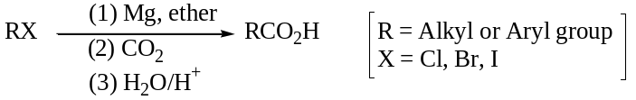

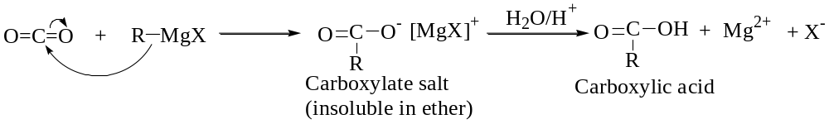
Mechanism:

4.5.3 Hydrolysis of Acid Derivatives

(a) Esters

Esters differ from acids by replacement of the hydrogen of the hydroxyl group of acid with an alkyl or aryl group. Hydrolysis of ester can be performed under acidic or basic conditions. Both methods lead to formation of carboxylic acids.
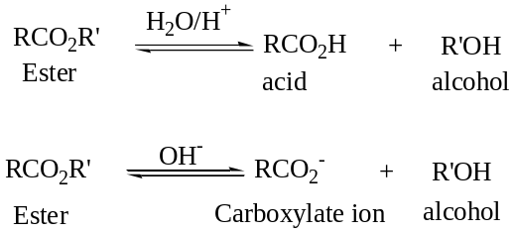

The role of the acid catalyst is to protonate the carbonyl oxygen. In doing so, it increases the electrophilic character of the carbonyl carbon toward attack by water to form a tetrahedral carbonyl addition intermediate. Collapse of this intermediate gives the carboxylic acid and an alcohol. In this reaction, acid is a catalyst; it is consumed in the first step but is regenerated at the end of the reaction.

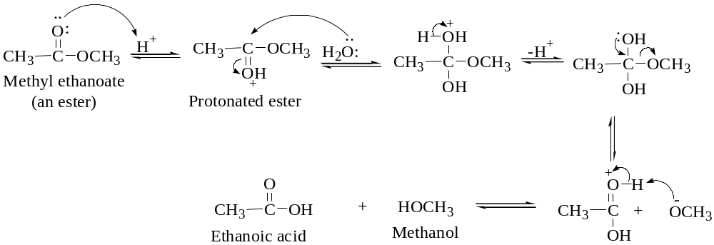
Base hydrolysis is by use of aqueous sodium hydroxide or potassium hydroxide is called saponification, a reference to the use of this reaction in the manufacture of soaps. Although the carbonyl carbon of the ester is not strongly electrophilic, hydroxyl ion is a good nucleophile and adds to the carbonyl carbon to form a tetrahedral carbonyl addition intermediate, which in turn collapses to give a carboxylic acid and an alkoxide ion. The acid reacts with the alkoxide ion to form a carboxylic acid anion and an alcohol. The mechanism is illustrated below.

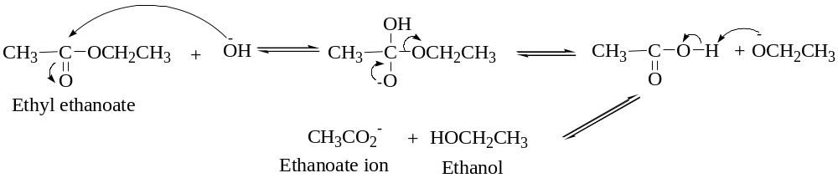
There are two major differences between hydrolysis of esters in aqueous acid and aqueous base.

- For the hydrolysis of an ester in aqueous acid, acid is required in only catalytic amounts. For the hydrolysis in aqueous base, base is required in equimolar amounts because it is a reactant, not a catalyst.
- Hydrolysis of an ester in aqueous acid is reversible while in aqueous base is irreversible.

(b) Amides

Amides are organic compounds where the hydroxyl group of the carboxylic acid is replaced with an amino group. That is, a nitrogen atom is directly bonded to the carbon of the carbonyl. When the nitrogen has two hydrogens, the amide is termed as primary (1⁰) amide. When the nitrogen has one hydrogen atom and an alkyl (or aryl) group it is termed as a secondary (2⁰) amide. If both hydrogens have been replaced with alkyl (or aryl) groups, the amide is termed as a tertiary amide.

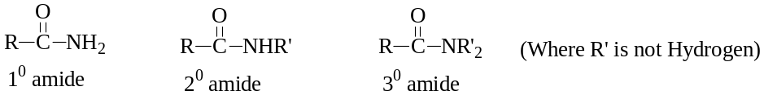
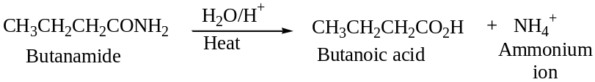
Amides undergo hydrolysis in hot aqueous acid to give a carboxylic acid and ammonium ion.

The steps in the mechanism of the acid hydrolysis of the amides are similar to that of ester. The mechanism is outline below.

1st Step: Protonation of the amide at the carbonyl oxygen.
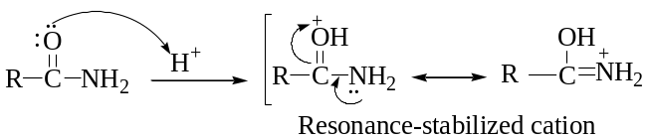

2nd Step: Addition of water to the carbonyl carbon followed by proton transfer gives a tetrahedral carbonyl addition intermediate.
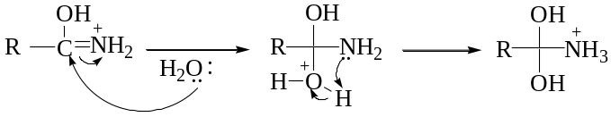

3rd Step: Collapse of the tetrahedral carbonyl addition intermediate coupled with a proton transfer.
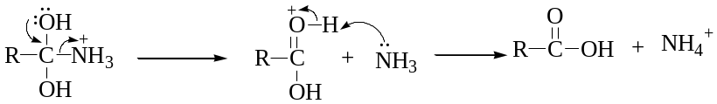

In aqueous base, the products of amide hydrolysis are carboxylic acid salt and ammonia or amine. Like the acid hydrolysis, vigorous conditions are required in base hydrolysis.
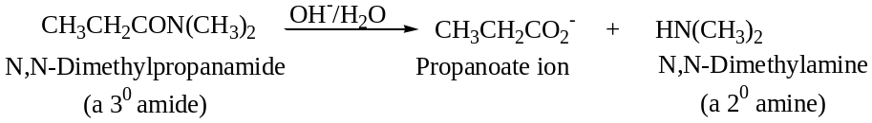

The mechanism for the base hydrolysis of amides is similar to that for the base hydrolysis of esters. In the mechanism, loss of nitrogen and transfer of proton from water to nitrogen are concerted so that the leaving group is ammonia, a weaker base and a better leaving group rather than amide ion (NH₂⁻), a stronger base and a poorer leaving group. The mechanism is outlined below.

Step 1: Addition of hydroxide ion to the carbonyl carbon to give a tetrahedral carbonyl addition intermediate.
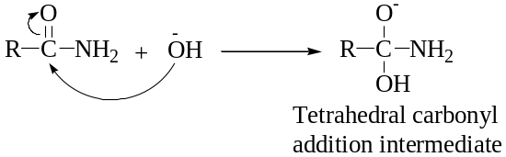

Step 2: Collapse of the tetrahedral carbonyl intermediate to form a carboxylic acid and ammonia.
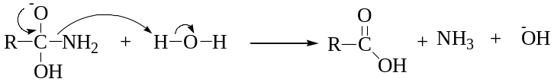

Step 3: Proton transfer to form the carboxylate anion and water where the hydrolysis is driven to completion by the acid-base reaction
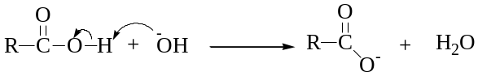

(c) Acid (acyl) halides

Acyl or acid halides are derivatives of carboxylic acids in which the hydroxyl group of the acid is replaced by a halogen. The most common ones are the acid chlorides.

Low-molecular-weight acid chlorides react very rapidly with water to form carboxylic acid and hydrogen chloride (HCl). Higher-molecular-weight acid halides are less soluble and consequently react less rapidly with water.
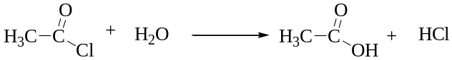

The carbonyl carbon is attacked by water directly leading to formation of tetrahedral carbonyl addition intermediate. The intermediate collapses to give hydrogen and chloride ions separately.

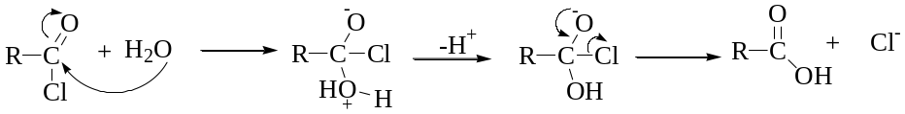
(d) Acid anhydrides

These are organic compounds that have two acyl groups bonded to an oxygen atom. They are generally less reactive than acid chlorides. But lower molecular weight anhydrides readily react with water to form two molecules of carboxylic acids.

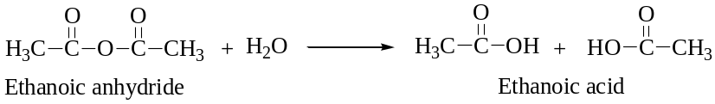
The mechanism is divided into two stages. The first one involves formation of the tetrahedral carbonyl addition intermediate and the second is the collapsing of the intermediate by elimination of acetate ion, which is a moderate base and a good leaving group.

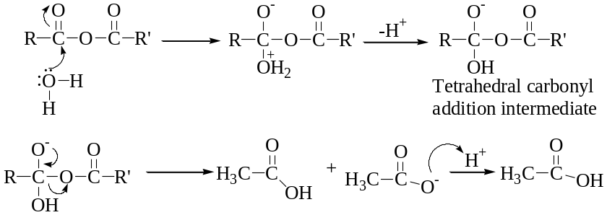
(e) Nitriles

Organic compounds with a cyano (C≡N) group bonded to carbon are called nitriles compounds. The cyano group is hydrolyzed in aqueous acid to a carboxyl group and ammonium ion.
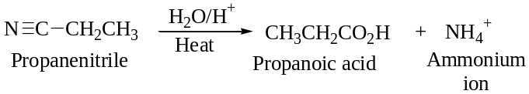

The mechanism involves addition of both hydrogen ions and water as the nitrogen-carbon bonds in the cyano group are removed as hydrogen atoms migrate from added water to nitrogen. The mechanism is illustrated below

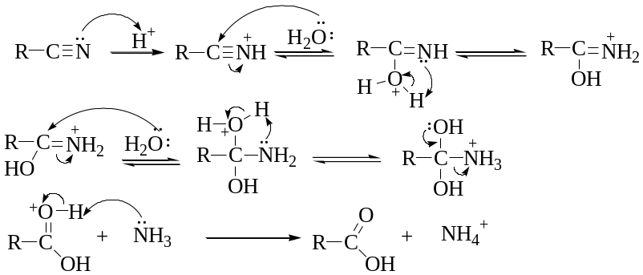
Nitrile compounds can also be hydrolysed in aqueous basic media. The products are a carboxylic acid anion and ammonia.
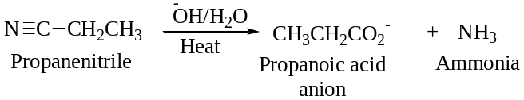

The basic hydrolysis involves initial formation of the anion of an imidic acid. Proton transfer from water leads to the intermediate undergoing keto-enol tautomerism to give an amide. Base hydrolysis of the amides was outline earlier to give carboxylic acid anion and ammonia.
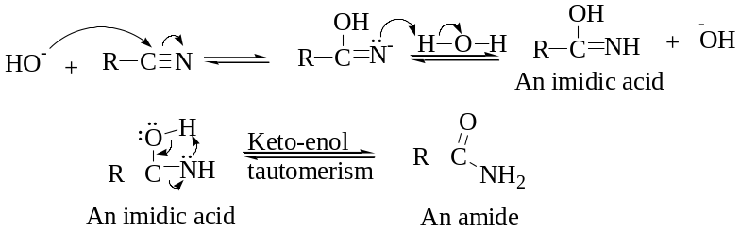

Study Questions

Q1. Write IUPAC names for the following compounds indicating stereochemistry where appropriate:
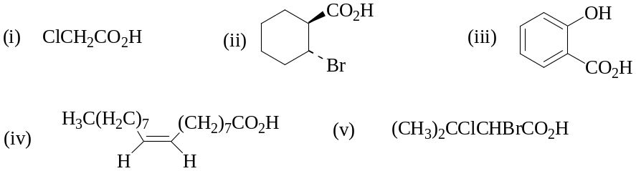

Q2. Draw structures of the following compounds:
- 3-methylbut-2-enoic acid
- (Z)-3-Phenyl-2-pentenoic acid
- 2-(N-Methylamino)propanoic acid

Q3. Ethanedioic acid has higher boiling point than ethanoic acid. Explain.

Q4. Using Curly arrows, write reaction mechanism of the following reactions:
- Acid hydrolysis of propanenitrile
- Hydrolysis of butanoic methanoic anhydride
- Base hydrolysis of ethyl ethanoate

