Selenium table
https://www.youtube.com/watch?v=oMmxcz94ugg
Nest for loop to go through rows and column
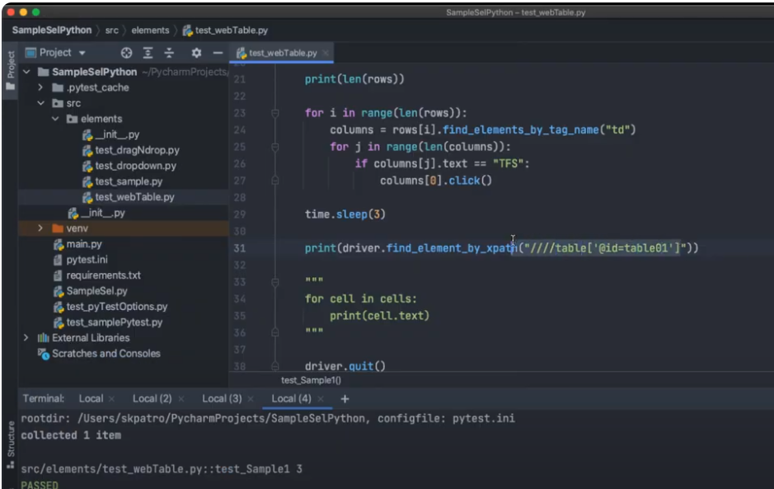
Find specific value in row and column.
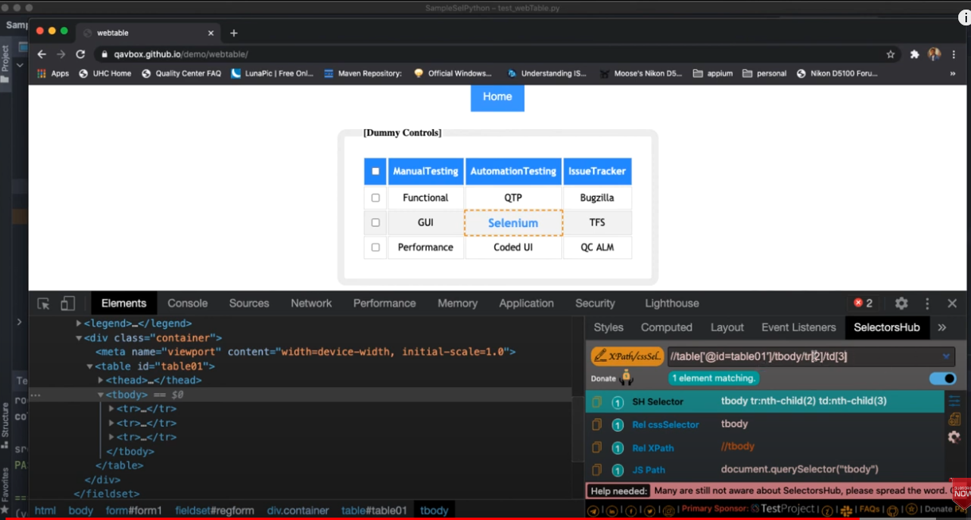
CSS selector
- by id: findElement(By.cssSelector("#idname") //this is similar with Cypress use # for id
- tag and id: findElement(By.cssSelector("input#idname")) // put the tag name infront of the id name
- tag and class: findElement(By.cssSelector("input.classname")) similar to cypress, put a . infront of the class name
- tag and attribute: findElement(By.cssSelector("input[name=email]")) similar to cypress, put [] of the attribute, like id, name
- tag class and attribute: findElement(By.cssSelector("input.inputtext[name=email]")) tag follow by .classname then attribut in []

Example of exception
- NoSuchElementException
- TimeoutException
- ElementNotVisibleException
- ElementNotSelectableException
- ElementClickInterceptedException
- ElementNotInteractableException

XPATH example
//a[@href='/Admin/Customer/List']//p[contains(text(),'Customers')]
//span[normalize-space()='Renaissance Recorders']
<button type = "button" class = "btn btn-default btn-lg">
//button[contains(@class.'btn-default')]

Some import
- from selenium import webdriver
- from selenium.webdriver.common.by import By
- from selenium.webdriver.support.ui import WebDriverWait
- from selenium.webdriver.common.action_chains import ActionChains
- from selenium.webdriver.support import expected_conditions as EC
- import time
- from datetime import datetime
- from os import environ

Locators
- ID
- Name
- Class Name
- Tag Name
- Link Text
- Partial Link Text
- XPath
- CSS Selector
assersion
# expected_title = "Recorders | Early Music"
# actual_title = self.driver.title()
# # assert actual_title.__eq__(expected_title)
assert "title name" in driver.title()

if text in texts:
assert True

For i in range(len(rows)):
Do something

Advanced XPath
https://www.youtube.com/watch?v=BRzlyGXx13Q

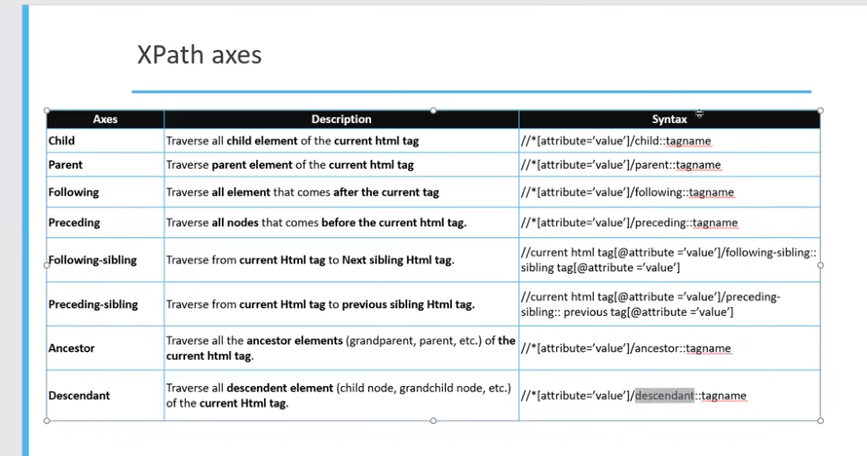

Example: self
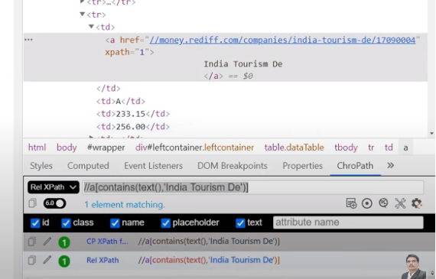

//a[contains(text(), “India Tourism De”)]/self::a
a is hyper link
Parent:
//a[contains(text(), “India Tourism De”)]/parent::td

Xpath function
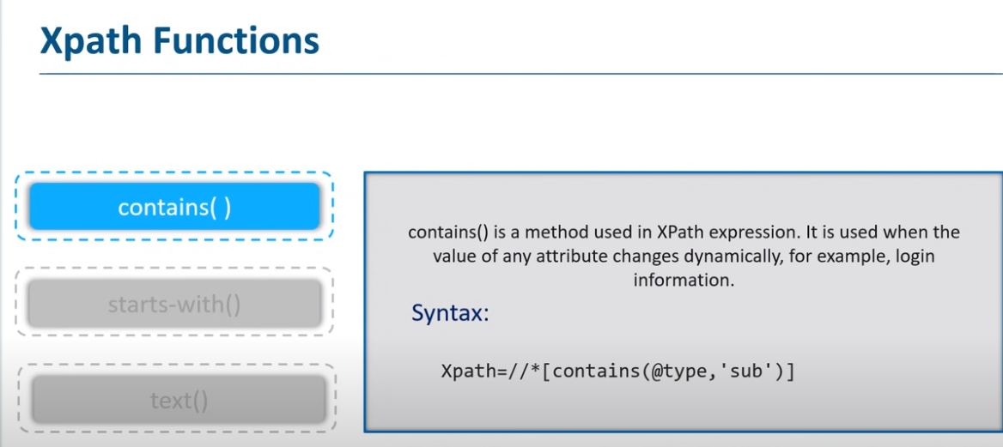

Example:
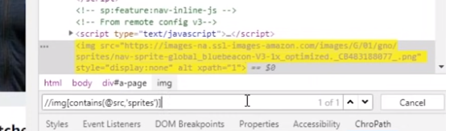

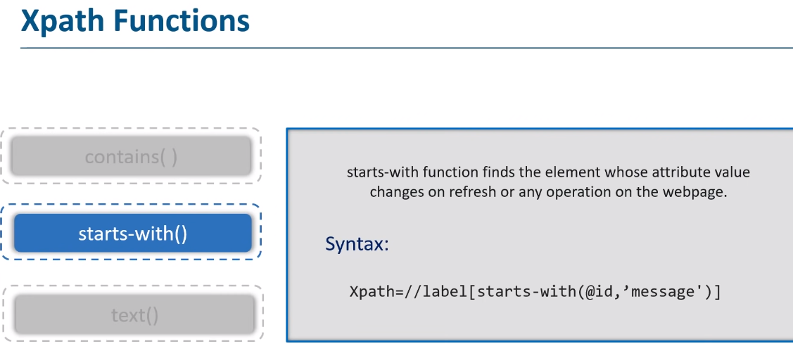

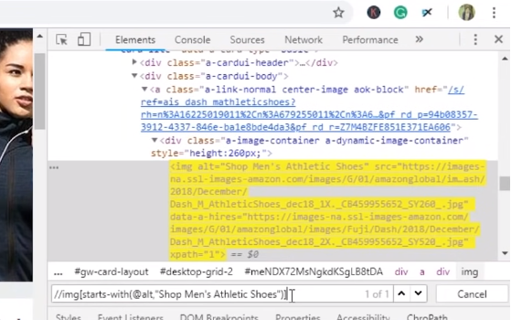

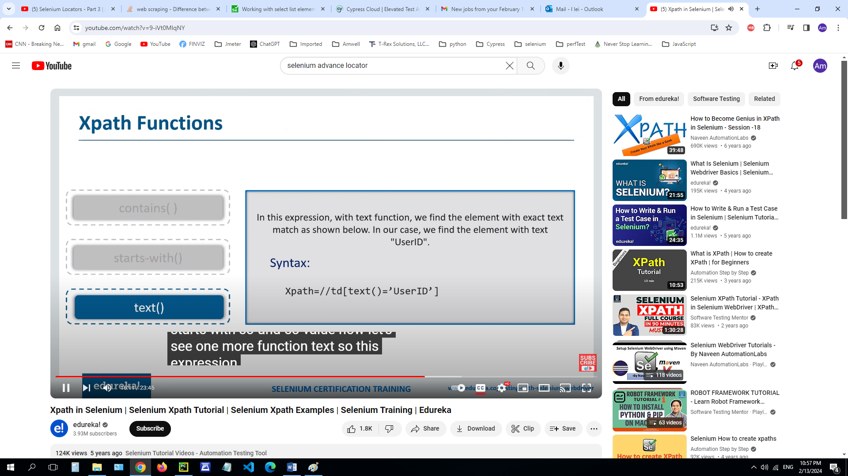

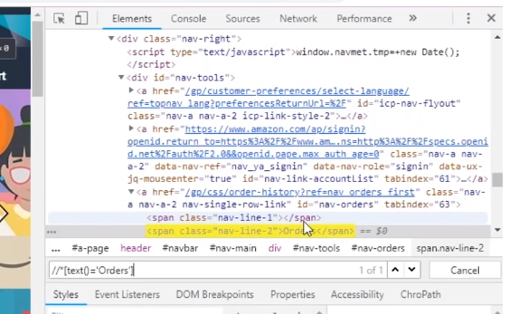

Use two functions together:
This example use contain() an text()

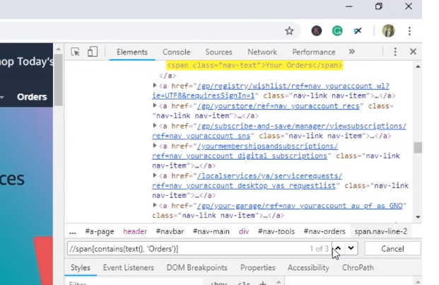

This example uses |
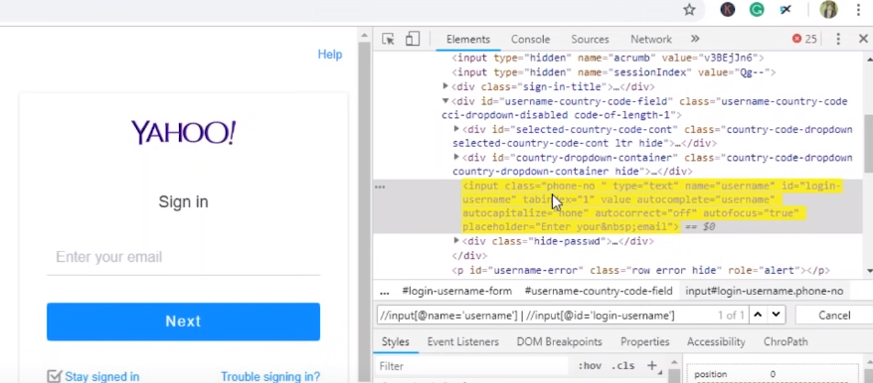

Also can use and
