**XAP K8 Deployment Framework – Test**

This is a readme document which show the framework and deployment process for K8 deployment into AWS EKS. We can deploy K8 into EKS in several ways as shown below.

Note: This is completed in personal AWS account. No other licenses required. Can be tested from local machine using AWS credentials or devops in AWS.

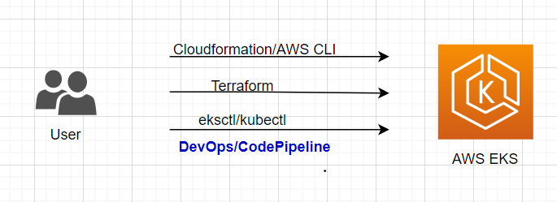

Here we are deploying K8 into EKS through eksctl/kubectl cli tools in AWS Codepipeline – **CodeBuild.** This is very simple deployment Steps using AWS native tools. Note: CLI tools are open source and can deploy **Manifest files** into EKS through CodeBuild. The workflow of **IaC** is built on this with the requirements. All files **for BuildSpec to Build and Deploy** will be pointed to parent directory.

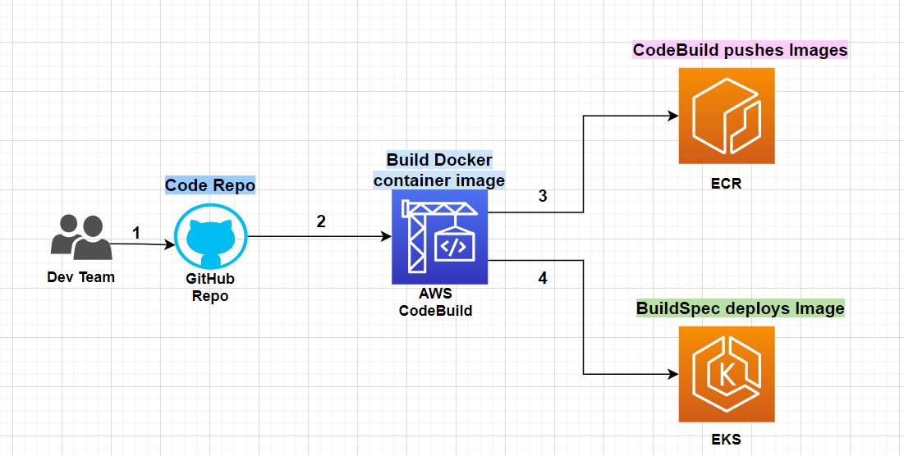

We can create multiple pipelines (For CodeBuild) as stages build and deploy. Here I have used one BuildSpec to build and deploy.

1. Build docker

2. Deploy K8

# References:

# Kubernetes Ingress with AWS ALB IngressController

# <https://aws.amazon.com/blogs/opensource/kubernetes-ingress-aws-alb-ingress-controller/>

# Eksctl/kubectl cli tools and commands

# <https://docs.aws.amazon.com/eks/latest/userguide/getting-started-eksctl.html>

# <https://eksctl.io/>

# Added enough readme files to the folder