Software Requirements Specification (SRS) Template

Items that are intended to stay in as part of your document are in bold; explanatory comments are in italic text. Plain text is used where you might insert wording about your project.

The document in this file is an annotated outline for specifying software requirements, adapted from the IEEE Guide to Software Requirements Specifications (Std 830-1993).

Tailor this to your needs, removing explanatory comments as you go along. Where you decide to omit a section, keep the header, but insert a comment saying why you omit the data.

Mentcare System
Amy Funk

Software Requirements Specification

Document

Version: 1.0.0 Date: 10/31/2017

Table of Contents
1. Introduction 5
1.1 Purpose 5
1.2 Scope 5
1.3 Definitions, Acronyms, and Abbreviations. 5
1.4 References 6
2. The Overall Description 6
2.1 Product Perspective 6
2.1.1 System Interfaces 7
2.1.2 Interfaces 7
2.1.3 Hardware Interfaces 7
2.1.4 Software Interfaces 7
2.1.5 Communications Interfaces 8
2.1.6 Memory Constraints 8
Mentcare system shall run on hardware(Linux serves) that’s is available....maximum server memory available is currently 32GB 8
2.1.7 Operations 8
2.1.8 Site Adaptation Requirements 8
1.2 Product Functions 8
2.3 User Characteristics 8
2.4 Constraints 8
2.5 Assumptions and Dependencies 9
2.6 Apportioning of Requirements. 9
3. Specific Requirements 9
3.1 External Interfaces 10
3.2 Functions 10
3.3 Performance Requirements 11
3.4 Logical Database Requirements 11
3.5 Design Constraints 11
3.5.1 Standards Compliance 11
3.6 Software System Attributes 11
3.6.1 Reliability 11
3.6.2 Availability 11
3.6.3 Security 11
3.6.4 Maintainability 13
3.6.5 Portability 13
3.7 Organizing the Specific Requirements 14
3.7.1 System Mode 14
3.7.2 User Class 14
3.7.3 Objects 17
3.7.4 Feature 17
3.7.5 Stimulus 17
3. 7.6 Response 17
3.7.7 Functional Hierarchy 18
3.8 Additional Comments 18
4. Change Management Process 18
5. Document Approvals 18
6. Supporting Information 18

1. Introduction

The Mentcare system is designed with two overall goals in mind:

- To provide better management information about mental healthcare in the region.
- To provide an improved records system for clinical staff involved in diagnosis and treatment.

1.1 Purpose

The purpose of this SRS is to provide a framework for building out the Mentcare system. It will include all requirements, as well as, features that are out of scope.

1.2 Scope

Below is a list of features that are required and are therefore in scope:

- Management information that allows health service managers to assess performance against local and government targets and to monitor the costs of treatment.
- Clinical information on medical history, diagnoses and treatments.
  - Individual Care Management
  - Patient Monitoring
  - Managing Involuntary Detention
  - Administrative Reporting
- The system must be capable of rich communication with other patient tracking systems.
- Security measures to ensure patient privacy and safety.
Additionally, here is a list of features that are out of scope of this system:
- The system should not be capable of tracking non-mental health related issues.

1.3 Definitions, Acronyms, and Abbreviations.

(DOB) – Date of Birth

Initial patient information. Information normally gathered during a patient’s first arrival in a healthcare provider’s office or in an emergency room. This includes but not limited to name, address, Social Security Number and any health insurance numbers.

Non-Digitized Professionals. Health Care providers who have no access to digital records through lack of hardware, software, or preference to legacy flat file charting methods

ISO 8601. A standard format for representing date and time recommended by the International Organization for Standardization

1.4 References

HIS-SRS Document
http://itech.fgcu.edu/faculty/zalewski/ism4331/his-srs.doc

Mentcare Requirements PDF

2. The Overall Description
The Software Requirement Specification will define and illustrate the overall project and its requirements- both functional and non-functional. In addition the SRS will define the users and their respective characteristics as well as any constraints to development that the team has identified.
The format of the SRS document will address the overall project first- including functions and objectives in an overview. This section will also address how this software interfaces with other legacy systems and/or diagnostic equipment connected to it. Then the subsequent sections will specifically addresses the components of the larger software system. These sections delineate specifications for every facet of the components design.

2.1 Product Perspective

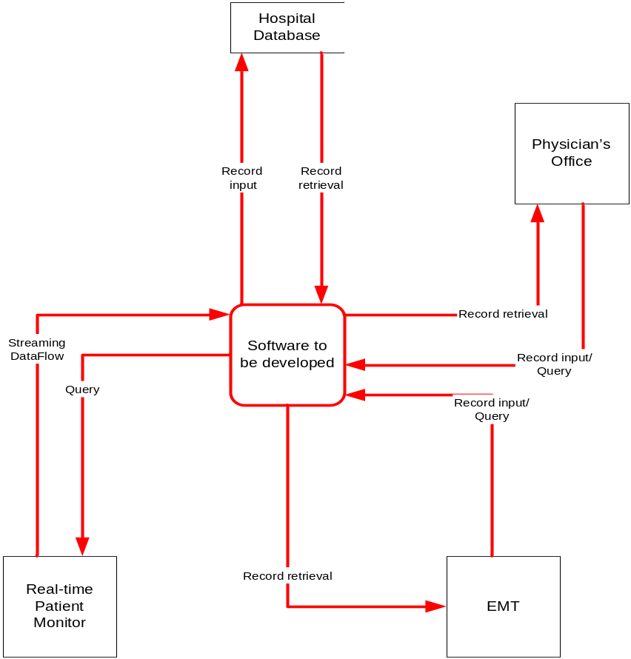

2.1.1 System Interfaces

The user interface to the system shall be an interactive forms-based interface.

As far as possible, all user selections shall be made using menus of allowed items.

This avoids certain types of user input errors where invalid information is input.

2.1.2 Interfaces
TBD

2.1.3 Hardware Interfaces

Linux Servers

2.1.4 Software Interfaces

This document will identify the pertinent software products we will develop including a Host DBMS, JAVA software supported and web-based Patient, Physician, and Ambulatory Input/Outputs, and sensor driven inputs for real-time patient monitoring. The SRS will show that we will be utilizing SQL server and ASP for interfacing with the Input/Outputs as well as Java applets for the real-time acquisition of health data from remote sources. Finally, utilizing the security attributes of XML, XSL, and a secure socket layer in the protocol stack we hope to address the valid security concerns about the networking and transmission of confidential health care information.

2.1.5 Communications Interfaces

TBD

2.1.6 Memory Constraints

Mentcare system shall run on hardware(Linux serves) that’s is available....maximum server memory available is currently 32GB

2.1.7 Operations

TBD

2.1.8 Site Adaptation Requirements

TBD

Product Functions

The software must request username and password for access to data, only after authentication will allow access to the system.

The software must identify the patient by a unique numeric identifier derived from a function performed on the patient’s birth date.

The software must require high levels of error correction and input validation.
The software to be developed must display the correct patient name.
The software must retrieve, update, and store data from multiple input locations.

2.3 User Characteristics

The primary user will be a healthcare professional like a physician, a nurse, or an emergency medical technician.
Nurse Administrators, Physician Office Administrators, System Administrators and/or Therapists will have limited access and information capabilities.

2.4 Constraints

The following operational constraints shall apply to the Mentcare system:

- The Mentcare system shall make use of the health authorities drug information system that includes information about the characteristics of drugs and the costs of these drugs. Details of the interface to this system are available in the document Mid-Scot-DrugSys- 2011.

- The Mentcare system shall provide summary information about patients and treatments for the national patient record system. The format of the information required is defined in the document Mid-Scot -NatSysInfo-2010. Interface definition for the National Patient Record System.

- The Mentcare system shall make use of the Mid-Scotland health authority’s single sign- on authentication system. This is a multi-factor authentication system that requires both a login/password and answers to personal questions for each user. Information about this system is available in the document Mid-Scot -AuthSys-2013.

- The Mentcare system shall run on hardware (Linux servers) that is available in the authority’s data centre. Note that the maximum server memory available is currently 32GB. System administrators in the center are responsible for system backup.

- The Mentcare system security shall conform to the standards and provisions for secure medical systems as set out in Mid-Scot-Security-Requirements-2013.

- There is an existing system for prescribing medication called the PRESCRIPTION system. It is desirable that this system should be used rather than implement new prescribing functionality in the Mentcare system.

2.5 Assumptions and Dependencies

The system relies on a Physician relationship with a mental health system with which he/she is a staff member.

The SDLC chosen to implement the system will be model driven and based on subsequent versions to insure data integrity and functionality.

2.6 Apportioning of Requirements.

TBD

3. Specific Requirements

The software must allow input of patient data from patient (initial) home, secured access at Physician and Nurse Workstations, and from the data streaming real-time monitoring equipment.

The software must request username and password for access to data, only after authentication will allow access to the system.

The software must require high levels of error correction and input validation.

The software must allow browsing by the physician of historical medical information of his/her patients only.

The software must identify the patient by a unique numeric identifier derived from a function performed on the patient’s birth date.

The software to be developed must display the correct patient name.

The software must retrieve and sort medical record information and allow for screen and print output of said information.
Note. Print output will include name, DOB, and requested diagnostic information only.

3.1 External Interfaces

TBD

3.2 Functions

The software must request username and password for access to data, only after authentication the system will allow access.

The software must require high levels of error correction and input validation.
Note. Message box prompts would require a second entry of key data fields including name, DOB, Social Security Number, medications and allergies. Doctor’s inputs will similarly prompt proper code sets for diagnosis.
The software interface must follow design conventions which allow for familiar location of drop down menus, help etc.
Input errors will be returned in red with appropriate message box.

More than three attempts at login and failure will produce a red flag to system administrator.

3.3 Performance Requirements

95% of the transactions shall be processed in less than one second.

Data should be secured and backed up every quarter hour.

Power supply should have a back up and a disaster recovery plan.

3.4 Logical Database Requirements

TBD

3.5 Design Constraints

Hardware, software, and data communication elements must be sourced within budgetary constraints.

3.5.1 Standards Compliance

TBD

3.6 Software System Attributes

TBD

3.6.1 Reliability
TBD

3.6.2 Availability

The Mentcare system shall be continuously available during ‘normal’ clinic working hours between 0800 and 1830, Monday to Friday.
Periods of scheduled maintenance for the Mentcare system shall normally be arranged during the authority’s ‘systems at risk’ periods i.e. between 2100 and midnight, Monday to Friday and between 0800 and 1200, Sunday.

3.6.3 Security
The Mentcare system must conform to the legal safeguards set out in the 1998 UK Data Protection Act. In summary, this means that the system must:
- Maintain information securely and ensure that it is only accessed by authorised users.
- Allow individuals access to their personal records.
- Ensure data that is maintained on an individual to be relevant for the purpose for which it is maintained. Therefore, it is unlikely that the Act would permit details of patient purchases from the hospital shop (for example) to be maintained in their medical record.
- Provide means for people to challenge and correct information in the system that the data holder cannot demonstrate to be correct.
- Only maintain information while it is required for its purpose. For medical systems, you might argue that this is the patient’s lifetime or even longer if historical medical analysis is to be supported. In addition to the Data Protection Act, the provisions for the management of patient information set out in AAAA-Clinical Information Management-2012 shall apply to the Mentcare system. In the event of any system requirement here being in conflict with the Data Protection Act, the conflict must be resolved so that the legal provisions as set out in Data Protection Act are maintained.
Access to the functionality of the Mentcare system shall be controlled according to the role of the information user. For example, an administrator role may access details such as patient name and address but not details of their medical conditions. A security administrator is responsible for setting up the access permissions for the system.
- The Mentcare system shall include a role-based access control system that allows access to information to be specified in terms of the role of the system user.
- The Mentcare system shall support differential access to patient information depending on the role of the information user. Initial roles supported should be a clinical role, an administrator role and a medical records role. Provision shall be made in the system for adding new roles such as a ‘researcher’ role or a ‘patient’ role.
- The system shall provide a facility to set up and edit security permissions for each role.
- Access permissions shall be set up in accordance with a the Mentcare security policy (to be defined)
- All changes to security permissions shall be logged with details of who made the change, the date and time of the change and the changes made.
- The Mentcare system shall be maintained on a central server and records shall be accessed and updated in place by staff using the system.
- The Mentcare data server shall be maintained as a separate computer in a physically secure location.
- The Mentcare data server shall be backed up onto tape or disk each evening at or around 8pm. Backup policy shall conform to the standards set out in AAAA-Clinical Information Management-2012.
- A log of all transactions during a clinic session shall be maintained on local computers running the system. The Mentcare system shall allow these to be replayed against a copy of the database to recreate amended records if required. This allows records to be restored in the event of system failure in an clinic.
- All PCs used to run the Mentcare system shall have a static IP address and access and update requests shall only be accepted from PCs whose address is registered with the server.
- To reduce the probability of SQL poisoning attacks, the system shall validate all inputs that may be part of database queries. Any input that includes valid SQL shall be rejected.
- The length of all free-form user text inputs shall be limited and the system shall reject any inputs whose length is greater than the allowed limit. This reduces the probability of attacks based on buffer overflow.
- The system shall not allow copies of patient records or transactions to be stored on portable storage devices such as USB flash drives.

3.6.4 Maintainability

TBD

3.6.5 Portability

TBD

3.7 Organizing the Specific Requirements

TBD

3.7.1 System Mode

TBD

3.7.2 User Class

Clincal Requirements
Clinical staff use the system directly when patients attend for a consultation. They access and read individual patient records and, for every consultation, update the patient record with details of the consultation and the treatment prescribed. Patient records must be updated at each consultation.
Individual doctors may also access the system in read-only mode outside of consultations. For example, a doctor who is reading a paper about a new drug treatment may use the system to see if she has any patients for whom this may be useful.
The critical clinical requirements for the system are:
- The Mentcare system shall allow for the creation, updating, storage and management of patient records. The specific format of patient records shall be determined in collaboration with clinical and medical staff but it shall include at least the following information: A unique patient identifier, which should normally be their national health number. If patients do not have or know their NH number, then a unique patient ID shall be generated by the system. Personal patient information (name, address, date of birth, contact details, registered medical practice, family contacts); A risk assessment for self-harm/violence; Diagnoses of conditions (patients may suffer from several conditions at the same time); Treatments (several treatments may be prescribed including CBT); Prescribed medications (several medications may be prescribed); Consultations; Referrals (information about referrals to other clinical departments, social services, etc.) Information as required by the Mental Health Act (see Section 4).
- The system shall use a relational database system from the approved list published by the health authority. The specific choice of database system may be delayed until implementation.
- One or more free form text input fields shall be provided to allow comments on the patient by individual clinicians to be recorded. Mental health conditions are complex and this complexity cannot necessarily be captured in choices from drop-down menus. It is essential that clinical staff can write narrative comments about a patient.
- To reduce the interaction time required, the system shall provide a ‘no change’ button which will cause a consultation record to be created and which will simply carry forward the diagnoses and medication from the previous consultation.
- As a general principle, staff should not be required to re-enter patient information that is already recorded in the system. Whenever possible, therefore, provision should be made for prefilling forms with existing system information.
- The system shall automatically create a consultation record at the start of each consultation recording the date and time and the clinical staff (up to 6) involved. This should allow clinical staff to record comments on the consultation, referrals and changes of medication made.
- The system shall maintain a record of all medication prescribed, date of prescription and the prescriber. Provision shall be made in each prescription for free-form comments to be included by the prescriber.
- The system shall maintain a record of all diagnoses made, date of diagnosis and the diagnostician. The conditions diagnosed shall be selected from a list of known conditions and it shall be possible for multiple conditions to be diagnosed. Provision shall be made for free-form comments about the diagnoses to be included by the prescriber.
- When a patient has been referred to another clinical, information about all referrals including the date of referral, the referrer and any information provided by the referrer shall be maintained by the system.
- It shall be possible to update a patient record during a consultation when the record has been opened or at a later date. Records which have not been updated during a consultation should be flagged to indicate that they are not completely up-to-date. This allows for system failure or for individual doctors, for whatever reason, being unable to update the record at the time of a consultation. An example of such a situation is where a patient threatens or commits violence and has to be forcibly restrained.
- It shall be possible, from within the system, to consult the known side-effects for any drug that may be prescribed using the system.
- The system shall provide a risk indicator field that allows the risk status of the patient to be recorded. Risk status reflects the clinical assessment of whether the patient is likely to be a danger to themselves or others.
- The Mentcare system shall support the printing of medication prescriptions. The medications prescribed shall be chosen from the list of medications approved for use by the health authority. Several medications may be prescribed on a single prescription. It is recommended that the PRESCRIPTION system currently used by the mid-Scotland health authority is used to provide this feature.
Administrator Requirements
Clinic and health service administrators use the system for two main functions:
- To manage patient appointments and to set up meetings of clinical staff for discussion of patients and involuntary detention.
- To define and generate reports for clinic management on diagnoses, prescribed treatments and numbers of patients seen by clinical staff.
This leads to the following administrative requirements:
- The Mentcare system shall integrate with the health service APPOINTMENTS system so that patient appointments are made and managed using the APPOINTMENTS system.
- The Mentcare system shall allow the list of clinic appointments for any specific clinic to be downloaded to the Mentcare system. For each clinic, the appointments for that clinic shall be automatically downloaded from the APPOINTMENTS system to the Mentcare system for viewing in the Mentcare system. The previous list of appointments shall be deleted automatically before a new list is downloaded.
- The patient record shall include a facility to record if a patient has missed an appointment along with details, if available, of why the appointment was missed.
- Patient records shall contain a record of all meetings set up by clinical staff to discuss that patient. Meeting information shall include the date and time of the meeting, the staff involved and a summary of the meeting decisions.
- The system shall provide facilities for administrators to set up meetings by proposing a list of staff involved and a list of possible dates/times for the patient meeting. The system shall automatically email staff involved with the meeting proposal. If staff are not available, it is the responsibility of administrators to find an alternative date and time.
- A report format definition tool shall be provided for administrators to define the format of the reports required by managers. A list of available reports shall be maintained by the system. Initially, the developers should work with administrators to define a set of common reports.
- The Mentcare system shall allow administrators to select a management report to be generated and shall generate that report from the patient information.
- The Mentcare system shall allow administrators to save the management report on a local storage system. (They may then email it to hospital managers or print the report.)

Management Requirments

Health service managers do not use the system directly but require regular reports on the treatment process for mental health patients. These reports do not contain individual patient details but might record information such as the numbers of patients who attended each clinic each month, a summary of the drugs prescribed each month, a summary of the times that patients have had to wait for appointments, etc.
The reports are generated for managers by administrators – they must not contain information about identifiable, individual patients.
- The system shall maintain lists of patient conditions and treatments and clinicians shall select the patient condition and treatment from menus generated from these lists. The rationale for this is consistency of terminology for management reporting. If free form input is allowed then different users of the system may refer to the same thing in different ways (e.g. a drug may be available under several different brand names.
- The Mentcare system shall generate weekly reports for each clinic showing the number of patients attending each clinic on each day that it runs, the clinicians involved and the total number of patients who have attended for mental health treatment. The report should also summarise the number of patients suffering from each condition, the total amounts of each drug prescribed as medication and the costs of these drugs to the health authority.

3.7.3 Objects
TBD

3.7.4 Feature
TBD

3.7.5 Stimulus
TBD

3. 7.6 Response
The response time of the system contributes to both operator satisfaction and operator reliability. If the response time is too long, operators will become frustrated with having to wait for this system; this frustration can lead to errors being made.
- The system shall normally respond to all user queries about an individual within 2 seconds.
- If a system response is greater than 2 seconds, then the system shall display an indicator to the user that processing is taking place. This avoids user frustration if there has been a system failure and they keep waiting for a response that does not arrive.

3.7.7 Functional Hierarchy
TBD

3.8 Additional Comments
TBD

Change Management Process
TBD
Note:
Changes can only occur between the hours of 2100 to midnight Monday through Friday, and between 0800 to 1200 Sunday.

Document Approvals

TBD: pending discovery of primary stakeholders

Supporting Information
N/A

