Software   
Requirements  
Specification

Version 1.0 ● 21 FEB 2015

[GIANT E-COMMERCE CLOUD]

|  |  |
| --- | --- |
| VERSION: 1.0 | REVISION DATE: 22 Feb,2015 |

|  |  |  |  |
| --- | --- | --- | --- |
| **Name** | **Title** | **Signature** | **Date** |
| CHANDRAMOULI |  |  |  |
|  |  |  |  |
|  |  |  |  |

Contents

Section 1. E-Commerce Site Overview

1.1 Purpose

1.2 Business Context

1.3 General Pre-requisites & Assumptions

1.4 Scope

Section 2. E-Commerce Merchant Self Help (MSH)

2.1. Purpose

Section 3. Inventory File-upload Interface

3.1. Purpose

Section 4. Suppliers Management - Overview

4.1. Purpose

Section 4. References

Section 6. Glossary

Section 7. Revision History

Section 8. Appendices

# Section 1. E-Commerce Site Overview

## **1.1 Purpose**

*Initial purpose of this document is to list out some of the major functionalities of E-Commerce website.*

⇒

## **1.2 Business Context**

## **1.3 General Pre-requisites & Assumptions**

|  |  |  |  |
| --- | --- | --- | --- |
| S.No | Topic | Item Description | Explanation |
|  | Open Source Shopping Cart Software | Prestashop |  |
|  | Analytics Tool | Google Analytics | Google Analytics to be configured for each and every page of the shopping site. |
|  | Google Tag Manager | Used for marketing efforts | Shopping Site to be configured with Google Tag Manager |

## **1.4 Scope**

**Objective**

To create a scalable and flexible e-commerce platform targeting online customers in order to meet their online shopping needs with unique user experience.

It should be simple, specific, attractive, usable and accessible.

The platform should be scalable by data, applications, users and B2B networks. The platform should have a scalable database.

The platform should be accessible through various channels such as smart phone, tablet, and laptop, desktop and cross-browser compatibility.

**Technology:** Open source software and cloud based technology.

**To follow data driven model for e-**commerce site development. Later to create each module as a service. This helps to support user’s scalability.

**Initial Scope**

Initial scope involves the necessary functionalities to support E-commerce website via http protocol.

Later the scope to be enlarged for Web Application to be hosted via Android / IPhone -Playstore, etc to support all mobile devices.

1. **Review and Star ratings(negative and positive) – Must Have**

* This is one of the most important information that users will base their purchase on besides price.
* Users want to see positive and negative reviews. Too many positive reviews don’t give balanced feedback, and make customers suspicious that the reviews could be phony.

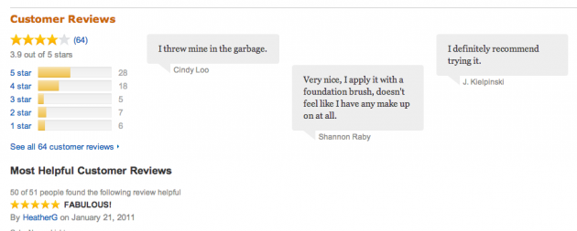

* If products don’t have reviews on the website directly, we should try to link reviews from other site that sell the same product or include a consumer reports testimonial.

1. **Size and dimensions – Must Have**

(This to be handled while uploading product images- to be kept in mind. Example below for illustration)

* Example: I recently bought a single-serve espresso pot online. I love it, but it’s a lot smaller than I expected! I’d never bought an espresso pot before, and I really wish the product images had shown someone using it, or had shown it next to another object for scale.

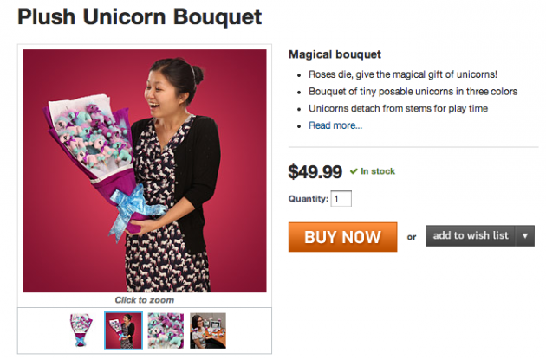

* By the way, numbered dimensions aren’t much help on their own, unless you’re selling computers, furniture, or TVs. **Telling customers that a purse has an 11-inch strap is much less powerful than showing a picture of a model wearing it.**

1. **Pictures & Videos for Product display (Video good to have)**

* Provide a 360 degree view of the product. Rotating is great otherwise static images are fine.
* Need to have incredible visuals (eg: refer to the pottery barn website : <http://www.potterybarn.com>)
* Image sizes should be big. Show large images and product description viewable on mouse over.
* For certain products we might want to show a small video to demonstrate the product. The shopping site should support this feature.

1. **Product Comparison**

A product comparison module allows shoppers to select multiple products and compare them side by side.

1. **E-mail Campaigns (Must have)**

5.1. Welcome Series - Subscription Confirmation

5.2. Abandoned Cart Series

5.3. Important Campaigns & Product Launches E-mail series

5.4. Follow-up ‘After the Sale’ Series

5.5. ‘We Miss You’ Series

5.6. Useful Information Series

5.7. Anniversary of purchase series

1. **Daily Deals (Must have)**

This feature allows offering daily deals directly from online store.

1. **Loyalty Program (Must have)**

* This feature offers incentives such as points or cash for products.
* Based on the effort, this to be released at initial or at a later stages.

1. **Multilanguage storefront**

This can be handled at a later stage.

1. **Video Tutorials / Product Usage Tour:**

Show video tutorials / Simple Tour for the first time for customers on how to shop from the site and to answer some of their queries in advance through video tutorials.

1. **Customized Gifts**

* Offer discounts with bundled products
* Persononilized packaging

1. **Shopping site to support multiple country / currency**

Shopping site should automatically detect the user’s country location and show the products prices in respective currencies. (India site showing in INR / Singapore site should reflect it in SGD, and so on)

1. **Product Catalog –** Grid View.
2. **New Arrival**

This can be handled at a later stage.

1. **Recommended Products.**

This can be handled at a later stage.

1. **Admin – Product enrollment with categories, Product Tracking and Shipping**
2. **Payment Gateway Integration**
3. **Discount and Offers.**

**Products to be listed with discounted price. This listing should be dynamic (location wise). For example, during Diwali season, there should be major discounts / promotions targeting India & Singapore customers. Whereas during Chinese New Year, only Singapore customers enjoy promotions.**

Price variation for the products. This can be handled at a later stage.

1. **Sign-Up for Promotion & Newsletters to enjoy discount during next purchase.**

Somewhere during home page visit by new users, there should be a pop-up message as below to motivate users to sign-up for our newsletters and promotions so that they get a discount of 25% or whatever during next purchase.



1. **Search Functionality (Most Critical)**

This will turn out very critical when there are too many products in the catalog. For example, in the catalog there is “Denim”. If customer searches for “Jeans”, then “Denim” product should be listed part of search results.

One example is to show an image thumbnail for the search results below 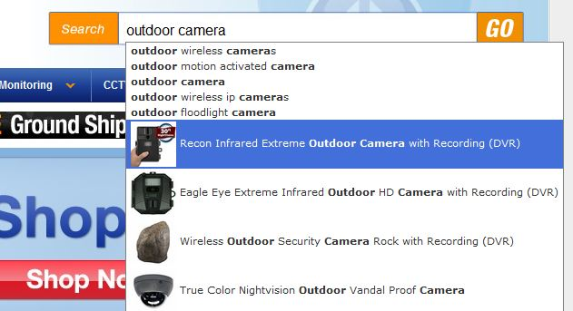

1. **5 Click Checkout Process (Most Critical)**

When a user logs in to the site, should be able to start and complete the checkout process in a maximum of 5 clicks. This enable’s for simple and clear navigation. This increases customers buying decisions.

1. **Order Confirmation – SMS Notification**

Once user purchases a product, apart from E-mail confirmation on their order, an SMS to be sent to user’s registered phone number. User may opt for this or not and it will be managed in user’s preference section. The SMS should be short & sweet, describing the transaction and product details with delivery dates.

1. **Shipping Duration**

Analyze the best approach to handle shipping duration and how we can show the shipping duration dynamically to the customer before they make the payment.

1. **Best Deals**

* Show promotional items like “Best Deals”, “Deal of the day”, “Promotional Offers” and so on.
* This should be customized as per user, user’s location / country, season and so on.

1. **Reporting**

To build a separate reporting module that extracts reports from the e-commerce backend database to support the following reports.

* + - 1. To show the list of orders that are placed for specific duration (Show Start Date & End date) to retrieve
      2. List of orders and their respective supplier details (Supplier name, address, e-mail & phone numbers)
      3. Logistics Report to show the list of products that needs to be checked with the suppliers for availability.

1. **Feedback:**

Feedback functionality to be incorporated into the website.

# Section 2. E-Commerce Merchant Self Help (MSH)

## **2.1. Purpose**

* Let’s call this as Merchant Self Help.
* Through this website, merchants should be able to provide us updated inventory online.
* Merchants could upload list of product catalogs that are in stock with quantity and pricing.
* Have to explore any existing open source product availability to cater this requirement.

# Section 3. Inventory File-upload Interface

## **3.1. Purpose**

* Alternative to Merchant Self Help (MSH) functionality, let us provide a simple login page and a file upload functionality wherein merchants can upload a simple excel file containing products name, description, product ID, number of stocks available, product price, etc.
* Explore any open source product to cater this requirement as well.

## 

# Section 4. Suppliers Management - Overview

## **4.1. Purpose**

To provide inventory management module for suppliers.

Suppliers to access their separate production catalog from the same domain, for example [www.kickloo.com/suppliers/IndiaClothing/login.php](http://www.kickloo.com/suppliers/IndiaClothing/login.php)

Suppliers can login and manage their list of products with images and update total stocks available after keying in user id and password.

Have to search for an open source module and integrate it with our current main E-commerce site.

# Section 4. References

*Provide a list of all documents and other sources of information referenced in the SRS and utilized in developing the SRS. Include for each the document number, title, date, and author.*

|  |  |  |  |
| --- | --- | --- | --- |
| **Document No.** | **Document Title** | **Date** | **Author** |
|  |  |  |  |
|  |  |  |  |
|  |  |  |  |
|  |  |  |  |
|  |  |  |  |
|  |  |  |  |

# 

# Section 6. Glossary

*Define of all terms and acronyms required to interpret the SRS properly.*

⇒

# Section 7. Revision History

*Identify changes to the SRS.*

|  |  |  |  |
| --- | --- | --- | --- |
| **Version** | **Date** | **Name** | **Description** |
|  |  |  |  |
|  |  |  |  |
|  |  |  |  |
|  |  |  |  |
|  |  |  |  |
|  |  |  |  |

# Section 8. Appendices

*Include any relevant appendices.*

⇒