RL methods:
1. Value Based: mapping between an action and a value (optimal value). Sample efficient and steady.
- Q value, Bellmann equation
- Deep Q networks, Double Dueling Q Networks
2. Policy Based: find optimal policy directly without the Q value. They are better for continuous and stochastic environments, have a faster convergence
- Policy Gradients
- REINFORCE
3. Actor-Critics:
Both value- and policy-based. The actor decides which action to take; the critic tells the actor how good its action was and how it should adjust.
- A2C (Advantage Actor-Critic): (Improved version: synchronous, with multiple agents)
- Q(s, a) = V(s) + A(s, a)
(V(s) = state value function, A(s, a) = Advantage)
- A3C (Asynchronous Advantage Actor-Critic):
- released by DeepMind in 2016. Simple, robust, fast, achieving higher scores.
- multiple agents with their own weights, interacting with a different copy of
the environment in parallel
- drawback: some agents will be using older version of parameters
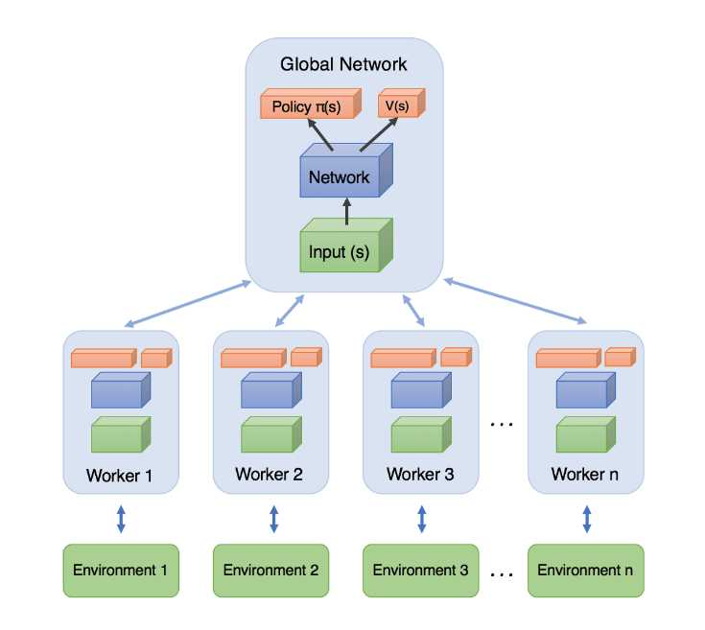

A self-learning finite element extraction system based on reinforcement learning
Jie Pan1, Jingwei Huang2 , Yunli Wang3, Gengdong Cheng4 and Yong Zeng

1. Use A2C to generate high-quality quadrilateral elements while maintaining the remaining geometry’s quality for the continuous generation of good quality elements.
2. Take the good quality elements generated from the A2C method as samples to train an FNN for fast generation of high-quality meshes. Relieves the human algorithm designers.

Smart designing of the smart element extraction system:
A smart system can make adaptive decisions corresponding to various environmental situations. The smartness of the element extraction system is two-fold:
1) how various complex boundary shapes can be processed by three element extraction rules. These three rules alone are sufficient to process any environmental situation.

2) among all boundary edges of a geometric domain, the system is able to smartly pick an optimal edge and its corresponding rule to generate a quadrilateral.

Scikit-geometry, Sympy, OpenGym sample:
1. observation_space: partial observation including the following points:
- p0 (center)
- pl1 (left to origin)
- pl2
- pr1 (right to origin)
- pr2
- p_theta1 (potential vertex to generate in fan-shaped area 1)
- p_theta2 (potential vertex to generate in fan-shaped area 2)
- p_theta3 (potential vertex to generate in fan-shaped area 3)

To find p_theta1,2,3 coordinates (existing poins in polygon):
1. generate a circle centered at p0 with radius d
2. define fan-shaped area using angle pl2_p0_pr2/3 (defined below)
3. obtain coordinates of start and end points on the circle defining the fan-shaped area
4. test for point in polygon:
a. projection of vector generated by point ccw to start
b. projection of vector generated by point cw to end
c. x² + y² <= r²
If there are no existing points inside the fan-shaped area:
1. p_theta1 = (d cos theta1/2, d sin theta1/2)
2. p_theta2 = (d cos theta2/2, d sin theta2/2)
3. p_theta3 = (d cos theta3/2, d sin theta3/2)

To find angle theta (pl1_p0_pr1):
1. use formula theta = tan⁻¹((m1-m2)/(1+m1*m2))
2. handle special cases:
a. m1 = -m2: slopes are perpendicular – theta is 90 degrees
b. m1 or m2 is horizontal: theta is tan⁻¹(m2) or tan⁻¹(m1)
c. m1 is undefined (vertical slope):
1. find angle with horizontal axis
2. if pr1 is in quadrant 1: theta is (90-angle)
3. if pr1 is in quadrant 2: theta is (90+angle)
4. if pr1 is in quadrant 3:
- pl1 in 1: theta is (180-angle)
- pl1 in 3: theta is (90-angle)
5. if pr1 is in quadrant 4:
- pl1 in 1: theta is (90-angle)
- pl1 in 3: theta is (180-angle)

