P76074648 張媤婷

**Training_rate=0.7**

**Decision Tree**

Match = 686 / 700

Confusion_matrix =

[[487 9]

[ 5 199]]

precision recall f1-score support

0 0.99 0.98 0.99 496

1 0.96 0.98 0.97 204

avg / total 0.98 0.98 0.98 700

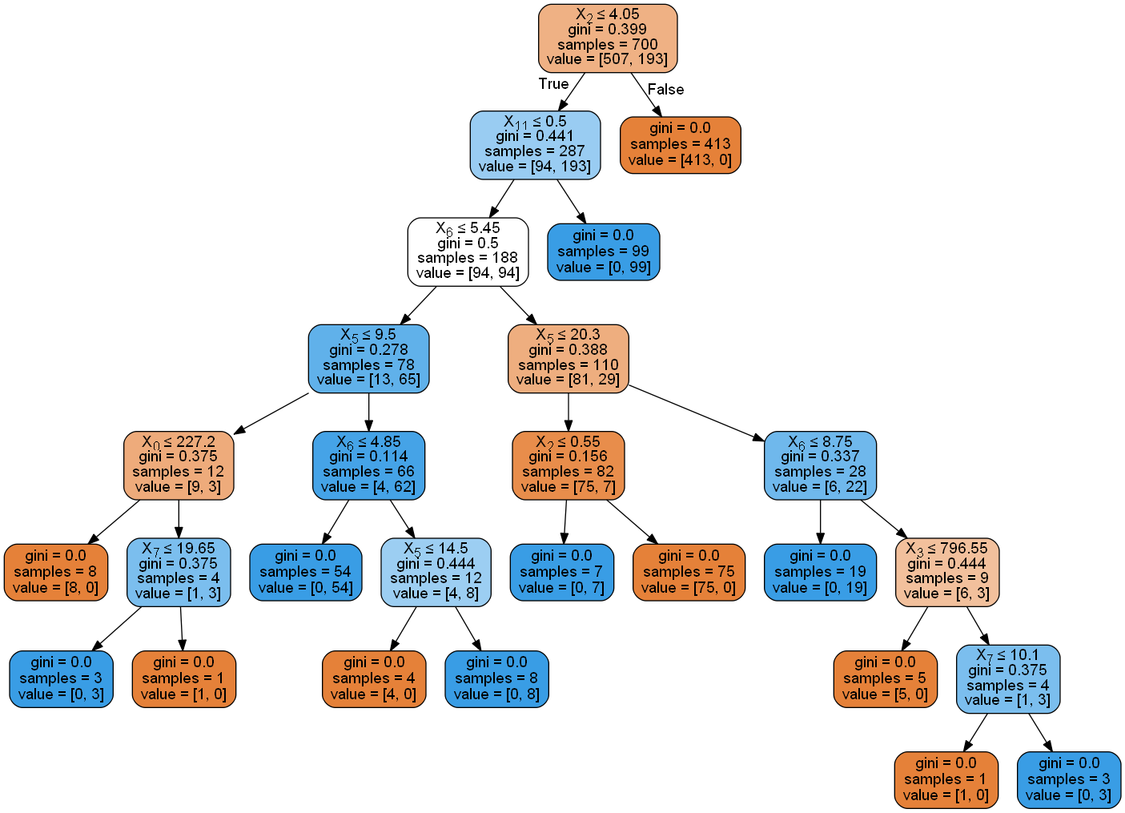

**Random Forest**

Match = 688 / 700

Confusion_matrix =

[[492 4]

[ 8 196]]

precision recall f1-score support

0 0.98 0.99 0.99 496

1 0.98 0.96 0.97 204

avg / total 0.98 0.98 0.98 700

**SVC**

Match = 607 / 700

Confusion_matrix =

[[496 0]

[ 93 111]]

precision recall f1-score support

0 0.84 1.00 0.91 496

1 1.00 0.54 0.70 204

avg / total 0.89 0.87 0.85 700

**KNN**

Match = 561 / 700

Confusion_matrix =

[[424 72]

[ 67 137]]

precision recall f1-score support

0 0.86 0.85 0.86 496

1 0.66 0.67 0.66 204

avg / total 0.80 0.80 0.80 700