Smart Closet Organiser
Final Submission Report
(20103780) Amy Comyns Haugh
4-7-2026

Contents
Table of Figures 3
Plagiarism Declaration 4
Acknowledgements 4
Introduction 5
Project Overview 6
Background 7
Motivation 8
Problem Statement 9
Background Research & Industry Context 10
Aims & Objectives 12
Project Contribution & Impact 13
Design 14
Architecture Model 14
User Stories 16
Risk Assessment 19
Methodology 21
Agile & Scrum 21
Scrum Artifacts 21
Sprints 23
Sprint Review & Backlog Refinement 23
Version Control 24
Technologies 25
Languages 26
Tools 26
Smart Closet Organiser Implementation 28
Sprint 1: Core Backend & Firebase 28
Sprint 2: AI Stylist Feature Implementation 30
Sprint 3: User Profiles & Google Sign-In 32
Sprint 4: Calendar Feature 33
Sprint 5: Virtual Try-On Feature 35
Sprint 6: Donation Feature 37
Sprint 7: UI Improvements 39
Sprint 8: AI Image Scanning 41
Sprint 9: AI Voice Input & Bug Fixes 42
Sprint 10: Donation Planning & Map Integration 43
Sprint 11: Location-Based Weather Integration 44
Sprint 12: Final Polish & Bug Fixes 45
Final Bug Fixes & Improvements 46
Application Navigation Road Map 47
1. Login Screen 47
2. Register Screen 48
3. Home / Wardrobe Dashboard 49
4. My Closet 50
5. Add / Edit Item Screen 51
6. Outfits Screen 52
7. Virtual Try On 53
8. AI Stylist 54
9. Calendar 55
10. Donation: Flagged Tab 56
11. Donation: Plan & Map 57
12. Profile & Settings 58
Conclusion & Evaluation 59
References 61

Table of Figures
Figure 1High-level architecture of the Smart Closet Organiser showing the interaction between the UI, ViewModel, and Data Layers 13
Figure 2 Detailed data architecture illustrating integration with Firebase services, local storage, external APIs, and Background Processing 14
Figure 3 Login Screen 46
Figure 4 Register Screen 47
Figure 5 Home Screen 48
Figure 6 Closet Screen 49
Figure 7 Add/ Edit Item Screen 50
Figure 8 Outfit Screen 51
Figure 9 Virtual Try On 52
Figure 10 AI Stylist 53
Figure 11 Calendar 54
Figure 12 Donation: Flagged Tab 55
Figure 13 Donation: Plan & Map 56
Figure 14 My Profile & Setting Screen 57

Plagiarism Declaration
I affirm that the work I am submitting is entirely my own and has not been taken from any other source, except where properly cited. I understand that plagiarism, collusion, and copying are serious offences that can result in academic penalties. I have read and understood the assignment regulations and have properly cited all sources of information in my work. This assignment has not been previously submitted by me or anyone else for assessment on this or any other course.
I understand that plagiarism is the presentation of another person’s work or ideas as if they were my own, and that this constitutes academic dishonesty. I acknowledge that any form of plagiarism, collusion or falsification of data is a serious academic offence and may result in disciplinary action.
All sources consulted and referenced throughout this report. Including websites, academic papers and online documentation, are listed in full in the References section at the end of this document.

Acknowledgements
I would like to take this opportunity to express my sincere gratitude to all those who have supported me throughout the development of the Smart Closet Organiser project.
First and foremost, I would like to thank my project supervisor for their consistent guidance, constructive feedback and encouragement throughout the duration of this final year project. Their expertise and advice have been invaluable in shaping both the technical direction and written quality of this report.
I would also like to thank my fellow students and peers for their feedback, suggestions and moral support during the development process. User testing sessions and informal discussions provided insights that significantly improved the application’s usability and design.
Finally, I would like to thank my family and friends for their patience and encouragement during what has been a demanding but rewarding academic year. Their support has been a great source of motivation throughout this project.

Introduction
Choosing what to wear is a small but repeated daily problem that can become frustrating when users have large wardrobes, busy schedules, changing weather conditions, and no structured way to organise their clothing. Many people own more clothes than they regularly wear yet still struggle to put together suitable outfits quickly. This often leads to wasted time, repeated outfit choices, forgotten clothing items, and unnecessary spending on new clothes.
The Smart Closet Organiser was developed to address this problem through a practical and intelligent Android mobile application. The project combines wardrobe management, outfit planning, artificial intelligence, weather-aware recommendations, and virtual outfit previewing into one unified system. Rather than acting as a simple digital clothing catalogue, the application is designed to function as a personal wardrobe assistant that helps users organise what they own, make better outfit decisions, and plan ahead more effectively.
This report presents the final implementation of the Smart Closet Organiser and documents the technical, design, and development decisions made throughout the project. It explains how the application evolved from an initial concept into a feature-rich mobile system through an iterative Agile development process. It also demonstrates how modern Android development technologies, cloud services, and AI integration can be used together to solve a real everyday problem in a useful, engaging, and innovative way.

Project Overview
The Smart Closet Organiser is an Android-based mobile application that enables users to digitise and manage their wardrobe in a more structured and intelligent manner. Users can add clothing items, upload and store their images, categorise clothing, create and save outfits, and maintain a personalised wardrobe in the cloud. Building on this core functionality, the application introduces several advanced features including AI-generated outfit suggestions, calendar-based outfit planning, user profile management, and a virtual try-on interface for previewing combinations before saving them.
The purpose of the application is not only to store wardrobe data, but to actively support decision-making. The app helps users choose what to wear based on their own clothing, live weather conditions, and styling rules, reducing the time and mental effort involved in outfit selection. It also allows users to plan outfits in advance for work, events, holidays, or everyday use, making wardrobe organisation more practical and efficient.
A key strength of the Smart Closet Organiser is that it combines multiple useful functions within one platform. Existing wardrobe applications often focus on only one aspect of the problem, such as item storage, outfit planning, or recommendations. By contrast, this project integrates wardrobe digitisation, outfit management, AI styling, weather-aware suggestions, calendar planning, and virtual try-on functionality into a single cohesive system. This makes the application more valuable to the user, as it supports the full process of wardrobe organisation from storage and planning to decision-making and outfit visualisation. The project vision in the earlier planning report already centred on combining wardrobe organisation, AI recommendations, planning tools, and visual outfit support into one mobile solution, and the final implementation carries that vision through into a much more complete working system.

Background
The way individuals manage their wardrobes has remained largely unchanged despite significant advancements in mobile technology and artificial intelligence. In most cases, people still rely on memory, habit, or manual organisation when choosing what to wear. As a result, large parts of a wardrobe may remain underused, forgotten, or difficult to style, even when users own clothing suitable for a wide range of occasions.
This issue becomes more significant when considered in the context of modern lifestyles. People are often required to plan outfits around work, college, travel, social events, and changing weather conditions, yet many do not have any digital tool that gives them a complete and usable overview of what they already own. This gap creates an opportunity for a solution that combines convenience, organisation, and intelligent support.
The original project concept was based on the idea of creating a personal digital wardrobe that would allow users to store clothing details, create outfits, receive recommendations, and plan ahead more effectively. It was also intended to support better use of existing clothes and reduce the tendency for clothing to go unworn or be forgotten. The final version of the Smart Closet Organiser builds on that foundation by delivering a more advanced implementation that combines cloud-connected storage, AI-assisted outfit generation, planning tools, and interactive user features within a single Android application.

Motivation
The motivation for this project came from a common personal and social problem: many people regularly struggle with deciding what to wear, even when they own plenty of clothing. This daily decision can take more time and energy than expected, particularly when users are trying to balance style, comfort, weather, and occasion. What appears to be a simple decision can quickly become repetitive, inconvenient, and mentally tiring.
Beyond convenience, the project is also motivated by the issue of clothing underuse and unsustainable consumption. Many users wear only a small portion of their wardrobe regularly, while other items remain unused for long periods because they are forgotten, difficult to style, or not visible within the wardrobe as a whole. A digital system that helps users see, organise, and plan their existing clothes more effectively can encourage more conscious use of clothing and reduce unnecessary purchasing.
The project was also motivated by an interest in combining fashion, sustainability, and intelligent mobile technology. From the planning stage, the aim was to create an application that was not only useful but also engaging and modern, using features such as AI recommendations, outfit visualisation, and planning tools to improve the user experience. This made the Smart Closet Organiser an opportunity to solve a real everyday problem while also demonstrating the practical value of contemporary Android and AI development techniques.

Problem Statement
The core problem addressed by this project is the inefficiency of traditional wardrobe management. Many users do not have a clear overview of the clothes they own, which makes it difficult to create outfits, plan ahead for events, or make full use of their wardrobe. This lack of visibility often leads to repeated outfit choices, forgotten clothing items, poor organisation, and wasted time when getting dressed.
Although existing wardrobe and styling applications attempt to address parts of this problem, many are incomplete in their approach. Some offer basic wardrobe storage but limited intelligence, while others provide recommendations without strong planning or visualisation support. There is a clear need for a more integrated solution that combines wardrobe organisation, outfit management, personalisation, planning, and intelligent recommendations in one user-friendly application.
The Smart Closet Organiser addresses this need by providing an all-in-one Android application that allows users to store and organise wardrobe items, create and save outfits, receive personalised AI outfit suggestions based on weather and wardrobe contents, plan looks in a calendar, and preview combinations using a virtual try-on feature. In doing so, the project moves beyond simple clothing storage and instead offers a more complete system for wardrobe decision support, organisation, and long-term usability.

Background Research & Industry Context
Several existing applications attempt to address the problem of wardrobe management, but none provide a fully integrated solution that combines organisation, AI recommendations, planning, and sustainability in one place.
Stylebook is one of the most established wardrobe apps on the market. It allows users to photograph and catalogue their clothing, create outfits, and plan looks on a calendar. However, it lacks any AI-powered recommendation engine and does not integrate live weather data, meaning outfit suggestions are entirely manual. It is also only available on iOS, limiting its accessibility.
Cladwell takes a different approach by offering AI generated outfit suggestions based on a capsule wardrobe. While it does provide recommendations, it requires users to build their wardrobe from a predefined set of items rather than photographing and uploading their own clothes, making it less personal and less reflective of what users actually own.
Google's Lookbook and apps such as Smart Closet focus primarily on item storage and basic outfit assembly but do not incorporate weather awareness, donation tracking, or virtual try-on functionality.
The Smart Closet Organiser addresses the gaps left by these existing solutions. By combining wardrobe digitisation with AI powered and weather-aware recommendations, a virtual try-on feature, calendar planning, and a sustainability focused donation tracker, the application offers a more complete and intelligent wardrobe management experience than any single competitor currently provides. The addition of AI image scanning and voice input further differentiates it by reducing the manual effort required to build and maintain a digital wardrobe.
A review of relevant literature and industry research further validates the project's core assumptions. Research into consumer behaviour and fashion sustainability consistently highlights the overconsumption problem. According to the United Nations Environment Programme, the fashion industry is responsible for approximately 10% of global carbon emissions, and a significant proportion of purchased clothing is discarded within a year of purchase. Digital tools that extend the active use-life of clothing are therefore considered a meaningful intervention in addressing the environmental impact of fashion.
In the field of mobile application design, research emphasises the importance of user experience in driving adoption and retention. Studies on wardrobe management applications suggest that users abandon tools that require extensive manual data entry or that do not provide meaningful, personalised value. This finding directly informed the design decision to integrate AI powered recommendations that reduce cognitive load and automate decision making.
Academic work on recommendation systems highlights that collaborative filtering and content-based filtering are the two primary approaches for generating personalised suggestions. For the Smart Closet Organiser, a content-based approach is most appropriate, as it generates recommendations based on attributes of the user's own wardrobe items such as colour, category and season, rather than relying on data from other users.
Research into the Agile software development methodology, particularly Scrum, consistently demonstrates its effectiveness for iterative, adaptive development. For a solo developer working within a defined academic timeframe, adapted Scrum practices including time-boxed sprints, a prioritised backlog and regular self-review provide the structure needed to manage scope and maintain quality.

Aims & Objectives
The primary aim of this project is to design and develop a functional, intelligent and user-friendly mobile wardrobe management application for Android.
The specific objectives of the project are as follows:
- To develop a secure user authentication and profile management system using Google Firebase.
- To implement a comprehensive clothing item management module that allows users to add, edit, categorise and search wardrobe items.
- To build an outfit creation and management feature that enables users to combine clothing items into saved outfits.
- To integrate a calendar-based planning tool that allows users to assign outfits to specific dates and events.
- To develop an AI-powered recommendation engine that suggests outfits based on the user’s wardrobe, style preferences and real-time weather conditions.
- To implement a sustainability-focused donation tracking feature that identifies and highlights infrequently worn items.
- To design an intuitive, accessible and visually appealing user interface that meets the needs of the target audience.
- To document the development process thoroughly, including design decisions, challenges encountered and lessons learned.

Project Contribution & Impact
The Smart Closet Organiser makes several meaningful contributions at the intersection of mobile application development, artificial intelligence and sustainable fashion technology.
From a technical perspective, the project demonstrates how modern Android development tools, specifically Kotlin, Jetpack Compose and Firebase can be used by a solo developer to build full-stack mobile application within an academic project context. The integration of a content-based AI recommendation engine with real-time weather data provides a practical example of how machine learning and external APIs can be combined to deliver intelligent, personalised user experiences.
From a social and environmental perspective, the application has the potential to contribute meaningfully to more sustainable clothing consumption. By encouraging users to engage with their full wardrobe, the app can reduce unnecessary clothing purchases and extend the active use-life of existing clothing items. The donation tracking feature provides a direct mechanism for users to transition from ownership to conscious decluttering.

Design

Architecture Model
The Smart Closet Organiser is built on the Model-View-ViewModel (MVVM) architectural pattern, which is the recommended architecture for Android applications using Jetpack Compose. This pattern enforces a clear separation of concerns across three distinct layers, each with well-defined responsibilities.
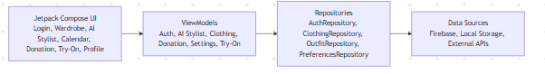
Figure 1High-level architecture of the Smart Closet Organiser showing the interaction between the UI, ViewModel, and Data Layers
The Presentation Layer consists of all Composable functions written using Jetpack Compose. These functions are responsible solely for rendering the user interface and responding to user interactions. They observe state exposed by the ViewModel and re-compose automatically when that state changes, ensuring the UI is always consistent with the underlying data.
The ViewModel Layer acts as the intermediary between the UI and the data sources. Each screen in the application has a corresponding ViewModel that holds and manages UI-related state, processes business logic and exposes data to the Composable layer through StateFlow and LiveData objects. By isolating business logic in the ViewModel, the application becomes easier to test and maintain.
The Data Layer is structured around a Repository pattern. Each Repository class acts as a single source of truth for a particular type of data, abstracting the decision of whether to fetch data from Firebase Cloud Firestore or from a local cache. This layer communicates with three primary data sources: Firebase Authentication for user identity management, Firebase Cloud Firestore for structured data persistence (clothing items, outfits, calendar entries) and Firebase Storage for hosting clothing images.
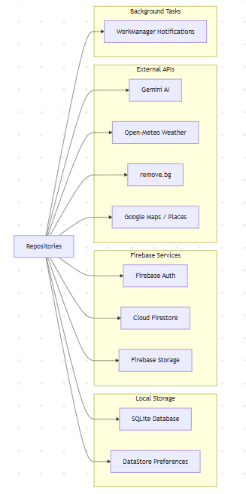
Figure 2 Detailed data architecture illustrating integration with Firebase services, local storage, external APIs, and Background Processing
Additionally, the Data Layer includes an external integration with the OpenWeatherMap API, which provides the real-time environmental data consumed by the AI recommendation engine. This integration is handled through a dedicated Retrofit service class, keeping the weather logic cleanly separated from the core wardrobe data management code.
This layered MVVM architecture ensures the application is modular, testable and scalable. Each layer can be modified or extended independently without needing changes across the entire codebase, which is particularly important for a project that will continue to evolve through iterative sprints.

User Stories
The following user stories define the functional requirements of the application from the perspective of the end user.

User Story 1: User Registration and Login
As a new user, I want to register for an account so that my wardrobe data is saved securely and accessible from my device.
Priority: High
Acceptance Criteria:
- The user can create a new account using an email address and password.
- The user receives an error message if their email is already registered.
- Returning users can log in and their wardrobe data is retrieved from the previous session.
- The user can log out securely, and their data is not accessible without re-authentication.

User Story 2: Adding a Clothing Item
As a wardrobe-conscious user, I want to add clothing items to my digital wardrobe so that I have a complete record of my clothes.
Priority: High
Acceptance Criteria:
- The user can upload a photo of a clothing item from their device camera or gallery.
- The user can input metadata including category, colour, size and season.
- The item is saved to Firebase Firestore and appears in the wardrobe overview screen.
- The clothing image is stored in Firebase Storage and displayed as a thumbnail.

User Story 3: Creating an Outfit
As a busy professional, I want to combine clothing items into saved outfits so that I can plan my wardrobe efficiently.
Priority: High
Acceptance Criteria:
- The user can select multiple clothing items from their wardrobe to form an outfit.
- The user can assign a name and description to the outfit.
- The outfit is saved and visible in the outfits overview screen.
- The user can edit or delete saved outfits.

User Story 4: AI Outfit Recommendation
As a time-pressed user, I want the app to recommend outfits based on my wardrobe and the current weather so that I can get dressed quickly without compromising on style.
Priority: High
Acceptance Criteria:
- The AI engine fetches the current weather from the OpenWeatherMap API.
- The system filters clothing items by season and temperature suitability.
- One outfit suggestion is displayed to the user each day.
- The user can accept, reject or save the suggested outfit.

User Story 5: Calendar Outfit Planning
As an organised user, I want to assign outfits to specific dates in a calendar so that I can plan ahead for work, events and special occasions.
Priority: Medium
Acceptance Criteria:
- The user can navigate a monthly calendar view within the app.
- The user can select a date and assign an existing outfit to it.
- Assigned outfits are visible when the user selects a date.

User Story 6: Donation Tracking
As an environmentally aware user, I want the app to notify me when I have not worn certain items for a long time so that I can consider donating or removing them from my wardrobe.
Priority: Medium
Acceptance Criteria:
- The app tracks the last worn date and wear count for each clothing item.
- Items that have not been worn for a user-defined period are flagged in the donation screen.
- The user can mark items as donated, removing them from the active wardrobe.
- The user can customise the inactivity threshold in settings.

Risk Assessment
A thorough risk analysis has been conducted to identify, assess and mitigate the key risks associated with the development and deployment of the Smart Closet Organiser. Each risk is assessed in terms of its likelihood and impact, with corresponding mitigation strategies outlined below.
Risk | Likelihood | Impact | Mitigation Strategy
Technical Complexity of AI Engine | Medium | High | Begin with a simple rule-based recommendation model. Research a better ML models in later sprints once core functionality is stable.
Time Constraints/  Scope Creep | High | High | Maintain a prioritised backlog. Core features (wardrobe management, outfit creation, AI recommendations) are developed first, optional features are deferred.
Firebase Service Outage or Cost Overrun | Low | Medium | Use Firebase free tier quotas carefully. Implement local caching to reduce read/write operations. Monitor usage via Firebase console.
Data Privacy & Security Risks | Low | High | Use Firebase Security Rules to ensure users can only access their own data. Do not share user data with third parties without explicit consent.
OpenWeatherMap API Rate Limits | Medium | Low | Cache weather responses locally for a minimum of one hour. Implement a fallback that allows outfit suggestions without weather data if the API is unavailable.
Device Compatibility Issues | Medium | Medium | Test on multiple Android API levels using the Android Emulator. Use responsive Jetpack Compose layouts that adapt to different screen sizes
User Adoption / Usability Concerns | Medium | Medium | Conduct usability testing with a small group of peers. Iterate on UI design based on feedback before final release.
Loss of Code / Version Control Failure | Low | High | Use GitHub for version control with regular commits after each development session. Maintain a backup of the repository.

Methodology

Agile & Scrum
The Smart Closet Organiser project is developed using an adapted Agile Scrum methodology, tailored to accommodate the constraints of a solo developer working within an academic project timeline. Agile was selected over alternative approaches such as the Waterfall model because of its emphasis on iterative delivery, flexibility in response to change and continuous testing and review.
Traditional Scrum is a framework designed for cross-functional teams, typically comprising a Product Owner, Scrum Master and Development Team. For this project, all three roles are assumed by the developer, with the project supervisor acting as an informal stakeholder who reviews progress at key milestones.
The Agile approach has been particularly valuable in managing the inherent uncertainty of a technically ambitious project. Features such as the AI recommendation engine and Firebase integration presented unforeseen challenges during development. The flexibility built into the Agile framework allowed these challenges to be absorbed without derailing the overall project timeline, as tasks could be reprioritised and sprint goals adjusted accordingly.

Scrum Artifacts
Three primary Scrum artifacts are used to manage and track the project’s progress: the Product Backlog, the Sprint Backlog and the Increment.

Product Backlog
The Product Backlog is a prioritised list of all features, enhancements and tasks required to deliver the complete Smart Closet Organiser application. It is maintained as a living document that is updated at the end of each sprint during the Sprint Review and Backlog Refinement session. Items in the Product Backlog are written as user stories where applicable and are estimated in terms of complexity.
The current Product Backlog includes the following categories of items: core wardrobe management features, AI recommendation engine development, Firebase integration tasks, UI/UX design and testing, calendar integration and donation tracking functionality. Items are continuously reprioritised based on project progress and any new requirements or technical insights that emerge during development.

Sprint Backlog
The Sprint Backlog is a subset of the Product Backlog selected for completion within a single sprint. At the start of each sprint, the highest-priority items from the Product Backlog are selected and broken down into specific, actionable tasks. Each task is assigned an estimated time to completion and tracked throughout the sprint.
The Sprint Backlog is maintained using a simple Kanban-style board with three columns: To Do, In Progress and Done. This visual representation provides a clear and immediate overview of progress within each sprint and helps identify bottlenecks or tasks that are taking longer than expected.

Increment
The Increment represents the sum of all completed Product Backlog items at the end of each sprint. For this project, each Increment is a working, testable version of the Android application that can be installed and demonstrated on a device or emulator. The application’s codebase on GitHub serves as the definitive record of each Increment, with tagged commits marking the end of each sprint.

Sprints
The project followed a two-week sprint cycle throughout the development. At the start of each sprint, I identified the highest priority features from the Product Backlog and planned the work accordingly. Any technical questions, design decisions or uncertainties that arose during a sprint were brought to my supervisor for guidance, ensuring I stayed on track and made informed choices throughout the process. Sprints were used as a way to stay focused and deliver working features incrementally rather than trying to build everything at once.

Sprint Review & Backlog Refinement
At the end of each sprint, I reviewed what had been completed against the sprint goal and updated the Product Backlog to reflect any new priorities or insights gained during development. If a task was not completed, it was assessed and either carried forward or reprioritised. Backlog refinement allowed me to continuously adjust the scope of upcoming sprints based on what I had learned, keeping the project realistic and manageable. Any significant changes in direction or scope were discussed with my supervisor during our check-ins.

Version Control
Version control is a fundamental aspect of the development process for the Smart Closet Organiser. The project uses Git for source code management, with the repository hosted on GitHub. This approach ensures that the complete history of the codebase is preserved, all changes are traceable and the project can be restored to any previous state if needed.

The branching strategy adopted for this project follows a simplified version of the Git Flow model. The main branch always contains the most recent stable, tested version of the application. Development work is conducted on a development branch, and individual features or bug fixes are developed on separate feature branches that are merged back into the development branch upon completion.

Commits are made frequently, typically after the completion of each logical unit of work, such as a new screen, a new data model or a significant bug fix. Each commit message follows a structured format that clearly describes the nature of the change, making the commit history easy to navigate and review.

At the end of each sprint, the development branch is merged into the main branch, and a tagged release is created. This tagged release corresponds to the Sprint Increment and provides a clear, versioned record of the application’s state at each stage of development.

Using GitHub also provides a measure of duplication and backup for the project’s codebase. In the event of local hardware failure, the complete codebase and development history can be restored from the remote repository.

The repository also contains supporting documentation, including the project’s README file, which provides an overview of the application, instructions for building and running the project, and a changelog summarising the key changes introduced in each sprint.

Technologies
The Smart Closet Organiser was built using a combination of cloud services, external APIs and development frameworks, each selected to best support the specific requirements of the application.

Google Firebase
Served as the primary backend for the project. Firebase Authentication was used to handle user login and registration, supporting both email and password sign-in and Google Sign-In via the GoogleID credential library. Firebase Firestore was used as the main NoSQL database, storing all clothing items, outfits, calendar entries and user profile data. Firebase Storage was used to host clothing images uploaded by users, with each image referenced by a URI stored in Firestore. Firebase's built-in offline persistence was also enabled, allowing the app to function without a network connection and sync automatically when connectivity is restored.

Google Gemini API
Powers the AI Stylist feature. The generative AI model analyses the user's wardrobe data alongside live weather conditions and a custom fashion rules engine to generate personalised outfit suggestions in real time. The API is accessed via the official Android Generative AI SDK.

Open-Meteo API
Provides real-time weather data used by the AI Stylist. It supplies current temperature and weather conditions based on the device's location, allowing the AI to tailor outfit suggestions to the actual weather. This API was integrated using Retrofit with Gson conversion.

Remove.bg API
Is used to remove the background from clothing images when a user adds a new item to their wardrobe. The image is sent to the remove.bg REST API via an OkHttp multipart request, and the processed PNG is returned and saved locally before being uploaded to Firebase Storage. A toggle on the Add Clothing screen allows the user to choose whether to apply background removal or keep the original image, addressing cases where the removal produces inaccurate results on darker or more complex clothing items.

SQLite
Was implemented as a local backup store alongside Firebase. Using Android's built-in SQLiteOpenHelper, the app maintains a local database of clothing items that ensures the wardrobe remains accessible offline and acts as a fallback if cloud data is unavailable.

Languages
The Smart Closet Organiser was developed entirely in Kotlin, which is Googles officially recommended language for Android Development. Kotlin was chosen for its concise expressive syntax, it’s built in null safety which reduces runtime crashes and its support for asynchronous programming through coroutines. Coroutines were used extensively throughout the project to handle network calls, Firebase operations and AI Requests without blocking the main thread, keeping the UI responsive at all times. Kotlin’s interoperability with Java also meant that the large ecosystem of existing Android libraries was fully accessible during development.

Tools

Android Studio
Android Studio was the primary IDE used throughout the project. It provided the full package of Android Development tools including the layout editor, Logcat for debugging, the Android Emulator for testing across different API Levels and the Gradle build system for managing dependencies. The built-in profiler was used to monitor memory and CPU Usage and identify any performance issues during development. The project targets Android SDK 35, with a minimum SDK of 30.

Jetpack Compose
Was used as the UI framework for the entire application. All screens were built using Composable functions, replacing the earlier XML-based layouts. Compose's declarative approach significantly reduced boilerplate code and allowed for faster iteration on UI design. Navigation between screens was handled using the Jetpack Navigation Compose library.

Hilt
Was used for dependency injection throughout the project. It manages the creation and provision of key dependencies such as Firebase services, repositories and View Models, reducing coupling between components and making the codebase easier to maintain and test.

Retrofit
Was used to handle HTTP networking for both the Open-Meteo weather API and the remove.bg background removal API. It was configured with a Gson converter for JSON parsing and an OkHttp logging interceptor to assist with debugging API responses during development.

Coil
Was used for asynchronous image loading within Jetpack Compose screens. It handles loading clothing images from both Firebase Storage URLs and local URIs, with built-in caching to reduce unnecessary network requests.

Dokka
Was integrated into the build configuration to generate HTML documentation from KDoc comments in the source code, providing a structured reference for the project's classes and functions

KtLint
Was used as a code style linter to enforce consistent Kotlin formatting standards across the codebase throughout development.

GitHub
Was used for version control and release management. All code was committed regularly and tagged releases were used to mark each major version of the application, as described in the Version Control section.

Smart Closet Organiser Implementation

Sprint 1: Core Backend & Firebase
The primary objective of the first sprint was to establish a secure, scalable, and reliable backend infrastructure for the Smart Closet Organiser application, while also modernising the user interface architecture. A key early decision was to migrate the entire user interface from traditional XML-based layouts to Jetpack Compose. This shift to a declarative UI framework significantly improved code readability and made the UI more flexible and easier to maintain. It also aligned the project with modern Android development practices, allowing for faster iteration and better integration with state management.
Alongside the UI migration, Firebase was integrated as the core backend solution, enabling the application to transition from a purely local system to a cloud-connected platform capable of storing user data securely online. The purpose of this integration was to allow users to manage their wardrobe, including clothing items, outfits, and images, in a way that is both persistent and accessible across sessions, while also ensuring that each user’s data remains private and isolated.
User authentication was implemented using Firebase Authentication with email and password support, providing a complete login, registration, and logout flow. Each authenticated user is assigned a unique user ID (UID), which is used throughout the application to associate all data with the correct user. Authentication state is validated before any interaction with cloud services, ensuring that only authorised users can perform operations. This is reinforced through the use of security checks such as request.auth.uid, which guarantees that users can only access and modify their own data.
Cloud Firestore was integrated as the primary NoSQL database for storing structured data such as clothing items and outfits. A user-centric data model was designed, where each user has their own collection of data organised under their UID. This structure simplifies querying, improves scalability, and ensures strict data separation between users. To manage database operations effectively, repository classes were implemented to handle creating, updating, deleting, and retrieving user-specific data. This abstraction layer improves code organisation and maintainability by separating business logic from direct database interactions.

Firebase Storage was used to handle user-uploaded images of clothing items. When a user selects an image using the Android image picker, the file is uploaded to a structured storage path based on their UID, and a download URL is generated. This URL is then stored in Firestore alongside the corresponding clothing item, allowing images to be easily retrieved and displayed in the user interface. Two key fields are maintained for each image, one for displaying the image (imageUrl) and another for managing deletion (imagePath). When a clothing item is removed, both the Firestore document and the associated image in storage are deleted, ensuring that no unused files remain in the system. Images are displayed using the Coil image loading library, prioritising the cloud-based URL while allowing fallback to local sources if necessary.
Security rules were implemented across both Firestore and Firebase Storage to enforce strict access control. These rules require users to be authenticated and ensure that all read and write operations are restricted to the authenticated user’s data path. By enforcing conditions such as request.auth.uid == uid, the system prevents unauthorised access and guarantees complete data isolation between users.
To improve reliability and user experience, a hybrid data architecture was introduced to support offline functionality. Local storage mechanisms, including an SQLite database for clothing items and JSON storage for outfits, were combined with Firebase’s cloud services. Data is first stored locally and then synchronised with the cloud when an internet connection is available. Additionally, Firebase’s built-in offline persistence was enabled, allowing users to continue interacting with their wardrobe even without connectivity. This approach ensures faster data access, continuous usability, and automatic synchronisation once the device reconnects to the internet.
Finally, an image background removal feature was implemented to enhance the visual consistency of clothing items within the app. This allows users to isolate garments from their backgrounds, resulting in cleaner and more uniform presentation across the wardrobe interface. Overall, this sprint successfully established both the core backend infrastructure and a modern UI foundation, providing a strong and scalable base for future feature development.

Sprint 2: AI Stylist Feature Implementation
The second sprint focused on enhancing the Smart Closet Organiser by introducing an intelligent, user-facing feature designed to differentiate the application from standard wardrobe management systems. This led to the development of the AI Stylist, powered by Google’s Gemini API, which was selected due to its accessibility, cost-effectiveness, and seamless integration with Android. The goal of this feature was to provide users with personalised outfit recommendations based on both their existing wardrobe and real-time environmental conditions.
To support this functionality, a dedicated AiStylistViewModel was implemented to manage the AI interaction lifecycle. This View Model handled distinct UI states, including idle, loading, success, and error, ensuring a clear separation between business logic and presentation. This approach improved maintainability and allowed the UI to react dynamically to asynchronous API responses without becoming tightly coupled to the underlying logic.
A key component of the AI feature was the development of a custom Fashion Rules engine, which was embedded directly into the AI prompt. This system ensured that generated outfit suggestions followed realistic styling principles, such as avoiding colour clashes, maintaining appropriate layering, and selecting clothing suitable for specific weather conditions. Rather than relying solely on raw AI output, this structured prompt design significantly improved the consistency and quality of recommendations.
To generate personalised suggestions, the prompt dynamically incorporates the user’s wardrobe data retrieved from Firebase, grouping items by category such as tops, bottoms and jackets. In addition, live weather data for Dublin is included, allowing the AI to adapt recommendations based on temperature and conditions such as rain, wind, or sunshine. This combination of personal data and contextual information ensures that the output is both relevant and practical for the user’s daily needs.
From a user interface perspective, a new AI Stylist tab was added to the bottom navigation bar alongside the existing wardrobe functionality. This required extending the navigation structure while maintaining consistency with the existing design. The result is a seamless transition between managing wardrobe items and receiving AI-generated outfit suggestions.

An additional feature introduced in this sprint was the ability to match AI-generated recommendations with actual wardrobe items. The system parses the AI response, extracts relevant clothing descriptions, and maps them to items stored in the user’s collection. The corresponding images are then displayed within the UI, creating a direct visual link between the suggested outfit and the user’s available clothing. This significantly improves usability by making the recommendations actionable rather than purely textual.
This sprint also included improvements to the image processing pipeline. The original background removal implementation using a local library was found to be unreliable, particularly with complex colours where parts of the clothing were incorrectly removed. As a result, this was replaced with the remove.bg REST API, which provided significantly more accurate results. To improve user experience and manage API usage, an optional toggle was introduced, allowing users to choose whether background removal should be applied. Additionally, a device-specific bug was resolved where images captured on certain phones appeared rotated incorrectly. This was fixed by reading and applying EXIF metadata before processing the image.
Several stability issues were also addressed during this sprint. Notably, a crash occurring during image selection was traced to a mismatch between the FileProvider authority defined in the Android manifest and the value expected in the code. Correcting this inconsistency resolved the issue and improved overall application stability.
From an architectural perspective, the sprint maintained consistency with the existing design patterns used in the application. Hilt dependency injection was used throughout to ensure modularity and testability, while API keys for external services were securely stored in local properties and exposed via BuildConfig, preventing them from being committed to version control. The implementation also adhered to the existing MVVM architecture, ensuring that new features integrated cleanly with the established codebase.

Sprint 3: User Profiles & Google Sign-In
The third sprint focused on improving user account management and personalisation within the Smart Closet Organiser application. Building on the existing authentication system, this release introduced support for Google Sign-In alongside the traditional email and password login, enhancing both usability and accessibility. Integration with Google Sign-In allowed users to authenticate quickly using their existing accounts, reducing friction during onboarding and improving the overall user experience. This required extending the existing authentication flow within Firebase Authentication to support multiple providers while maintaining secure session handling and user identification.
In addition to authentication improvements, a dedicated user profile section was introduced to provide greater personalisation and account control. This profile interface is accessible via a user icon located in the top navigation bar, and displays key user information including name, email address, biography, and profile image. The design of this section aimed to centralise all user-related settings in one place, improving navigation and reducing clutter in the main application screens.
Users are able to edit their display name and personal bio directly within the app, allowing for a more customised experience. Profile images can also be uploaded from the user’s device, adding a visual identity to each account. These updates are reflected in real time and persist across sessions, contributing to a more engaging and user-centric interface.
From a backend perspective, profile data is managed across multiple Firebase services. Core authentication details such as email and account identity are handled through Firebase Authentication, while additional user information such as display name and bio is stored in Firestore. Profile images are stored in Firebase Storage, following a structured and user-specific storage path similar to the clothing image system. This multi-service approach ensures that user data is both secure and scalable, while maintaining clear separation between different types of information.
As part of this sprint, certain functionality was reorganised to improve overall usability. Actions such as signing out and exporting wardrobe data were moved into the profile section, helping to declutter the main interface and create a more intuitive navigation structure. This change reflects a broader focus on refining the user experience as the application grows in complexity.

Sprint 4: Calendar Feature
The fourth sprint focused on extending the functionality of the Smart Closet Organiser by introducing a calendar-based outfit planning system. The goal of this feature was to allow users to organise and schedule outfits for specific dates, transforming the application from a reactive wardrobe tool into a proactive planning assistant. This addition improves overall usability by helping users prepare outfits in advance for events, work, or daily wear, encouraging better organisation and more effective use of their wardrobe.
A new Outfit Planner screen was introduced and made accessible through the bottom navigation bar via a calendar icon. The interface was built around a monthly calendar view, implemented using an existing calendar UI component to ensure reliability and reduce development time. Users can interact with the calendar by selecting any date, which triggers a bottom sheet interface allowing them to assign an outfit to that day. This interaction was designed to be intuitive and consistent with modern mobile UI patterns.
When assigning an outfit, users can choose from their existing saved outfits and optionally add contextual notes, such as “Work”, “Wedding”, or “Holiday”. These notes provide additional meaning to planned outfits and enhance the organisational aspect of the feature. If an outfit is already assigned to a selected date, users are given the option to update or remove it through the same interface, ensuring flexibility and ease of modification.
To improve visual feedback and usability, dates that have an outfit assigned are marked with a small indicator beneath the calendar number. This allows users to quickly identify which days have been planned without needing to open each individual date. In addition, an “Upcoming” section was implemented below the calendar, displaying all future planned outfits in chronological order. Each entry in this list is expandable, revealing detailed information including the outfit description, associated season, and a horizontally scrollable list of clothing items complete with images and labels. This provides users with a clear and engaging overview of their upcoming outfit plans.

From a backend perspective, all calendar-related data is stored in Firebase Cloud Firestore under each user’s account, ensuring persistence across sessions and devices. The data model integrates with the existing outfit structure, linking selected dates to outfit IDs and associated metadata. Security rules were also extended to ensure that users can only read and write their own calendar data, maintaining consistency with the application’s overall data protection strategy.

During development, several important issues were identified and resolved. A key bug was discovered where clothing item images were not appearing within outfit displays. This issue was traced back to the local SQLite database, which lacked an image_url column. As a result, image references retrieved from Firebase Storage were not being preserved when clothing items were associated with outfits. This was resolved by introducing a database migration that safely added the missing column without deleting existing user data. Additionally, the Firestore outfit repository was updated to correctly store and retrieve the imageUrl field for each clothing item, ensuring consistency between local and cloud data.

Sprint 5: Virtual Try-On Feature
The fifth sprint focused on enhancing the interactivity and usability of the Smart Closet Organiser through the introduction of a Virtual Try-On feature. This feature was designed to allow users to visually assemble and evaluate outfit combinations using their own wardrobe items before committing to saving them. The goal was to provide a more engaging and practical decision-making experience, enabling users to experiment with different clothing combinations in a dynamic and intuitive way.
The Virtual Try-On module was implemented as a new screen within the application and fully integrated into the existing navigation structure. Built using Jetpack Compose and Material 3 components, the feature follows a two-phase interaction model designed to streamline the outfit creation process. In the first phase, users browse their wardrobe items organised by category, including tops, bottoms, jackets, and shoes. Each category is presented through a horizontally swipe able image slider using a pager component, allowing users to quickly scroll through available items. A chip-based tab row enables easy switching between categories, while a mini canvas at the top of the screen provides real-time visual feedback on selected items. A progress indicator further enhances usability by showing how complete the outfit is as selections are made.
Once at least one item has been selected, users can transition to the second phase by tapping the “Try On” button. This phase presents a preview of the outfit using vertically stacked, full-width cards for each clothing category. Each card is also swipe able, allowing users to dynamically swap individual items without leaving the preview screen. This design reduces unnecessary navigation and maintains context, making it easier for users to compare and refine outfit combinations. The jacket category was treated as optional, and an appropriate empty state was implemented to ensure the layout remains visually consistent even when no items are available.
Users are able to save outfits directly from the preview phase by assigning a name, after which the outfit is persisted using the existing backend infrastructure. Specifically, outfits are stored in Firebase Cloud Firestore via the existing repository layer, while also being saved locally to support offline access. This ensures consistency with the application’s hybrid data architecture and allows users to access their saved looks regardless of connectivity. Additionally, previously saved outfits can be quickly reloaded into the try-on interface through a slide-down panel accessible from the top app bar, improving efficiency and encouraging reuse of existing combinations.

The feature adheres to the existing MVVM design pattern used throughout the application. A dedicated TryOnViewModel was introduced to manage state and business logic, ensuring a clear separation between UI and data handling. Dependency injection was handled using Hilt, maintaining modularity and consistency with previous features. Navigation to the Virtual Try-On screen was integrated into the bottom navigation bar, ensuring that the feature fits seamlessly within the overall application flow.
Overall, this sprint significantly improves the user experience by introducing a highly interactive and visually driven feature that supports outfit experimentation and decision-making. The Virtual Try-On feature not only enhances engagement but also reinforces the practical value of the application, bridging the gap between wardrobe management and real-world outfit planning.

Sprint 6: Donation Feature
This sprint focused on implementing a donation tracking feature to support more sustainable wardrobe usage and encourage users to make better use of their existing clothing. This feature allows the application to identify items that have not been worn for extended periods and prompt users to either keep or donate them. The goal was to address the issue of underutilised clothing while reinforcing the application’s broader focus on organisation and conscious consumption.
The feature was developed within the existing application architecture, adhering to the Model-View-ViewModel (MVVM) pattern used throughout the project. No changes were required to the existing data model, as the system was able to leverage the lastWorn field already stored for each clothing item in Firebase Cloud Firestore.
The core business logic is handled within a dedicated DonationViewModel, where items are evaluated based on how long they have been inactive. The number of days since an item was last worn is calculated and compared against a configurable threshold defined in months. Items exceeding this threshold are flagged for user review. To ensure efficiency, items that the user has already interacted with are excluded from future checks by storing their identifiers locally. This prevents repeated prompts and reduces unnecessary processing.
For managing user preferences and decisions, Android DataStore Preferences was introduced as a lightweight and modern alternative to traditional SharedPreferences. This was used to store both the user-defined inactivity threshold and the list of items that have already been reviewed. DataStore integrates seamlessly with Kotlin coroutines and Flow, aligning with the existing asynchronous patterns used throughout the application and ensuring a consistent architectural approach.
The user interface was implemented using Jetpack Compose and follows the same design patterns as the rest of the application. The donation screen presents a list of flagged items, allowing users to act directly. A built-in settings panel enables users to adjust the inactivity threshold without navigating away from the screen, simplifying the user experience. The feature was integrated into the main navigation structure by extending the bottom navigation bar with a new entry, maintaining consistency with previously added features such as the planner and virtual try-on.

Two key interaction flows were implemented. Choosing to keep an item removes it from the flagged list locally without modifying cloud data, reducing unnecessary database writes. Choosing to donate an item triggers a full deletion from Firestore, reusing the existing repository methods for removing clothing items. This ensures consistency with the application’s existing data handling behaviour.

Finally, the feature was designed with offline resilience in mind. Firestore operations are wrapped in error handling to ensure that the application remains stable even without network connectivity. If data cannot be refreshed, the previously loaded state is preserved, maintaining a smooth user experience.

Sprint 7: UI Improvements
This sprint focused on refining the overall user interface and improving the user experience through visual consistency, better navigation structure, and usability enhancements. Unlike previous sprints which introduced new core features, this phase concentrated on polishing existing functionality to ensure the application feels cohesive, intuitive, and aligned with modern mobile design standards. All improvements were implemented within the existing Jetpack Compose framework without introducing any new external dependencies.
A key improvement in this sprint was the standardisation of card styling across the application. Previously, list-based screens used the default Material 3 elevated card style, which resulted in a visually inconsistent and overly heavy interface. This was replaced with a unified design approach using transparent card backgrounds combined with a subtle teal border that aligns with the application’s primary colour scheme. Elevation was removed to achieve a cleaner, more modern aesthetic. This updated styling was applied consistently across all major list views, including clothing items, outfits, donation items, and search results, establishing a clear and cohesive visual identity throughout the app.
Improvements were also made to how clothing images are displayed. The previous implementation used a cropping approach that often cut off important parts of clothing. This was replaced with a fitting scale that ensures the entire clothing item remains visible within its frame. Thumbnails were redesigned using a fixed container with a neutral background and a subtle border, providing a consistent visual structure. For items without images, a placeholder icon was inserted.
Usability was further enhanced by replacing the direct delete button on item cards with a three-dot overflow menu. This change reduces the risk of accidental deletion and aligns with standard Android design patterns for secondary actions. The delete option remains available but is now presented more safely within a dropdown menu, improving overall interaction design.
The clothing filtering system was expanded to improve discoverability and organisation. A new “Dresses” category was added, and additional sub-category filters were introduced for tops, allowing users to refine their wardrobe view more precisely. These filters were implemented using horizontally scrollable chip rows to ensure accessibility across different screen sizes, resolving previous layout issues where certain categories could be pushed off screen.

A significant structural improvement was the introduction of a dedicated settings screen. Previously, account-related actions such as exporting wardrobe data and signing out were embedded within the profile screen, leading to unnecessary clutter. These functions were moved into a separate settings interface, accessible via a gear icon in the profile screen. The settings screen includes sections for synchronisation status, data management, and account actions, improving organisation and aligning with standard application design. The profile screen was simplified accordingly to focus solely on user information and editing functionality.
Additionally, the persistent offline sync banner previously displayed on the main screen was removed, as it created unnecessary visual noise. This functionality was relocated to the settings screen, where it is more contextually relevant and only accessed when needed.
Finally, the application icon was updated to provide a more polished and recognisable visual identity. The new icon was integrated across all required resource configurations and referenced within the application manifest.

Sprint 8: AI Image Scanning
This sprint focused on improving the efficiency and usability of the clothing item input process by integrating AI-powered image analysis. The goal of this feature was to reduce the amount of manual data entry required when adding new clothing items, addressing a usability issue identified during earlier testing where users found the input process repetitive and time-consuming.
To achieve this, an AI-assisted scanning feature was introduced using Google’s Gemini Vision capabilities. This allows users to upload an image of a clothing item and automatically extract key details such as title, description, colour, and category. By automating this process, the application provides a faster and more convenient way to add items to the wardrobe while maintaining data quality.
From an implementation perspective, a dedicated helper class was created to manage communication with the AI service. When triggered, the system loads the selected image from the device, reduces its size to meet API constraints, and sends it to the AI model along with a structured prompt requesting a formatted JSON response. The returned data is then parsed into a structured result object and passed back to the application for use within the user interface.
The feature was integrated into the existing architecture by extending the presenter and view layers. A manual scan action was introduced, allowing users to trigger the AI analysis only when desired. This design choice ensures that API usage remains controlled and avoids unnecessary requests. During processing, the interface displays a loading state to provide feedback, and once complete, the detected values are automatically populated into the input fields. Users retain full control and can edit or override any AI-generated data if needed.
A key design decision was the use of a cloud-based AI model instead of on-device alternatives. While on-device solutions such as ML-based label detection were considered, they were limited to generic classifications and could not generate meaningful descriptions. The chosen approach provides significantly richer and more useful outputs, improving the overall quality of stored wardrobe data.
The feature was tested using a range of clothing images, including simple items, patterned garments, and images with complex backgrounds. Results were generally accurate, particularly for colour and category detection. In cases where the AI was unable to produce a result, the system falls back to manual input, ensuring reliability and preserving the user experience.

Sprint 9: AI Voice Input & Bug Fixes
This sprint focused on enhancing the AI Stylist feature by introducing personalised user input through both voice and text. The original implementation generated outfit suggestions based solely on wardrobe data and real-time weather conditions, which, while functional, lacked the ability for users to express personal preferences such as mood, style, or occasion. This sprint addressed that limitation by allowing users to provide a “vibe” or request, making the AI suggestions more tailored and user driven.
The feature was implemented by extending the existing architecture of the AI Stylist module. A new state variable was introduced within the ViewModel to store the user’s input, which can be updated through the user interface and accessed during suggestion generation. When an outfit recommendation is requested, the user’s input is conditionally incorporated into the AI prompt, ensuring that suggestions reflect both the user’s preferences and practical constraints such as current weather conditions.
From a user interface perspective, a new input section was added to the AI Stylist screen, positioned above the main action button. This section supports two input methods. The primary method uses the device’s native speech recognition system, allowing users to speak their request. This approach leverages built-in Android functionality for improved compatibility and avoids the complexity of implementing custom speech recognition. Once captured, the spoken input is converted to text and displayed within the interface. A secondary text input field is also provided, enabling users to manually enter or edit their preferences. This dual-input design ensures accessibility and flexibility for different user preferences.
A key aspect of this implementation was prompt engineering. The user’s input is only included in the AI request when it is present, preventing unnecessary modifications for users who choose not to provide additional guidance. The prompt explicitly instructs the AI model to balance user preferences with environmental conditions, ensuring that suggestions remain practical and appropriate.
Additional refinements were made to improve the quality and presentation of AI-generated output. Formatting issues caused by markdown-style text in responses were resolved by implementing a custom text rendering solution that correctly displays styled content. Furthermore, improvements were made to prevent the AI from substituting missing clothing categories with inappropriate alternatives, ensuring that outfit suggestions remain accurate and realistic based on the user’s actual wardrobe.
The feature was tested using both voice and text input across different scenarios. Voice input successfully captured and processed user requests, while text input provided a reliable alternative. The resulting outfit suggestions demonstrated improved personalisation, with the AI incorporating user preferences effectively into its recommendations.

Sprint 10: Donation Planning & Map Integration
This sprint focused on expanding the donation feature from a simple flag-and-delete mechanism into a fully structured donation planning system. The objective of this enhancement was to provide users with a more meaningful and practical workflow, allowing them to schedule, track, and complete clothing donations rather than immediately removing items from their wardrobe. This shift aligns more closely with the project’s sustainability goals by encouraging intentional and organised donation behaviour.
The feature was implemented within the existing Model-View-ViewModel (MVVM) architecture, maintaining consistency with the rest of the application. A new data model was introduced to represent donation plans, which are stored as a subcollection within each user’s document in Firebase Cloud Firestore. This approach ensures that donation data remains securely scoped to the authenticated user while integrating seamlessly with the existing data structure and security rules.
A key component of this sprint was the integration of an interactive map to help users locate nearby donation points. This was implemented using Google Maps within a bottom sheet interface, allowing users to browse donation locations without leaving the main workflow. Location data is retrieved using the device’s location services, ensuring accurate and relevant results. Nearby donation centres are fetched through the Google Places API, providing real-time location data based on the user’s current position.
To support planning, users can schedule donation events for specific dates. This functionality was implemented using Android’s WorkManager, which allows background tasks to be scheduled reliably even if the application is closed or the device is restarted. Notifications are triggered on the selected date to remind users to complete their donation, improving follow-through and reinforcing user engagement with the feature.
Additional functionality was introduced to enhance the overall experience. Donation statistics are calculated based on completed donation plans stored in Firestore, providing users with insight into their donation activity. A favourite location feature was also implemented by tracking how often each donation point is used, allowing the application to highlight frequently visited drop-off locations. Lightweight local storage was used to manage this preference data efficiently without unnecessary cloud operations.
Several technical challenges were encountered during development. Integrating an interactive map within a draggable bottom sheet required careful handling of touch events to ensure smooth interaction. Additionally, configuring background task scheduling alongside dependency injection required custom initialisation to ensure compatibility. These challenges were resolved through iterative debugging and testing, resulting in a stable and responsive implementation.

Sprint 11: Location-Based Weather Integration
The focus on this sprint was to improve the accuracy and personalisation of the weather-based outfit recommendation system by introducing location-based weather support. In the original implementation, weather data was retrieved using fixed coordinates for Dublin, meaning all users received the same weather conditions regardless of their actual location. This limitation was addressed by allowing users to select and persist their own location, ensuring that outfit suggestions are tailored to their specific environment.
To support this functionality, a local persistence mechanism was introduced using Android DataStore Preferences. A dedicated repository was created to manage location data, exposing a reactive data stream that can be observed by other components within the app.
For location search, the Open-Meteo Geocoding API was integrated, enabling users to search for and select their desired city. This approach was selected over third-party alternatives to reduce dependency overhead and maintain consistency with the existing weather API, which also uses Open-Meteo. By reusing the same service provider, the implementation avoids additional configuration complexity and simplifies maintenance.
A new ViewModel was introduced for the settings screen to handle location search and persistence logic. This ensures that the user interface remains clean and focused, while business logic and data handling are managed separately.
A key architectural improvement was made in the way weather data is retrieved. Instead of fetching weather data once using static values, the system now observes changes in the stored location using a reactive data flow. Whenever the user updates their location in the settings screen, the weather data is automatically refreshed without requiring a manual reload or application restart. This reactive approach improves responsiveness and ensures that the application remains up to date with minimal user effort.
The user interface for location selection was integrated into the settings screen and designed to match the existing visual style of the application. Consistent card styling and layout patterns were used to maintain a cohesive user experience across all screens.

Sprint 12: Final Polish & Bug Fixes
The final sprint focused on refining the overall quality of the Smart Closet Organiser through targeted bug fixes, usability improvements, and final interface enhancements. Development was managed through dedicated feature branches, allowing improvements to be implemented and tested in an organised and controlled manner.
A number of user-facing improvements were introduced to enhance usability. A forgot password feature was added to the authentication flow, allowing users to reset their account credentials with their email. This was integrated using Firebase Authentication and exposed through a dialog interface within the login screen, providing clear feedback during the reset process. Visual improvements were also made, including the addition of a branded Google sign-in button and consistent icon styling across screens, contributing to a more professional and recognisable interface.
Several interface refinements were implemented to improve navigation and interaction. The outfit creation screen was updated to include a back navigation option, addressing a usability gap where users previously had no way to exit without saving. The clothing carousel and item selection screens were redesigned with improved styling, image previews, and clearer grouping by category, making the application more intuitive to use. Additional consistency updates were applied across profile and list screens to align with the established design language.
Significant attention was given to resolving functional issues identified during testing. A critical fix was applied to the clothing edit workflow, where previously uploaded images were incorrectly reprocessed, causing errors on newer Android versions. This was resolved by distinguishing between existing cloud-stored images and newly selected local files. Issues related to category mismatches and filtering logic were also addressed, ensuring that clothing items are displayed correctly across all views.
Performance and reliability improvements were made to data handling and offline functionality. The export feature was updated to use scoped storage, ensuring compatibility with modern Android versions and preventing silent failures on physical devices. Offline detection was enhanced by introducing explicit network checks, allowing the application to correctly switch between cloud data and local backups. A manual synchronisation option was also added, giving users greater control over when local changes are pushed to the cloud.
Additional fixes were applied to improve the accuracy and quality of AI-generated content. Adjustments to the AI prompt and data preparation logic ensured that outfit suggestions do not contain duplicate clothing categories, resulting in more realistic and structured outputs.

Final Bug Fixes & Improvements
In the final stages of development, a number of additional issues were identified and resolved to improve the stability and correctness of the application prior to final submission and demonstration. These fixes focused on ensuring consistent behaviour across devices, improving UI reliability, and resolving crashes.
One issue affected the clothing carousel, which was intended to display the five most recently added items. The problem arose because items retrieved from Firebase Cloud Firestore were not guaranteed to be returned in insertion order. As a result, selecting the last five items from the unsorted list did not reliably reflect what was added to the wardobe. This was resolved by explicitly sorting the list by item ID before extracting the most recent entries, ensuring consistent and correct ordering across all data retrieval paths.
A layout issue was also identified on larger devices within the calendar screen. The original implementation used a lazy grid nested inside a scrollable container, which caused incorrect height calculations and resulted in the calendar occupying most of the screen while compressing the upcoming outfits section. This was resolved by restructuring the layout to use a non-lazy grid approach combined with a single lazy column for the overall screen. This ensures that each section is rendered with appropriate space and behaves consistently across different screen sizes.
Another issue occurred within the donation feature, where the screen briefly appeared blank after scheduling a donation. This was caused by a composable being rendered outside the main layout structure, leading to a full recomposition when its state changed. By restructuring the layout so that all components exist within the same composable hierarchy, the issue was resolved and the screen now transitions cleanly after scheduling.
A critical crash was identified when scheduling donation notifications. This was caused by an invalid configuration in the background task setup, where mutually exclusive scheduling options were used together. The conflict was resolved by removing the inappropriate configuration, ensuring that notifications are scheduled correctly and the application no longer crashes during this process.

Application Navigation Road Map
The following section provides a step-by-step walkthrough of the Smart Closet Organiser, illustrating the full user journey from initial authentication through to all of the core features. Each screen is presented in the order a user would naturally encounter it.

1. Login Screen
The entry point to the application. Users can sign in using their email and password or authenticate with the Google Sign In Button. A Forgot Password option is available for users who need to reset their credentials.

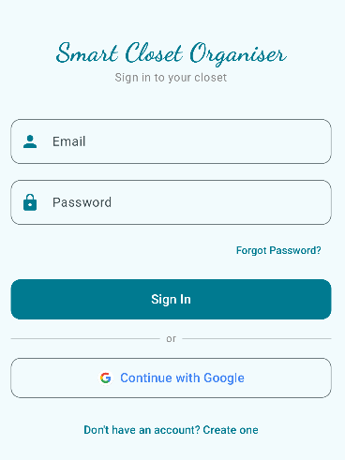
Figure 3 Login Screen

2. Register Screen
New users are directed here to create an account using their name, email address and password. Firebase Authentication handles account creation securely in the background.
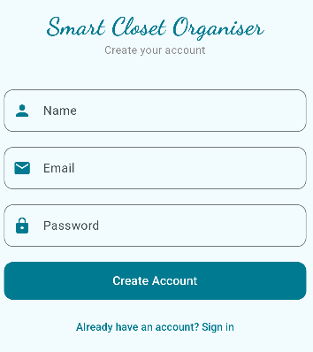
Figure 4 Register Screen

3. Home / Wardrobe Dashboard
The central hub of the application. Displays a live weather card based on the user’s location, a scrollable item carousel and quick access to the full clothing list. The bottom navigation bar provides access to all main sections of the app.
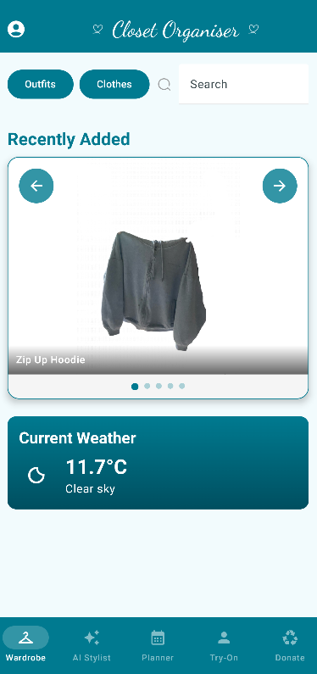
Figure 5 Home Screen

4. My Closet
Displays all clothing items stored in the user’s wardrobe as a scrollable list. Items can be filtered by category (Tops, Bottoms, Shoes, etc). Tapping an item opens it for editing. By pressing the three dots at the end of clothing cards is used to delete the item. 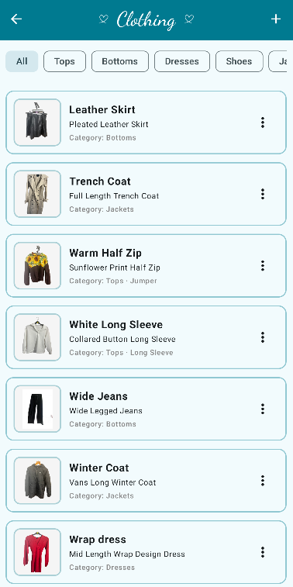
Figure 6 Closet Screen

5. Add / Edit Item Screen
Allows the user to add a new clothing item by entering details such as title, category, colour, size, season and last worn date. An image can be uploaded with an optional background removal toggle. The AI scan feature can auto-fill fields by analysing a photo of the item.
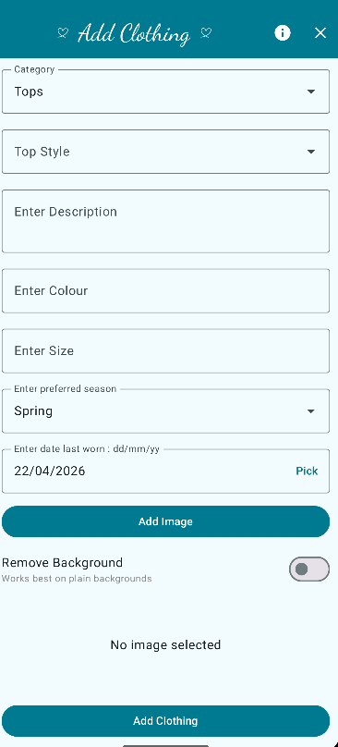
Figure 7 Add/ Edit Item Screen

6. Outfits Screen
Displays all saved outfits created by the user. Each outfit groups together individual clothing items. Users can tap an outfit to view, edit or delete it, or navigate to create a new one by selecting items from their wardrobe. 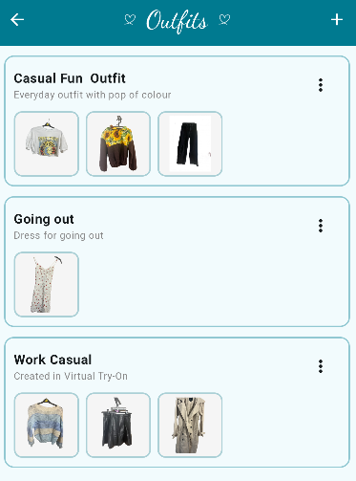
Figure 8 Outfit Screen

7. Virtual Try On
Allows the user to preview clothing combinations visually before saving them as an outfit. Items are layered on screen, giving the user a sense of how pieces look together without physically trying them on. 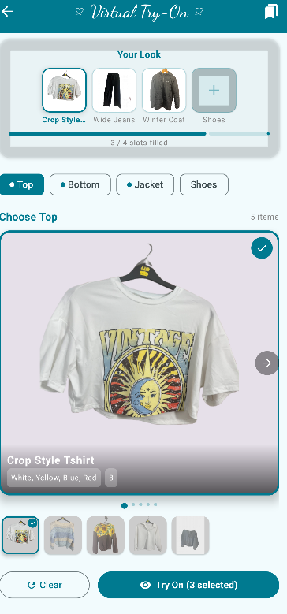
Figure 9 Virtual Try On

8. AI Stylist
The AI-powered recommendation engine suggests outfit combinations based on the contents of the user's wardrobe, current weather conditions and built-in fashion styling rules. Users can also use voice input to describe what they are looking for, and the AI will interpret the request and generate a matching suggestion. 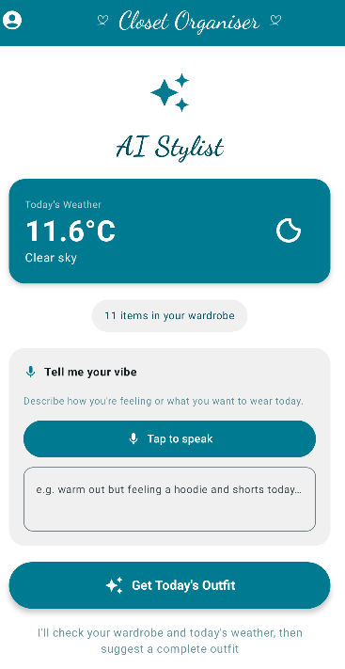
Figure 10 AI Stylist

9. Calendar
A monthly calendar view that allows users to plan outfits in advance by assigning a saved outfit to a specific date. This is particularly useful for planning ahead for events, trips or work schedules.

Figure 11 Calendar

10. Donation: Flagged Tab
Automatically identifies clothing items that have not been worn recently and flags them for potential donation. This feature encourages users to engage with their full wardrobe and supports more sustainable clothing habits. 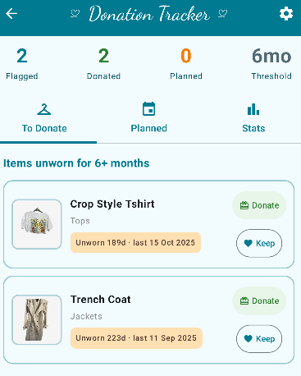
Figure 12 Donation: Flagged Tab

11. Donation: Plan & Map
Allows the user to plan a donation by selecting flagged items and scheduling a reminder. A map integration displays nearby donation centres, making it easy to act on the plan.
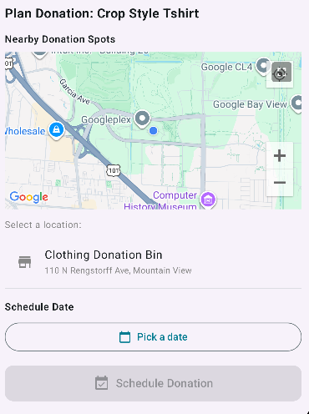
Figure 13 Donation: Plan & Map

12. Profile & Settings
Displays the user's profile information including their name and photo. From here users can edit their display details and access settings such as location preferences and notification controls.
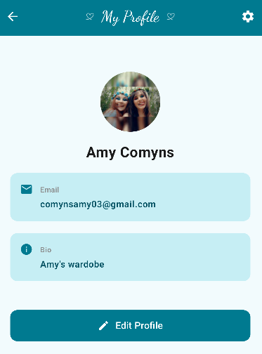
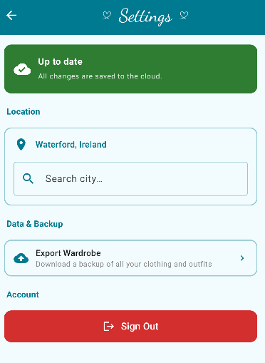
Figure 14 My Profile & Setting Screen

Conclusion & Evaluation
The Smart Closet Organiser project demonstrates the successful design and development of a comprehensive and intelligent mobile application that addresses a common everyday problem through the use of modern technologies and user-centred design. Over the course of multiple iterative sprints, the application evolved from a foundational wardrobe management system into a feature-rich platform with artificial intelligence, planning tools, sustainability features, and interactive user experiences.
The project achieved its primary aim of developing a functional and user-friendly wardrobe management application. Core features such as secure authentication, cloud-based data storage using Firebase, outfit creation, and image management were successfully implemented and extended through advanced functionality. The integration of an AI Stylist powered by Google’s Gemini API introduced personalised outfit recommendations, while additional features such as the calendar planner, virtual try-on module, and donation system enhanced both usability and real-world relevance.
From a technical perspective, the project demonstrates strong use of modern Android development practices. The adoption of the Model-View-ViewModel (MVVM) architecture ensured a clear separation of concerns, while dependency injection, coroutines, and Flow-based state management contributed to a scalable and maintainable codebase. The integration of multiple external services, including cloud storage, AI, APIs, location services, and background processing, highlights the ability to design and implement a complex, full-stack mobile application.
A key strength of the project is its focus on user experience. Features such as AI-assisted input, voice interaction, intuitive navigation, and consistent UI design demonstrate a clear emphasis on reducing user effort and improving usability. The final stages of development, which focused on polishing and bug fixing, ensured that the application reached a level of quality and stability expected of a production-ready system.
If I were to complete the project again, I would approach certain aspects differently based on what I learned throughout development. One of the main changes would be allowing more time for user testing earlier in the process, as many of the improvements made in later sprints came directly from usability issues I only noticed after features were already built. Starting this earlier would have helped refine the design sooner and reduce the need for reworking parts of the app.
I would also spend more time planning how features connect together across the app, particularly as new functionality such as the AI Stylist, calendar, and donation system were added. While the Agile approach worked well for building features incrementally, some adjustments were needed along the way as the project grew in complexity.
Looking forward, a key future improvement would be expanding the application beyond Android by developing an iOS version, making the app available across both major mobile platforms and increasing its accessibility. There is also strong potential to further develop the application with additional features such as wardrobe insights, usage tracking, and more advanced personalisation within the AI system.
Overall, the Smart Closet Organiser successfully meets its objectives by delivering an innovative, practical, and technically robust application. The project demonstrates not only strong technical ability, but also the effective application of technology to solve a real-world problem in a meaningful and user-focused way.

References
Google (2024) Jetpack Compose HorizontalPager. Available at: https://developer.android.com/develop/ui/compose/layouts/pager
Google (2024) Material 3 Navigation Bar in Compose. Available at: https://m3.material.io/components/navigation-bar/overview
Google (2024) Hilt dependency injection in Android. Available at: https://developer.android.com/training/dependency-injection/hilt-android
Google (2024) AnimatedContent in Jetpack Compose. Available at: https://developer.android.com/develop/ui/compose/animation/composables-modifiers#animatedcontent
Google (2024) Cloud Firestore, Add and manage data. Available at: https://firebase.google.com/docs/firestore/manage-data/add-data
Nielsen Norman Group (2020) Reducing the pain of outfit selection. Available at: https://www.nngroup.com/articles/progressive-disclosure
Google (2024) Gemini API documentation, Getting started. Available at: https://ai.google.dev/gemini-api/docs
Google (2024) Generative AI for Android developers. Available at: https://developer.android.com/ai/gemini-nano
Google (2024) Count tokens using the Gemini API. Available at: https://ai.google.dev/gemini-api/docs/tokens
Google (2024) SpeechRecognizer, Android developer reference. Available at: https://developer.android.com/reference/android/speech/SpeechRecognizer
Google (2024) RecognizerIntent, Android developer reference. Available at: https://developer.android.com/reference/android/speech/RecognizerIntent
Google (2024) State and Jetpack Compose. Available at: https://developer.android.com/develop/ui/compose/state
Google (2024) LinearProgressIndicator, Material 3 in Compose. Available at: https://developer.android.com/reference/kotlin/androidx/compose/material3/package-summary#LinearProgressIndicator
Google (2024) LazyRow and LazyColumn in Jetpack Compose. Available at: https://developer.android.com/develop/ui/compose/lists
Nielsen Norman Group (2020) Wizards, Definition and design recommendations. Available at: https://www.nngroup.com/articles/wizards/
Google (2024) WorkManager, Schedule tasks with WorkManager. Available at: https://developer.android.com/topic/libraries/architecture/workmanager
Google (2024) OneTimeWorkRequest, Android developer reference. Available at: https://developer.android.com/reference/androidx/work/OneTimeWorkRequest
Google (2024) DataStore, Store data with Jetpack DataStore. Available at: https://developer.android.com/topic/libraries/architecture/datastore
Google (2024) Cloud Firestore, Get data with Cloud Firestore. Available at: https://firebase.google.com/docs/firestore/query-data/get-data
Ellen MacArthur Foundation (2017) A new textiles economy, Redesigning fashion's future. Available at: https://ellenmacarthurfoundation.org/a-new-textiles-economy
Remove.bg (2024) Remove.bg API documentation. Available at: https://www.remove.bg/api
Google (2024) Gemini API, Vision capabilities. Available at: https://ai.google.dev/gemini-api/docs/vision
Open-Meteo (2024) Open-Meteo API documentation, Free weather API. Available at: https://open-meteo.com/en/docs
Google (2024) ViewModel overview, Android Jetpack. Available at: https://developer.android.com/topic/libraries/architecture/viewmodel
Google (2024) StateFlow and SharedFlow. Available at: https://developer.android.com/kotlin/flow/stateflow-and-sharedflow
Google (2024) Places API, Nearby Search. Available at: https://developers.google.com/maps/documentation/places/web-service/nearby-search

