PROJECT: PAGE:

Live action google search

Fade transition with definition

L cut audio

Insert?

Live action scrolling in background

Straight cut to Live action of a woman using laptop- personal examples

L cut into goat videos/ jump cut?

Straight cut into TV- personal example

Croos-cut? Two tv screens- make graphical match cut?

Straight cut- screen shot (consistent angle)

Straight cut back to Netflix- fade tv out

J cut, fade in for chart

Wipe transition- chart

SEQ/SC: NOTES:

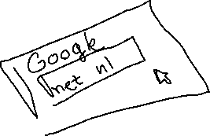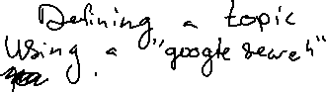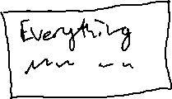

SEQ/SC: NOTES:

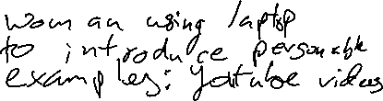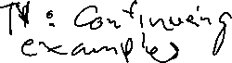

SEQ/SC:

NOTES:

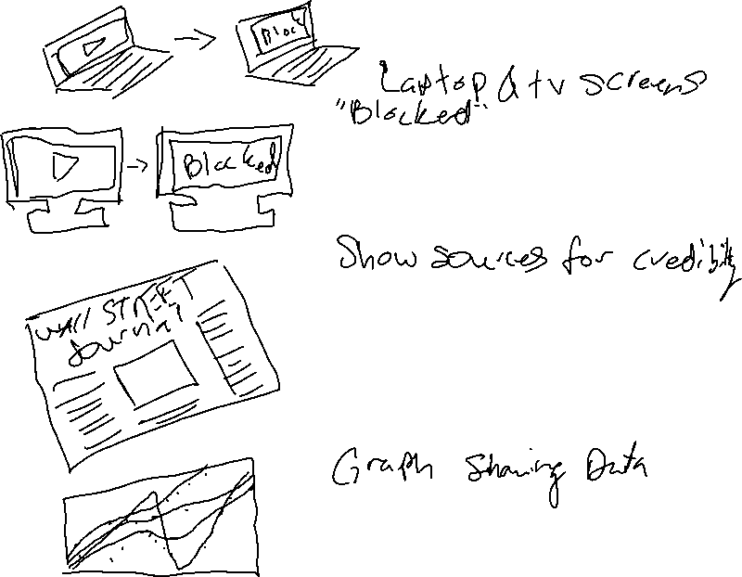

SEQ/SC:

NOTES:

SEQ/SC: NOTES:

