RESEARCH PROPOSAL FORM
(also referred to as the ‘Statement of Intent Form’, or SOI)

To be submitted by the researcher to the Institute Research Sub-Committee (IRC)

Research Title:
Harmonizing Movement and Technology: An Advanced Analysis of Dance Through Artificial Intelligence-Based Pose Estimation and Classification
Institute name
Institute of Information and Communication Technology
Course / Programme:
Bachelor of Science (Honours) in Multimedia Software Development
Level and year of study
Level 6 Year 3
Main area of study being proposed:
This study focuses on developing an artificial intelligence (AI) tool for evaluating technical precision in dance movements. Spanish dance requires intricate footwork, body movements, and precise arm positions. Traditionally, assessing this technical skill relies on human judgment, which can be subjective and prone to error. One’s approach to using AI for pose estimation and classification could significantly enhance objectivity and efficiency in performance assessments.
Name of Researcher:  Amy Grech | Researcher’s I.D. Number:  32702L
Signature of Researcher | Date of submission of Form  04/11/2024
Name of Tutor (or Recommended Tutor):
Oriana Ebejer

Personal Motivation for the Choice of Research Theme.
Spanish dance, with its rich tapestry of footwork, body movements, and intricate arm positions, demands a high level of technical precision from dancers. Evaluating this technical skill is a crucial aspect of both training and performance assessments. Traditionally, this evaluation relies on the trained eye of instructors and judges, a process that can be subjective and susceptible to human error.
As a dancer and dance instructor, I have encountered the challenge of assessing dance technique while observing multiple dancers or even a single dancer. This difficulty inspires my research focus on developing tools that can assist in dance technique assessment calculations.

Outline of Key Literature and Theoretical Framework or Propositions.
Prasad Dhore et al.'s paper aims to review human pose estimation techniques and propose an automated system for recognizing yoga poses, laying the groundwork for a self-training system to aid yoga practitioners. The focus is on facilitating self-learning, enhancing yoga practice, and preventing injuries from incorrect postures. It discusses various human pose estimation methods, including generative and discriminative approaches, and the use of top-down and bottom-up strategies for analyzing images and videos. Key algorithms like OpenPose, DeepCut, RMPE (AlphaPose), and Mask R-CNN are examined for their effectiveness in assembling human poses. The study emphasizes the importance of datasets such as MPII, COCO, and YOGA-82, which cover a wide range of human activities and yoga poses, for developing and evaluating pose estimation algorithms. Evaluation metrics like accuracy, precision, and recall are highlighted for assessing the accuracy of these methods. Despite progress, challenges such as environmental variability and the accurate grouping of body parts in crowded scenes persist. Recommendations for further research include improving datasets, refining algorithms, and integrating additional contextual information. Advancements in human pose estimation are expected to benefit numerous fields, including augmented reality, healthcare, and sports.
Xiaodan Hu et.al's study aims to enhance the interpretation of dance videos by developing algorithms that integrate the estimation of body movements and their feasibility within dance contexts. It employs a hierarchical framework that analyzes dance from the ground up, starting with video frames, progressing through human poses and movements, and culminating in the prediction of dance genres. Utilizing the UID dataset, which contains a wide array of dance videos, the research introduces novel algorithms for tracking 2D poses amidst occlusions and an unsupervised technique for estimating 3D poses, enriched by kinematic constraints and motion continuity. These methodologies not only predict dance genres but also improve understanding by breaking down dance videos into comprehensible elements. This paper highlights significant contributions, including the creation of a substantial dance video dataset with detailed pose annotations and the development of advanced pose estimation algorithms that demonstrate superior performance over existing methods. However, it recognizes the limitation of not achieving a fully unsupervised training regime for dance video recognition, suggesting future directions towards a completely unsupervised learning approach and the exploration of dance synthesis to validate the framework's efficacy further. Future research is encouraged to focus on refining the unsupervised aspects of the methodology and to consider expert evaluations of synthesized dances as a metric for the success of the extracted representations.
J. Iqbal et al.'s study addresses the advancement of algorithms for accurately recognizing and understanding human actions, with a specific focus on applications like martial arts, sports, and dance training. Utilizing Kinect sensor technology, this research aims to navigate the challenges posed by existing recognition systems that struggle with complex human gestures and the demarcation of movement sequences. By developing a more nuanced understanding of human motion, the paper seeks to enhance interaction between humans and robots, bolster video surveillance effectiveness, and refine home-based movement training methodologies. A key innovation presented is a Natural User Interface (NUI)-based dance training system that employs Kinect cameras to track and evaluate dance movements across various styles. This system rates learners by comparing their movements to those of expert choreographers, utilizing skeletal mapping for accuracy. The paper underscores the benefits of Augmented Reality (AR) in educational contexts—highlighting its affordability, interactivity, and user engagement—to facilitate effective dance training. The proposed solution introduces a pose matching algorithm that calculates the relative and normalized orientation (RNO) of joints, ensuring accurate pose recognition irrespective of the participant's distance or orientation relative to the Kinect sensor. This approach, promising real-time feedback on movement accuracy, is tested against traditional learning methods, showcasing superior frame-level accuracy and efficiency in learning times for specific dance movements. By integrating MATLAB and C Sharp programming, the study demonstrates the proposed system's effectiveness, setting the stage for further exploration into skeletal mapping and gesture recognition. This research contributes to the broader goal of creating AR-based learning environments that are more interactive and responsive, offering a holistic solution that blends skeletal data analysis, RGB-D imaging, and interactive user feedback for enhanced dance training experiences.
Anirban Saha et al.'s research focuses on developing a methodology to automate the recognition and classification of audios accompanying Kathak dance footwork, termed "Ladi," utilizing the Ladi audio dataset. This dataset comprises mono-format audio recordings from Kathak performances, which undergo preprocessing to remove noise, followed by beat detection and tracking. The core objective is to classify these processed Ladi audios into seven categories based on their rhythms and Mel-Frequency Cepstral Coefficients (MFCCs) using the K Nearest Neighbors technique. The study employs various audio signal processing methods, including feature extraction, peak picking, and tempo analysis, to achieve accurate classification. With a dataset initially containing 182 audio files expanded synthetically to 1400, the research demonstrated high accuracy levels in classifying the audios, with the best results showing a training accuracy of 95.2 percent and testing accuracy of 93.4 percent using a 90:10 split. The study highlights the potential for further enhancements in classification through subclassification based on bols and taals variations and suggests that more robust outcomes could be obtained using Convolutional Neural Networks (CNNs). This work aims to advance the technological analysis of Kathak dance performances, offering a foundation for future research in this area.
Yeonho Kim et al. study introduces a novel framework for markerless evaluation of dance performances, focusing on the use of human pose estimation techniques that are resistant to rotation and occlusion issues. It specifically utilizes ridge data and data pruning to estimate human poses accurately. Upon estimating poses, the framework extracts features to compare the timing and accuracy of poses between a dance teacher's performance and a learner's attempt. This method aims to assess dance performances both qualitatively and quantitatively, utilizing a comprehensive K-Pop dance database, marking a pioneering approach in evaluating both qualitative and quantitative aspects of dance using pose estimation technology. The approach employs Kinect camera-captured depth images for pose estimation and validates this through benchmark datasets like EVAL and SMMC-10. The study also introduces a dance teacher program that analyzes dance performance by comparing it against pre-recorded expert dances using a 22-dimensional feature vector, achieving a high level of agreement with expert evaluations. Despite its innovations, the framework faces challenges in distinguishing front from back views and in accurately identifying specific body parts in complex poses. The study suggests potential improvements in these areas and recommends expanding the database to include a wider variety of dance styles for broader applicability. This research signifies a substantial step forward in leveraging pose estimation for educational and entertainment purposes in dance.

Significance of the Study.
This study aims on developing a pose estimation and classification tool for Spanish dance focusing on dance evaluation and footwork. It focuses on dance interpretation. Thus, the proposed study contributes to the existing body of research by introducing a unique combination of pose estimation and dance-specific classification, thereby enriching the technological analysis of dance performances.

Hypotheses and/or Research Question/s
Hypothesis
Implementing an AI-based pose estimation and classification tool for basic arm positions in Spanish dance can significantly improve the precision of performance assessments.
Research Questions
- How accurately can the AI-based pose estimation tool identify and classify movements in Spanish dance when compared to traditional manual assessment methods?
- How accurately can the AI-based pose estimation tool identify and classify footwork in Spanish dance when compared to traditional manual assessment methods?
- What impact does the implementation of an AI-based pose estimation tool have on performance assessment of Spanish dancers?

Target Participants and Research Methods for Data Collection and Analysis
The target participants for this study are dancers of various levels and ages who specialize in Spanish dance. The research method for data collection and testing consists of several steps. First, the tool will be provided with images of arm movements and footwork positions, which will serve as its predefined dataset.
Next, the dancer will be assigned an exercise involving various sequences of these predefined positions, and their performance will be evaluated using two approaches. Arm movements will be analyzed from a frontal view, while footwork will be observed from a side view.
Finally, a checklist listing the executed steps, along with an overall rating for each position, will be given to the dancer. This feedback allows them to identify correctly performed steps and areas needing improvement.
This method of analysis aims to provide a comprehensive evaluation of the dancer's performance, offering valuable insights for both the dancer and the instructor.

Anticipated Contributions of the Study.
By developing an AI tool for evaluating technical precision in Spanish dance movements, this study introduces a novel approach to dance assessment. This could revolutionize the way dance performances are evaluated, moving away from traditional methods that rely on human judgment that are often subjective.

The use of AI for pose estimation and classification could significantly enhance the objectivity and efficiency of performance assessments. This could lead to more accurate and consistent evaluations, benefiting both dancers and instructors.

By focusing specifically on Spanish dance, which requires intricate footwork, body movements, and precise arm positions, this study addresses a gap in the current research landscape. This could pave the way for similar studies focusing on other specific dance forms.

While the study focuses on Spanish dance, the methodologies and tools developed could potentially be applied to other forms of dance or even other fields that require precise movement analysis.

Dissertation Project Plan.
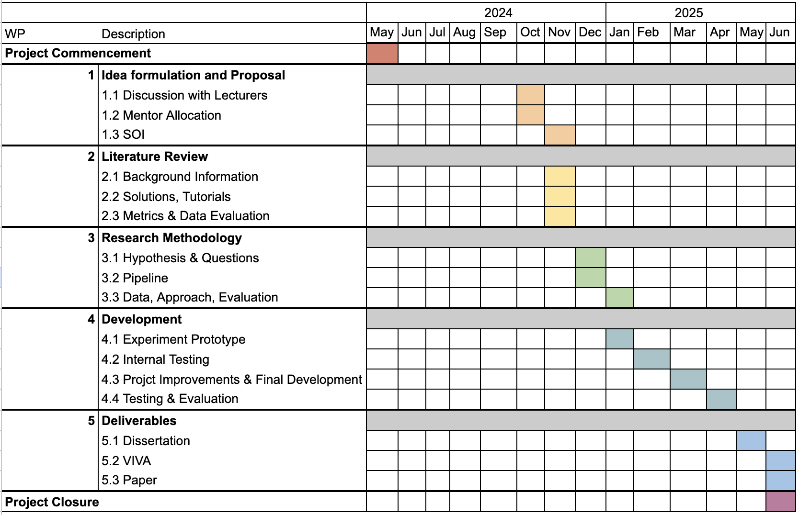

Ethical Considerations.
Refer to guidance points below. You are also additionally required to read MCAST Document 074 ‘Research Ethics Policy and Procedure’ that is available on the College website
Research shall be conducted in such a manner so as to avoid any psychological and physical harm to humans and animals and financial damage to organizations:
- Only the supervisor and examiners will have access to any data gathered.
- Participants will remain free to withdraw from the study at any time without having to provide any reason. In the case of withdrawal, all the records and information collection will be deleted.
- The participant, who is the sole proprietor of the data provided, is granting that such data would be processed for this study purposes only.
- The data collection process will be a transparent process.
- All transcriptions and/or electronic recordings reflecting the data collected, once exhausted, are to be deleted
- Confidentiality, anonymity and data protection procedures are to be ethically abided by.
- The researcher would provide a soft copy of the study to the participant, if required.

Enter details here regarding possibility of issues regarding confidential personal data:
In this research, there are no anticipated issues concerning the confidentiality of personal data, as the participating dancers are members of a dance school in which the researcher is also enrolled and have previously signed a confidentiality agreement permitting their appearance in photos and videos. Nonetheless, if an additional confidentiality agreement is required for this research, it can be readily provided.

Enter details here regarding possibility of physical harm:
Throughout this research no physical harm is possible as the dancer is required to follow a set of predefined beginner steps.
Enter details here regarding possibility of moral harm:
In this research, it is anticipated that no moral harm can be inflicted in any tests as the tool will not be offensive, insulting or disrespectful.
Enter details here regarding possibility of business harm:
The intention of this research is not to inflict any harm on businesses. Examiners will still need to be present for the rest of the assessment, such as evaluating artistry and performance.

List of Key References:

Prasad Dhore, Aparna Pande, Shital Mehta, and Saili Sable. Human pose estimation and classification: A review. Neuroquantology, 20(15):3199, 2022.
Xiaodan Hu and Narendra Ahuja. Unsupervised 3d pose estimation for hierarchical dance video recognition. In Proceedings of the IEEE/CVF International Conference on Computer Vision, pages 1101511024, 2021.
Javid Iqbal, Manjit Singh Sidhu, and Mutahir Bin Mohamed Ariff. Ar oriented pose matching mechanism from motion capture data. International Journal of Engineering & Technology, 7(4.35):294, 2018.
Yeonho Kim and Daijin Kim. Real-time dance evaluation by markerless human pose estimation. Multimedia Tools and Applications, 77:31199–31220, 2018.

Anirban Saha, Saptami Ghosh, Partha Pratim Das, and Indranil Sarkar. Recognition and classification of accompanying audios of kathak dance. In 2021 10th IEEE International Conference on Communication Systems and Network Technologies (CSNT), pages 860–864. IEEE, 2021.

This section is to be filled in by the representative of the Institute Research Sub-Committee (IRC) prior to forwarding of this Form to the ‘MCAST Research Ethics Committee’ for final ethics approval:
Nature of Ethical Consideration | Outcome (Tick) | Comments/Advice
All ethical issues have been adequately tackled.
Possibility of issues regarding misuse of data or some form of harm.

Details of Representative to the Institute Research Sub-Committee.
Name | Signature
Designation | Date
Annex 1: Participant Information Letter

Sample: 
Title of Research: Harmonizing Movement and Technology: An Advanced Analysis of Dance Through Artificial Intelligence-Based Pose Estimation and Classification
You are being invited to take part in a research study. Before you decide to participate, it is important for you to understand why the research is being done and what it will involve. Please take time to read the following information carefully and discuss it with others if you wish. Ask us if there is anything that is not clear or if you would like more information.
What is the purpose of the study?
I am writing to invite you to participate in a research study that aims to develop a tool to be used for assessment purposes related to Spanish dance.
Why have I been chosen?
You have been chosen because you fit the requirements needed for this study. I need Spanish dancers of different ages and grades to have a wide range of differences and results.
Do I have to take part?
Participation is voluntary. It is up to you to decide whether your daughter can take part or not. If you decide to allow their participation, you will be given this information sheet to keep and be asked to sign a corresponding consent form.
What will happen to me if I take part?
If your daughter takes part, she will be asked to perform a set of Spanish exercises and all this will be captured on video. There are no disadvantages or risks foreseen in taking part in the study.
What are the possible disadvantages and risks of taking part?
There are no disadvantages or risks foreseen in taking part in the study.
What are the possible benefits of taking part?
By taking part, you will be contributing to the development of a tool that may make the technique assessment process easier in the future.
What if something goes wrong?
If you wish to complain or have any concerns about any aspect of the way in which you have been approached or treated during the course of this study, please contact…(researcher is to give his/her MCAST email as a contact)
Will my details be kept confidential?
Please be assured that all information collected about you during the research will be kept strictly confidential. The researcher carrying out the study and MCAST will have access to such information, and it will not be shared with any other individuals. Participants should note that data/images collected from this project may be retained and published in an anonymized form. By agreeing to participate in this project, you are consenting to the retention and publication of data.
What will happen to the results of the research study?
The results will be written up into a dissertation for my final project of my Bachelor of Science (Honours) in Multimedia Software Development.

Who is organizing the research?
The research is conducted by the student as part of a degree in Multimedia Software Development.

Who may I contact for further information?
If you would like more information about the research before you decide…(researcher is to give his/her MCAST email as a contact)

Thank you for your interest in this research.
Annex 2: Participant (or Guardian) Consent Form

Sample:

Title of Research: ____________________________
Name of Researcher: ___________________________

Please initial box

- I confirm that I have read and understand the Information Letter
for the above study and have had the opportunity to ask questions.
- I understand that my/my charge’s participation is voluntary and that I/my charge am/are free to withdraw at any time without giving any reason.

3. I agree to allow my daughter/son/charge to take part in the above study.
(Statement 3 is to be included only when guardians/parents are involved in giving consent)

___________________ _________________ _____________
Name of Participant/
Guardian Date Signature

Researcher Date Signature

1 for participant; 1 for researcher

