14.1%

11.1%

6.8%
>12.5%

<12.5%
https://www.needpix.com/photo/download/528612/bullets-mauser-civil-war-projectile-free-pictures-free-photos-free-images-royalty-free
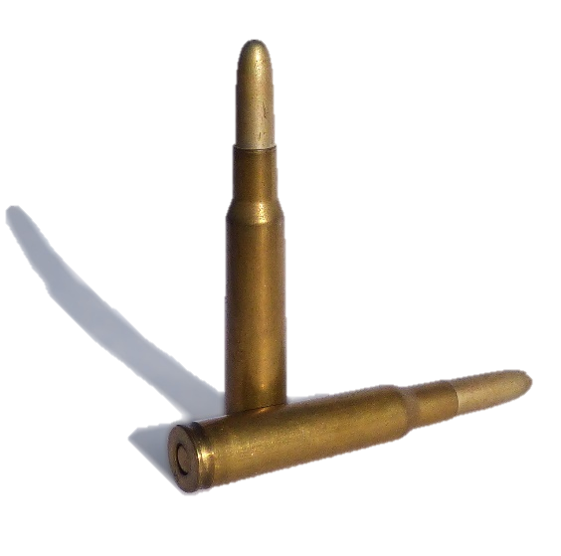
https://commons.wikimedia.org/wiki/File:Pyrodex_powder_ffg.jpg
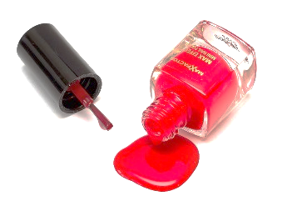
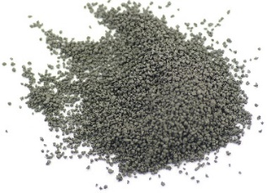
as image:
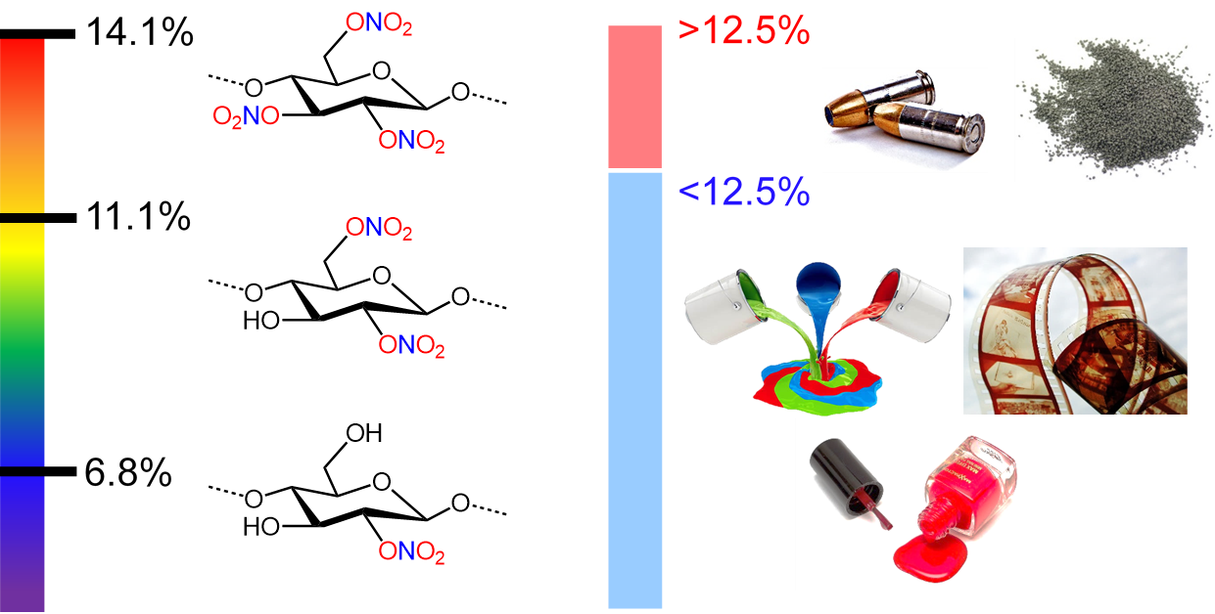

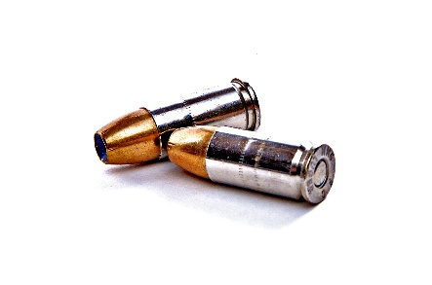
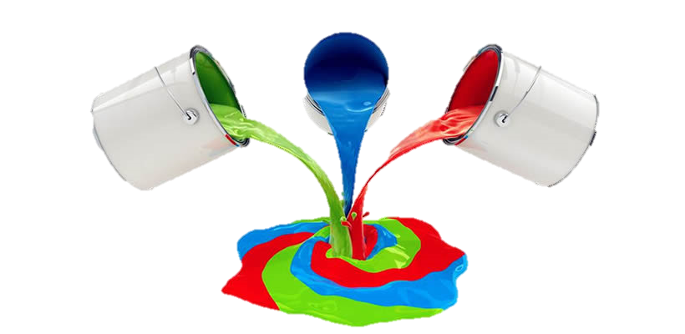

14.1%

11.1%

6.8%
>12.5%

<12.5%

